Note: Figure 1 gives an example of the influence of the various track/train characteristics on A_safe(V,d) and consequently on the EBD curve (see Error: Reference source not found).
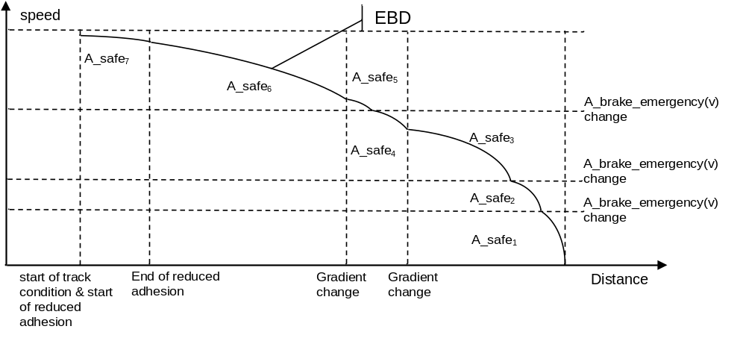
Figure 1: Influence of track/train characteristics on A_safe

