For dv_ebi, the following formula shall be applied:
when 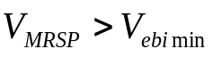:
with 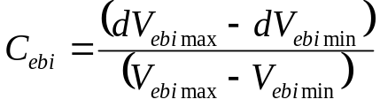
when 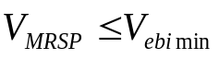: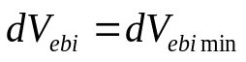

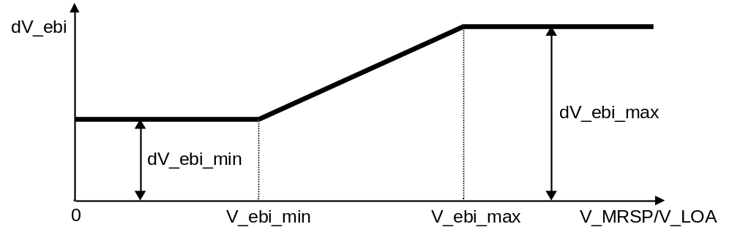
Figure 1: Definition of dV_ebi

