The position report shall contain at least the following position and direction data
- The distance between the LRBG and the estimated front end of the train.
- The distance from the estimated front end position to the min safe front end position and the distance from the estimated front end position to the max safe front end position.
- The identity of the location reference, the LRBG.
- The orientation of the train in relation to the LRBG orientation.
Note: Driver selected running direction is only handled by the on-board system.
- The position of the front end of the train in relation to the LRBG (nominal or reverse side of the LRBG).
- The estimated speed
- Train integrity information.
- Direction of train movement in relation to the LRBG orientation
- Optionally, the previous LRBG (see 3.4.2.3.3).
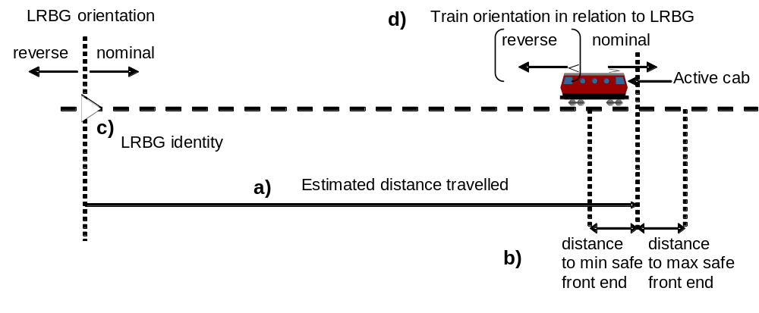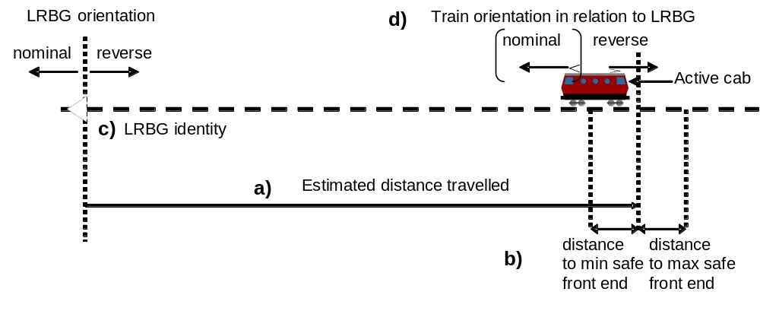
Figure 1: Information given in a position report (two examples to show the relation between LRBG and train orientation)

Intentionally deleted.

