Example: Extension of MA via a main balise group in Level 1
- by giving a new longer section, see Figure 21a
- by giving a first section to the same location as in the previous MA and a second section, see Figure 21b
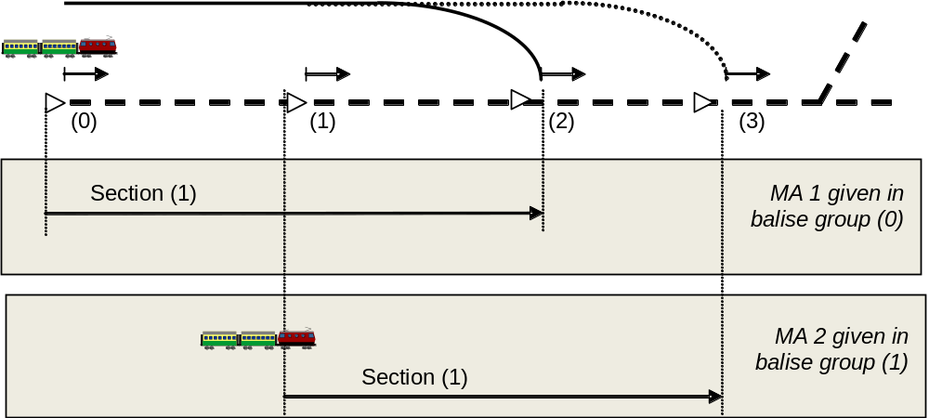
Figure 21a: Extension of an MA in Level 1, one section in the new MA
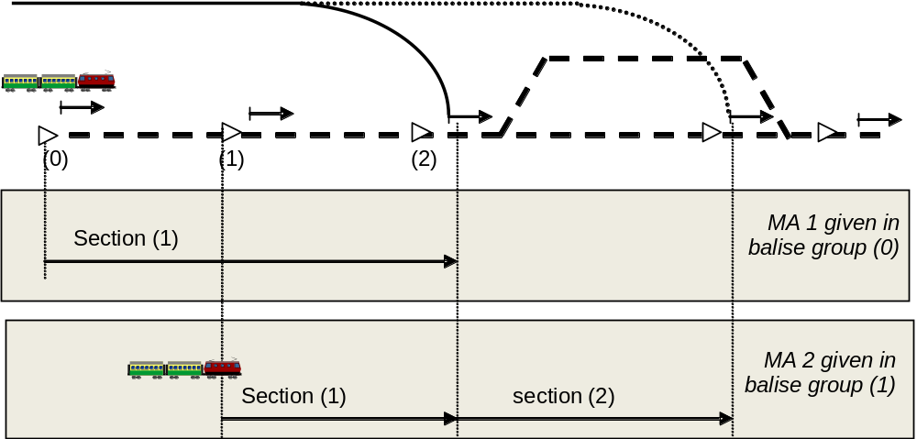
Figure 1b: Extension of an MA in level 1, two sections in the new MA

Example: MA update via infill information in Level 1. (Refer to section Error: Reference source not found for location reference of infill information)
- MA extension, by giving two new sections, see Figure 22a
- MA shortening, see Figure 22b
- MA repetition, see Figure 22c

