Justification:
- At locations where routes join: Infill information is the same for all routes, only linking information is different for different routes, see figure below (infill by means of balise group(s), loop or radio)

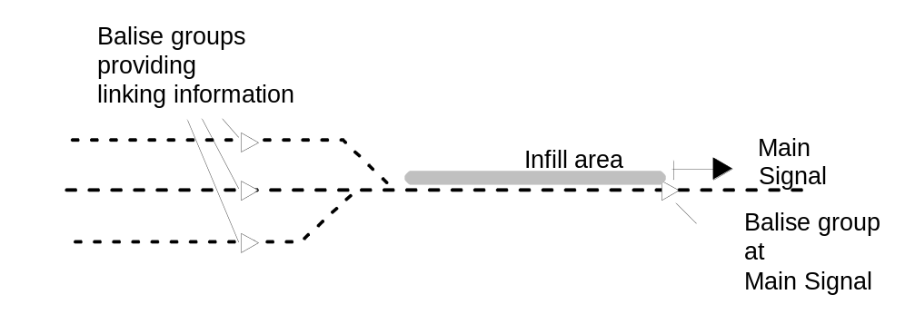
Figure 1: Routes Join in Rear of InFill Area
- In case of an infill area with multiple balise groups: all balise groups transmit identical information, as the information of all groups refers to the balise group at the main signal.

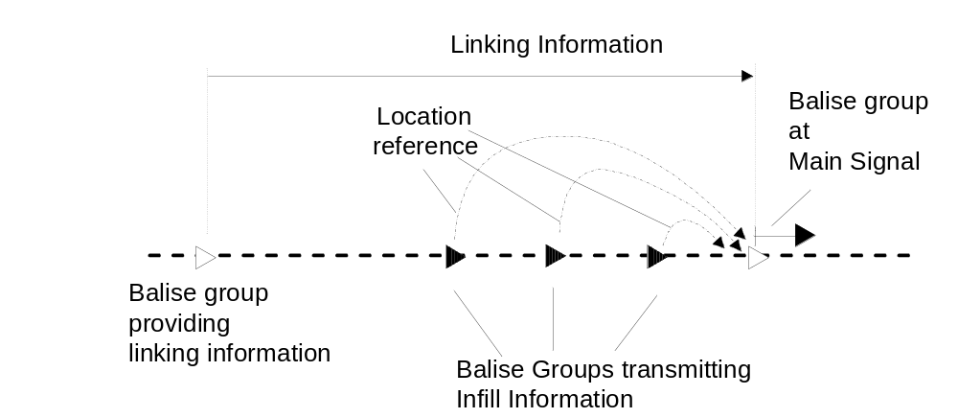
Figure 2: Location referencing of infill information transmitted by balise groups

