bioinformatics

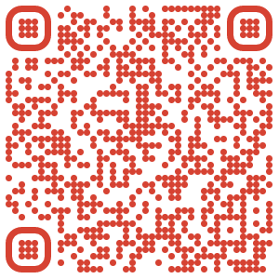

Examining the latest developments in bioinformatics, which is loosely defined as the intersection between the fields of molecular biology and computer science. Topics covered may include sequence searching and alignment, bioinformatics databases and ontologies, sequence variant analysis, sequence motif identification, metagenomics analysis, protein analysis, evolutionary/phylogenetic analysis, network/systems biology, machine learning/software development for predictive methods, and ethics in method/database development and analysis. Instruction will include lecture material and in-depth consideration of selected papers in the field.

TOPICS

|  |  |
| --- | --- |
| * Big data and semantics * Ontology * Orthology * Sequencing and analysis * Genome assembly | * SNV and SNP calling algorithms * Clustering and high dimensional data analysis * Network analysis * Metagenomics |

INSTRUCTORS

|  |  |  |  |  |
| --- | --- | --- | --- | --- |
|  |  |  |  |  |
| Fiona Brinkman | Sophie Sneddon ~ Bioinformatician, video game enthusiast, cat person |  |  |  |

