Capstone 3 - Dashboard Development
Project: Politrace (political discourse on Telegram and Twitter)
Student: Arsenii Linkin
For this capstone I had to build two dashboards on top of the database from Capstone 2. The data is political posts from Telegram and Twitter that I collected and cleaned in Capstone 1. There are 20,329 posts in total: 15,000 from Telegram and 5,329 from Twitter after cleaning. The whole thing runs on Flask, the normal charts are in Chart.js and the network graph is in D3.
One thing I hit straight away: the politrace.db file from Capstone 2 was empty (0 bytes), the data never actually saved to it. So I re-ran my load script from Capstone 2 to rebuild it from the cleaned CSVs. After that it had 20,329 posts, 4 channels and 36 named entities (21 leaders and 15 hotspots).

Step 1 - Dashboard plan
The brief says the two dashboards have to be different types, so I made one analytical and one strategic.
The story is simple. The geopolitics conversation online is mostly negative, and a small group of topics (Ukraine, Russia, Gaza, Israel, Trump) basically runs the whole thing. The two dashboards look at that from two sides.

Dashboard 1 - analytical
This one is for someone who wants to dig into the numbers, like an analyst or a journalist. It answers: how negative is it, is one platform angrier than the other, when do the spikes happen, and which channels post the most. The metrics on top are total posts, average sentiment, the negative share, average views and average post length.

Dashboard 2 - strategic
This is the big-picture view. Instead of digging into details it shows the whole map of the conversation: every leader and hotspot is a dot, connected to the others by how often they get mentioned in the same post. This is the part I wanted to look like the graph view in Obsidian. It is for someone who just wants to see who is connected to who without reading 20,000 posts.

Step 2 - Database and SQL
The dashboards read straight from the SQLite database (data/politrace.db). I started with SQLAlchemy but my Python is 3.14 and the version I had kept crashing on import, so I switched to the built-in sqlite3 module. It does the same job and now the only thing you have to install is Flask. The connection code is in backend/db.py. It opens a connection per query and closes it, which is fine at this size.
All the SQL is in backend/queries.py, and there is a commented copy in sql/queries.sql. I tried to make the database do the work instead of pulling everything into Python and counting there, so the counts, averages and groupings all happen in SQL with GROUP BY. The filters at the top of each dashboard (platform, dates, sentiment, search) get turned into one WHERE clause that every query reuses, and the values go in as bound parameters so there is no SQL injection.
The network query was the trickiest part. To find which two entities show up together I join the post_entity table to itself on the same post_id, with a < check so a pair is not counted twice, then count how many posts each pair shares. Anything below the slider value gets cut so the graph does not turn into a hairball.
I also had a bug where the date filter dropped the last day. The dates are stored with the time on them ("2026-05-27 22:12:57+00:00"), and comparing that as text against just "2026-05-27" pushed the whole last day out. That day had 3,437 tweets, so Twitter looked like it only had 1,892 posts. I fixed it by comparing on substr(date,1,10) so it goes by the calendar day.

Step 3
N/A, the brief marks this step as not required.

Step 4 and 5 - Building it and the charts
The front end is plain HTML, CSS and JavaScript. Chart.js for the normal charts and D3 for the network. Everything reloads when you change a filter. I put Chart.js and D3 into the static folder instead of linking a CDN, so the whole thing also works offline.
The back end is Flask. Each chart has its own small API route that returns JSON, and the JavaScript fetches it and draws it.
Charts on the analytical dashboard:
- posts per day with average sentiment on a second axis (bars + line)
- sentiment doughnut (positive / neutral / negative)
- platform comparison, stacked by sentiment
- top channels by number of posts
- histogram of post length in words
- scatter of views vs engagement, colored by sentiment
- a table of the most-viewed posts
The table shows the author and links to the original post. For Telegram I can build the real t.me link from the channel username and the message id, so you can click straight through to the post. The Twitter data is anonymized (no usernames, no ids), so those rows show as "Anonymous" with no link.
Strategic dashboard:
- the co-mention network graph (the main thing)
- KPI cards
- a tag cloud of the top entities, sized by mentions
- average sentiment per entity as a diverging bar chart
- a hotspot leaderboard table
That comes to 6 quantitative charts and 4 qualitative ones, which is over the 4 and 3 the rubric asks for.

Step 6 - UX and testing
A few things I did for usability:
- one filter bar controls both dashboards, and the colors mean the same thing everywhere (purple = leader, blue = hotspot, green/yellow/red = sentiment)
- every chart has a one-line note saying what it is
- on the graph you can drag nodes and zoom, and hovering a node fades everything except its neighbors so you can actually see the connections. Clicking a node pins that view.
- the graph only labels the big nodes by default, otherwise it is unreadable
- if a filter returns nothing, the table says so instead of breaking
For testing I checked that all the API routes return data without erroring, tried a bunch of filter combinations together (platform + sentiment + search + date), and took screenshots of both dashboards working.

Screenshots
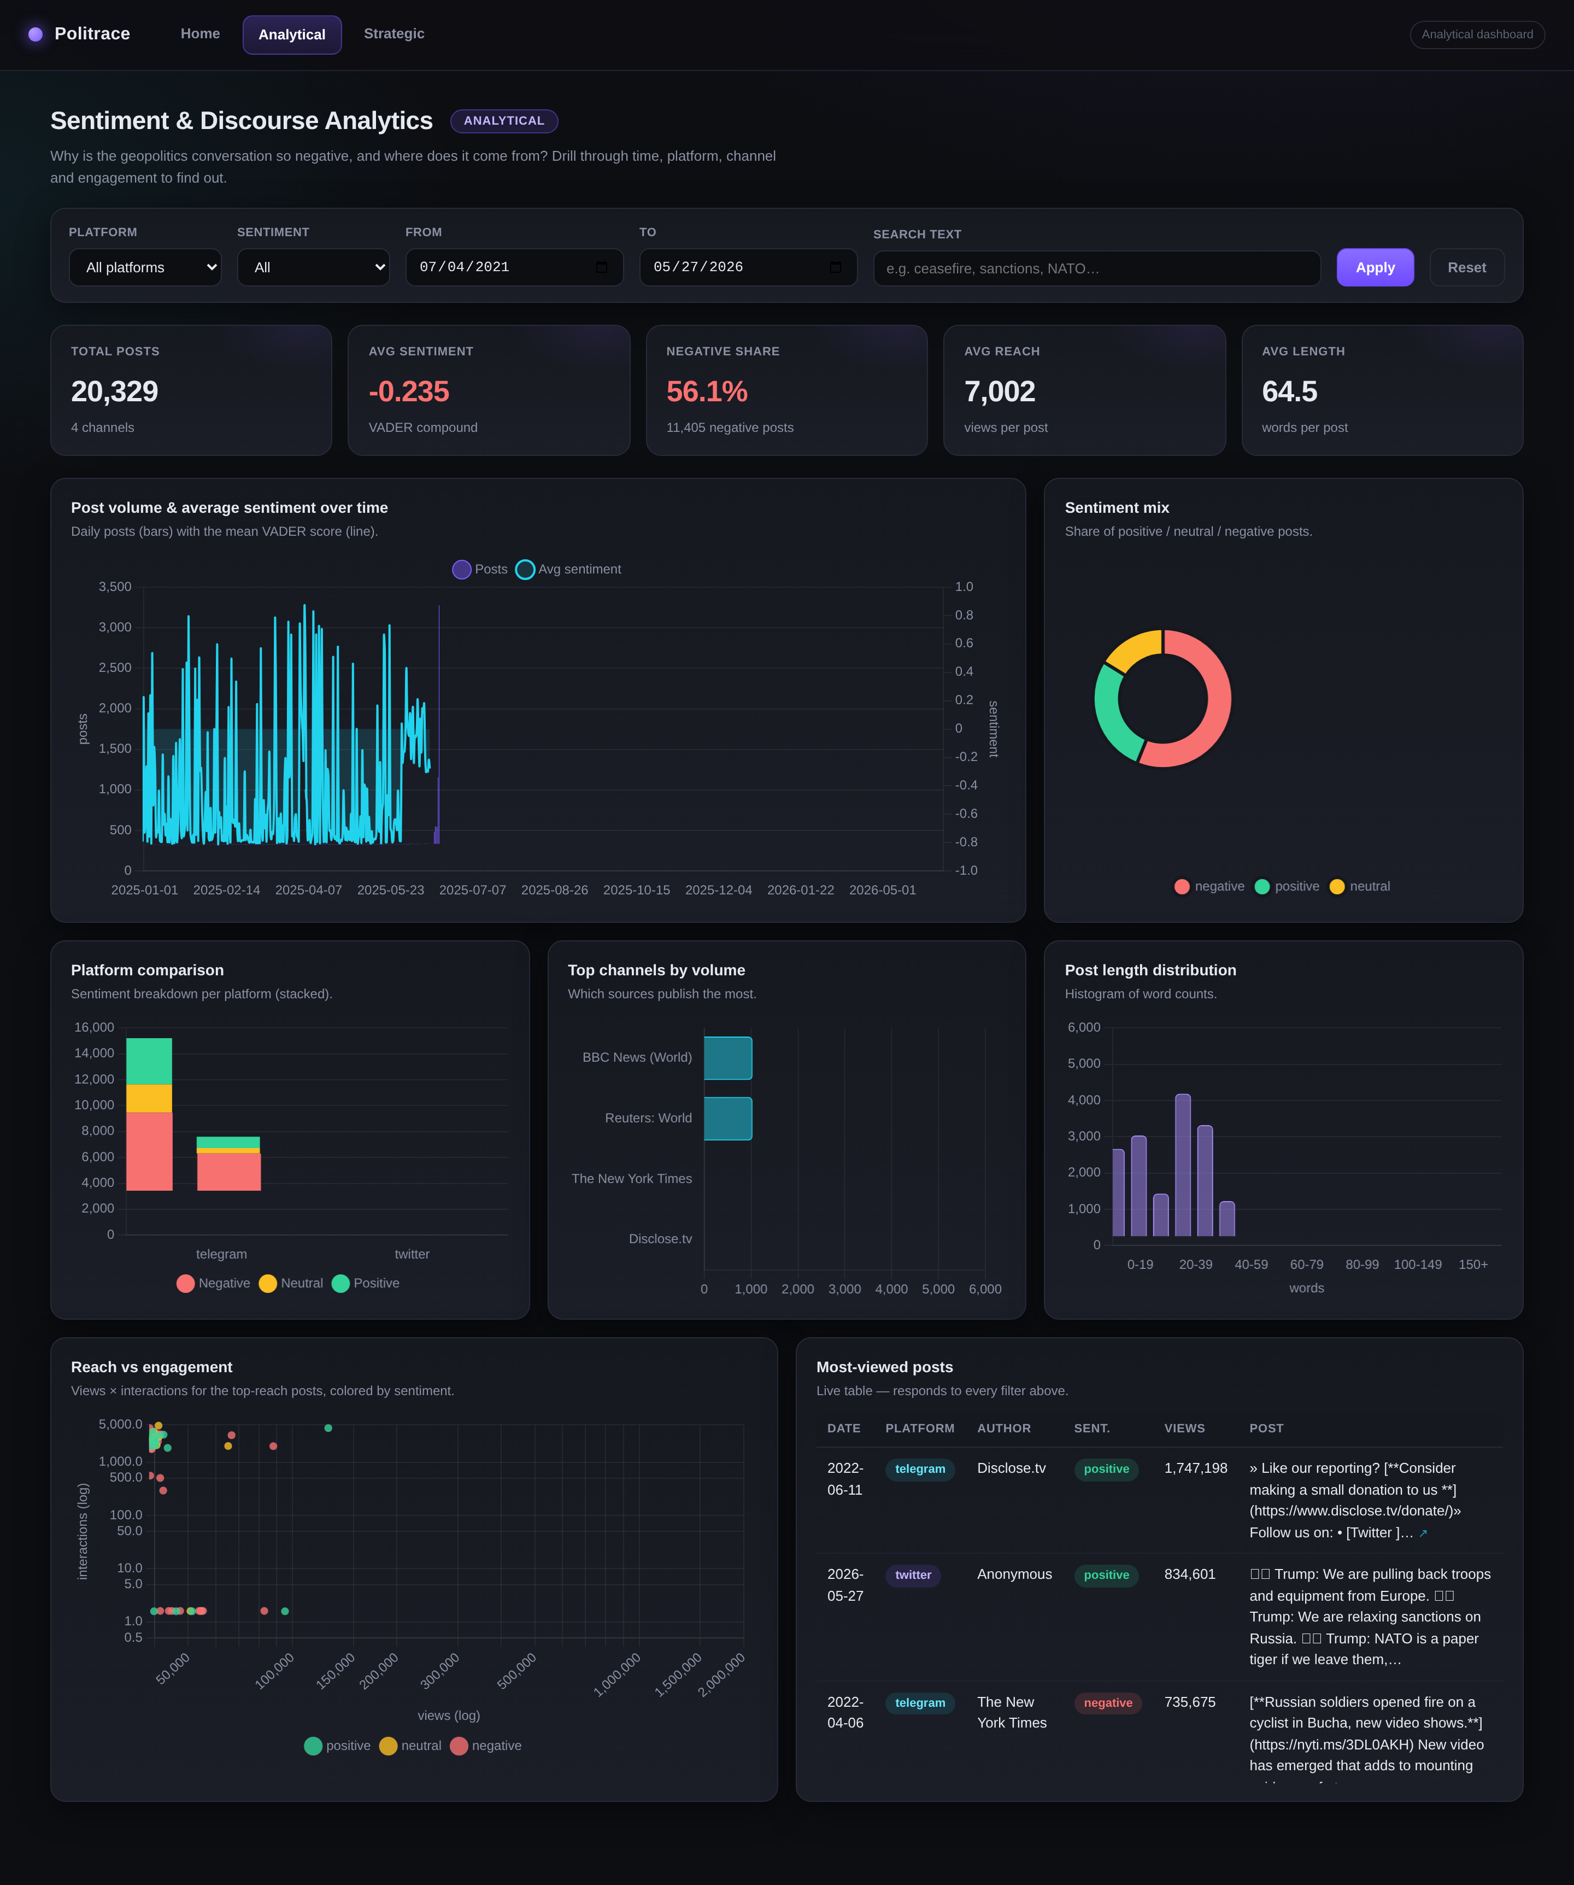
Figure 1. Analytical dashboard. Note the posts table on the bottom right with the author column and clickable links to the original posts.
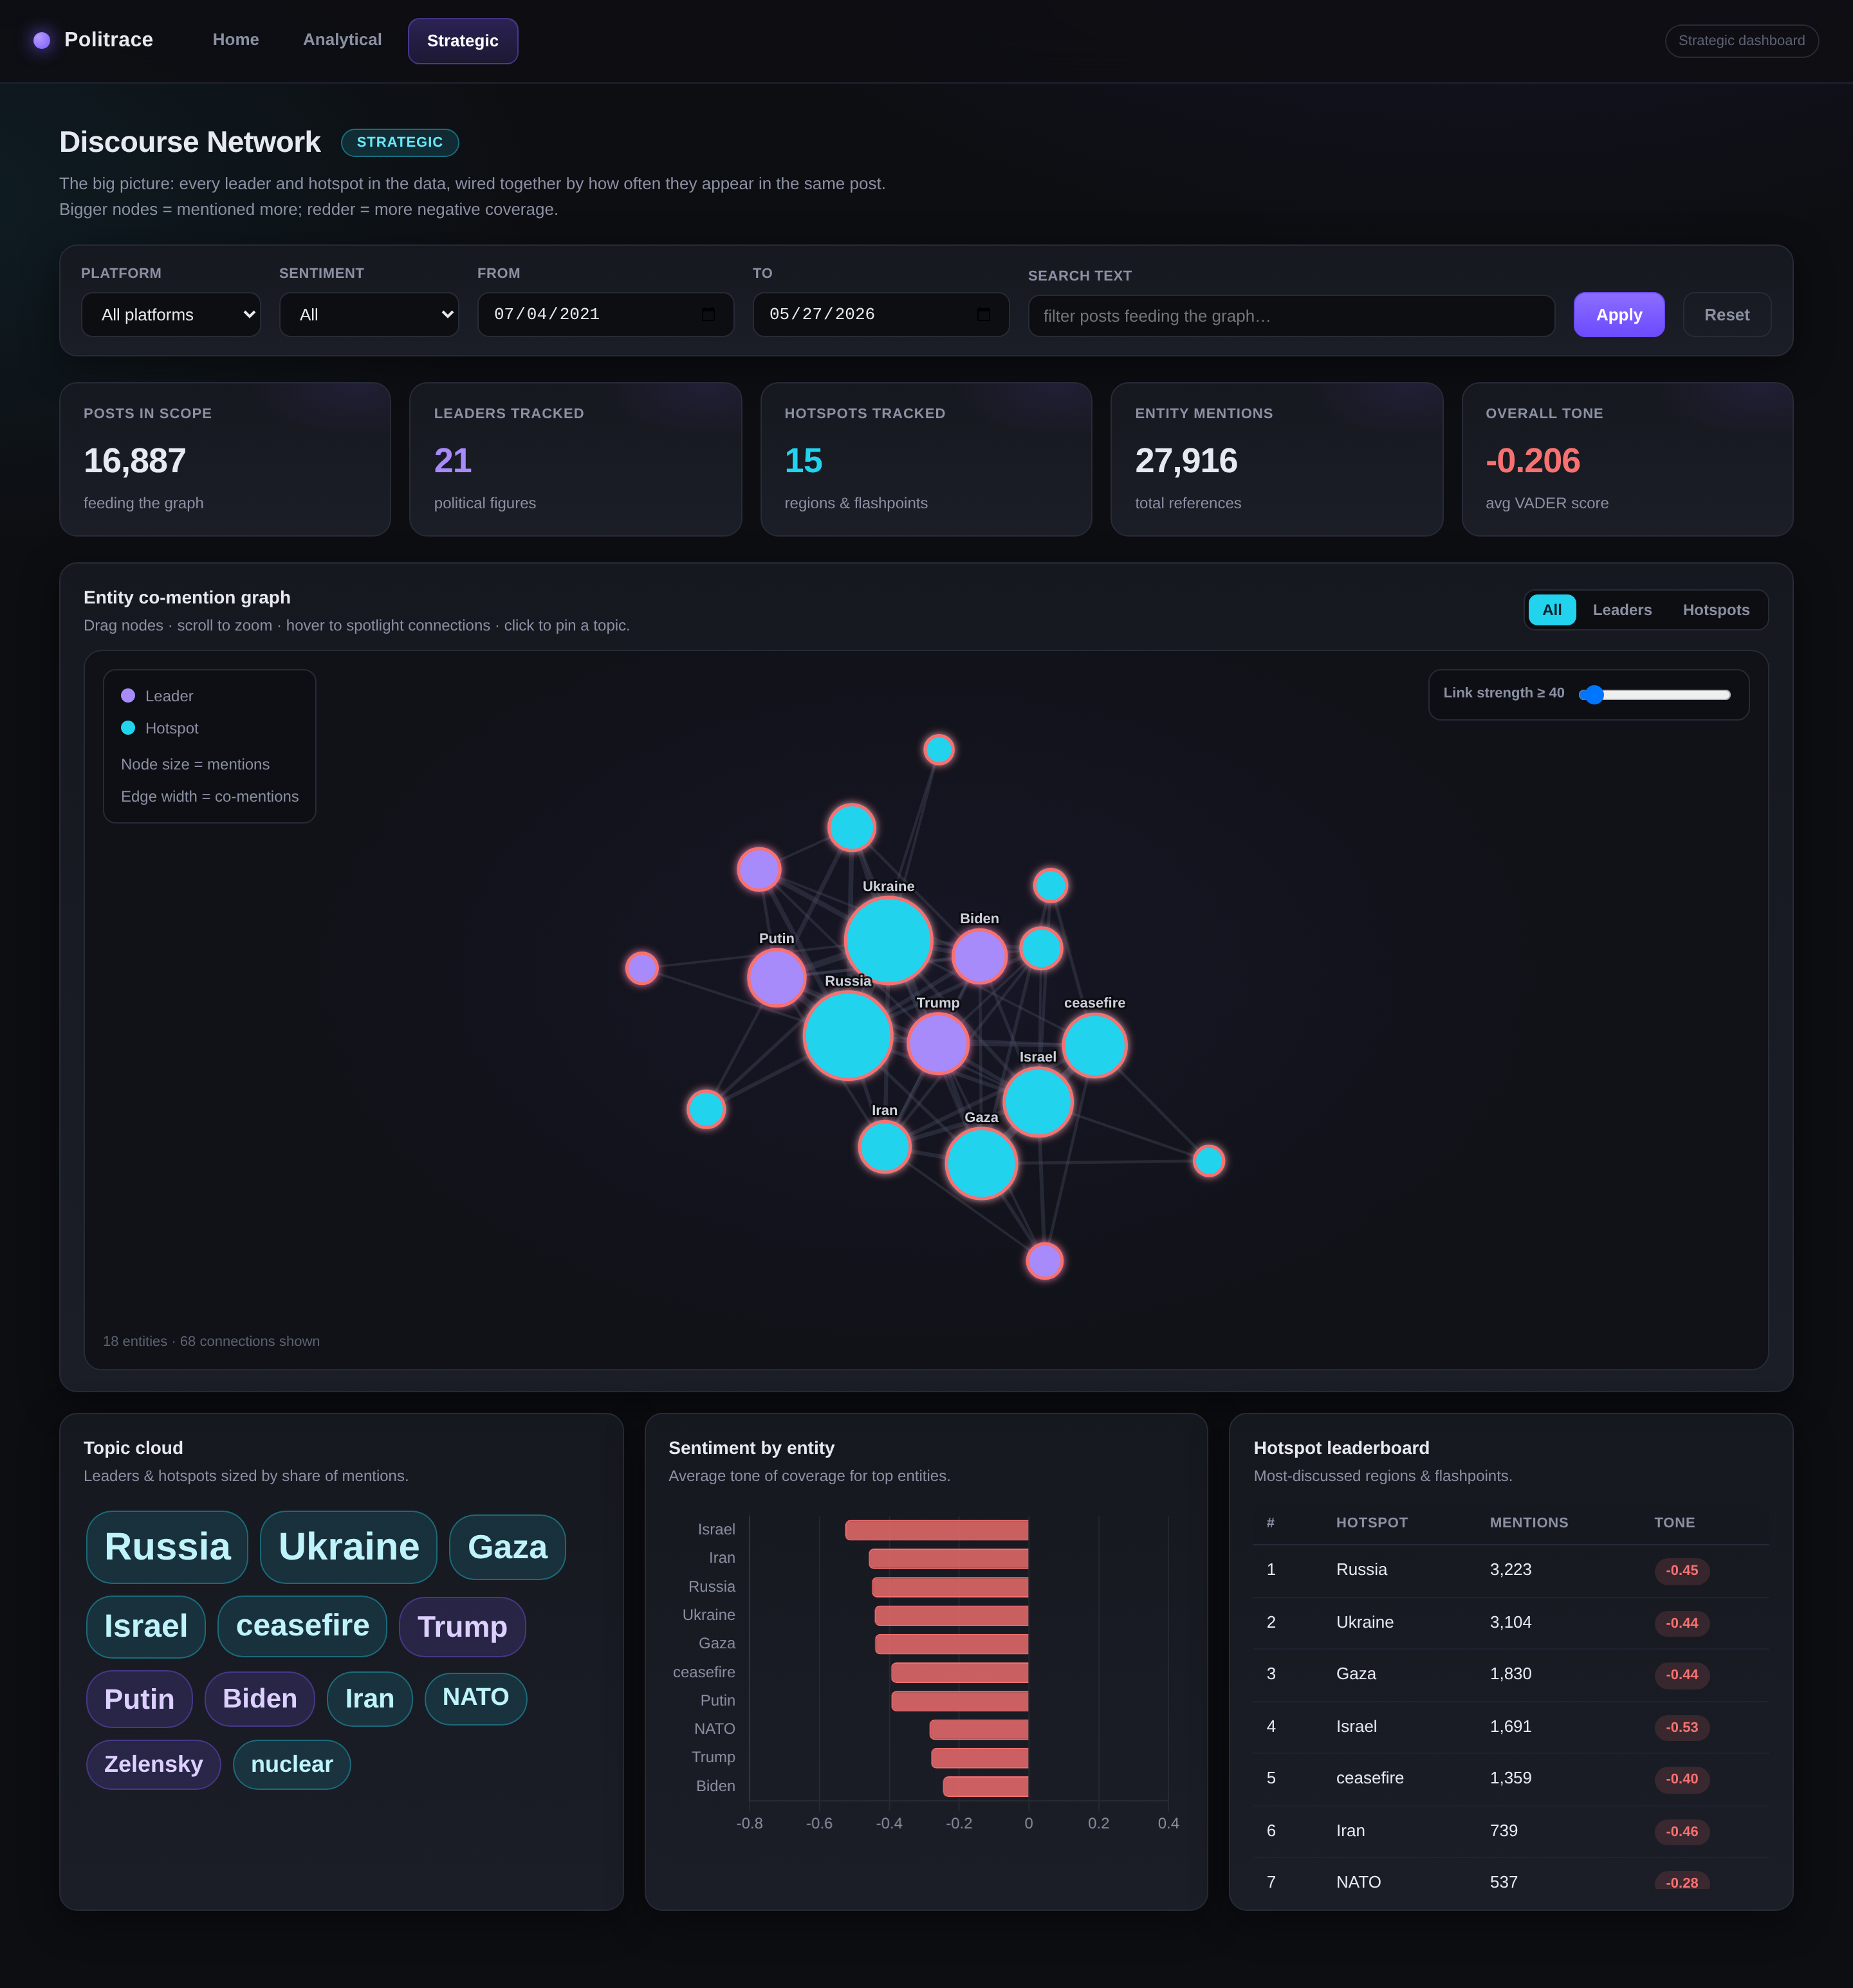
Figure 2. Strategic dashboard with the co-mention network in the middle.
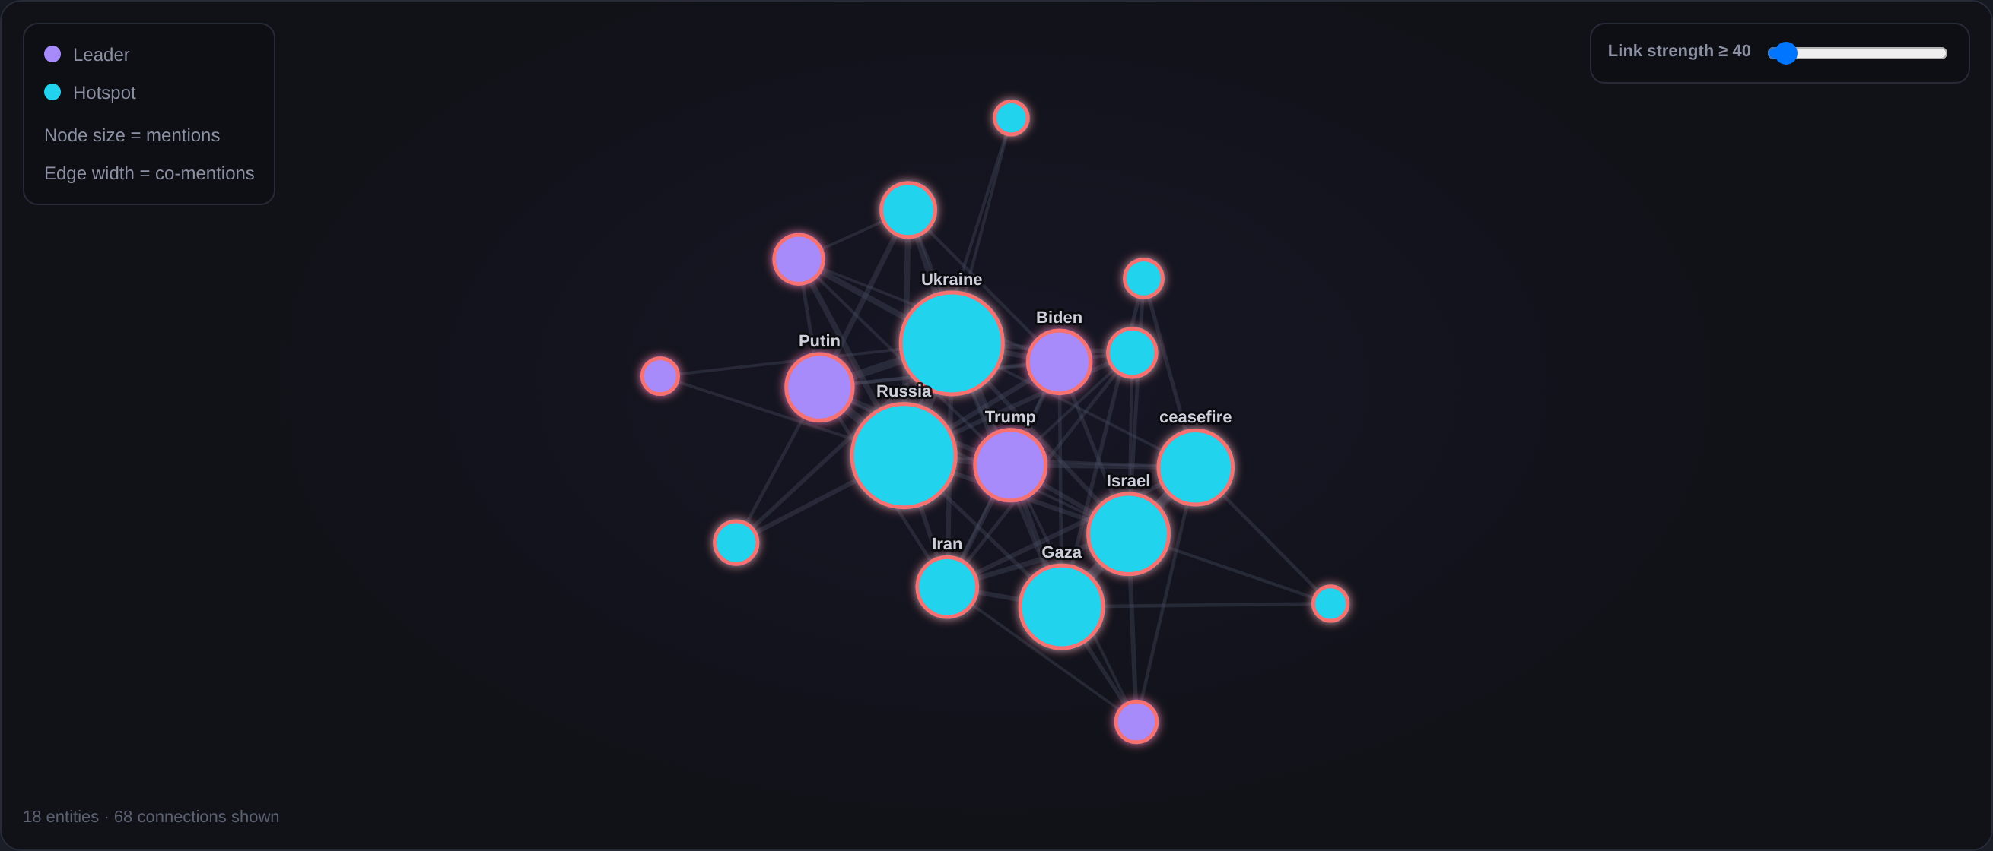
Figure 3. Close-up of the network graph. Bigger dots are mentioned more, purple is a leader and blue is a hotspot, the ring color is the average sentiment, and thicker lines mean the two are mentioned together more often.

How to run
cd capstone3
pip install -r requirements.txt
python app.py
# then open http://127.0.0.1:5000
GitHub: https://github.com/moriqqe/Politrace (the code is in the capstone3 folder)

