UX Report

Knockout Ticket

Valentin-Gabriel Morisca

06/06/2024

For this report, I have asked two friends to go through the website and give feedback through a questionnaire written by me.

The completed questionnaires, this report, and other documentation will be present in the git repository: <https://git.fhict.nl/I516431/knockout-ticket>

Overall, inconsistency of colors between the pages, uneven spacing, no validation, no error and notifications were present in the feedback from the two users, and from other observations I had.

Login Page and Signup Page were not subject to changes.

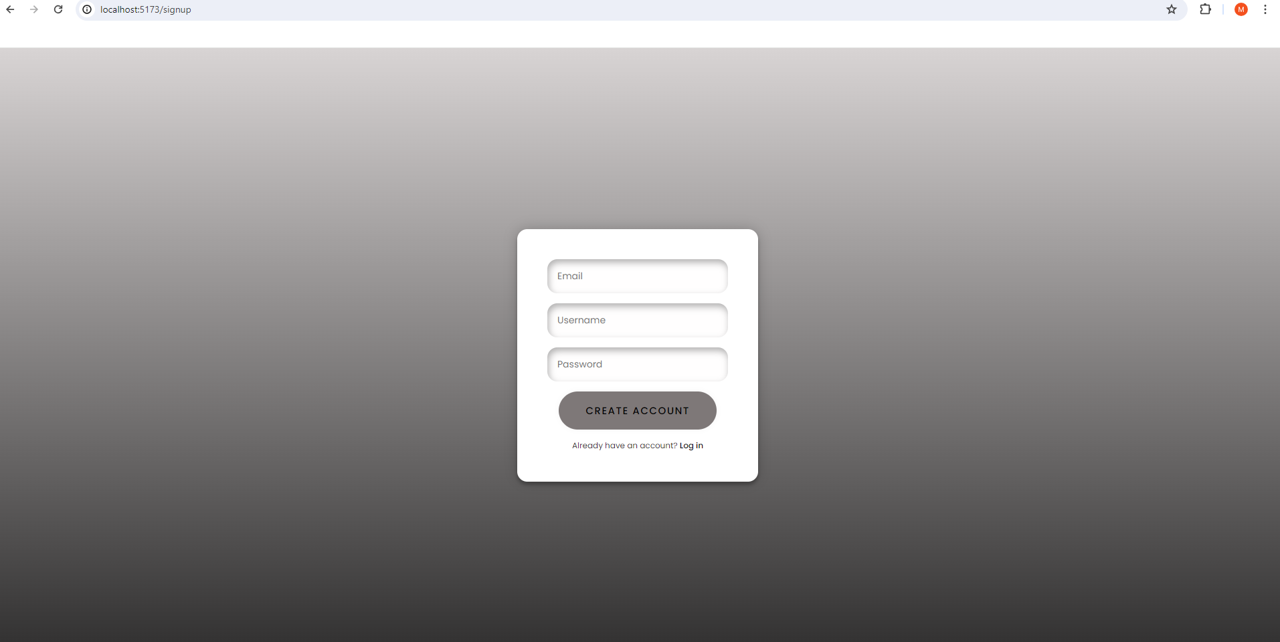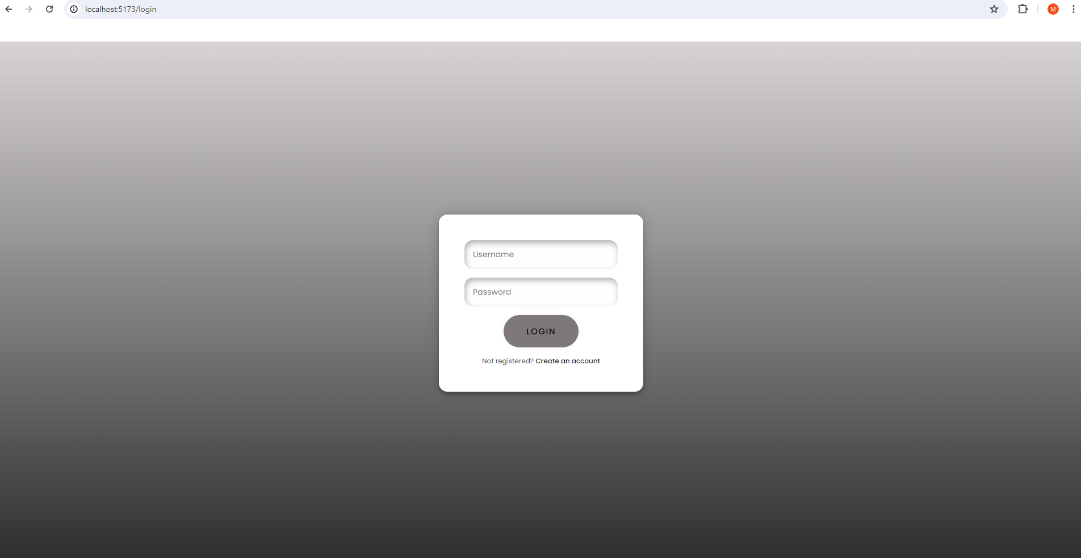

Next, the Home Page had a change, the color of the button has been changed to purple.

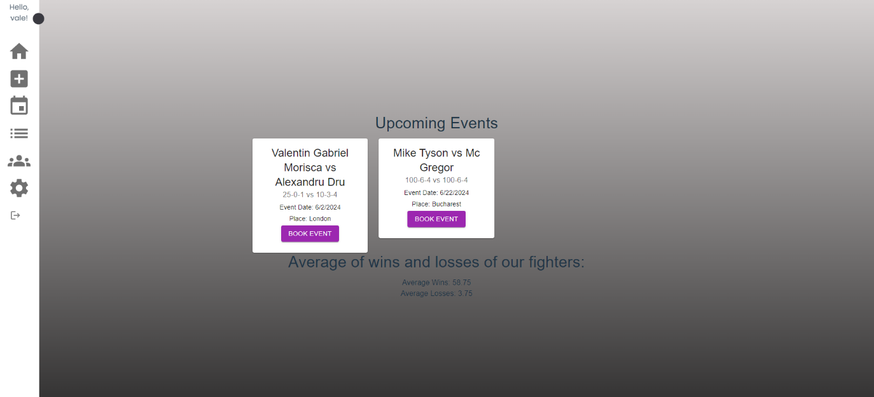 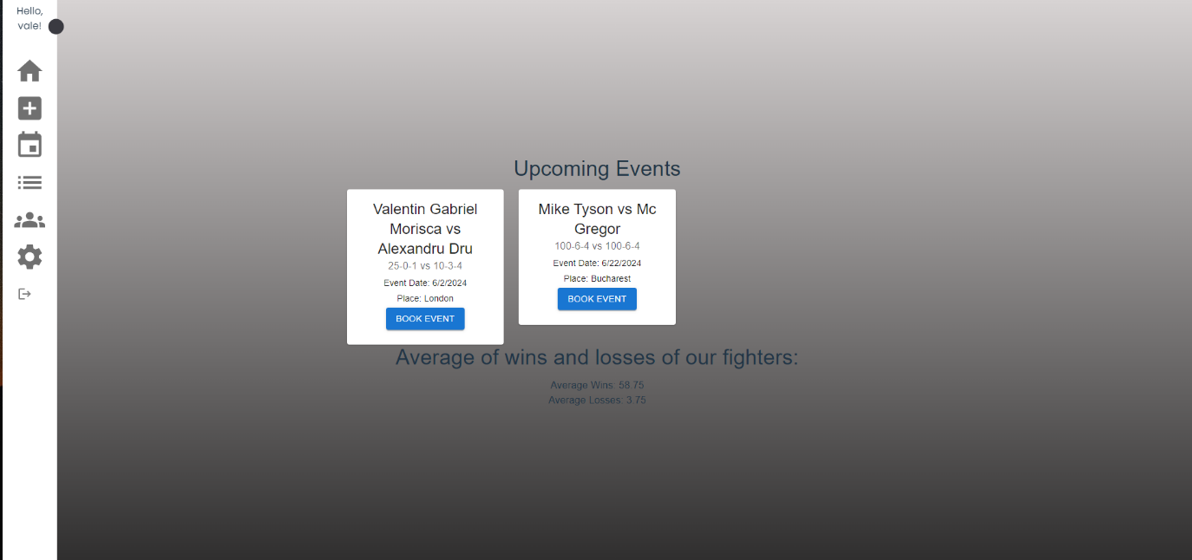

The book page had also been changed in the same manner.

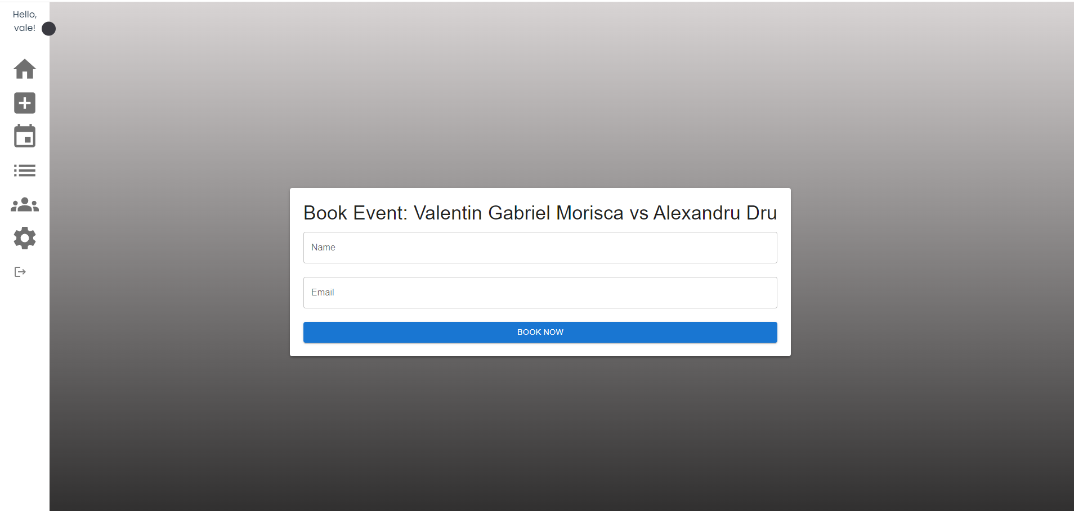

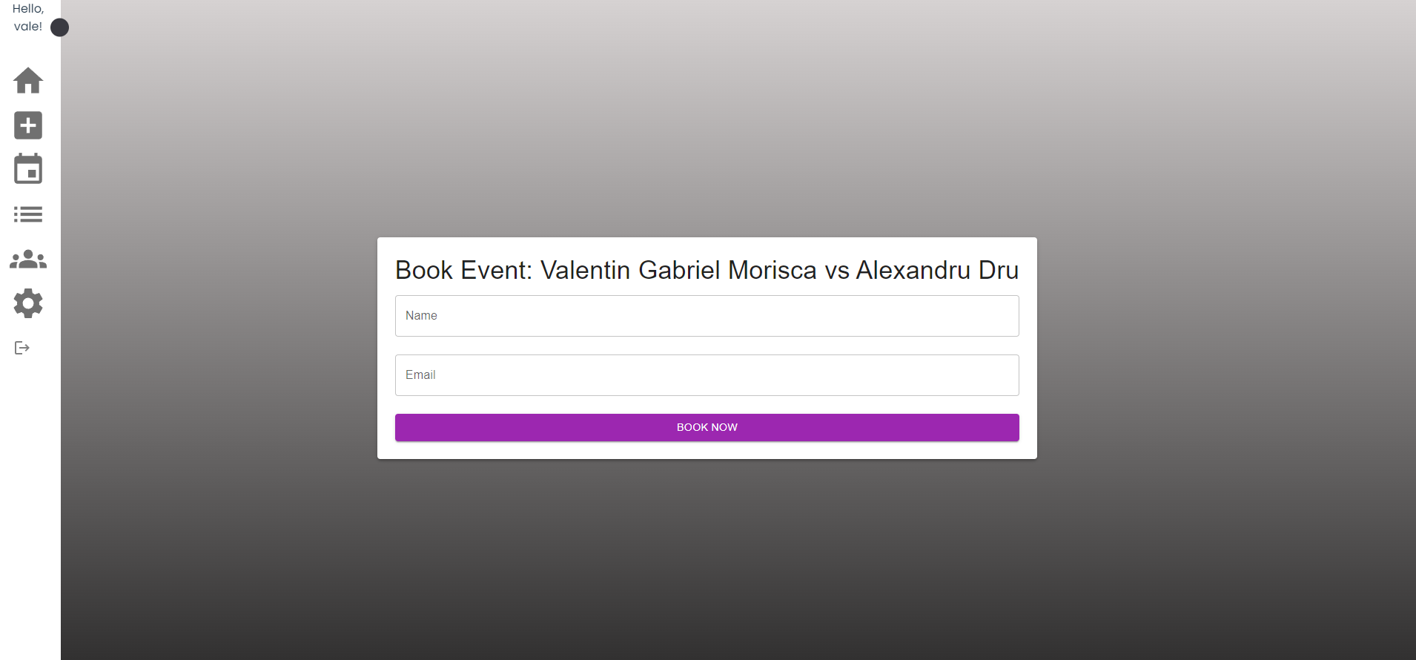

Also for the List of Boxers.

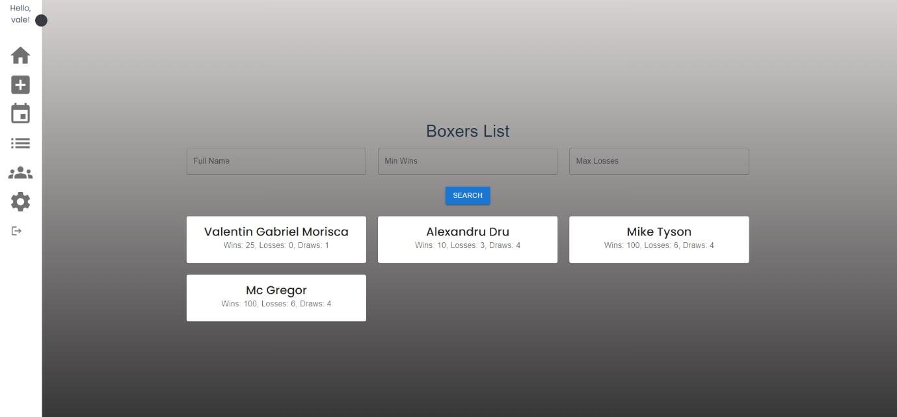

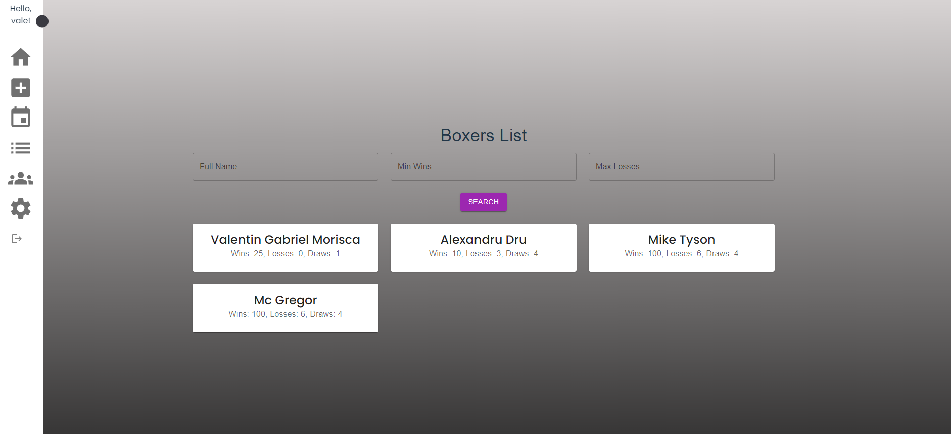

Next, the Create Boxer Page has not been affected.

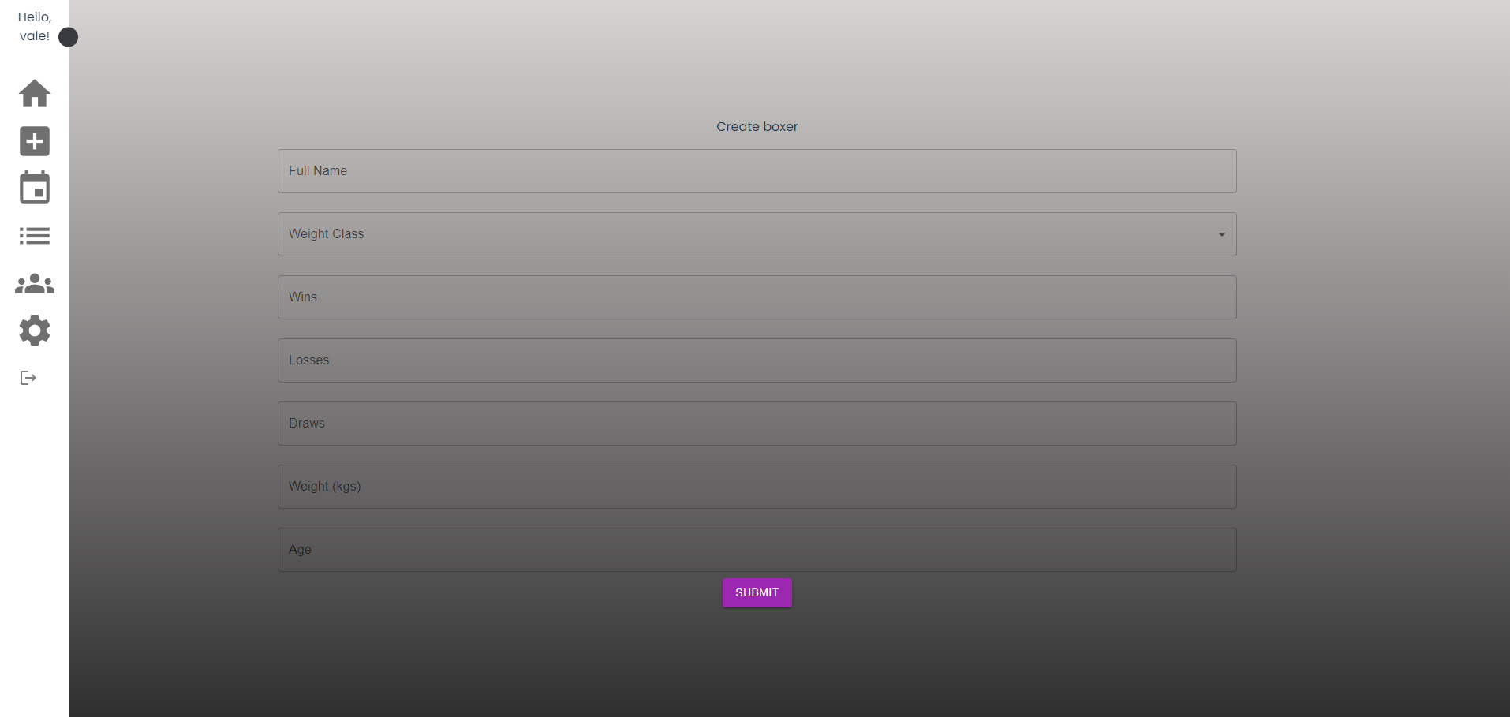

The page for Modifying a boxer has not been affected.

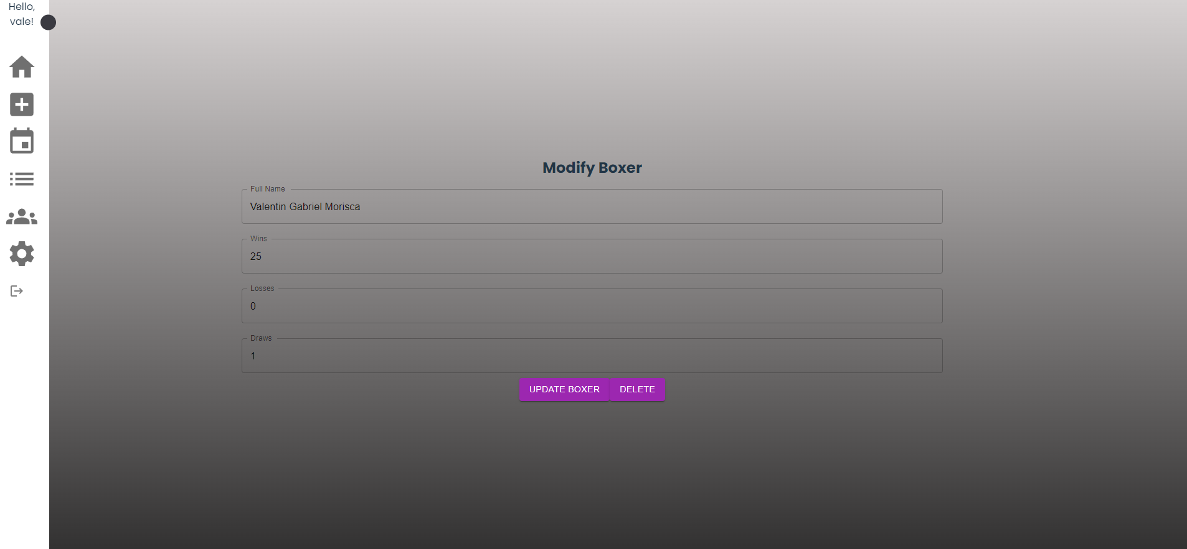

The Create Event Page had a few changes in the spacing between the input boxes, thus making it easier to read.

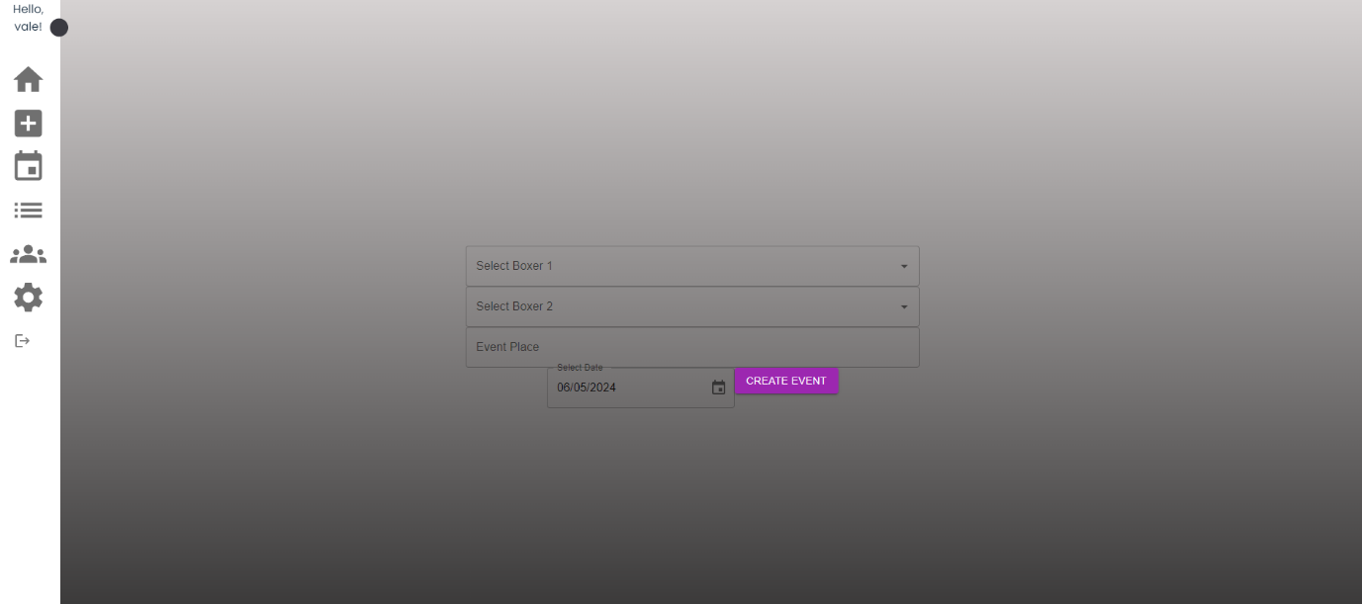

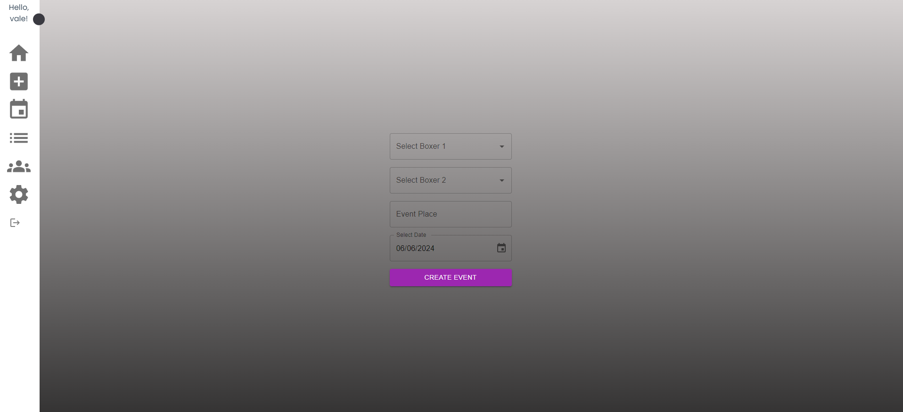

The List of Users Page did not undergo any changes.

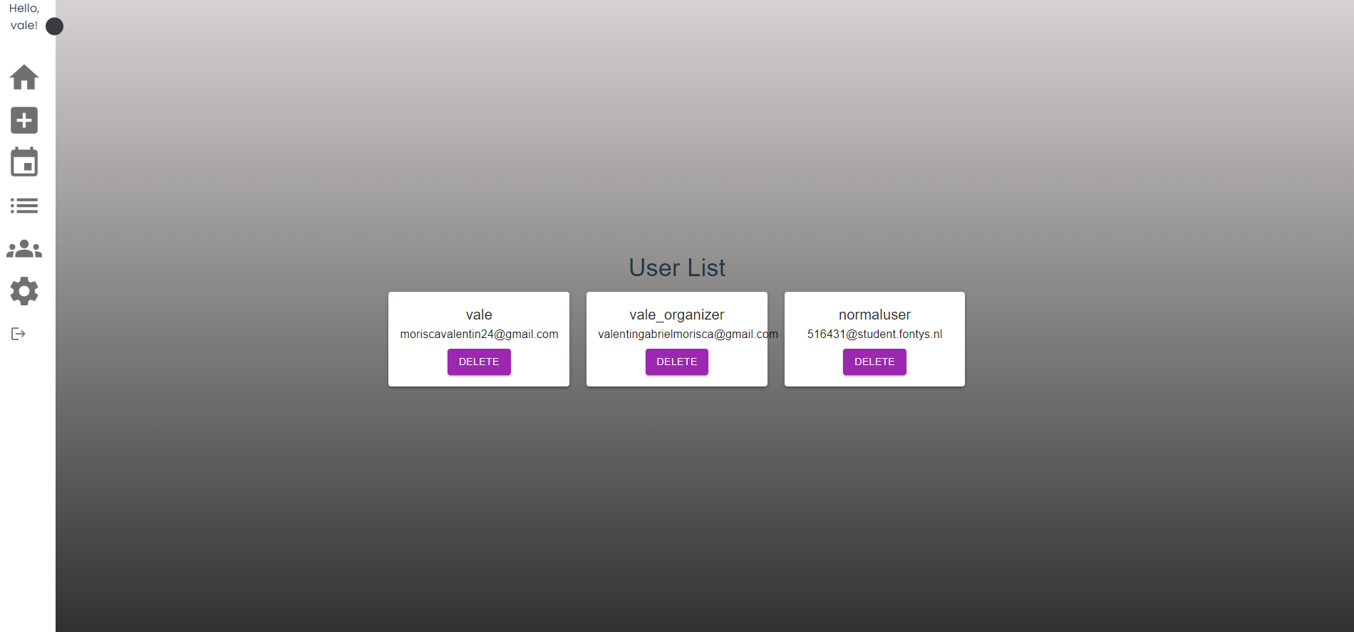

Page for User’s Settings:

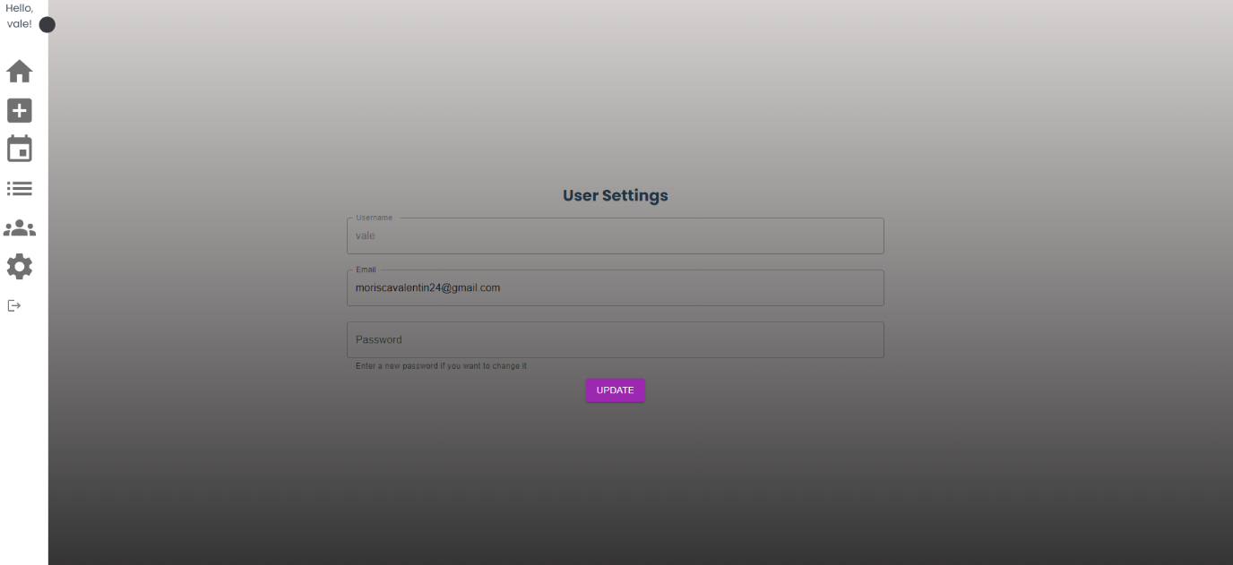

Also, validation checks have been added for some pages.

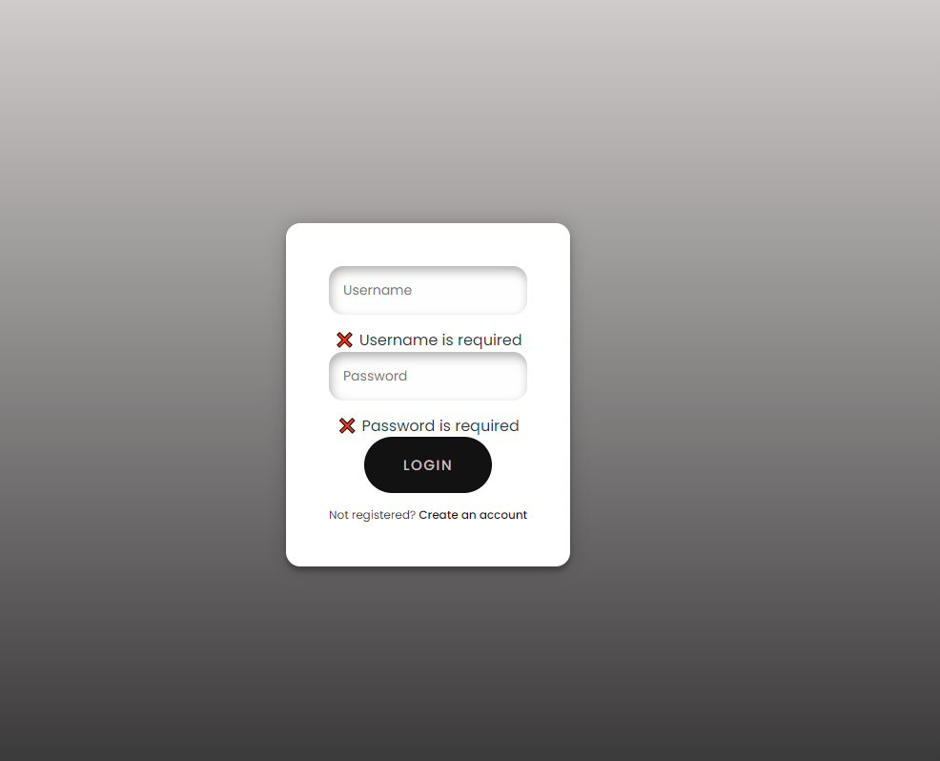

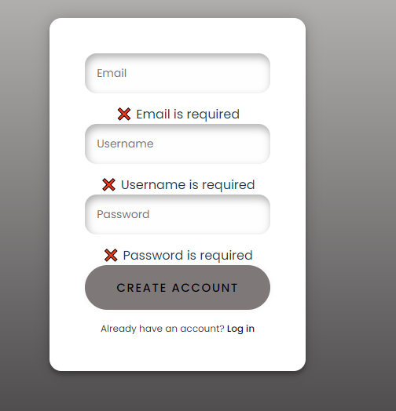

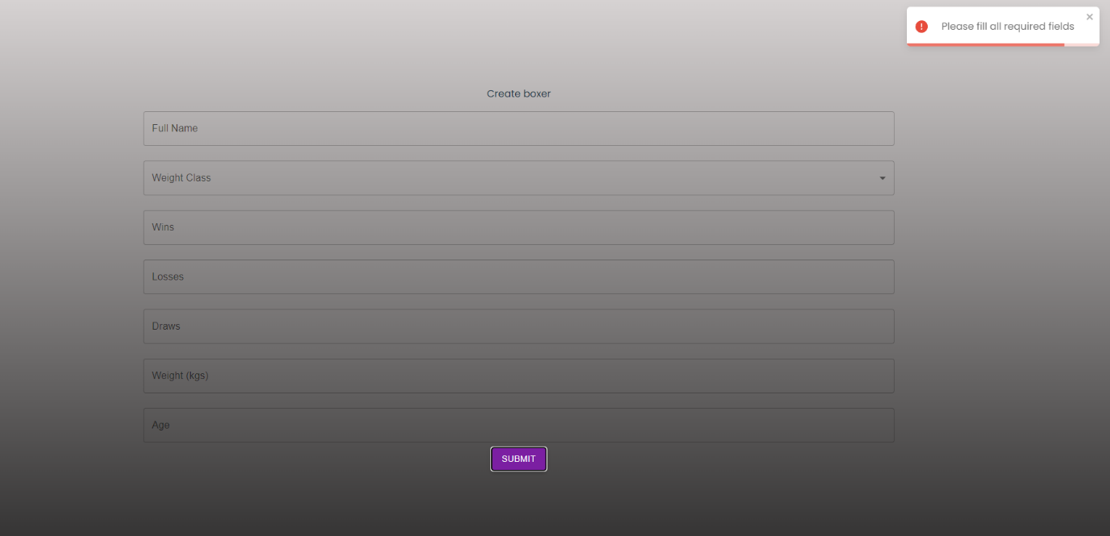

Also, a few Dialogs have been added to ensure that the user does not press a button by mistake, or ensure that they want those changes to happen.

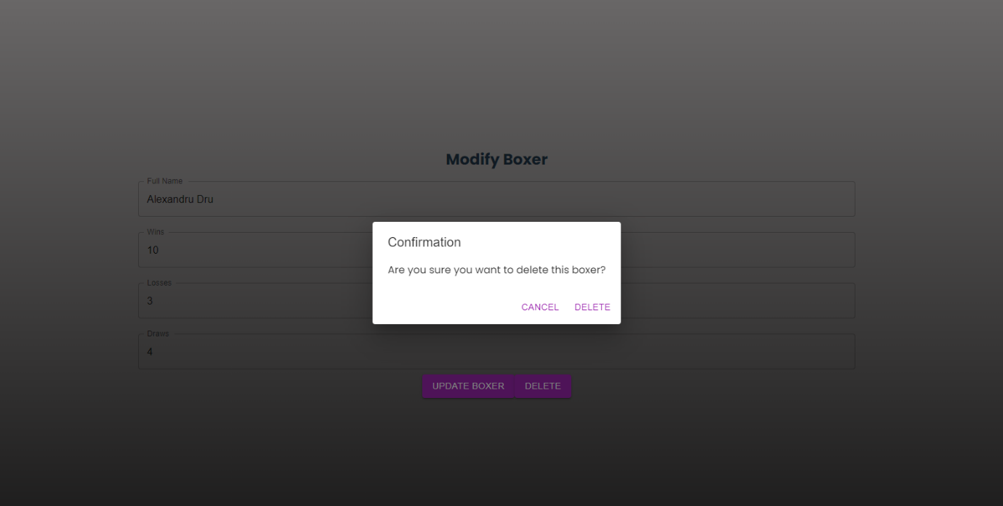

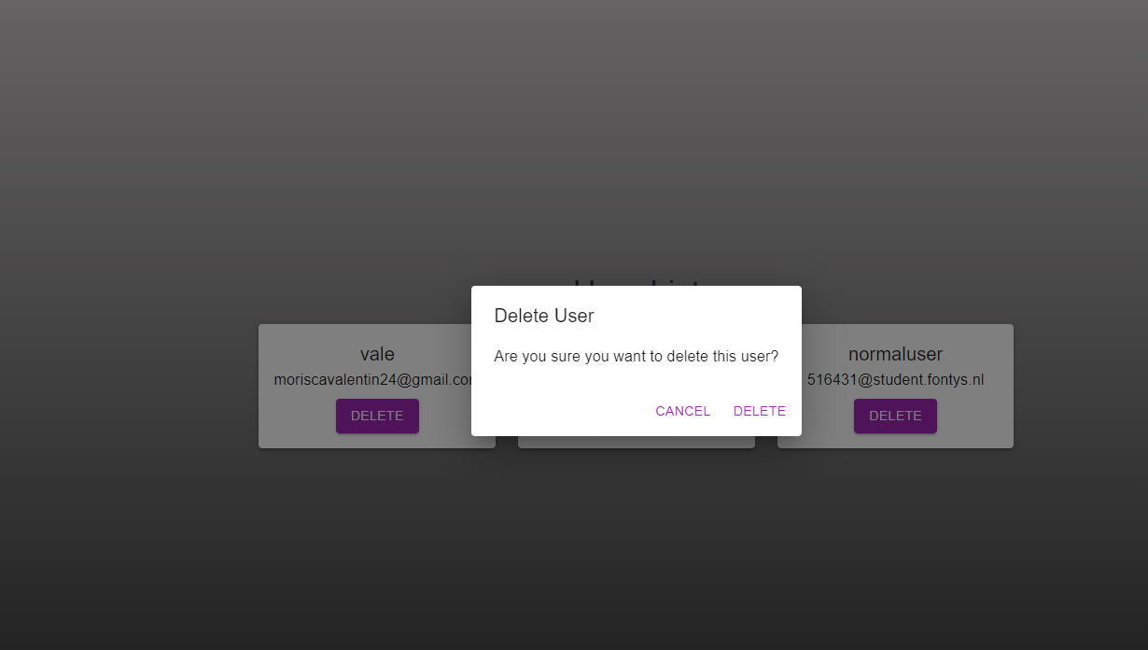

Lastly, the Sidebar also shows the Role of the user.

