**Appendix**

**Find out what FIMO does:**

**Various matches:**

**p-values for these matches:**

1. **9xG, 8xU, 2xA, 1xC =** 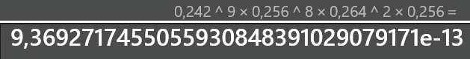
2. **9xG, 8xU, 2xA, 1xC**
3. **Text

   Description automatically generated**
4. **9xG, 8xU, 2xA, 1xC**
5. 
6. **6xG, 9xU, 2xA, 3xC**

**Background:**

**Best match:**



Best match: 7xG, 7xU, 4xC, 2xA