**The role of social interaction in the creation of bitcoin price bubbles (2012-2018) – Nora Tombers & Moritz Tröndle**

**Abstract**

The volume of current research literature regarding the interest in new data sources steeply increased lately. Using google trends or tweets as instrumental variables for social communication and interaction showed to be not only efficient in a diverse range of financial but also in political studies. In addition to these developments the bitcoin boom is stronger than ever. Not only due to the price increase from 13.10$ in November 2012 to 17,549$ in December 2017 but also due to the high volatility in the same period. (cf. Coindesk 2018)

Based on the research of Fama (1969) and Bikhchandani (1992), which showed the influences of price and social information on market dynamics, Garcia et. al (2014) investigated the role of social interactions in the creation of price bubbles. The Garcia study was created in the time frame of 2009 – 2013 and explored the two feedback loops of social-interaction and user-adaption in the creation of bitcoin bubbles.

Due to the earlier mentioned market developments, a follow up study of the Garcia paper (2014), regarding an extended time frame seems to be really interesting. Our paper *“The role of social interaction in the creation of bitcoin price bubbles (2012-2018)”* aims to investigate the development of the detected socio-economic feedback loops by Garcia with more current data. To follow-up the study the google searches of “bitcoin”, tweets containing the hashtag #bitcoin, the daily new number of unique bitcoin addresses and the BTC/USD price will be used to create an VAR model. With an impulse function the influence of social interaction and user adaption in the creation of price bubbles between November 2012 and March 2018 will be explored.

Visually comparing the google search data and the development of the bitcoin price in USD (Figure 1.) already shows potential. Additionally, a pearson correlation of 0.89 confirms these assumption for now.

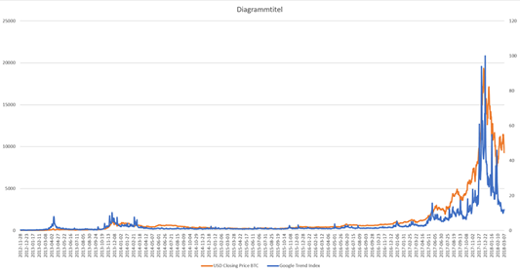

Figure 1 USD/BTC Closing price (orange) & Google Search Index (blue)

**Questions:**

* Is it enough to estimate an VAR and impulse function?
* Do we have to test robustness with additional data sources (Wikipedia, facebook…)
* Can we use the dauly new number of unique bitcoin addresses (see below) for the user adaption cyle
* How should we estimate the fundamental value?

**Used literature / data:**

Attention towards the subject: [https://news.bitcoin.com/data-company-tracks-crypto-adoption-using-social-media/](https://l.facebook.com/l.php?u=https%3A%2F%2Fnews.bitcoin.com%2Fdata-company-tracks-crypto-adoption-using-social-media%2F&h=ATNb2edcUb_7dhG4seoepqfIUbOaPtUVKLJcomAAE1hZry7RPTCectTq1Wlv4pKDPSFxQ2gWKL0BSumteimAwK4gUW84Swcoufax4I5jE7hjjg1-3EVPOucElV0)

New numer of unique bitcoin addresses: <https://blockchain.info/de/charts/n-unique-addresses?timespan=all>

Garcia D, Tessone CJ, Mavrodiev P, Perony N. 2014 The digital traces of bubbles: feedback cycles between socio- economic signals in the Bitcoin economy.J. R. Soc. Interface 11: