|  |  |  |
| --- | --- | --- |
| **Lab Activity 4: Client Side Scripting - Javascript** | | |
| Lab Summary | : | This lesson covers Web page development using HTML and Scripting (JavaScript). |
| Learning Outcomes | : | At the end of this session, students will be able to:   1. apply HTML and JavaScript effectively to develop interactive, functional, and visually appealing web pages (P4, Practical). 2. demonstrating a thorough understanding of syntax, structure, event handling, and DOM manipulation to enhance user experience (P4, Practical). |

# Lab Practice:

1. Write an HTML with JavaScript statements to change the content of the <p> to “Hello there!”.

<div id="myElement">

<p>Welcome to my website!</p>

</div>

**Output and Code:**

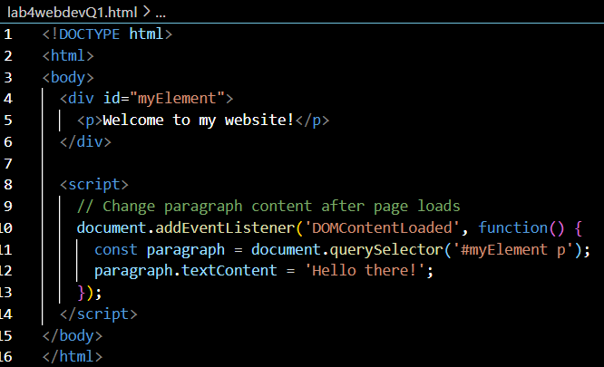



1. Based on the HTML code below, write an HTML with a JavaScript function named checkInput() that uses if else condition to validate if the number entered is lower or higher than 10. If it is lower than 10, then make an alert of “The number is lower than 10”, otherwise “The number is higher than 10”. If the user entered other than numbers (eg:alphabets), alert “Please insert a number!”.

<input type="text" id="userInput" placeholder="Enter a number">

<button onclick="checkInput()">Check</button>

**Output and Code:**

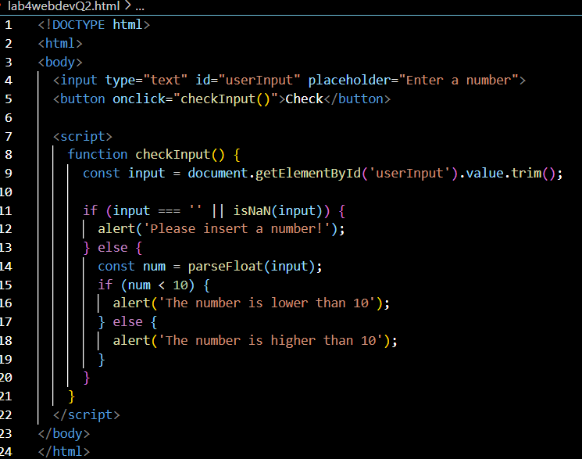

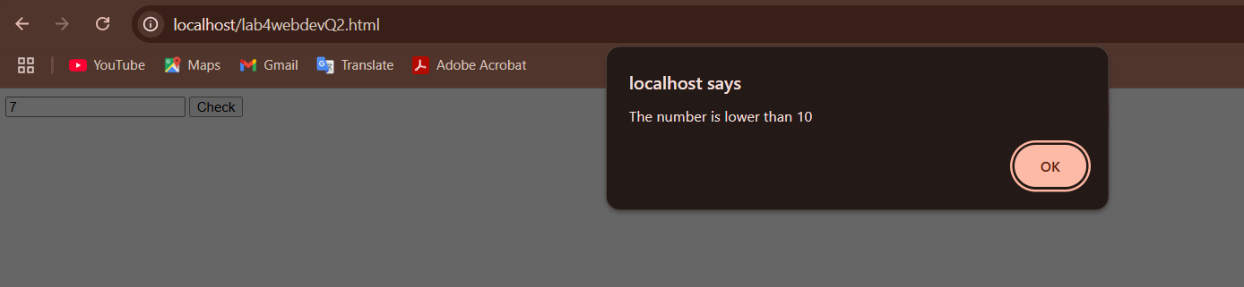

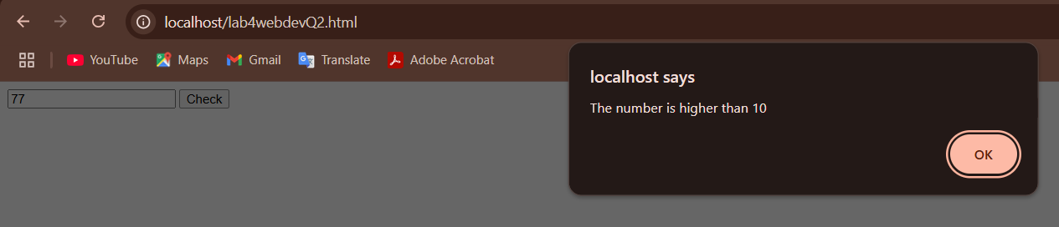

1. Complete the JavaScript code below to produce the expected output. Write your answer in a complete HTML code.

<p id="demo"></p>

    <script>

let text = "";

    for (let i = 0; **//complete your answer here**) {

      text += "The number is " **//complete your answer here**

    }

    document.getElementById("demo").innerHTML = text;

    </script>

**Expected output:**

The number is 1

The number is 2

The number is 3

The number is 4

The number is 5

**Output and Code:**

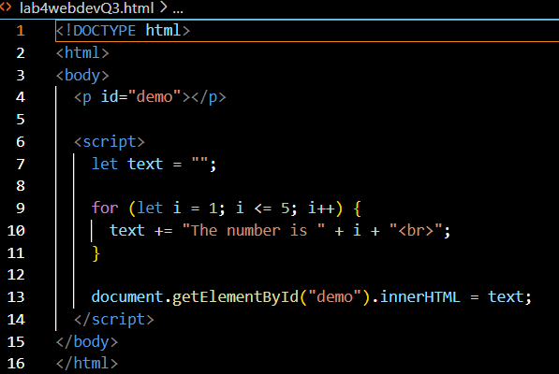

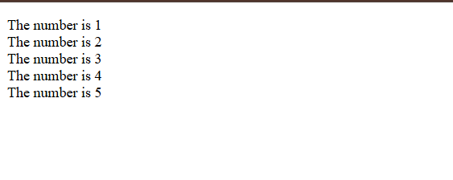

1. Push all codes to your GitHub repository.
2. Copy your answer and screenshot the output in Google Docs. Include your GitHub repository link.
3. Upload the Google Docs to your own Google Site.
4. Submit a screenshot of your Google Site through Author.