Open your Loop Project in Xcode

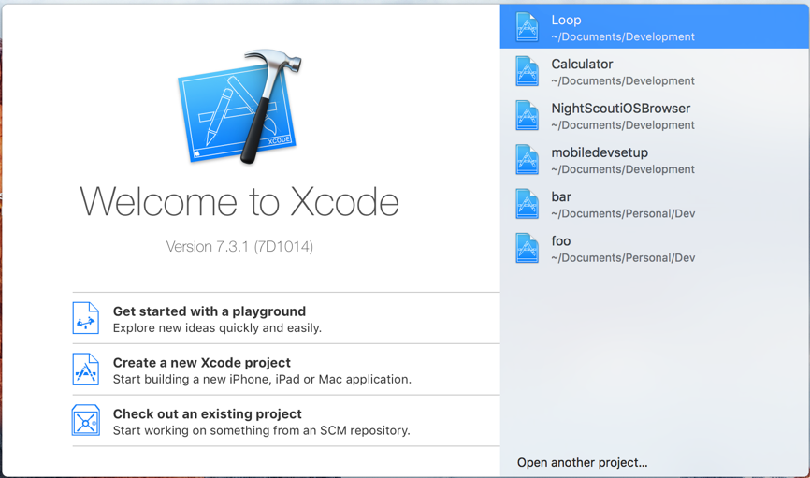

Commit any changes you may have made to your Current Branch/Fork

From the Menu at the top select: [Source Control] > [Commit]…

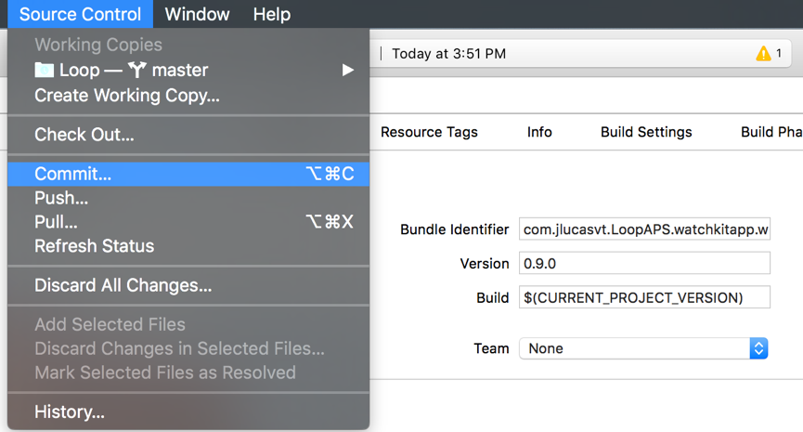

Enter a “Commit Message in the white space at the bottom” (required)

Click [Commit Files] button

(If you have no changes to commit, it will be greyed out and you can just “Cancel”

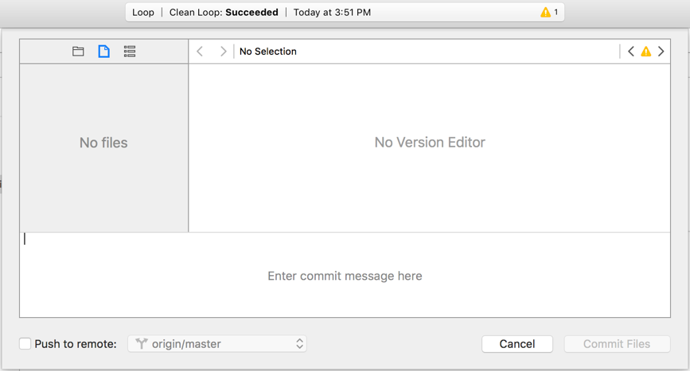

Next we want to make sure you are on our local master branch

Select the menu item [Source Control]

It will list the current working branch eg “Loop – master” 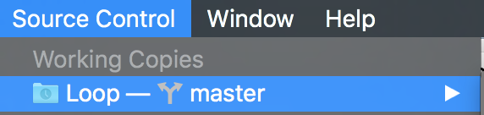

If master is not the current branch choose “Switch to Branch..” and Select your Master Branch

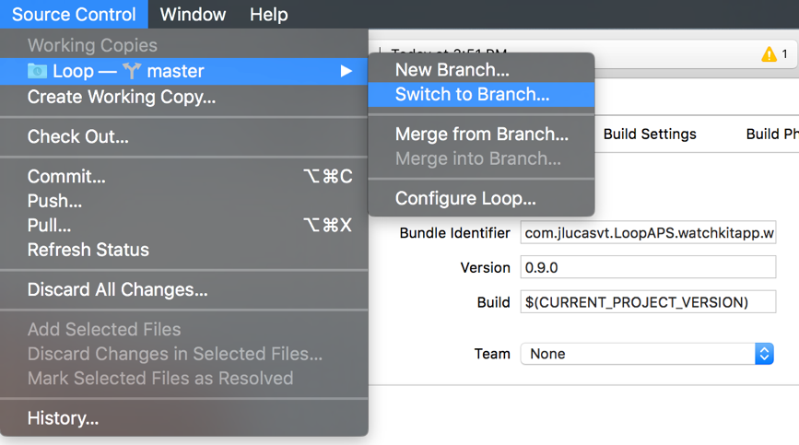

Typically, this will be under the “origin” or “Local Branches” section

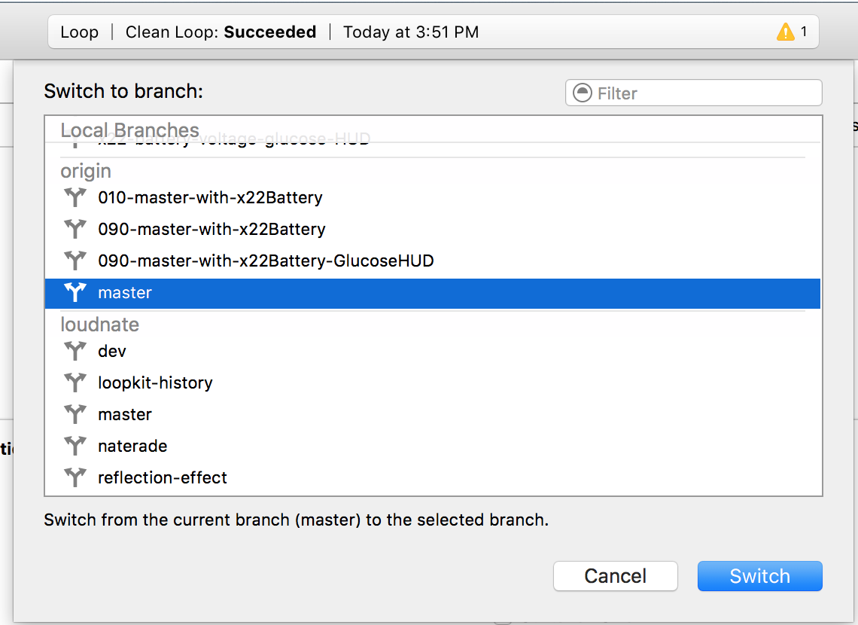

Now that we are on your Master branch, and you have committed.

You are ready to Pull the remote changes from loudnate/master

Select [Source Control] and [Pull…]

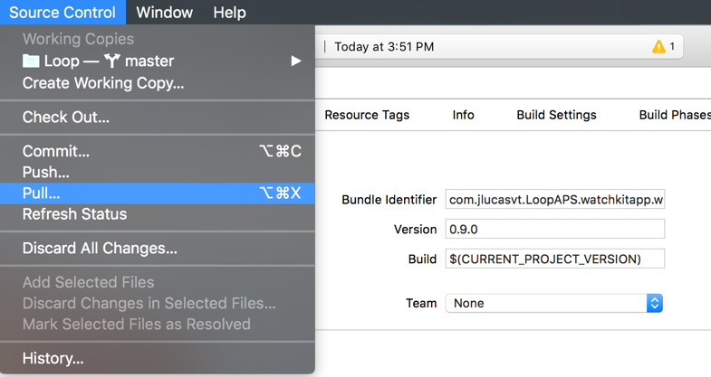

You will be given the choice to pull from other branches.

Select loudnate/master

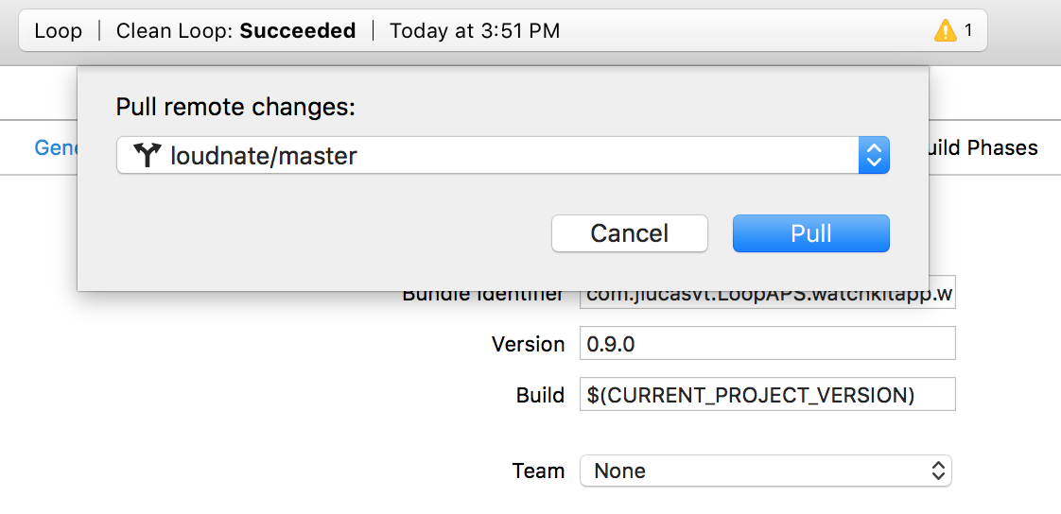

Xcode will process the changes between your current master version and the current loudnate/master version (current release)

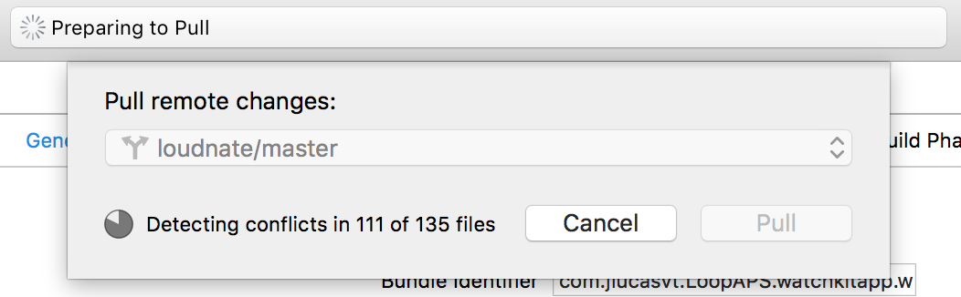

Once all the changes are identified you can save them to your local branch by clicking “Pull”

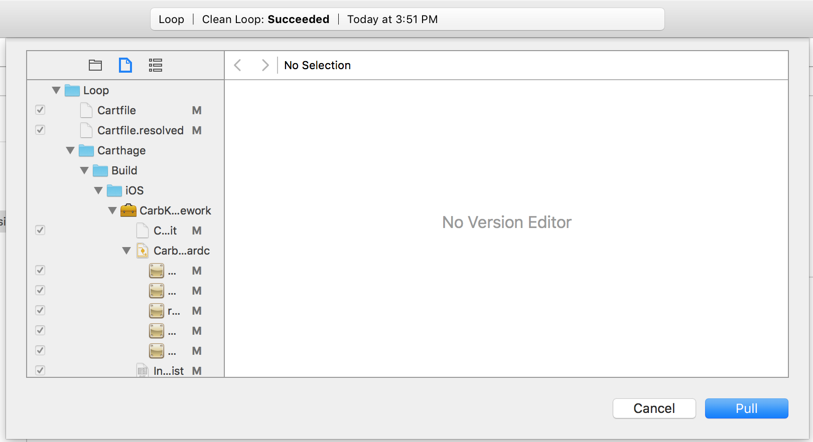

Now your version of Loop should be updated to the loudnate/master (current release)

