1. UML Drawings

2. Code in folder/ GitHub

3.

i. When extending the Integer class, I receive an error “Cannot inherit from final”. Finals cannot be changed or are “immutable” in Java and therefore the class cannot be overwritten.

ii. The integer class is immutable because it can be used to save memory and time. Since so many people use the library it is widely accessed and needs to be fast as possible.

iii. I would create a method in the class that needed it and use the integer class. So that I would still get the correct result without inheriting the other methods.

4. Code in folder/ GitHub

5. Code in folder/ GitHub

I found the most difficult part of the assignment to be question 2. I tried to program it before going over the intricacies of the UML diagram. Not fully preparing made changing the code confusing.

The entire assignment was completed. Half is answered questions in here and the other is code which is on GitHub. In addition, the code coverage was 100%.

Lines of code: 24

Lines of tests: 40

Unit Test coverage: (found in the index.html outlined in the README.md)

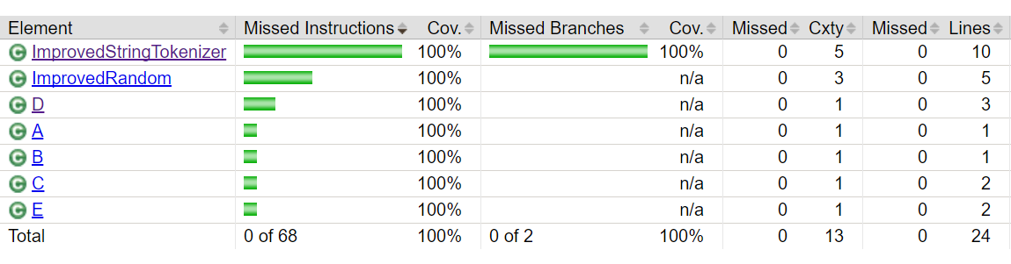

Cyclomatic complexity: 2