Troubleshooting

General steps:
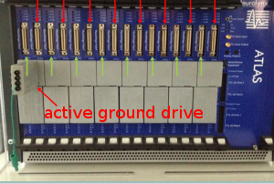
noisy signal:
- check cables going into the amplifier including the active ground drive.
- Make sure none of the cables are touching the floor
- double check whether maybe your reference is noisy (rereference in netcom remote app)
- try turning off /unplugging the lights, cell phone chargers, the bed…

problems with network
- check all cables: data cables and network cables in PC, wall, amplifier

13.8.2020
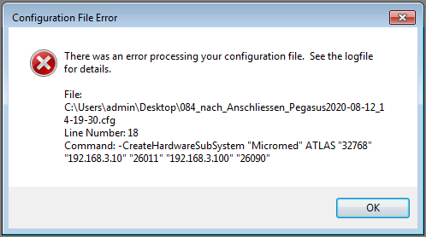
PC froze, recording and acquisition stopped working, there was a screenshot with an error popup “TCP connection failed”.
When rebooting the PC and trying to start Pegasus with the same config file, there was an error pointing to this line in the config file:
-CreateHardwareSubSystem "Micromed" ATLAS "32768" "192.168.3.10" "26011" "192.168.3.100" "26090"
Solved by restarting the Amplifier

When starting Pegasus, there can be a popup with an error saying something about the Events.nev file. This happens when it’s trying to write Events.nev into a folder that doesn’t exist, and THIS in turn happens when using a config file that was saved from within Pegasus (as opposed to generated using the config converter)
Solved by creating the directory that it wants to write Events.nev into

