CoreDocs
Vendor Document Approval, Transmittals & the Master Register (MDDR)
User Guide · PPE Technologies · Coreflow
Generated from the in-app guide — June 2026

What this guide covers
- Getting started: Dashboard
- Document-control workflow: Incoming Batches, My Reviews, Transmittals
- Register, search & reporting: Document Search, MDDR - Master Register, Reporting
- Admin: Import & Sync, Users, Vendors & Packages

Getting started

Dashboard
Your home screen — an at-a-glance view of the document-control workload and the way in to every part of CoreDocs.
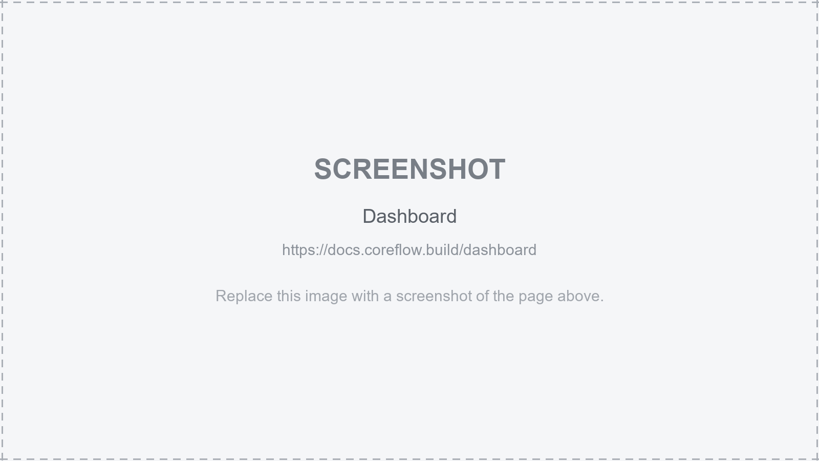
Screen: Dashboard
- The left sidebar is your main menu — what you see depends on your role (Document Controller, Reviewer, Engineering/Project Manager, Vendor or Admin).
- The summary cards show the current state of play — batches awaiting action, reviews due, documents by status. Click one to jump straight in.
- Use the top-right menu for your account and to sign out. The Guide button (top of every page) explains the screen you are on.

Document-control workflow

Incoming Batches
Vendor document batches as they arrive — the Document Controller's inbox for logging and distributing new submissions.
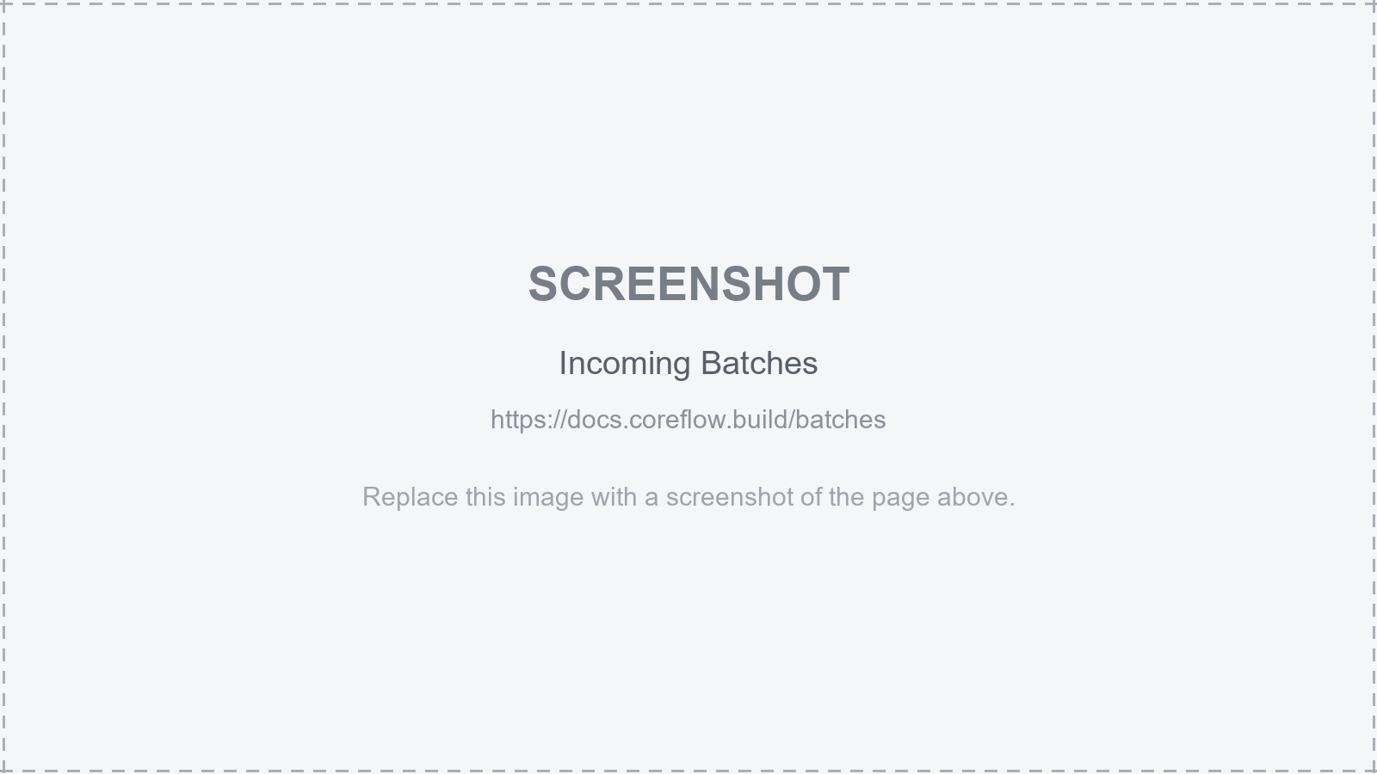
Screen: Incoming Batches
- Each batch is a set of documents submitted together (from Aconex / the vendor). Open one to see its documents and metadata.
- Register the batch into the master register, then assign the documents to the right reviewers / disciplines.
- Track a batch's progress from received -> under review -> returned, so nothing sits unactioned.

My Reviews
The documents assigned to you to review, and where you record your review outcome.

Screen: My Reviews
- Open a document to view it (and any markups), then set your status - e.g. approved, approved-with-comments, or rejected/returned.
- Add review comments; these flow back to the Document Controller and onto the transmittal.
- Clear your list before the due date - overdue reviews hold up the whole document cycle.

Transmittals
Formal issue and receipt of documents - the auditable record of what was sent to whom, when, and why.
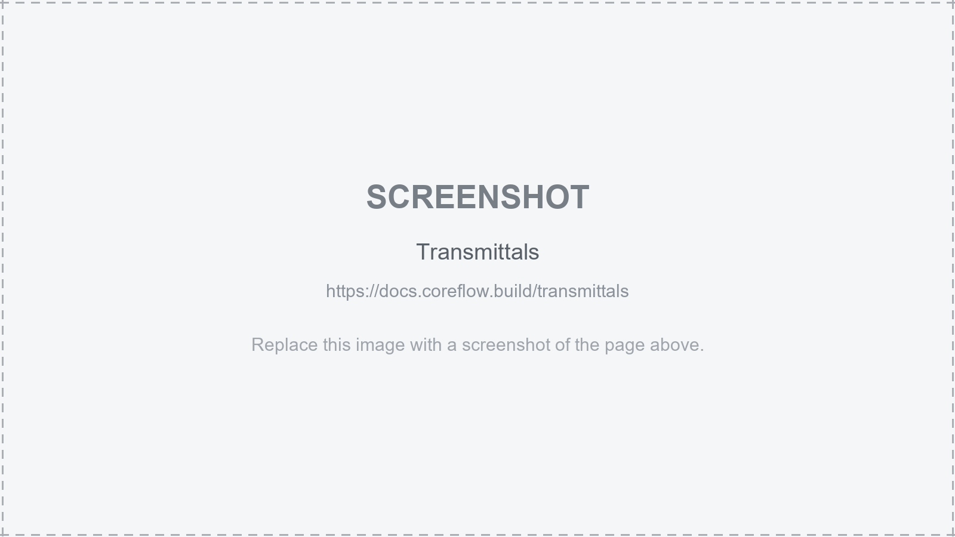
Screen: Transmittals
- Create a transmittal to issue documents (e.g. returning reviewed vendor docs, or sending for construction) with a cover sheet.
- Each transmittal has a unique number and lists its documents, revisions and the reason for issue.
- Open a past transmittal to see its full history - the permanent record for audits and claims.

Register, search & reporting

Document Search
Search the master document register - find any deliverable by number, title, discipline, status or revision.
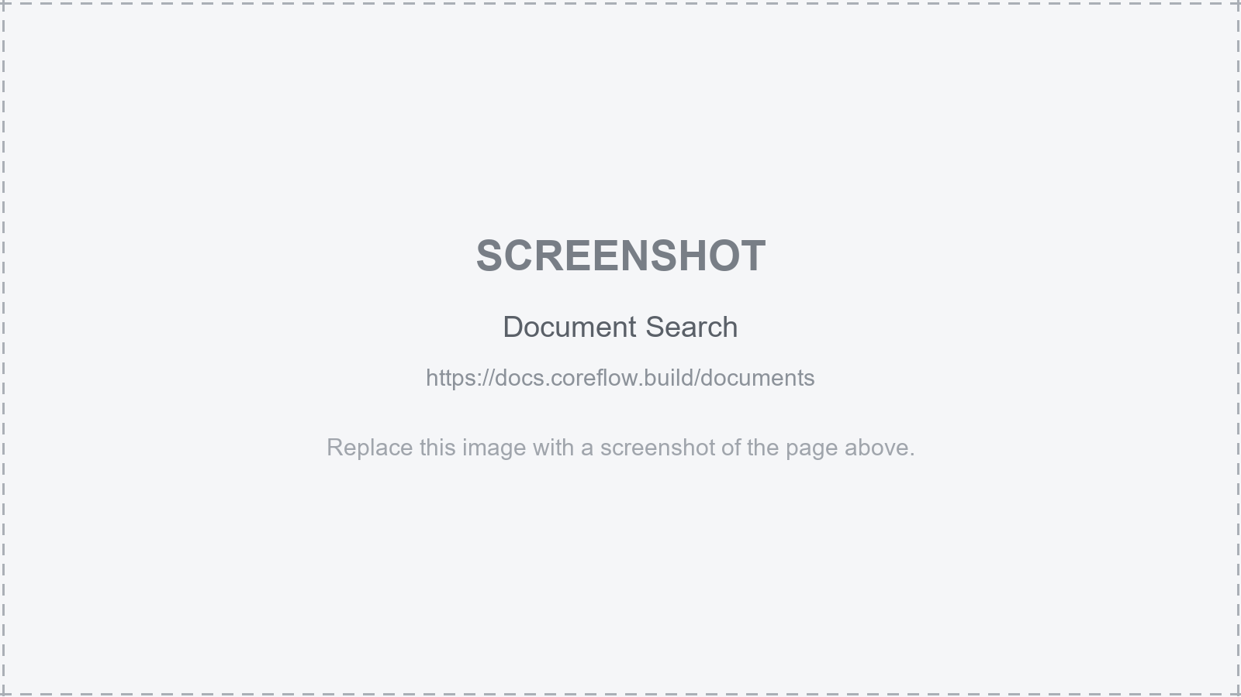
Screen: Document Search
- Type a document number or title; use the filters (discipline, status, vendor, revision) to narrow the list.
- Open a document to see its full history - every revision, review and transmittal it has been through.
- This is the quickest way to answer 'what's the latest revision / status of X?'.

MDDR - Master Register
The Master Deliverables & Document Register - the controlled master list of every deliverable, its planned dates, current revision and status.
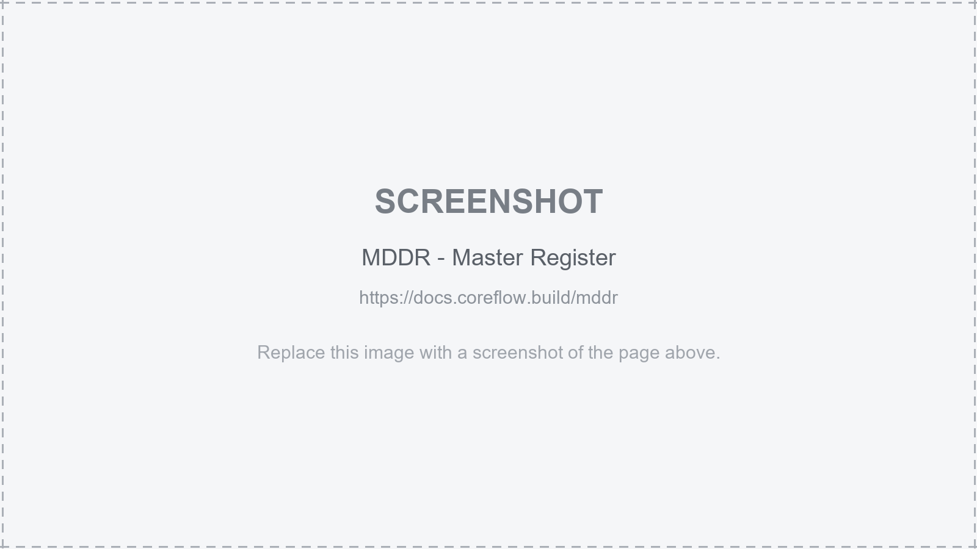
Screen: MDDR - Master Register
- Each row is a deliverable with its document number, title, discipline, planned vs actual dates and current status/revision.
- Filter by package / vendor / discipline / status to focus on a slice of the register.
- This is the single source of truth for deliverable progress - it drives the reporting and the client returns.

Reporting
Progress and status reports built from the live register - for the project team and the client.
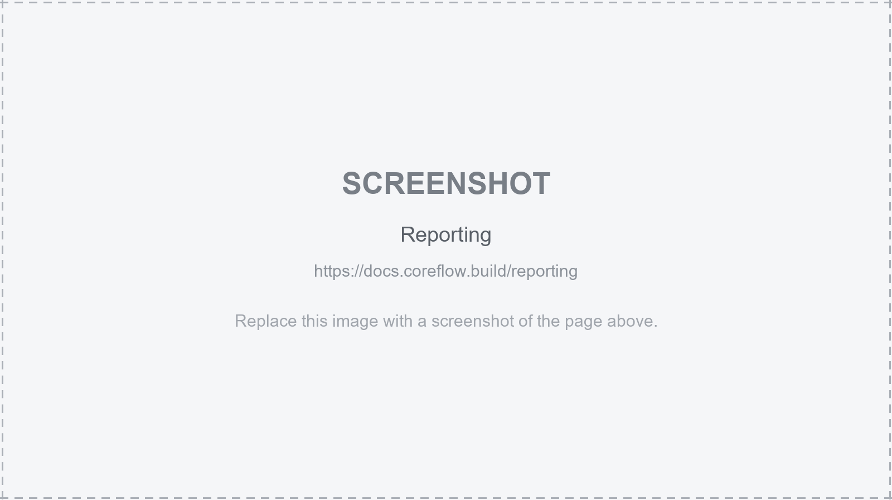
Screen: Reporting
- Status / progress reports summarise the register by discipline, vendor or package.
- Use these for the document-control return and to spot bottlenecks (overdue reviews, ageing batches).
- Reports read live from the MDDR, so they are always current - no manual spreadsheet upkeep.

Admin

Import & Sync
Bring documents and metadata in - bulk import of the document index and the SharePoint / Aconex sync (admin only).
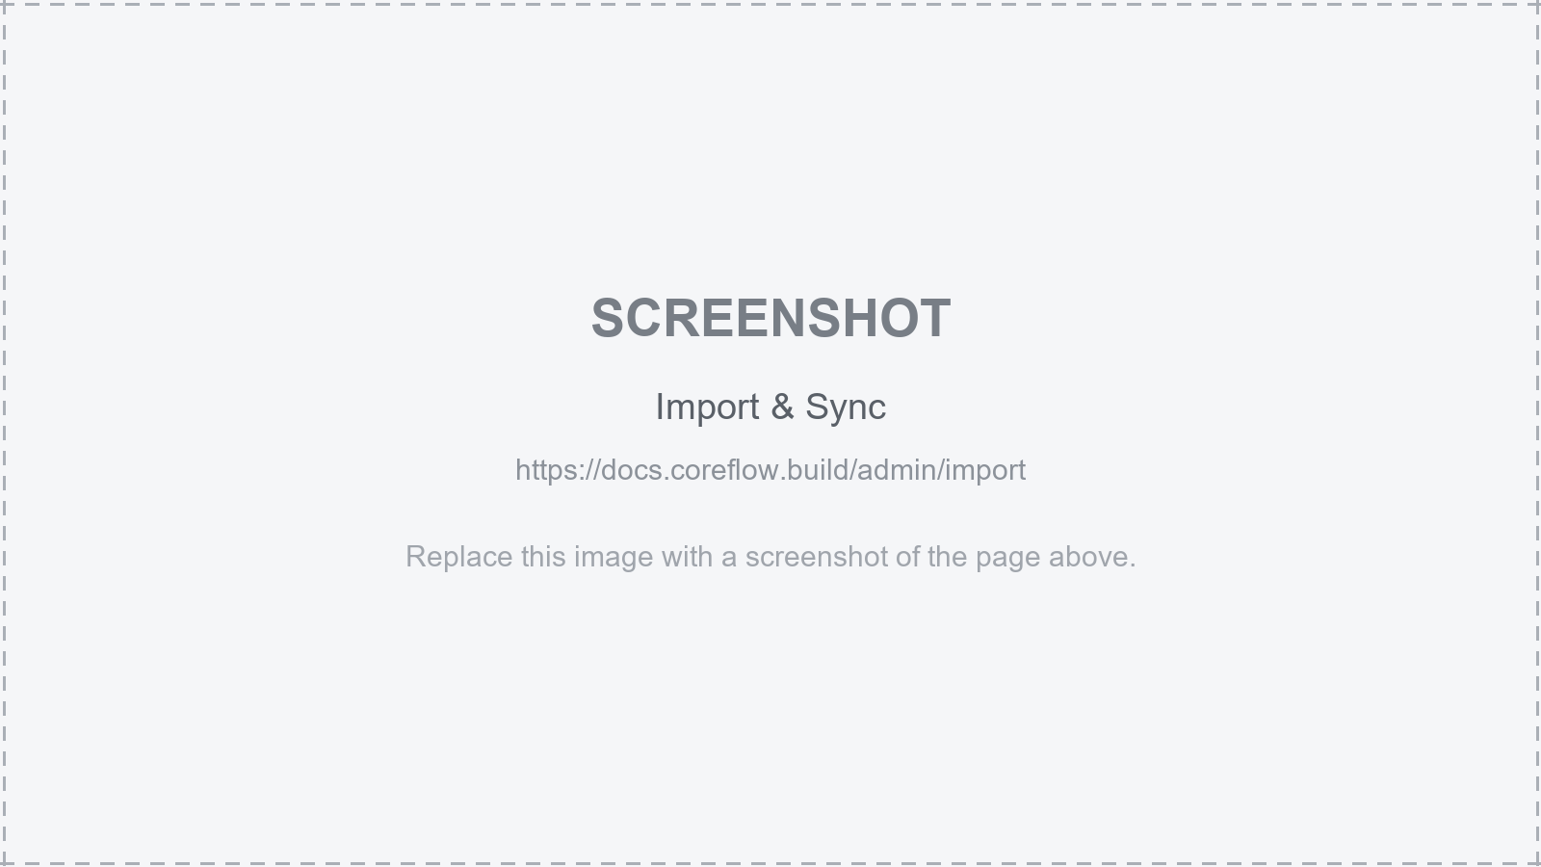
Screen: Import & Sync
- Import a document-index spreadsheet to seed or update the register in bulk.
- Run the SharePoint sync to pull the latest files/metadata into CoreDocs.
- Imports are designed to be safe to re-run; check the result summary after each run.

Users
Manage who can access CoreDocs and what they can do - user accounts and roles (admin only).
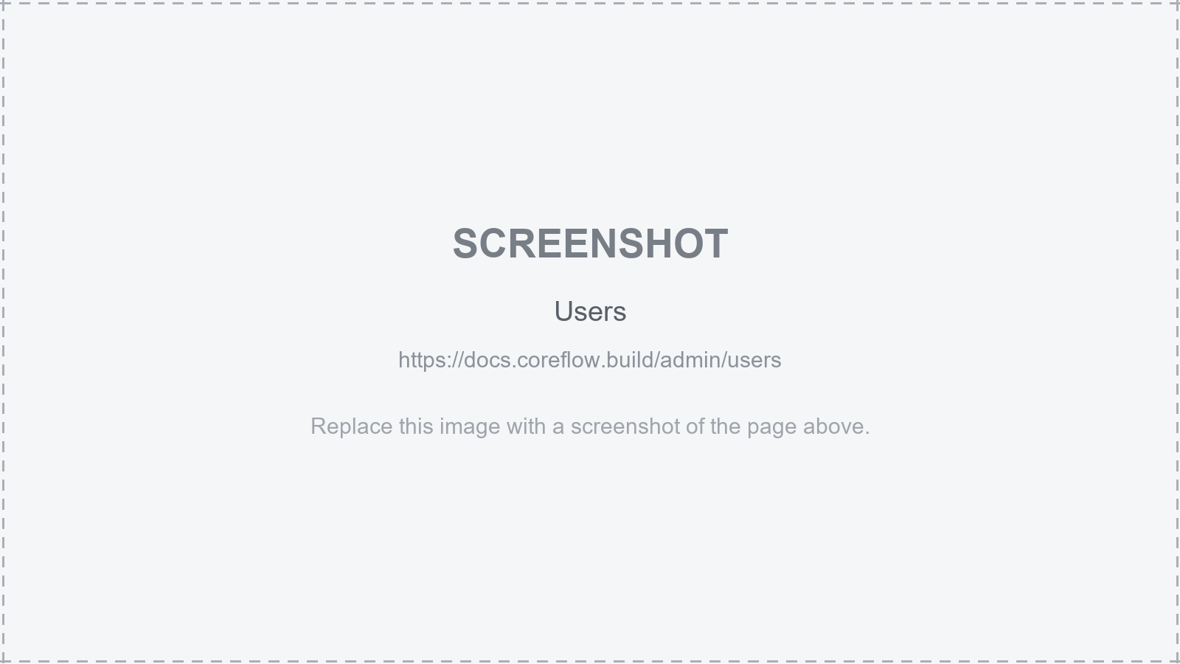
Screen: Users
- Each user has a role that controls their menu and permissions: Document Controller, Reviewer, Engineering/Project Manager, Vendor or Admin.
- Set a person's role here; it takes effect on their next page load.
- Keep the reviewer list current so batches can be assigned to the right people.

Vendors & Packages
The vendors and work packages that documents belong to (admin only).
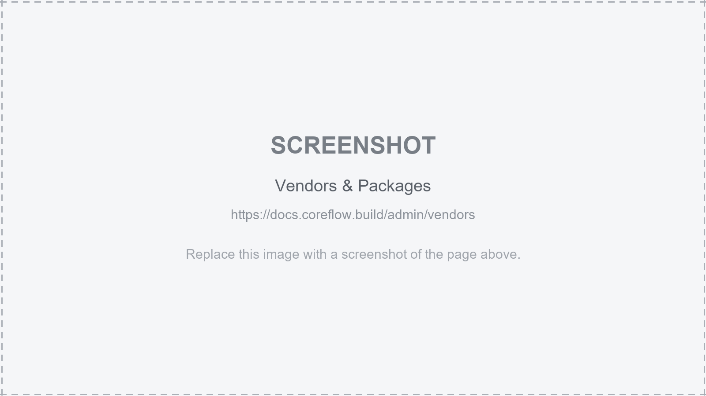
Screen: Vendors & Packages
- Maintain the list of vendors and the packages/disciplines they deliver against.
- Correct vendor/package setup is what lets batches, the register and reporting group documents properly.

End of guide — CoreDocs, PPE Technologies

