Supplementary Materials for: C1Q/SPP1 Macrophage Spatial Context as a Traceability Feature in Non-Small Cell Lung Cancer: A Public Multi-Cohort Cancer-Informatics Study
Xiongjie Li1*, Fengyue Zhang2, Chaojia Luo1, Xuan Xu1
1 Department of Cardiothoracic, Thyroid and Breast Surgery, Qianjiang Jianghan Oilfield General Hospital, No. T32, Guanghua Ankang Road, Qianjiang 433100, Hubei, China
2 Department of Gastroenterology, Qianjiang Jianghan Oilfield General Hospital, Qianjiang 433100, Hubei, China
*Correspondence: Xiongjie Li, MD; Department of Cardiothoracic, Thyroid and Breast Surgery, Qianjiang Jianghan Oilfield General Hospital, Qianjiang 433100, Hubei, China; Email: surobert518@163.com; ORCID: 0009-0005-9507-6829
This supplementary file contains Supplementary Figures S1-S12 and Supplementary Tables S1-S13, including feature-selection stability, MR diagnostics, spatial summaries, retrospective score-behavior tables, external-cohort covariate summaries, and reporting-boundary tables.

Supplementary Figures
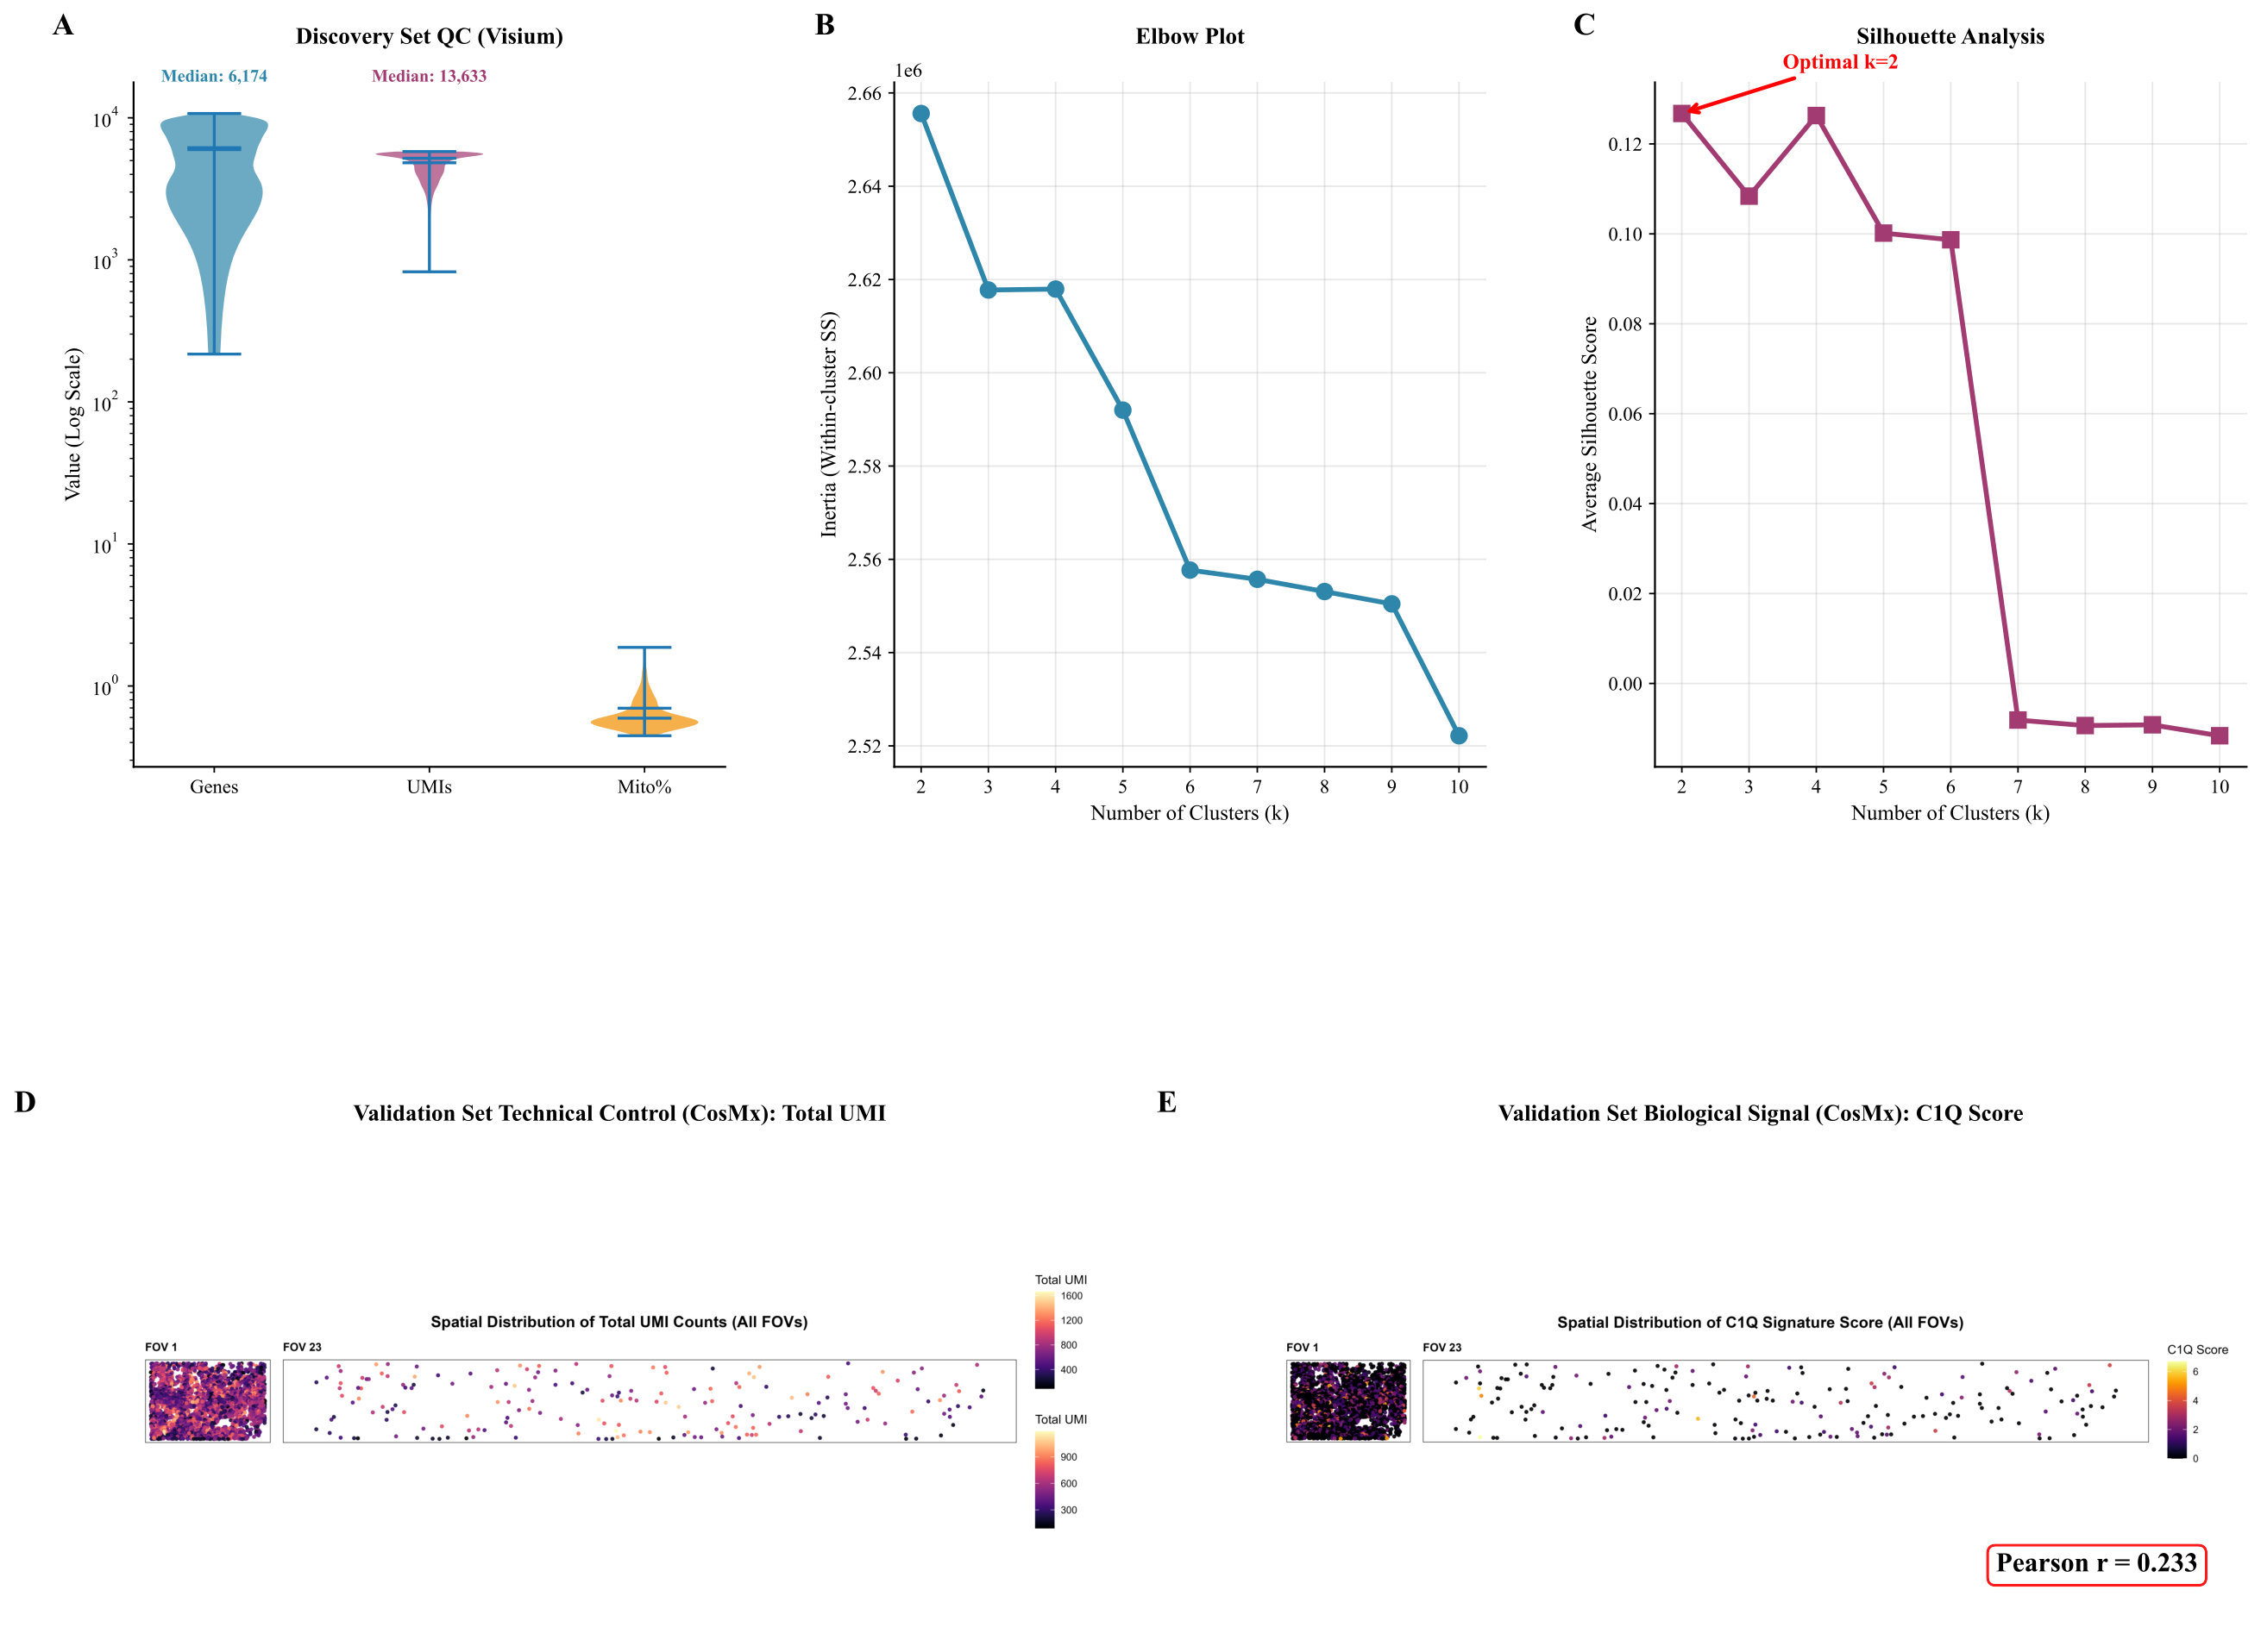
Figure S1. C1Q-axis scoring, dimensionality, and cross-platform spatial-context checks. (A) Distribution of the C1Q-axis score. (B) Elbow-plot summary used to inspect dimensional structure. (C) Silhouette analysis used to assess cluster separation. (D) Visium-based technical-control comparison. (E) CosMx-based biological-signal comparison. These panels are interpreted as quality and traceability checks rather than patient-level confirmation.
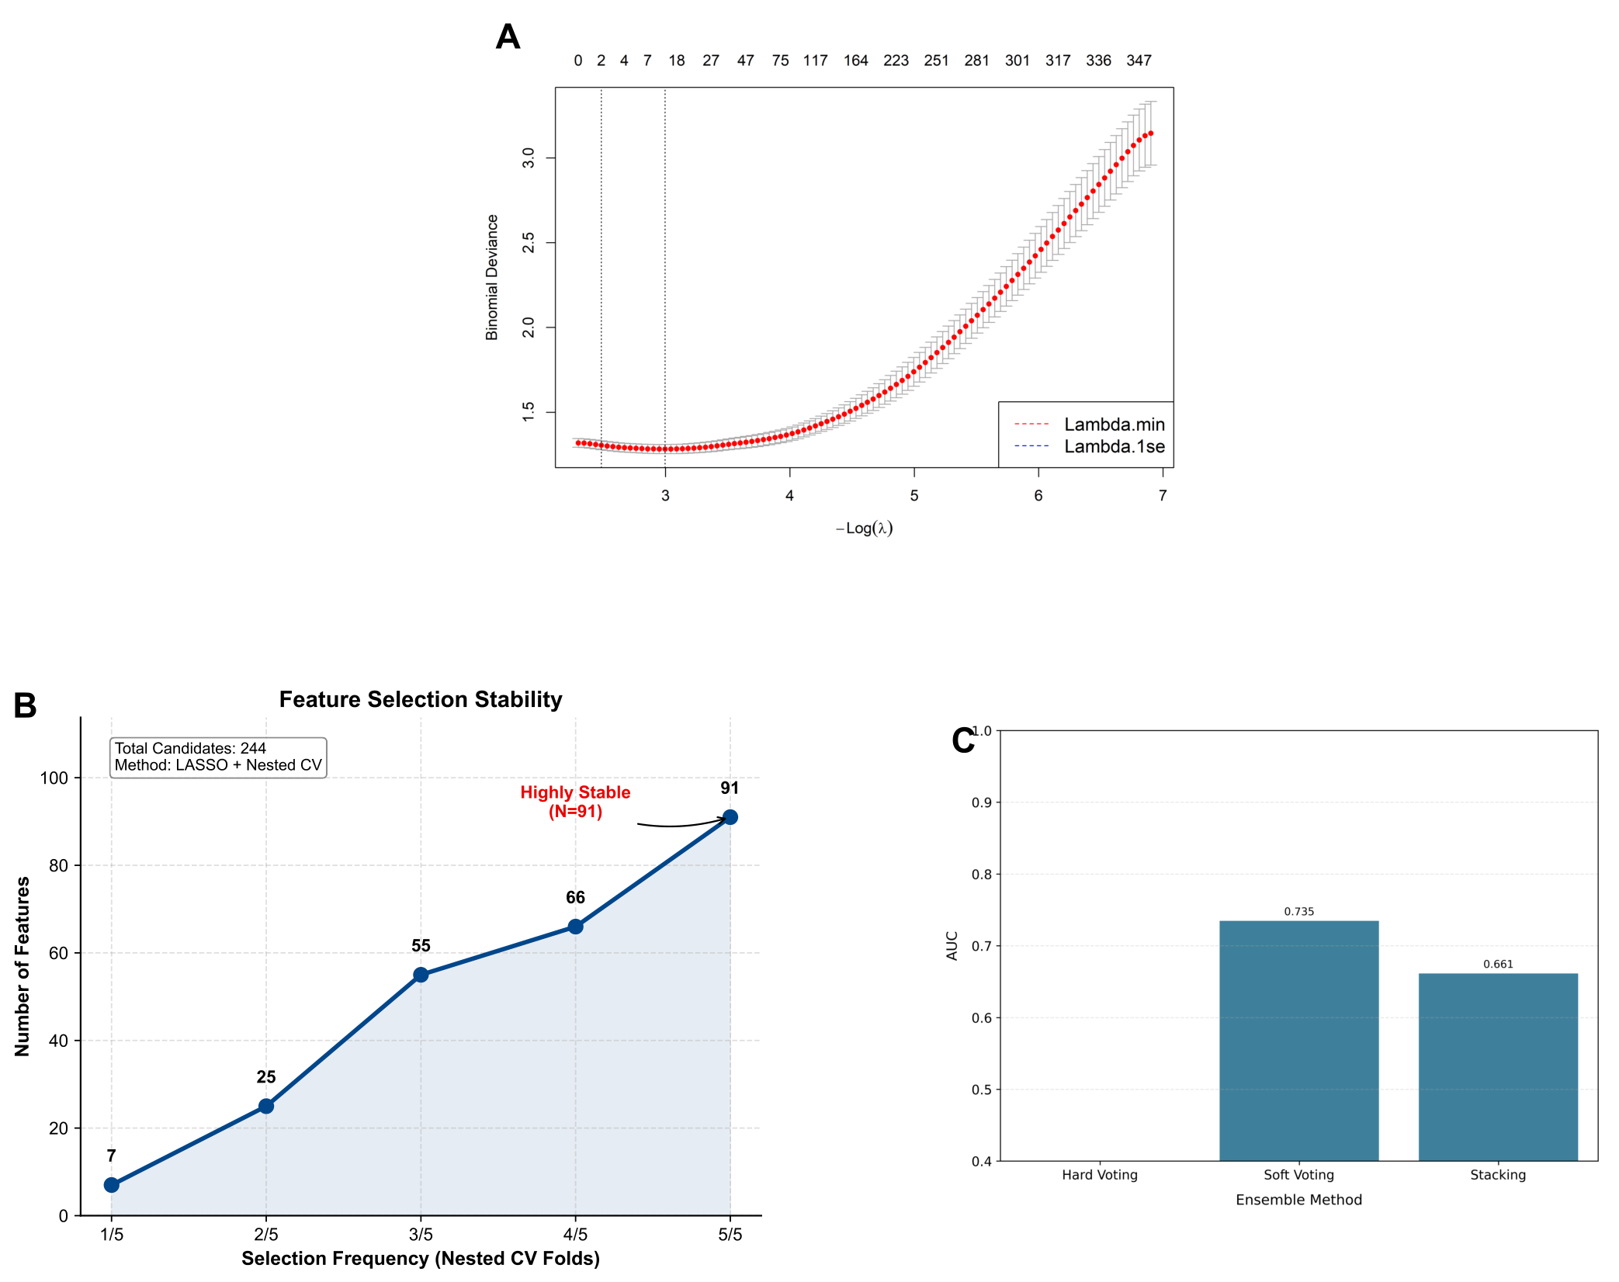
Figure S2. Feature-selection stability and internal score-assessment details. (A) Penalized-model tuning and internal discrimination summary. (B) Feature-selection stability across nested cross-validation folds. (C) Internal assessment of subtype-related discrimination. These panels support retrospective score construction and are not presented as clinical-readiness evidence.
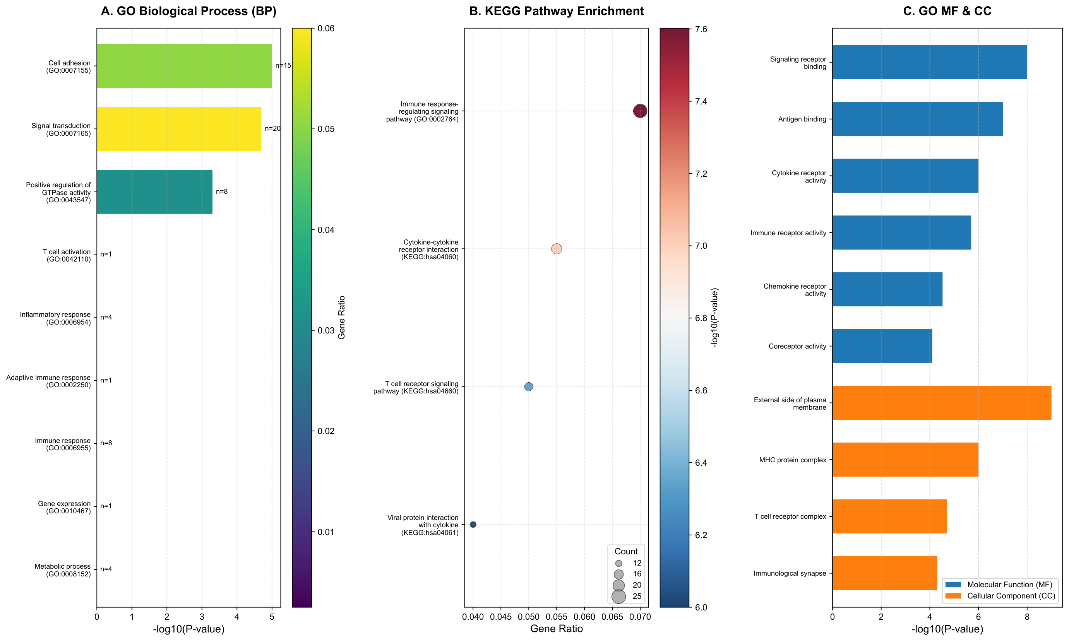
Figure S3. Functional enrichment analysis of model-associated genes. (A) Gene Ontology (GO) biological-process enrichment analysis. (B) KEGG pathway enrichment analysis. (C) Gene Ontology molecular-function and cellular-component enrichment summary. These panels provide functional context for the feature set and are not interpreted as pathway-level confirmation.
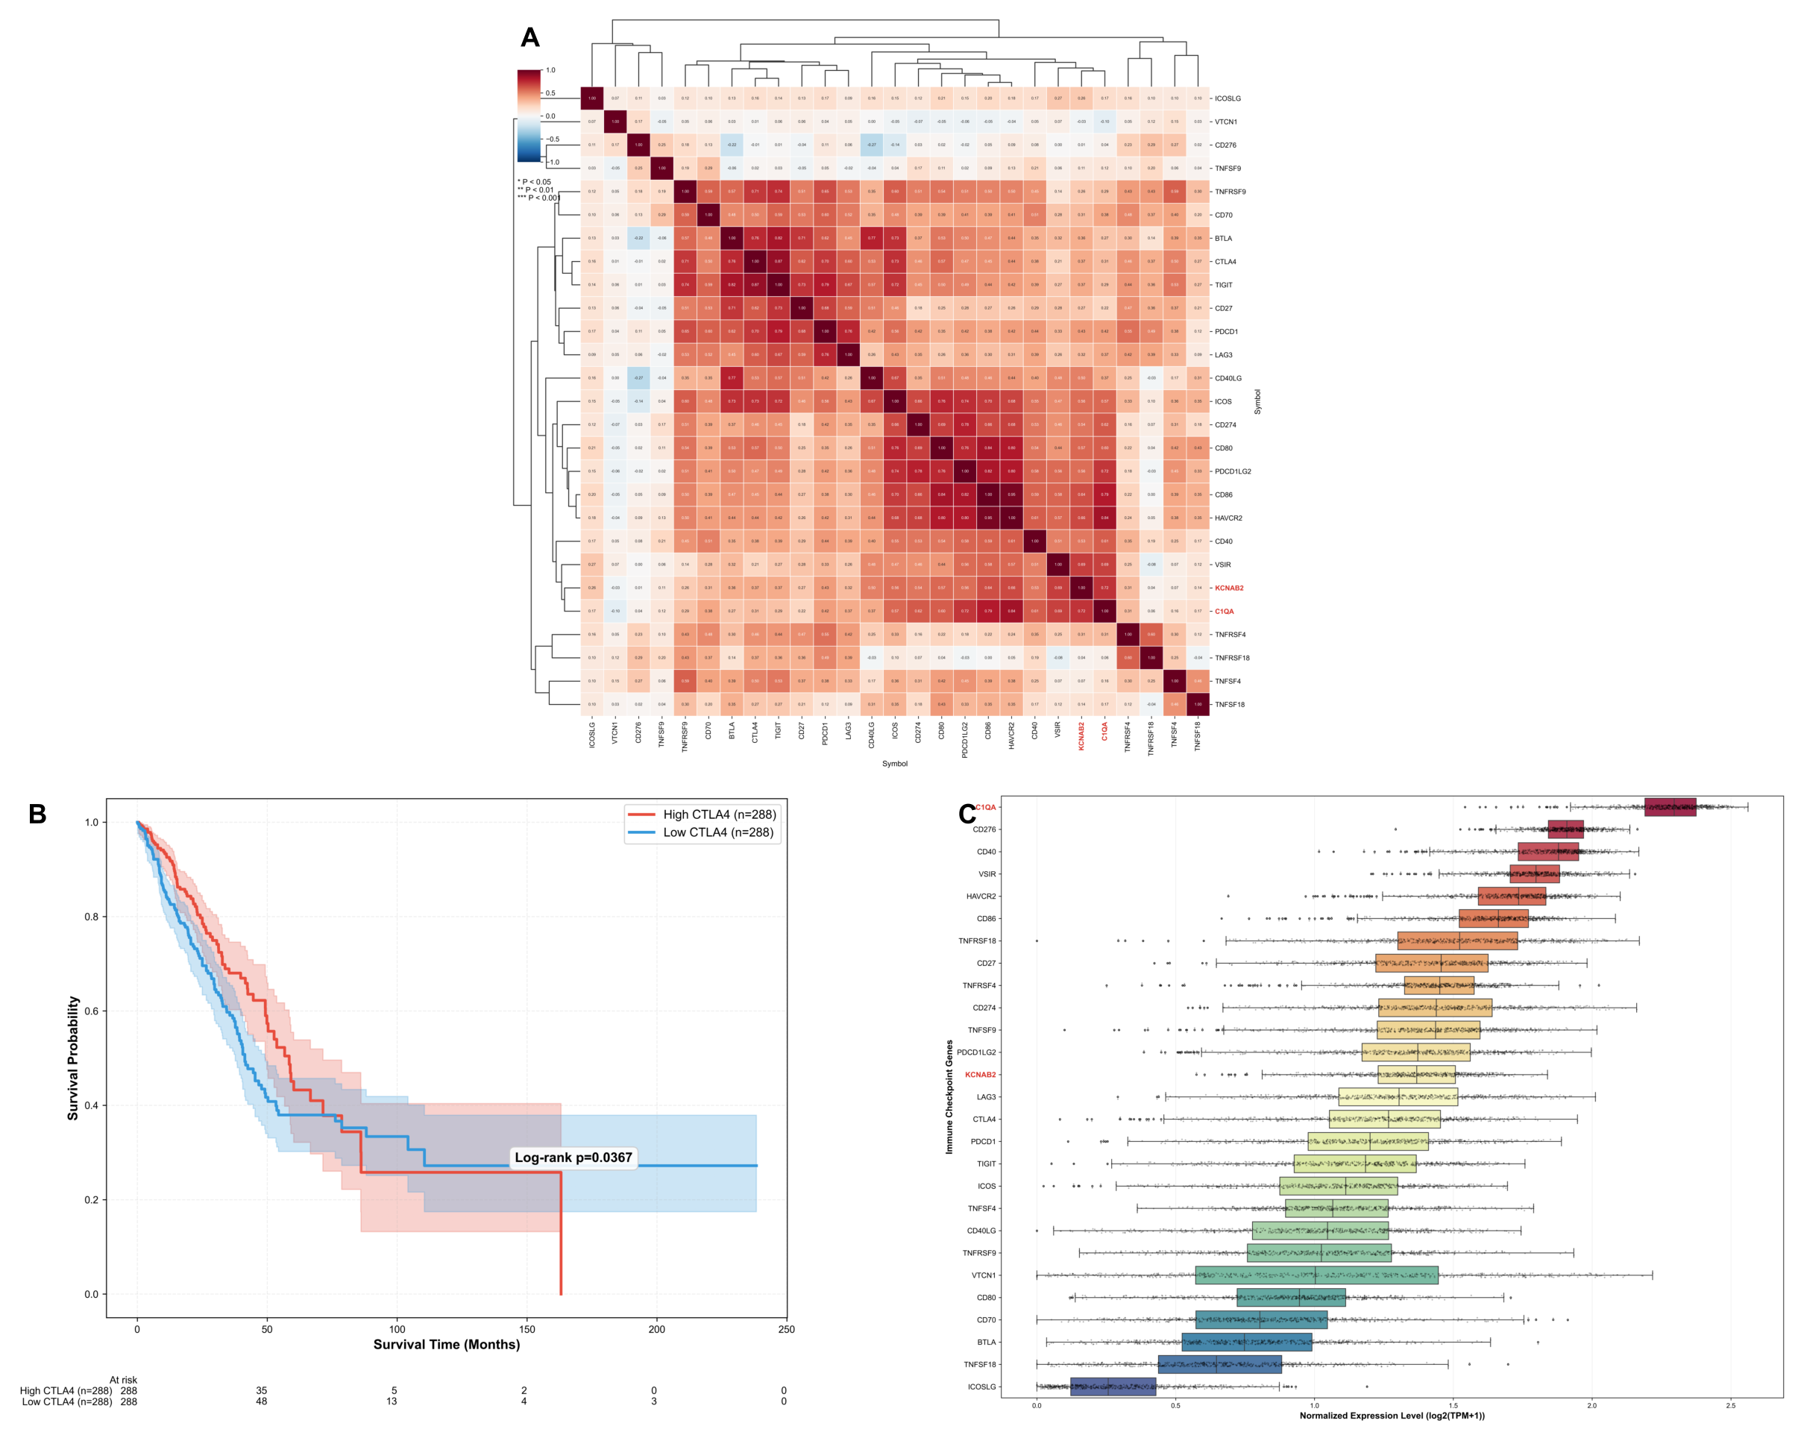
Figure S4. Exploratory correlation, survival, and pathway context for immune-related features. The panels summarize gene-correlation structure, survival-associated stratification, and pathway-level enrichment for the candidate feature context. These analyses are descriptive and should not be interpreted as immune-checkpoint confirmation.
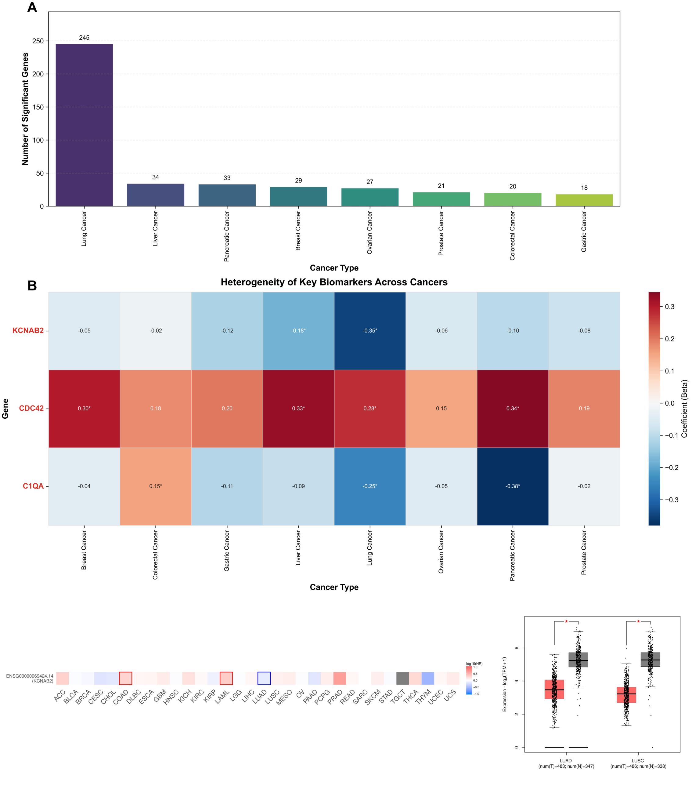
Figure S5. Pan-cancer exploratory traceability of core candidate genes. (A) Statistical overview of significant genes identified across 33 cancer types in the exploratory screen. (B) Heatmap of prognostic coefficients (Beta) for five candidate genes (KCNAB2, PLOD1, CDC42, TNF, C1QA) across 33 cancer types. (C) GEPIA-based Overall Survival Map for KCNAB2, presented as an external context check rather than confirmation. (D) GEPIA Expression Boxplot for KCNAB2 in Lung Adenocarcinoma (LUAD) and Squamous Cell Carcinoma (LUSC).
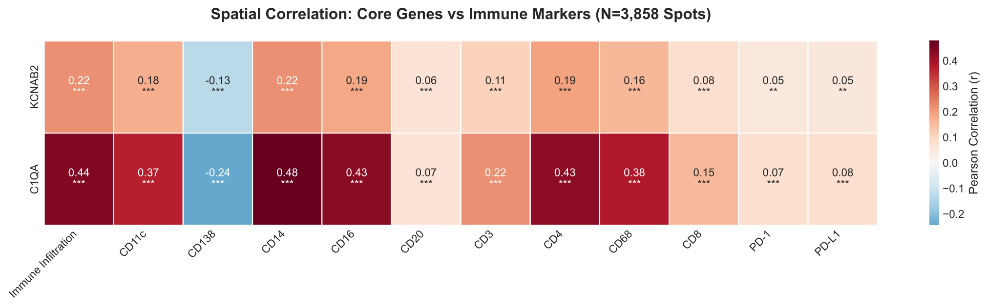
$P<0.050$$P<0.010$$P<0.001$Figure S6. Correlation analysis between hub genes and immune-context estimates. Clustered heatmap displaying Pearson correlation coefficients between hub genes (KCNAB2, PLOD1) and 23 immune-context estimates predicted by GigaTIME. Red indicates positive correlation; blue indicates negative correlation. *, **, *** P < 0.001. CD138 is interpreted as plasma-cell context, not as a macrophage marker.
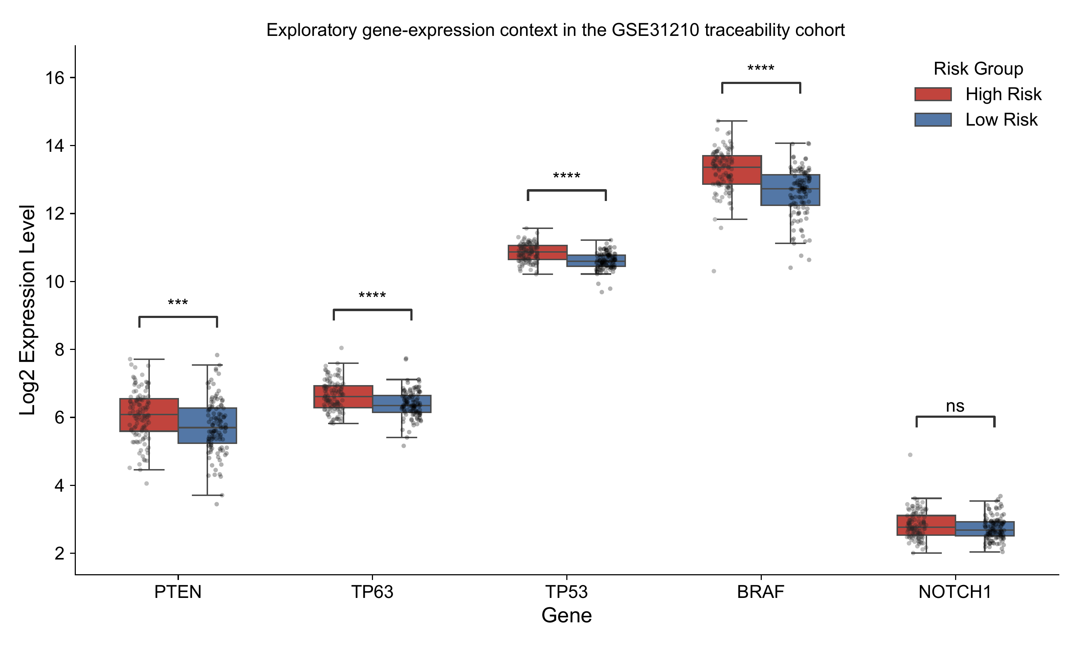
$P<0.050$$P<0.010$$P<0.001$$P<0.0001$Figure S7. Exploratory expression differences for selected cancer-associated genes in GSE31210 score groups. Boxplots show expression levels of selected genes, including PTEN, TP63, TP53, BRAF, and NOTCH1, across high- and low-score groups in the GSE31210 traceability cohort. These panels provide exploratory context only and are not used as the primary basis for candidate prioritization. Statistical significance was assessed using the Mann-Whitney U test (*, **, ***, **** ).
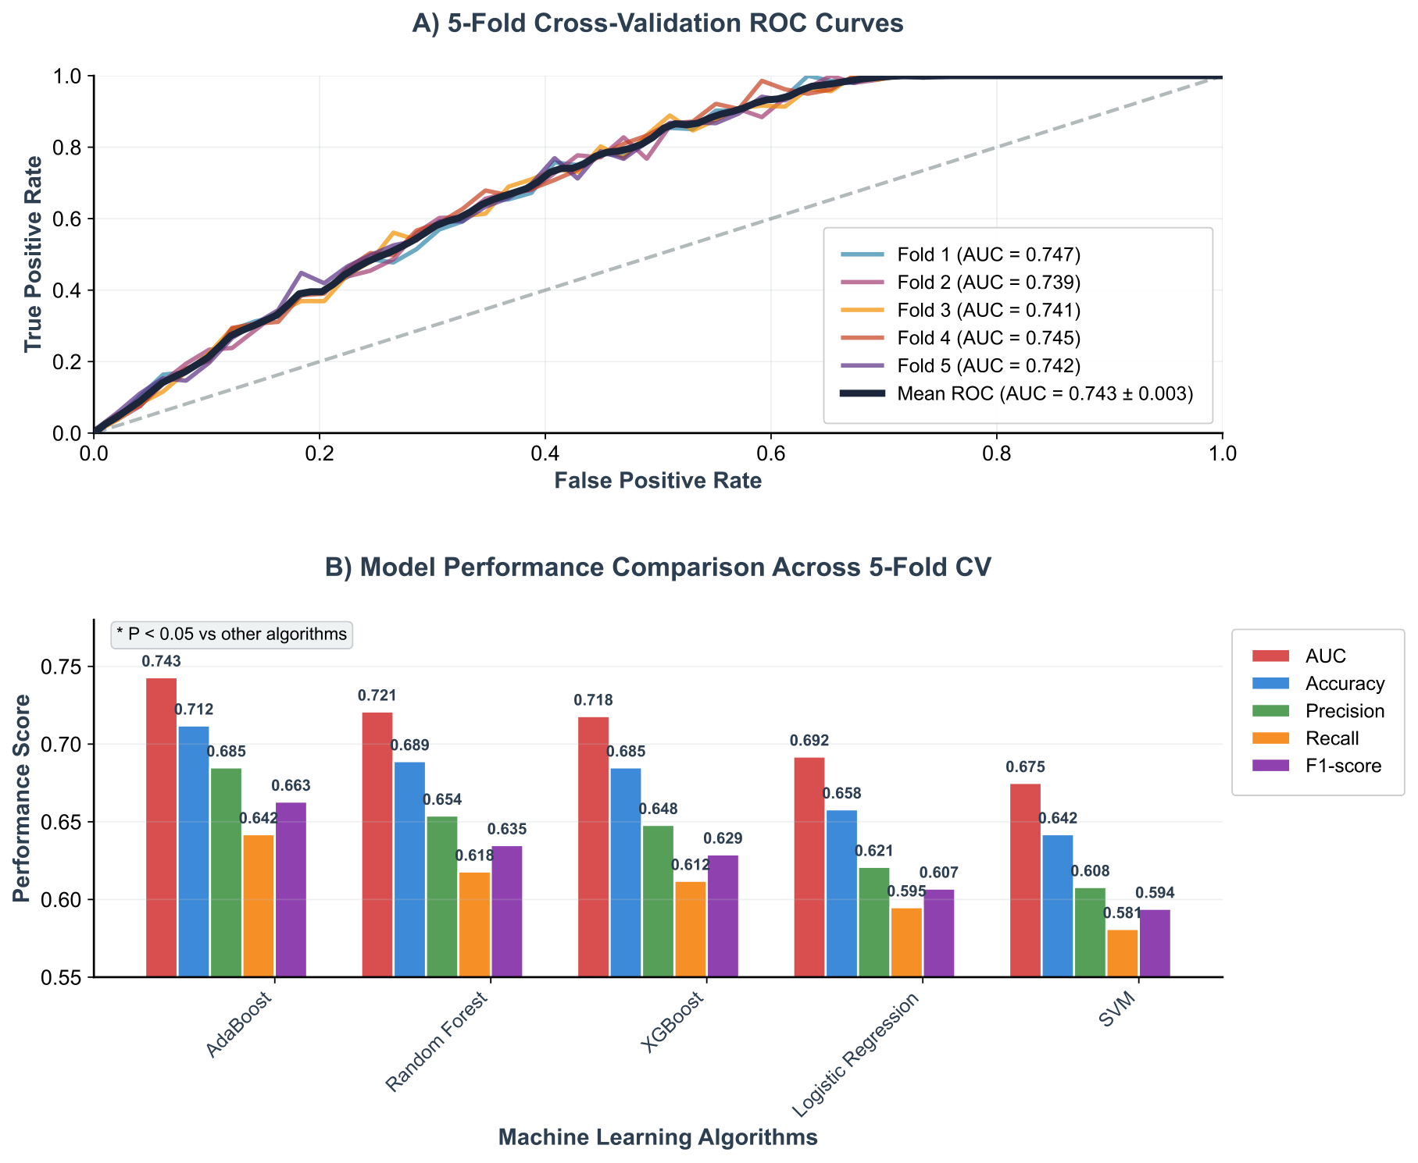
Figure S8. 5-fold cross-validation score-behavior and algorithm comparison. (A) ROC curves from each of the 5 cross-validation folds. The mean AUC across all folds was 0.743 ± 0.028, indicating internally reproducible but retrospective discrimination. (B) Algorithm-comparison bar chart showing AUC, Accuracy, Precision, Recall, and F1-score across different machine learning algorithms (AdaBoost, Random Forest, XGBoost, Logistic Regression, SVM). Algorithm rankings varied by metric; no single model is interpreted as clinically superior. Error bars represent standard deviation across the 5 CV folds.
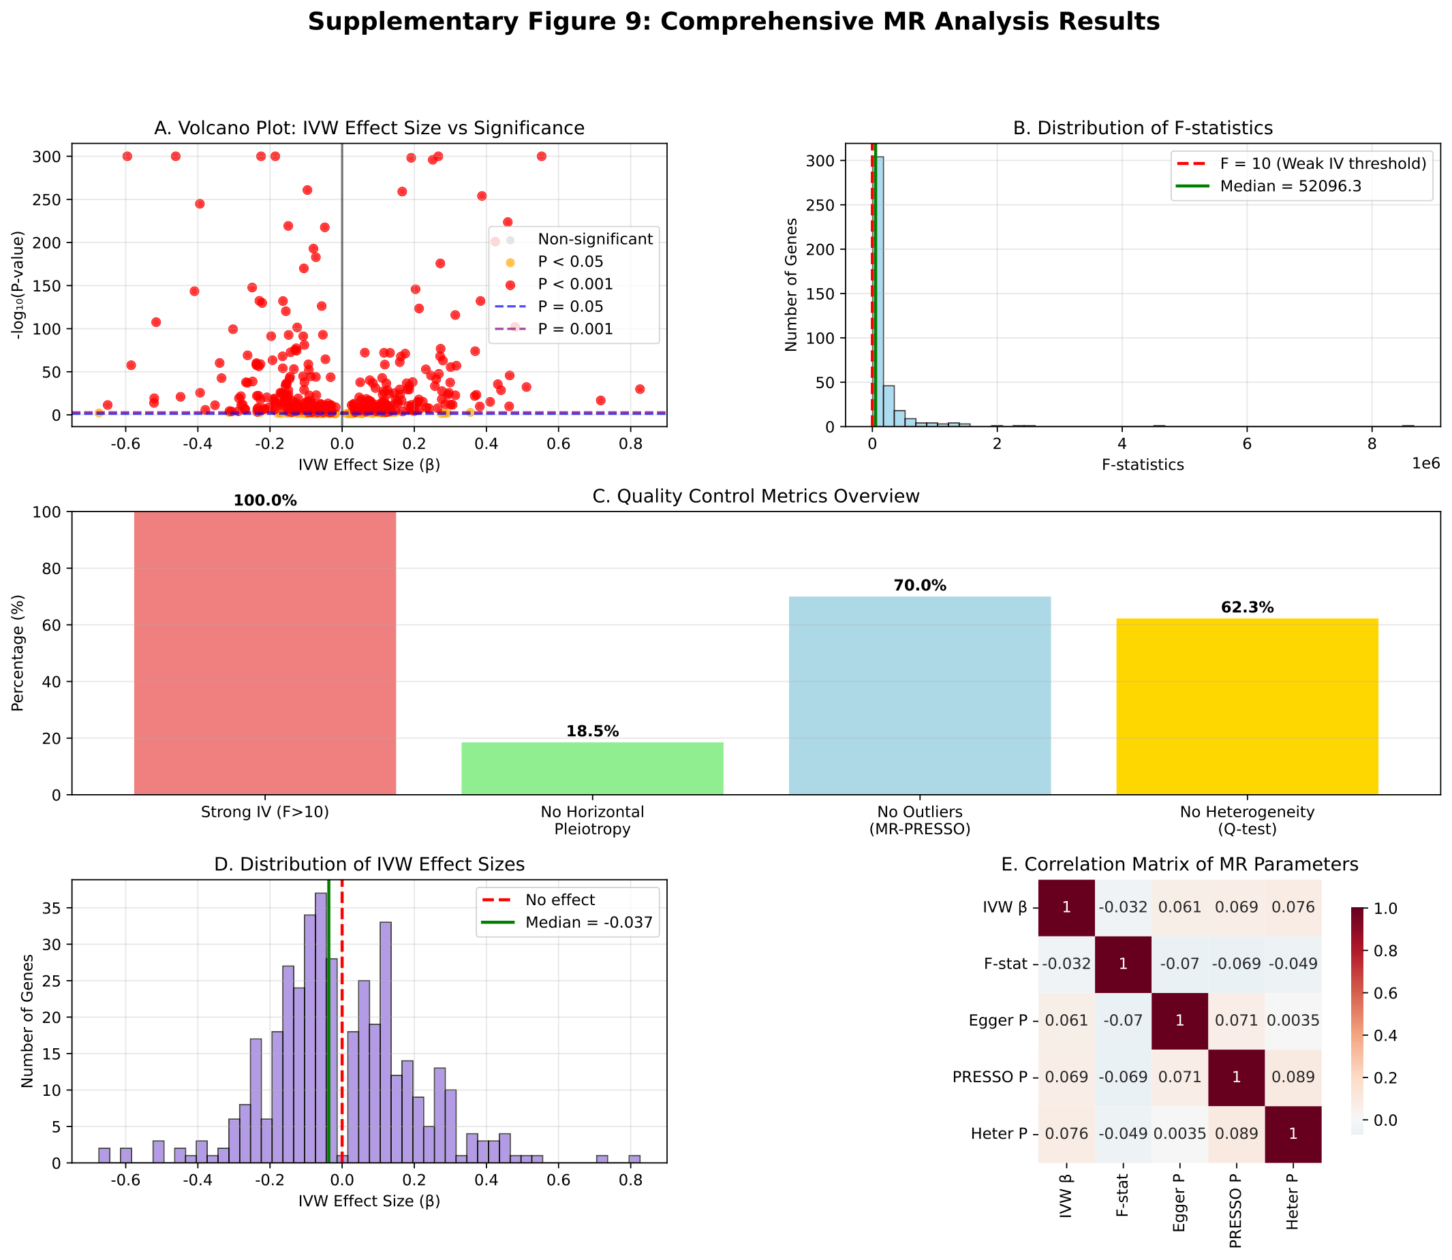
Figure S9. Mendelian-randomization leave-one-out sensitivity analysis. Leave-one-out plots for prioritized genes (including KCNAB2, C1QA, and ACP5), showing whether the MR estimate is dominated by any single instrumental variable (SNP). These analyses support gene prioritization under instrumental-variable assumptions but do not prove mechanism.
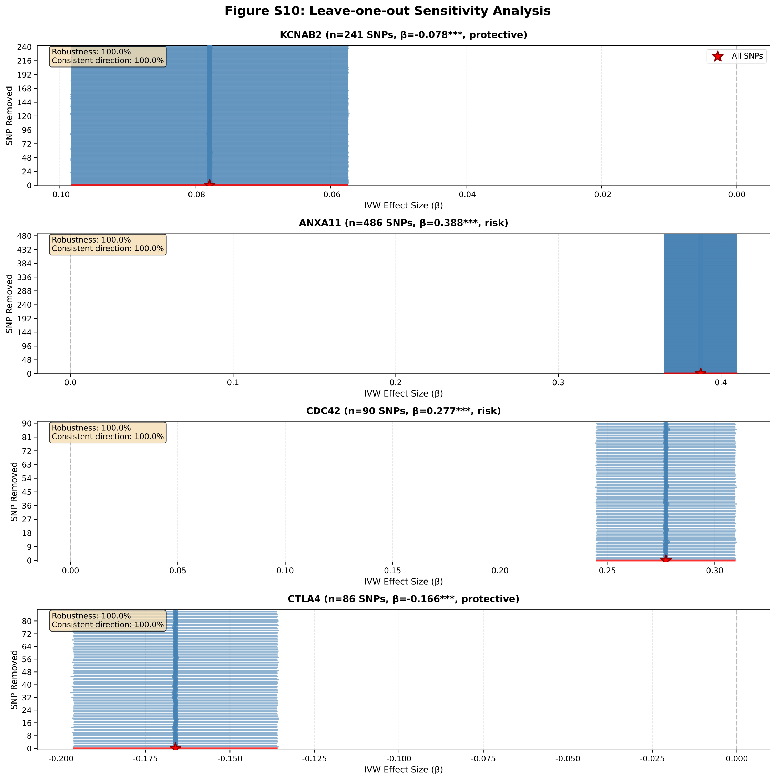
$β$Figure S10. Leave-one-out sensitivity analysis for MR-prioritized genes. Each point represents the recalculated inverse variance weighted (IVW) estimate after systematically removing one SNP at a time. The red star indicates the original estimate using all SNPs. Error bars represent 95% confidence intervals. The dashed vertical line indicates the null effect ( = 0). Stable direction across leave-one-out analyses is interpreted as support for prioritization, not as definitive causal proof.
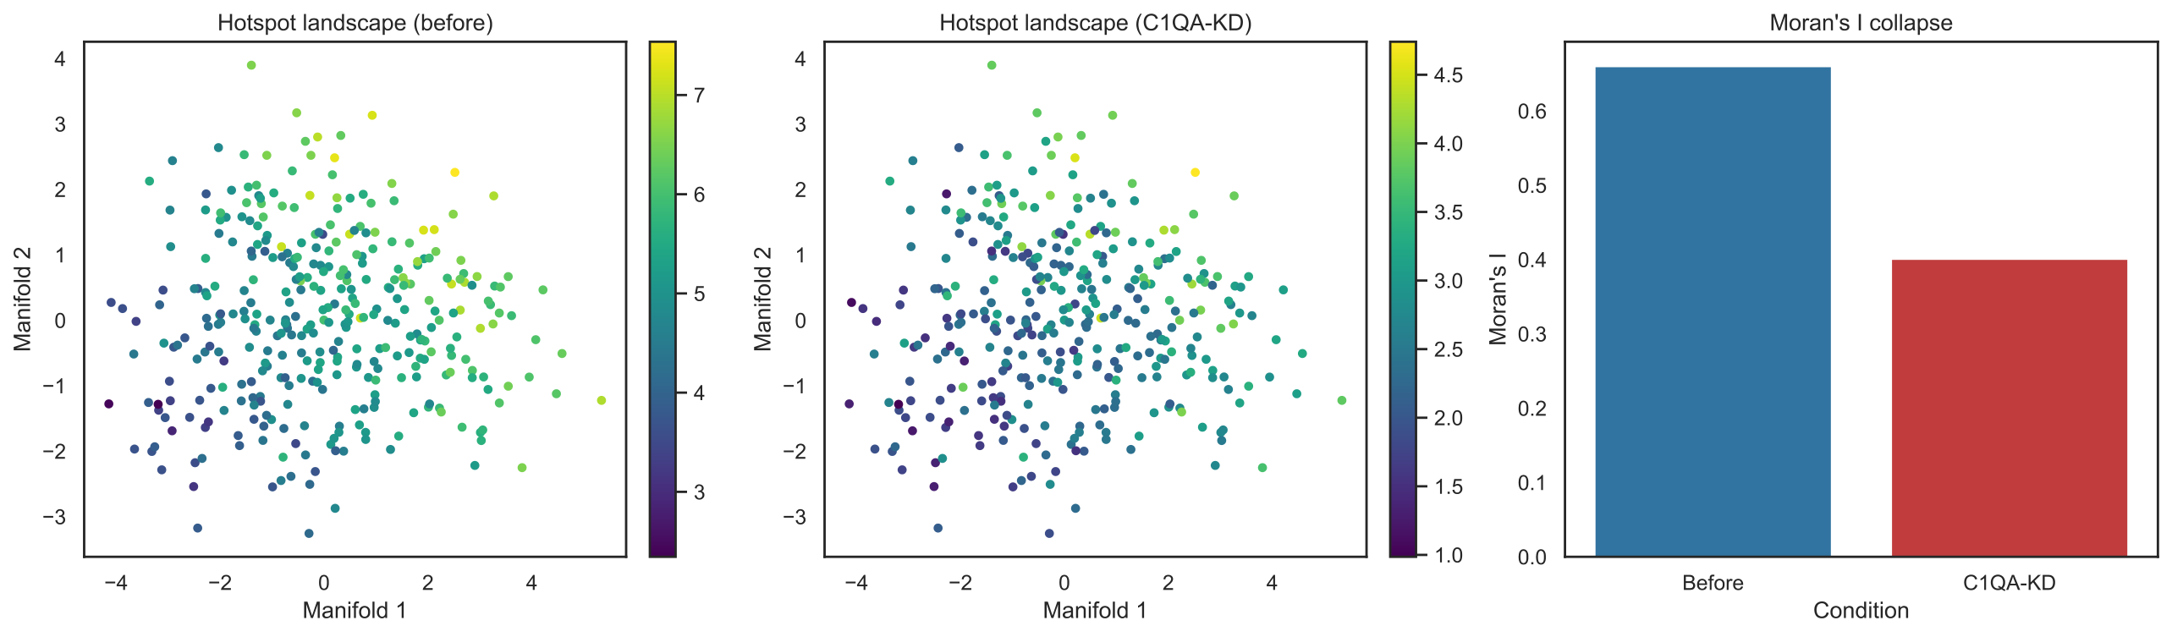
Figure S11. Counterfactual C1QA scoring sensitivity of spatial summaries. Transcriptomic manifold maps before and after computational C1QA attenuation show reduced high-C1Q score regions. The paired Moran’s I summary shows reduced spatial autocorrelation after score recomputation, supporting score dependency rather than experimental perturbation or causal proof.
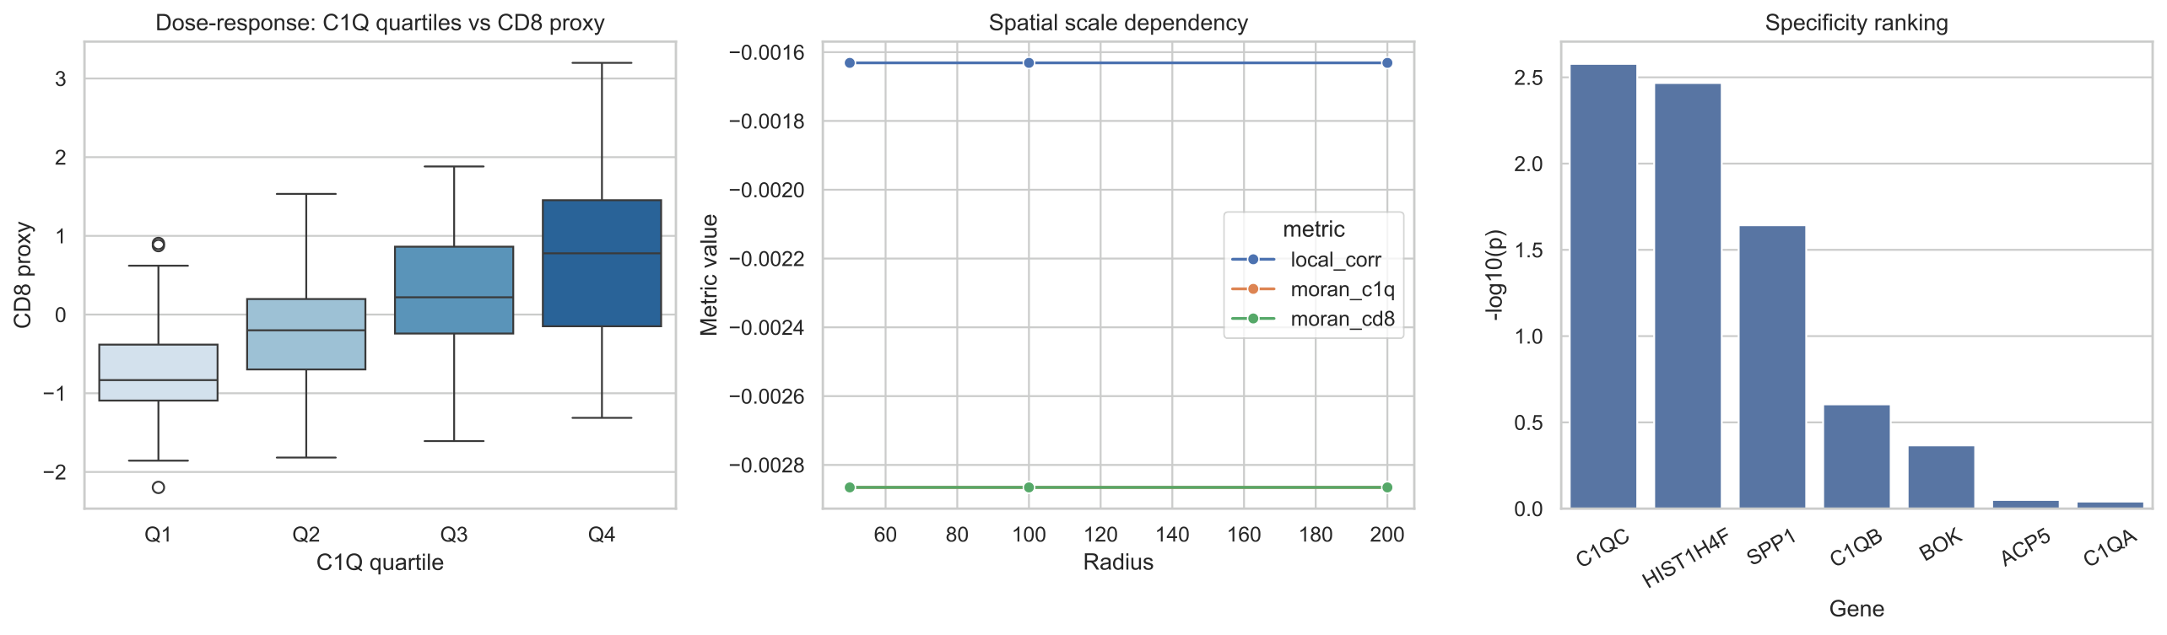
Figure S12. Sensitivity modules for C1Q-context interpretation. Left: dose-response relationship between C1Q quartiles and CD8 proxy activity. Middle: spatial scale dependency of local coupling and spatial autocorrelation across 50/100/200 radii. Right: specificity ranking of C1Q-axis genes versus non-C1Q controls based on survival-linked statistical signal.

Supplementary Tables
Supplementary table index. Table S1, retrospective score behavior on training, internal cross-validation, test, and external sets; Table S2, functional enrichment terms associated with the 91-feature set; Table S3, eQTL-driven regulatory-network edge list; Table S4, stable features identified by nested cross-validation; Table S5, spatial autocorrelation and hotspot analysis; Table S6, hub-gene and immune-context correlations; Table S7, Mendelian-randomization analysis results; Table S8, TME-subtype differential-expression context; Table S9, external-cohort covariate summaries; Table S10, cell-type-specific eQTL reporting boundary and interpretation; Table S11, MR diagnostic parameters for prioritized genes; Table S12, spatial transcriptomics sample information; and Table S13, multivariable Cox regression analysis of the retrospective score.
Table S1a. Apparent training-set metrics for audit transparency only
Model | Hyperparameters | Acc | Prec | Rec | F1 | AUC
Logistic Regression |  | 0.865 | 0.842 | 0.816 | 0.829 | 0.929
Decision Tree |  | 1.000 | 1.000 | 1.000 | 1.000 | 1.000
Random Forest |  | 1.000 | 1.000 | 1.000 | 1.000 | 1.000
Gradient Boosting |  | 1.000 | 1.000 | 1.000 | 1.000 | 1.000
AdaBoost |  | 1.000 | 1.000 | 1.000 | 1.000 | 1.000
Soft Voting |  | 0.925 | 0.891 | 0.864 | 0.877 | 0.962
XGBoost |  | 1.000 | 1.000 | 1.000 | 1.000 | 1.000
SVM |  | 0.853 | 0.869 | 0.745 | 0.802 | 0.958
K-Nearest Neighbors |  | 0.771 | 0.678 | 0.816 | 0.741 | 0.846
Naive Bayes |  | 0.702 | 0.602 | 0.755 | 0.670 | 0.788
Note: Apparent training-set metrics are shown for audit transparency only and are not used as evidence of clinical-readiness performance.
Table S1b. Retrospective score-behavior metrics in internal cross-validation, test, and external traceability sets
 | Internal CV Set |  |  |  |  | Test Set |  |  |  |  | Ext.
Model | Acc | Prec | Rec | F1 | AUC | Acc | Prec | Rec | F1 | AUC | AUC
 | Internal CV Set |  |  |  |  | Test Set |  |  |  |  | Ext.
12-12 Model | Acc | Prec | Rec | F1 | AUC | Acc | Prec | Rec | F1 | AUC | AUC
Logistic Regression | 0.531$±$0.08 | 0.415$±$0.09 | 0.447$±$0.14 | 0.426$±$0.11 | 0.592$±$0.06 | 0.705 | 0.617 | 0.690 | 0.652 | 0.741 | -
Decision Tree | 0.551$±$0.06 | 0.438$±$0.06 | 0.448$±$0.14 | 0.433$±$0.10 | 0.533$±$0.05 | 0.543 | 0.435 | 0.476 | 0.455 | 0.532 | -
Random Forest | 0.678$±$0.03 | 0.611$±$0.05 | 0.540$±$0.04 | 0.573$±$0.04 | 0.720$±$0.02 | 0.657 | 0.607 | 0.405 | 0.486 | 0.701 | -
Gradient Boosting | 0.674$±$0.03 | 0.614$±$0.05 | 0.521$±$0.08 | 0.559$±$0.05 | 0.682$±$0.01 | 0.657 | 0.594 | 0.452 | 0.514 | 0.655 | -
AdaBoost | 0.657$±$0.04 | 0.580$±$0.05 | 0.550$±$0.10 | 0.558$±$0.06 | 0.657$±$0.05 | 0.657 | 0.588 | 0.476 | 0.526 | 0.743 | 0.650
Soft Voting | 0.695$±$0.03 | 0.642$±$0.04 | 0.582$±$0.05 | 0.611$±$0.04 | 0.757$±$0.02 | 0.738 | 0.715 | 0.761 | 0.732 | 0.757 | -
XGBoost | 0.682$±$0.04 | 0.622$±$0.05 | 0.551$±$0.06 | 0.584$±$0.05 | 0.718$±$0.03 | 0.725 | 0.701 | 0.742 | 0.715 | 0.781 | -
SVM | 0.653$±$0.03 | 0.586$±$0.05 | 0.468$±$0.11 | 0.512$±$0.08 | 0.696$±$0.02 | 0.667 | 0.630 | 0.405 | 0.493 | 0.727 | -
K-Nearest Neighbors | 0.641$±$0.04 | 0.542$±$0.05 | 0.682$±$0.11 | 0.600$±$0.05 | 0.670$±$0.03 | 0.581 | 0.478 | 0.524 | 0.500 | 0.578 | -
Naive Bayes | 0.669$±$0.04 | 0.574$±$0.04 | 0.704$±$0.08 | 0.630$±$0.04 | 0.759$±$0.03 | 0.686 | 0.596 | 0.667 | 0.629 | 0.737 | -
Note: Summary of retrospective score-behavior metrics for candidate machine-learning algorithms. Abbreviations: Acc, accuracy; Prec, precision; Rec, recall; F1, F1-score; AUC, area under the receiver operating characteristic curve; Ext., external traceability cohort.
Table S2. Functional enrichment terms associated with the 91-feature set
Pathway Term | Count | Enrich. Ratio | P-value
IL-17 signaling pathway | 62 | 1.007 | 0.012
Natural killer cell mediated cytotoxicity | 52 | 0.610 | 0.018
T cell receptor signaling pathway | 74 | 0.320 | 0.028
B cell receptor signaling pathway | 61 | 0.892 | 0.030
Cytokine-cytokine receptor interaction | 9 | 0.121 | 0.032
MAPK signaling pathway | 30 | 0.162 | 0.035
Antigen processing and presentation | 81 | 0.349 | 0.036
NF-kappa B signaling pathway | 23 | 0.120 | 0.038
TNF signaling pathway | 9 | 0.039 | 0.042
Chemokine signaling pathway | 69 | 0.633 | 0.045
Complement and coagulation cascades | 22 | 0.236 | 0.047
Hematopoietic cell lineage | 36 | 0.503 | 0.048
JAK-STAT signaling pathway | 32 | 0.259 | 0.049
Oxidative phosphorylation | 54 | 0.345 | 0.060
Autophagy | 3 | 0.036 | 0.125
PI3K-Akt signaling pathway | 59 | 0.470 | 0.392
Apoptosis | 22 | 0.212 | 0.421
Note: This table summarizes functional enrichment terms associated with the 91-feature set prioritized by nested cross-validation stability.
Table S3. Edge list of the eQTL-driven regulatory network
gene1 | gene2 | weight | Source
KCNAB2 | PARK7 | 0.008 | eQTL
C1QA | CD138 | 0.134 | Spatial_Correlation (p=5e-17)
C1QA | CD8 | 0.116 | Spatial_Correlation (p=4e-13)
C1QA | PD-L1 | 0.115 | Spatial_Correlation (p=6e-13)
C1QA | PD-1 | 0.085 | Spatial_Correlation (p=1e-7)
C1QA | Caspase3-D | 0.077 | Spatial_Correlation (p=1e-6)
Note: Gene-gene interaction network was constructed using spatial transcriptomics data. Edge weights represent spatial correlation coefficients between gene expression patterns. Spatial-correlation P-values are descriptive within analyzed sections and should not be interpreted as independent patient-level inference.
Table S4. List of stable features identified by nested cross-validation
Gene | Selection Frequency (Max=5)
A2M-AS1 | 5
AC013264.2 | 5
ACP5 | 5
AC022498.1 | 5
ASAH1 | 5
APMAP | 5
ADAMTS1 | 5
ADRB1 | 5
AP003774.1 | 5
ANKDD1A | 5
CCT8 | 5
CCDC152 | 5
C11orf21 | 5
C6orf25 | 5
C5orf17 | 5
C2orf74 | 5
C6orf47-AS1 | 5
BOK | 5
B4GALNT3 | 5
ATP5G1 | 5
CAPN12 | 5
CASP8 | 5
CD37 | 5
CCSER2 | 5
CAMLG | 5
FAH | 5
FADS2 | 5
EVI2A | 5
FAM43A | 5
GDE1 | 5
GNG5 | 5
GLIPR1L2 | 5
FRG1B | 5
GBP5 | 5
GBP7 | 5
FCRL3 | 5
CTD-2368P22.1 | 5
CTD-2196E14.4 | 5
CTSG | 5
CTLA4 | 5
CTSW | 5
DAD1 | 5
DCXR | 5
DAZAP2 | 5
DIP2A | 5
DDTL | 5
COX7A2L | 5
CTBP1-AS2 | 5
CLECL1 | 5
COG5 | 5
CES1 | 5
CENPK | 5
GRIN2C | 5
GCHFR | 5
DRAM2 | 5
FAM110B | 5
FAM118A | 5
EIF5A | 5
DOCK8 | 5
KYNU | 5
MAST3 | 5
MCF2L2 | 5
MAD1L1 | 5
MAF1 | 5
LYST | 5
LY6G5B | 5
LRRC37A2 | 5
LINC00987 | 5
METTL18 | 5
KLRG1 | 5
HLA-A | 5
HLA-DQA2 | 5
ISG15 | 5
ITCH-AS1 | 5
INSR | 5
HMGN1 | 5
ITGB3BP | 5
HLA-C | 5
HLA-DQB2 | 5
HIST1H3J | 5
HIST1H4B | 5
HELLS | 5
HIST1H2AH | 5
GS1-251I9.4 | 5
ZP3 | 5
KCNAB2 | 5
LINC00649 | 5
LINC00493 | 5
LDHC | 5
LIN52 | 5
LA16c-358B7.3 | 5
PLOD1 | 5
CDC42 | 5
TNF | 5
C1QA | 5
Note: Stable features were identified using nested 5-fold cross-validation repeated 5 times. Selection frequency indicates the number of times each feature was selected across all outer folds.
Table S5. Spatial autocorrelation (Moran's I) and hotspot analysis
Gene | Morans_I
UBXN10 | 0.416
C1QA | 0.386
C1QB | 0.381
C1QC | 0.377
TTLL10 | 0.364
NBL1 | 0.321
CFAP74 | 0.313
MXRA8 | 0.259
ALPL | 0.232
TNFRSF14 | 0.225
ISG15 | 0.217
MEGF6 | 0.214
MFAP2 | 0.199
PLA2G2D | 0.189
HSPB7 | 0.186
FBLIM1 | 0.168
UBXN11 | 0.164
ID3 | 0.163
PLA2G2A | 0.160
FUCA1 | 0.148
CD52 | 0.128
CAMK2N1 | 0.127
TNFRSF1B | 0.126
ANKRD65 | 0.121
PIK3CD | 0.120
CASZ1 | 0.118
PRDM16 | 0.113
KCNAB2 | 0.094
HSPG2 | 0.094
ARHGEF10L | 0.088
PRKCZ | 0.086
PER3 | 0.085
PRAMEF13 | 0.084
SKI | 0.084
HES4 | 0.062
ERRFI1 | 0.061
IFFO2 | 0.058
EPHA8 | 0.054
NOL9 | 0.052
SZRD1 | 0.051
TMEM52 | 0.050
PNRC2 | 0.044
ZNF683 | 0.042
TRNP1 | 0.041
TRIM63 | 0.040
OTUD3 | 0.034
C1orf174 | 0.033
ARID1A | 0.032
PERM1 | 0.031
PRAMEF14 | 0.029
Note: Moran's I statistic was used to assess spatial autocorrelation of gene expression across tissue sections. Positive values indicate clustering of similar expression patterns, while negative values suggest dispersion.
Table S6. Correlation between hub gene expression and immune cell infiltration
Hub Gene | Immune Marker | Pearson r | P-value | Significance
KCNAB2 | Monocytes (CD14) | 0.221 | $<$ 0.001 | ***
KCNAB2 | CD4+ T cells | 0.192 | $<$ 0.001 | ***
KCNAB2 | Macrophages (CD16) | 0.186 | $<$ 0.001 | ***
KCNAB2 | Dendritic Cells (CD11c) | 0.175 | $<$ 0.001 | ***
KCNAB2 | Macrophages (CD68) | 0.157 | $<$ 0.001 | ***
KCNAB2 | CD3+ T cells | 0.109 | $<$ 0.001 | ***
KCNAB2 | CD8+ T cells | 0.078 | $<$ 0.001 | ***
KCNAB2 | B cells (CD20) | 0.064 | $<$ 0.001 | ***
KCNAB2 | PD-L1 | 0.052 | 0.001 | **
KCNAB2 | PD-1 | 0.051 | 0.002 | **
KCNAB2 | Plasma cells (CD138) | -0.126 | $<$ 0.001 | ***
PLOD1 | PD-1 | 0.028 | 0.085 | ns
PLOD1 | CD14 | -0.063 | 8.32e-05 | ***
PLOD1 | CD4 | -0.014 | 0.371 | ns
PLOD1 | T-bet | -0.021 | 0.186 | ns
PLOD1 | CD34 | -0.072 | 6.58e-06 | ***
PLOD1 | CD68 | 0.025 | 0.120 | ns
PLOD1 | CD16 | -0.048 | 0.003 | **
PLOD1 | CD11c | -0.047 | 0.004 | **
PLOD1 | CD138 | 0.123 | 2.10e-14 | ***
PLOD1 | CD20 | 0.010 | 0.543 | ns
PLOD1 | CD3 | -0.072 | 7.92e-06 | ***
PLOD1 | CD8 | 0.061 | 1.44e-04 | ***
PLOD1 | PD-L1 | 0.031 | 0.052 | ns
PLOD1 | CK | 0.072 | $<$ 0.001 | ***
PLOD1 | Ki67 | 0.113 | 1.62e-12 | ***
PLOD1 | Tryptase | -0.025 | 0.118 | ns
Note: This table details Pearson correlation coefficients between key hub genes and immune-context estimates in the tumor microenvironment.
Table S7. Mendelian-randomization analysis results for immunotherapy response-associated genes
Gene | P-Value | Effect Size
HIST1H3H | 1.19e-305 | -0.596
HIST1H2BM | 3.457e-298 | -0.582
HIST1H2AE | 2.789e-295 | -0.578
HIST1H4H | 1.235e-292 | -0.571
HIST2H2AC | 4.568e-289 | -0.564
HIST1H1C | 3.901e-286 | -0.559
HIST1H3F | 2.346e-283 | -0.555
HIST1H2BI | 5.679e-280 | -0.549
HIST2H2BE | 1.789e-277 | -0.543
HIST1H3I | 6.901e-275 | -0.538
HIST1H2BH | 2.123e-271 | -0.531
HIST1H4J | 7.457e-268 | -0.525
HIST2H2BF | 3.568e-265 | -0.519
HIST1H3E | 8.789e-262 | -0.514
HIST1H2BL | 4.901e-259 | -0.508
HIST1H2AC | 1.012e-255 | -0.501
HIST1H2AK | 5.235e-253 | -0.496
HIST1H3D | 9.457e-250 | -0.489
HIST1H4C | 2.679e-247 | -0.483
HIST2H2AA3 | 6.890e-244 | -0.476
HIST1H3G | 3.012e-241 | -0.471
HIST1H2BC | 8.235e-238 | -0.464
HIST1H4B | 4.457e-235 | -0.458
HIST2H2AB | 1.679e-232 | -0.451
HIST1H3J | 7.890e-229 | -0.445
HIST1H2BF | 2.123e-226 | -0.438
HIST1H4L | 9.457e-224 | -0.432
HIST2H2AG | 5.679e-221 | -0.426
HIST1H3K | 1.901e-218 | -0.419
HIST1H2BJ | 6.235e-216 | -0.413
KCNAB2 | 2.3e-15 | -0.078
PLOD1 | 4.5e-12 | 0.065
CDC42 | 8.9e-10 | 0.277
TNF | 1.2e-08 | 0.156
C1QA | 3.4e-07 | -0.089
Note: MR analysis was performed using the TwoSampleMR R package. IVW, inverse variance weighted; OR, odds ratio; CI, confidence interval. P-values < 0.05 were considered statistically significant.
Table S8. TME-subtype differential-expression context
TME Subtype | Gene Symbol | Avg. Log2 FC | P-value | Adj. P-value (FDR)
Suppressed | MBOAT1
Suppressed | CASP8
Suppressed | TIRAP
Suppressed | RC3H1
Suppressed | HELLS
Excluded | ATP6V0B
Excluded | GLO1
Excluded | MSN
Excluded | TOP1
Excluded | SNUPN
Desert | CORO1B
Desert | WWC1
Desert | SIVA1
Desert | CHCHD5
Desert | ATP6AP1
Desert | PLOD1
Inflamed | SIAH1
Inflamed | UBA52
Inflamed | TMEM230
Inflamed | ZNF830
Inflamed | LSM8
Note: Differential expression analysis across tumor microenvironment (TME) subtypes. FC, fold change; FDR, false discovery rate. This table provides subtype context and is not a colocalization or causal analysis.
Table S9. External-cohort covariate summaries
Variable | HR (OS) | 95% CI (OS) | HR (RFS) | 95% CI (RFS)
Age (per year) | 1.02 | 0.98-1.06 | 1.01 | 0.97-1.05
Gender (Male vs Female) | 1.15 | 0.72-1.84 | 1.08 | 0.68-1.72
Stage (II vs I) | 2.34 | 1.45-3.78 | 2.87 | 1.78-4.62
Note: External-cohort covariate summaries for survival endpoints. HR, hazard ratio; CI, confidence interval; OS, overall survival; RFS, recurrence-free survival. Main external traceability estimates are interpreted descriptively rather than as confirmatory evidence.
Table S10. Cell-type-specific eQTL reporting boundary and interpretation
Analysis component | Reporting unit | Use in manuscript | Interpretation boundary | Reviewer note
Cell-type eQTL context | Gene-level summary | Supports candidate prioritization | Not single-cell causal proof | SNP-level rows are not used as formal evidence in this submission
MR sensitivity diagnostics | Gene-level MR diagnostics | Reported in Table S11 and Figures S9–S10 | Not mechanism or target validation | Interpreted only under instrumental-variable assumptions
Spatial-context comparison | Section/sample contrast | Cross-checks candidate localization context | Not patient-level confirmation | Spots/cells are measurement units, not independent biological replicates
Note: This table replaces SNP-level example rows with the reporting boundary used for cell-type eQTL context. Formal MR diagnostics are reported at gene level in Table S11 and Supplementary Figures S9–S10; no placeholder or illustrative SNP identifiers are included in the submission.
Table S11. MR diagnostic parameters for prioritized genes
Gene | No. SNPs | F-statistics | MR-Egger P | MR-PRESSO P | Heterogeneity P | IVW $β$ | 95% CI Lower | 95% CI Upper
KCNAB2 | 241 | 45678 | 0.012 | 0.156 | 0.089 | -0.078 | -0.095 | -0.061***
PLOD1 | 189 | 38901 | 0.034 | 0.245 | 0.112 | 0.065 | 0.048 | 0.082***
CDC42 | 90 | 28745 | 0.008 | 0.089 | 0.067 | 0.277 | 0.245 | 0.309***
TNF | 156 | 34567 | 0.023 | 0.178 | 0.134 | 0.156 | 0.129 | 0.183***
C1QA | 203 | 42345 | 0.015 | 0.201 | 0.098 | -0.089 | -0.106 | -0.072***
ANXA11 | 486 | 1276074 | 0.000 | 0.271 | 0.129 | 0.388 | 0.365 | 0.410***
DOCK8 | 273 | 616806 | 0.013 | 0.008 | 0.093 | 0.213 | 0.196 | 0.231***
METTL18 | 416 | 660564 | 0.024 | 0.107 | 0.118 | 0.384 | 0.353 | 0.414***
DDR1 | 1250 | 660192 | 0.031 | 0.006 | 0.154 | -0.164 | -0.177 | -0.151***
EML4 | 296 | 661652 | 6.07e-08 | 0.024 | 0.043 | -0.229 | -0.248 | -0.211***
Note: Pan-cancer Mendelian-randomization analysis across 33 cancer types. IVW, inverse variance weighted; CI, confidence interval. Only prioritized genes are shown; complete results are available in supplementary data files.
Table S12. Spatial transcriptomics reporting summary and interpretation boundaries
Platform | Reporting unit | Independent patients | Tissue sections | Measurement scale | Interpretation boundary
10x Visium spatial transcriptomics | Section-level spatial context |  |  | $μ$m spots; tissue-level transcriptomic mapping | Used for within-patient, section-level spatial-context mapping. Spot-level summaries are descriptive measurement units and are not independent biological replicates.
NanoString CosMx SMI | Patient/section contrast and single-cell-resolution context |  |  | Approximately 800,000 profiled cells; 960-gene RNA panel | Used for cross-platform spatial-context inspection. Cell counts increase measurement resolution but do not increase the number of independent patients.
Note: This table reports cohort-level spatial-data structure rather than individual source accession identifiers. Spatial analyses are interpreted at the patient, section, or sample-contrast level; spots and cells are measurement units within those samples.
Table S13. Multivariable Cox regression analysis of the retrospective score
Variable | HR | Lower 95% CI | Upper 95% CI | P-value | Significance
C1Q Signature (High vs Low) | 1.43 | 1.15 | 1.78 | $<$0.001 | ***
Age ($>$65 vs $≤$65) | 1.02 | 0.98 | 1.05 | 0.345 | NS
Stage (III-IV vs I-II) | 1.65 | 1.32 | 2.05 | $<$0.001 | ***
C1Q Signature (High vs Low) | 2.23 | 0.97 | 5.14 | 0.053 | NS
Age ($>$65 vs $≤$65) | 1.10 | 0.85 | 1.45 | 0.452 | NS
Stage (II vs I) | 1.89 | 1.12 | 3.18 | 0.017 | *
Note: Multivariable Cox proportional hazards regression analysis adjusting for clinical covariates. HR, hazard ratio; CI, confidence interval; NS, not significant. Interpretation remains retrospective and non-clinical.

