Exercise 3
Madeleine Rodriguez

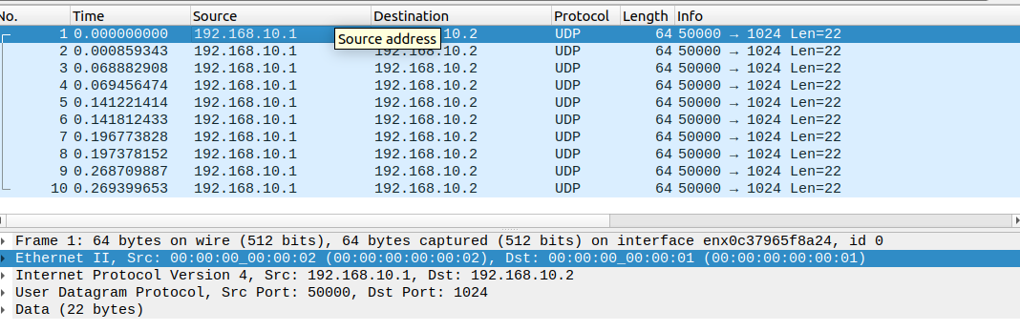
Screenshot from wireshark:
Here I sent 5 packets from the lab machine to the raspberry pi and 5 were sent back to the lab machine as the valid ethernet addresses meant all of the packets were returned to the source.

Table entry needed to drop traffic?

Adding 00:00:00:00:00:02 to be dropped to the table as this is the source mac address in send.py
This source mac address can also be seen in wireshark as this was the source address of the packets sent to the raspberry pi and the destination address of the packets the raspberry pi sent back.

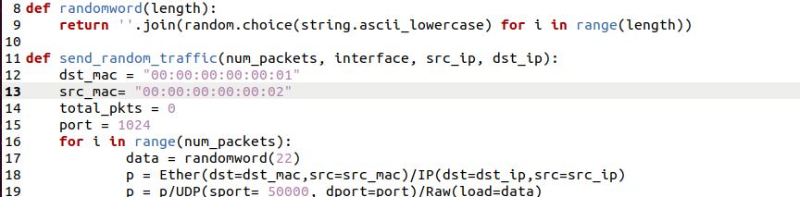

Code to drop packets from source mac address 00:00:00:00:00:02:
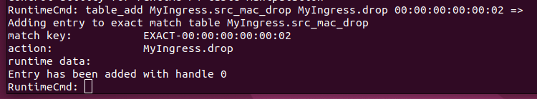

Result of dropping packets from this mac address:
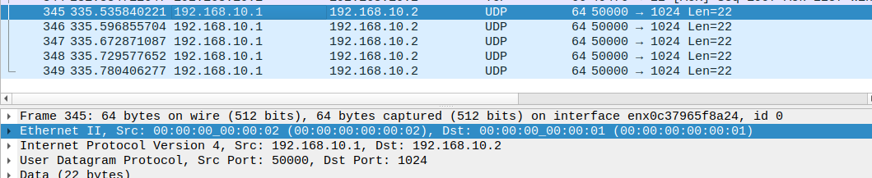

Five packets were received but none of them were sent back, as expected (the packets all had source mac address 00:00:00:00:00:02).

