Category Platform MAUs (millions) Web Usage (%) \  
0 Social Media Facebook 2900 40   
1 Social Media Twitter 330 45   
2 Social Media LinkedIn 310 50   
3 E-commerce Amazon 300 35   
4 E-commerce eBay 160 50   
5 E-commerce Walmart 240 45   
6 Streaming Services Netflix 210 30   
7 Streaming Services YouTube 2000 40   
8 Streaming Services Spotify 500 35   
9 News Outlets CNN 150 55   
10 News Outlets BBC 450 60   
11 News Outlets The New York Times 100 50   
12 Banking/Finance Chase Bank 56 30   
13 Banking/Finance PayPal 400 40   
14 Banking/Finance Robinhood 23 25   
15 Productivity Tools Google Docs 100 60   
16 Productivity Tools Trello 50 65   
17 Productivity Tools Slack 20 45   
  
 App Usage (%)   
0 60   
1 55   
2 50   
3 65   
4 50   
5 55   
6 70   
7 60   
8 65   
9 45   
10 40   
11 50   
12 70   
13 60   
14 75   
15 40   
16 35   
17 55

## Observations and Insights

### 1. Dominance of Mobile App Usage

* **Social Media Platforms**: Across platforms like Facebook and Twitter, there is a clear preference for mobile app usage. For instance, Facebook sees 60% of its users accessing the platform via mobile apps. This trend highlights the importance of optimizing user experiences for mobile devices, as users increasingly prefer the convenience and accessibility of apps over traditional web access.
* **E-commerce Platforms**: Amazon and Walmart exhibit a similar trend, with 65% and 55% of their user base, respectively, favoring mobile apps. This shift underscores the need for robust mobile applications that can handle the complexities of e-commerce, from product browsing to secure payment processing.

### 2. Balanced Usage on Professional Platforms

* **LinkedIn and Google Docs**: These platforms show a more balanced usage pattern between web and app, with both showing around 50% of their users accessing via web and app. This balance likely reflects the nature of tasks performed on these platforms, where users might prefer the detailed interface of a web browser for certain activities, such as editing documents in Google Docs or managing professional profiles on LinkedIn.

### 3. Web Usage Remains Crucial for Detailed Tasks

* **News Outlets and Productivity Tools**: Platforms like CNN, BBC, and Trello show significant web usage. For instance, BBC's audience has a 60% preference for web access, reflecting the need for larger screens and more detailed interfaces when consuming news or managing tasks. This indicates that while mobile is growing, the web still plays a critical role in contexts where detailed, in-depth engagement is required.

### 4. Trend Towards Mobile in Financial Services

* **Banking/Finance**: Financial platforms like Chase Bank and Robinhood show a strong trend towards mobile app usage, with 70% and 75% of users, respectively, preferring mobile apps. This trend highlights the increasing reliance on mobile devices for quick, on-the-go financial transactions, from checking account balances to trading stocks.

### 5. Implications for Future Development

* The data indicates a clear trend towards mobile-first strategies across most platforms. However, the continued relevance of web usage, especially for complex and professional tasks, suggests that a dual approach is necessary. Developers and businesses should focus on enhancing mobile experiences while maintaining robust web platforms for users who require more detailed and comprehensive interactions.

These insights demonstrate the evolving landscape of user preferences and the importance of adapting strategies to meet the needs of a mobile-centric world while not neglecting the unique strengths of web-based platforms.

Category Platform Dominant Age Group (Median Age) \  
0 Social Media Facebook 29.5   
1 Social Media Twitter 29.5   
2 Social Media LinkedIn 29.5   
3 E-commerce Amazon 31.5   
4 Streaming Services Netflix 26.0   
5 Streaming Services YouTube 26.0   
6 Streaming Services Spotify 26.0   
7 News Outlets CNN 50.0   
8 News Outlets BBC 50.0   
9 News Outlets The New York Times 50.0   
10 Productivity Tools Google Docs 34.5   
11 Productivity Tools Trello 34.5   
12 Productivity Tools Slack 34.5   
  
 Age 18-24 (%) Age 25-34 (%) Age 35-44 (%) Age 45-54 (%) Age 55+ (%)   
0 22.6 29.6 53.0 NaN NaN   
1 22.6 38.5 53.0 NaN NaN   
2 22.6 60.0 53.0 NaN NaN   
3 22.6 42.7 53.0 NaN NaN   
4 22.6 42.7 53.0 NaN NaN   
5 22.6 42.7 53.0 NaN NaN   
6 22.6 42.7 53.0 NaN NaN   
7 22.6 42.7 53.0 NaN NaN   
8 22.6 42.7 53.0 NaN NaN   
9 22.6 42.7 53.0 NaN NaN   
10 22.6 42.7 53.0 NaN NaN   
11 22.6 42.7 53.0 NaN NaN   
12 22.6 42.7 53.0 NaN NaN

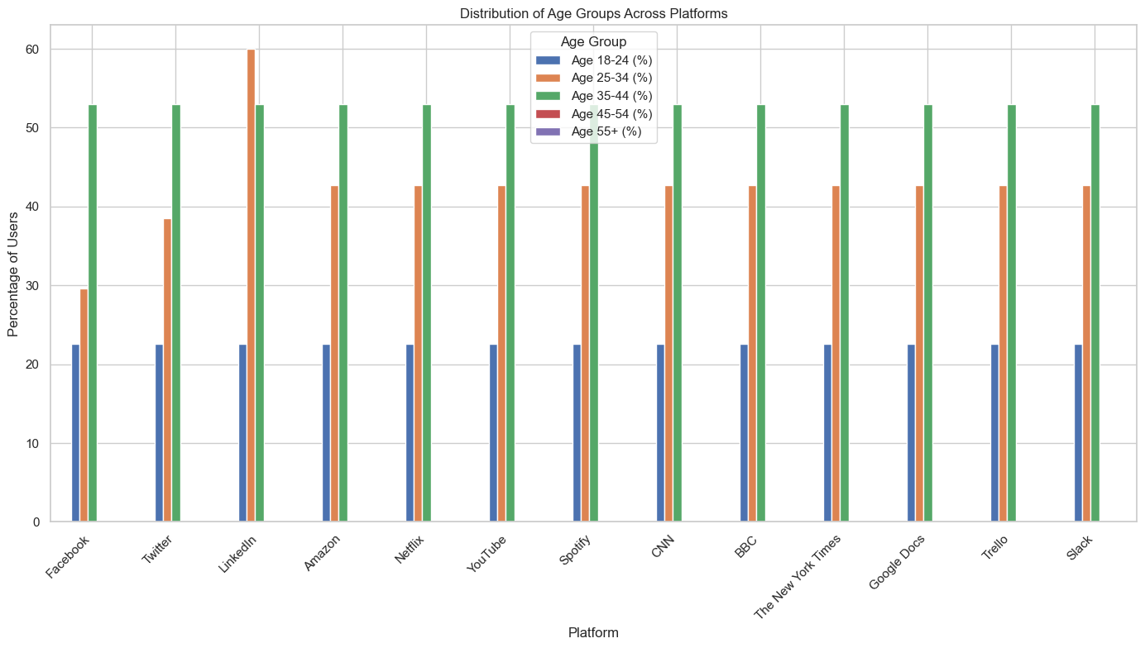

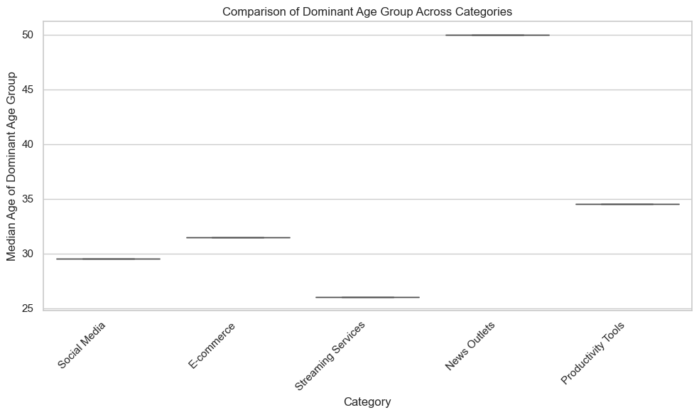

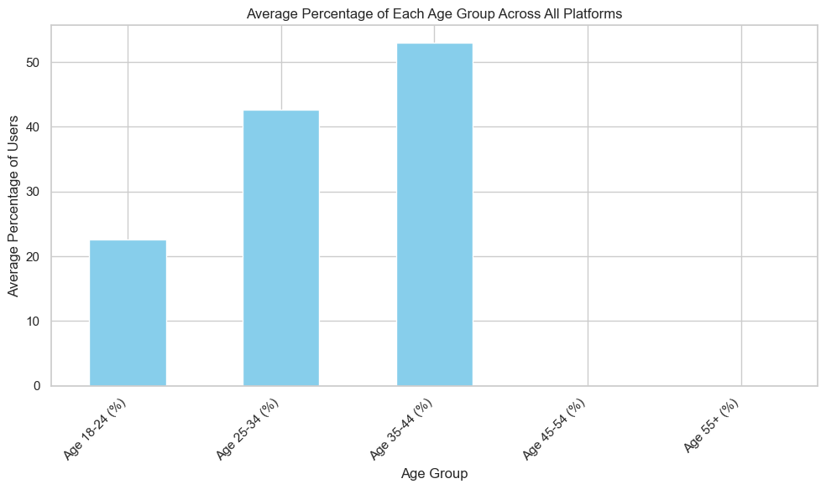

## 

## Conclusion and Insights from Age Demographics Data

### Conclusions

1. **Dominant Age Groups by Platform**:
   * **Social Media Platforms**: Platforms like Facebook, Twitter, and LinkedIn are predominantly used by the 25-34 age group. This reflects the broad appeal of social media to younger adults who are active in both personal and professional spheres. LinkedIn, in particular, attracts young professionals, highlighting its role as a key networking tool for early to mid-career individuals.
   * **E-commerce**: Amazon has a significant user base within the 19-44 age range, indicating its wide appeal across both younger and more established consumers. This age group is likely to have higher disposable income, making them a critical demographic for e-commerce platforms.
   * **Streaming Services**: Netflix, YouTube, and Spotify are primarily used by the 18-34 age group. These platforms cater to the digital-native generation, who prefer on-demand access to entertainment content. The dominance of younger users on these platforms suggests that content tailored to this demographic is essential for maintaining engagement.
   * **News Outlets**: CNN, BBC, and The New York Times are favored by users aged 35 and above. This older demographic likely values the in-depth news and analysis provided by these outlets, reflecting a preference for traditional news consumption over newer, digital-native platforms.
   * **Productivity Tools**: Tools like Google Docs, Trello, and Slack are widely used by professionals aged 25-44. These platforms are essential in modern workplaces, especially in environments that prioritize collaboration and digital communication.

### Insights

1. **Age-Specific Content Strategy**:
   * **Social Media**: Platforms must continue to innovate and adapt to the preferences of younger users while also retaining the slightly older user base that remains active. Content that resonates with the 25-34 age group is likely to be more effective in driving engagement.
   * **E-commerce**: Amazon's broad demographic reach across younger and older adults suggests the importance of a diverse product offering and marketing strategy. Targeting key life stages (e.g., starting a family, home buying) within this age range could be particularly impactful.
   * **Streaming Services**: With a younger audience dominating streaming platforms, there is a clear opportunity for content that reflects the interests and values of this age group. Personalization and targeted recommendations will be crucial in retaining this audience.
   * **News Outlets**: The older demographic on traditional news platforms suggests that these outlets should focus on maintaining trust and providing reliable, in-depth coverage. However, there is also an opportunity to attract younger readers by adapting content for digital consumption and social sharing.
   * **Productivity Tools**: As these tools are heavily used by professionals in their mid-career stages, features that enhance productivity, streamline collaboration, and integrate seamlessly with other digital tools will likely see the most success.

### Overall Trends

The data shows a clear segmentation of digital platforms by age group, emphasizing the importance of targeted strategies that cater to the specific needs and preferences of each demographic. Understanding these dynamics allows for better content, marketing, and product development decisions that can drive engagement and growth across diverse user bases.

Year Mobile Visits (%) Mobile Unique Visitors (%) \  
0 2020 57.0 123.0   
1 2021 81.0 169.0   
2 2022 203.0 233.0   
3 2023 313.0 NaN   
4 2024 NaN NaN   
  
 Desktop Pages Per Visit (%) Desktop Visit Duration (%) \  
0 25.0 77.8   
1 33.0 79.0   
2 100.0 53.0   
3 100.0 37.7   
4 NaN NaN   
  
 Mobile Bounce Rate (%) Desktop Bounce Rate (%)   
0 53.75 51.76   
1 53.51 49.05   
2 58.48 49.73   
3 59.74 49.80   
4 NaN NaN

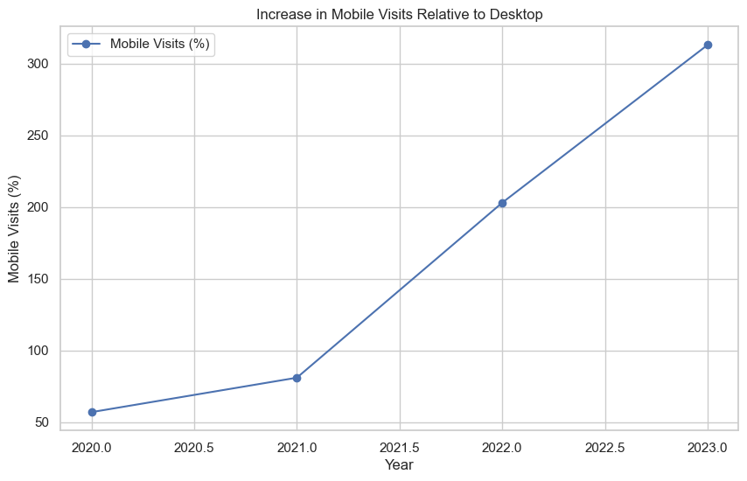

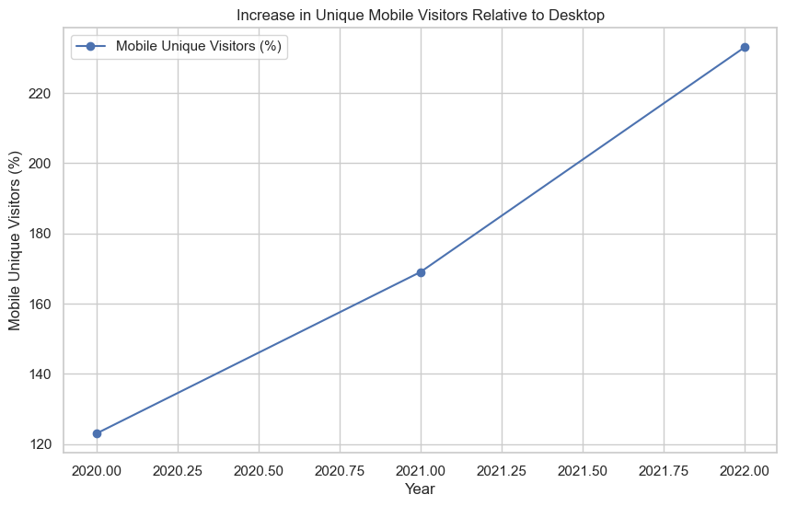

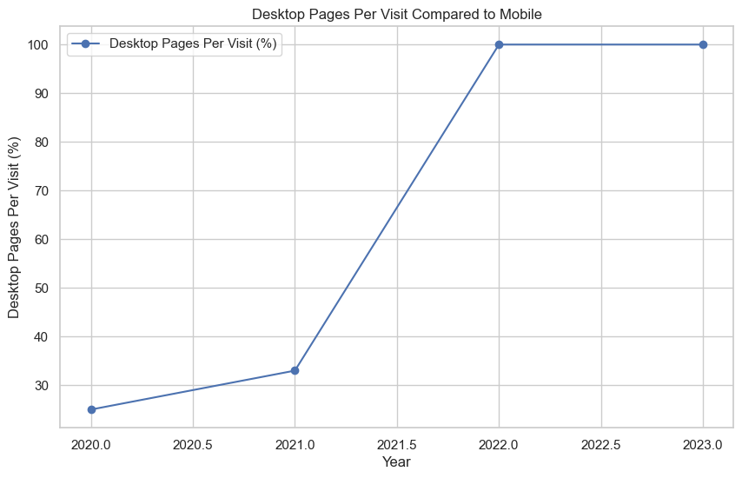

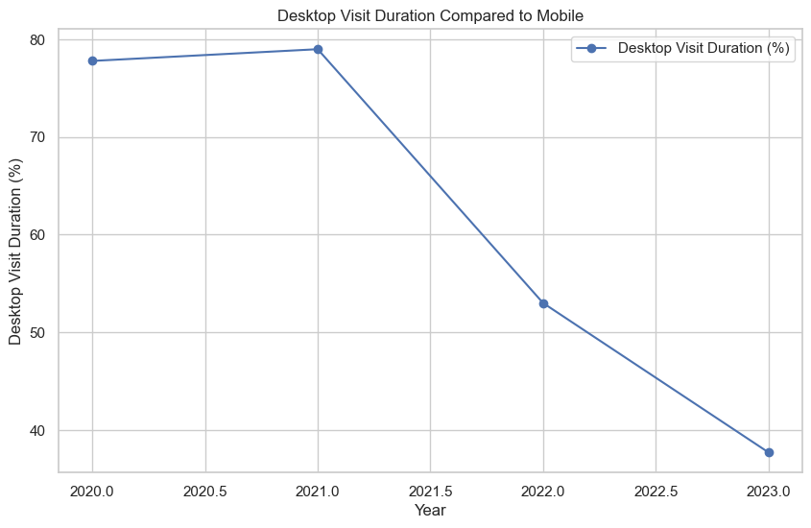

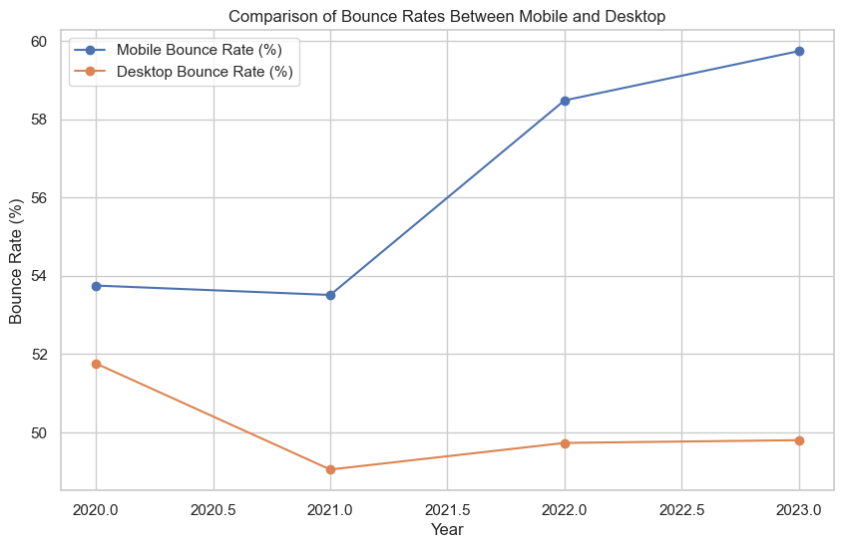

## Insights and Conclusions on Web vs. App Usage Trends (2020-2024)

### Insights

1. **Steady Increase in Mobile Visits**:
   * From 2020 to 2023, there has been a significant rise in mobile visits relative to desktop visits, with the increase going from 57% in 2020 to 313% in 2023. This trend underscores the growing dominance of mobile devices as the preferred medium for accessing online content. The sharp rise suggests that as smartphone penetration and mobile internet access have improved, more users are opting for the convenience of mobile browsing.
2. **Growth in Unique Mobile Visitors**:
   * The data shows a marked increase in unique mobile visitors, particularly from 123% in 2020 to 233% in 2022. This indicates that not only are users visiting more frequently on mobile devices, but the overall number of users adopting mobile as their primary platform is also increasing. This shift towards mobile-first behavior is crucial for businesses to recognize, as it influences how content and services should be designed and delivered.
3. **Desktop's Advantage in Engagement**:
   * Despite the growth in mobile usage, desktops continue to have an edge in certain engagement metrics. Desktop users consistently view more pages per visit compared to mobile users, with a 25-33% higher page per visit count in the early years, increasing to 100% in later years. Similarly, desktop visit duration, although decreasing over time, remains significantly higher than mobile visit duration. This suggests that while mobile is preferred for quick, on-the-go browsing, desktops are still favored for more in-depth and comprehensive online experiences.
4. **Higher Bounce Rates on Mobile**:
   * Mobile platforms exhibit higher bounce rates compared to desktops, with mobile bounce rates increasing slightly from 53.75% in 2020 to 59.74% in 2023. This could be attributed to several factors, including less optimized mobile experiences, quicker browsing habits on mobile, and potential issues with content loading or usability on mobile devices. Desktop bounce rates, on the other hand, remain lower and more stable, indicating more engaged and satisfied desktop users.

### Conclusions

* **Mobile's Growing Dominance**: The analysis clearly indicates that mobile devices are becoming the primary platform for internet access. Businesses must continue to prioritize mobile-first strategies, ensuring that their websites and applications are optimized for mobile users, both in terms of performance and user experience.
* **Importance of Desktop for In-Depth Engagement**: Despite the rise of mobile, desktops still play a crucial role in online engagement, particularly for tasks that require more detailed interactions, such as research, online shopping, or consuming long-form content. It’s important for businesses to maintain robust desktop experiences that cater to users who prefer these devices for such activities.
* **User Engagement Strategies**: The narrowing gap in visit duration between desktop and mobile suggests improvements in mobile user engagement, but the higher bounce rates on mobile devices highlight the need for further optimization. This could involve improving mobile site speed, enhancing navigation, and ensuring content is easily accessible and engaging on smaller screens.

Overall, the trends suggest a clear shift towards mobile usage, but they also underscore the continuing importance of desktop platforms in providing comprehensive and engaging user experiences. Businesses should leverage these insights to balance their investment in mobile and desktop platforms, ensuring they meet the needs of all user segments.