Collapse Pathways
A comparative historical collapse-pattern analysis and global fragility framework

Professional presentation dossier

Prepared for portfolio / presentation use
Adrian Moroianu
April 2026

Executive Summary
Collapse Pathways is an uncertainty-aware comparative research project that turns diverse historical interpretations into a structured dataset spanning 15 major cases of state, imperial, and regional breakdown. Rather than treating collapse as a single-cause event, the project identifies recurrent clusters of political, economic, social, environmental, military, and institutional stress. The final stage extends those historical findings into a present-day Global Fragility Index with scenario analysis.
- Dataset scope: 174 coded time-window rows covering 15 historical cases from the Western Roman Empire to Yugoslavia.
- Strongest historical signals: territorial loss, political fragmentation, legitimacy crisis, fiscal crisis, urban decline, and internal conflict.
- Uncertainty is explicit: difficult-to-compare variables are retained but marked as unknown (coded 9) rather than forced into false precision.
- Present-day extension: baseline Global Fragility Index of 73.35 / 100, with conservative and high-stress scenarios at 55.25 and 91.45.

1. Introduction
Historical collapse is often studied case by case, while public discussions of present-day instability often leap too quickly into prediction. This project is designed to sit between those extremes. It asks how collapse patterns can be studied comparatively, in a disciplined way, without pretending that ancient societies and the contemporary world are identical.
The project therefore uses a transparent coding framework and emphasizes three principles throughout: comparability, uncertainty handling, and interpretability. The result is not an “apocalypse model,” but a structured way to examine how breakdown pathways recur and how they might overlap with contemporary global conditions.

2. Research Question and Objectives
- Which factors recur most consistently across major historical collapses and severe systemic transformations?
- Which combinations of factors differentiate lower-collapse from higher-collapse rows?
- Which factors are strongly supported across the dataset, and which remain evidence-limited?
- How strongly do historically recurrent patterns overlap with selected present-day global stress conditions?

3. Project Design
The project follows a staged workflow from historical coding to present-day scenario analysis:
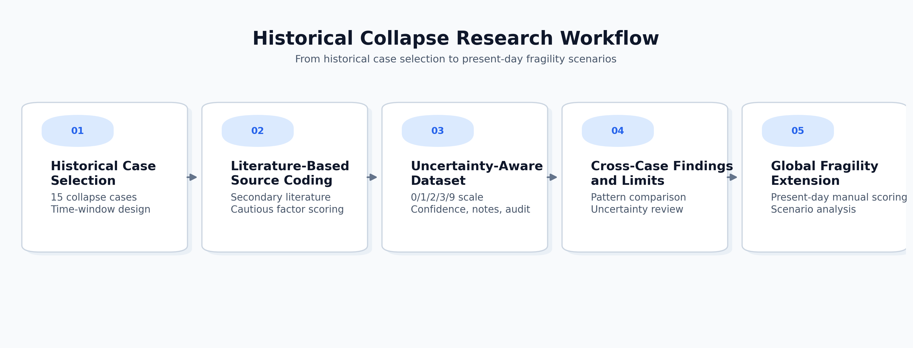
Figure 1. High-level workflow from historical case selection to present-day global fragility scoring.

Historical cases included
Western Roman Empire; Bronze Age Collapse States; Maya; Akkadian Empire; Khmer Empire; Han Dynasty Crisis; Byzantine Decline; Sassanian Empire; Easter Island; Classic Mesopotamian States; Ming/Qing Transition; Aztec Empire; Inca Empire; Soviet Union; Yugoslavia.

Factor framework
Category | Variables
Political | political_fragmentation, elite_conflict, succession_crisis, legitimacy_crisis, administrative_overload, corruption_governance_failure
Social | social_inequality, social_unrest_rebellion, demographic_pressure, migration_pressure, ethnic_sectarian_fragmentation, urban_decline
Economic | fiscal_crisis, taxation_extraction_pressure, trade_disruption, inflation_currency_instability, resource_dependency, agricultural_decline
Environmental | drought_climate_stress, flood_environmental_shock, temperature_anomaly, ecological_degradation, food_insecurity
Military / geopolitical | external_invasion_pressure, civil_war_internal_conflict, military_overstretch, territorial_loss
Institutional / resilience | institutional_rigidity, adaptive_capacity, logistics_food_storage_resilience, alliance_network_strength, recovery_capacity
Scoring scale: 0 = absent / no evidence, 1 = low, 2 = moderate, 3 = high, 9 = unknown / insufficient evidence / debated interpretation.

4. Data Construction and Uncertainty Handling
Each row in the dataset represents one case in one time window. The coding process translates literature-based expert interpretations into structured factor scores. Because not all cases support the same level of precision, uncertainty is treated as an explicit feature of the dataset rather than a nuisance to hide.
- Rows also track phase_label, collapse_outcome, collapse_within_next_window, data_confidence, source_count, and notes.
- Unknowns are coded as 9, preserving interpretive caution for debated or weakly evidenced variables.
- A sanity-review pass was used to catch timeline inconsistencies, repeated-note blocks, and undercoded or overconfident rows.
- The final dataset is intended for exploratory pattern analysis, not final historian-grade truth claims.

5. Main Historical Findings
Cross-case comparison shows that historical collapse is best understood as a multi-factor breakdown syndrome rather than a monocausal event.
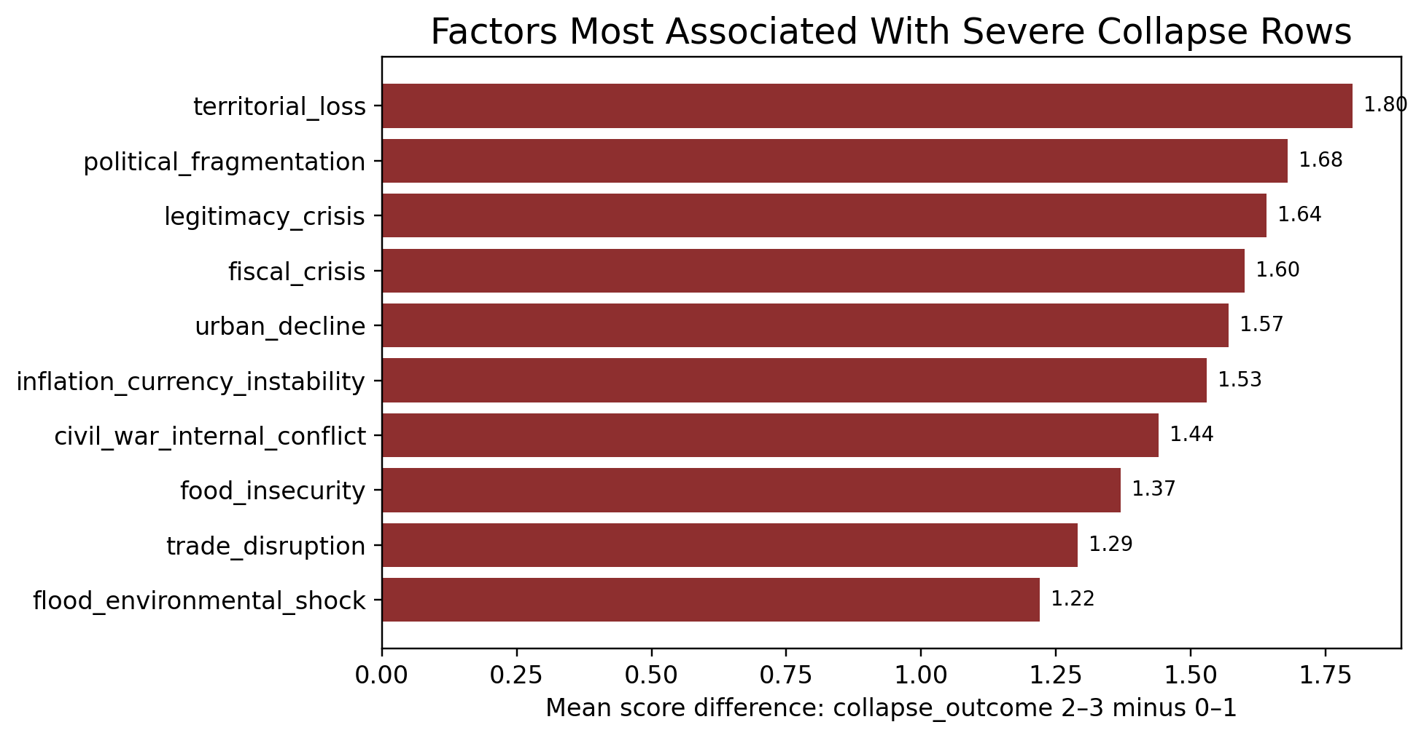
Figure 2. Factors that rise most sharply when moving from lower-collapse rows to severe-collapse rows.
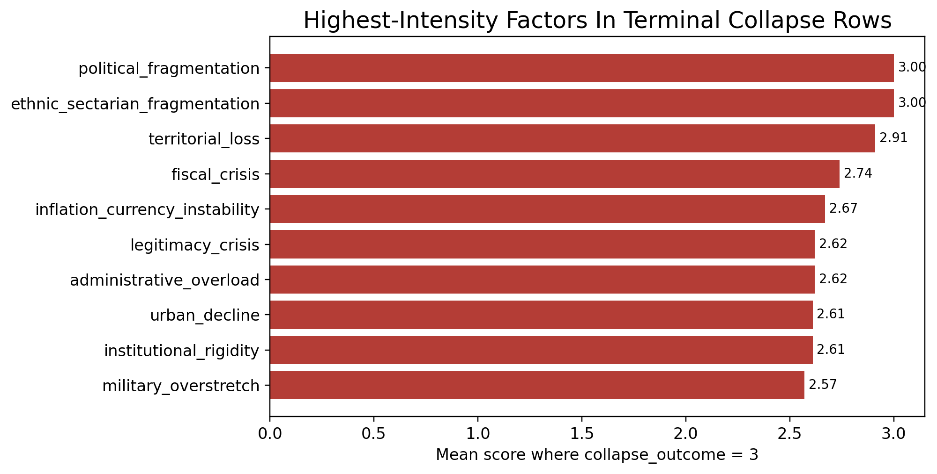
Figure 3. Highest-intensity factors within rows coded as terminal collapse or fragmentation.

Interpretation
- The strongest differentiators between lower-collapse and higher-collapse rows are territorial loss, political fragmentation, legitimacy crisis, fiscal crisis, urban decline, and civil/internal conflict.
- Terminal-collapse rows are especially intense on fragmentation, territorial erosion, fiscal stress, legitimacy strain, administrative overload, and institutional rigidity.
- The pattern supports a clustered explanation of collapse: political, territorial, and fiscal breakdowns tend to reinforce one another.

6. Evidence Limits and Interpretive Caution
Not all variables are equally comparable across cases. Some are important in particular contexts but remain difficult to code consistently across all 15 cases.
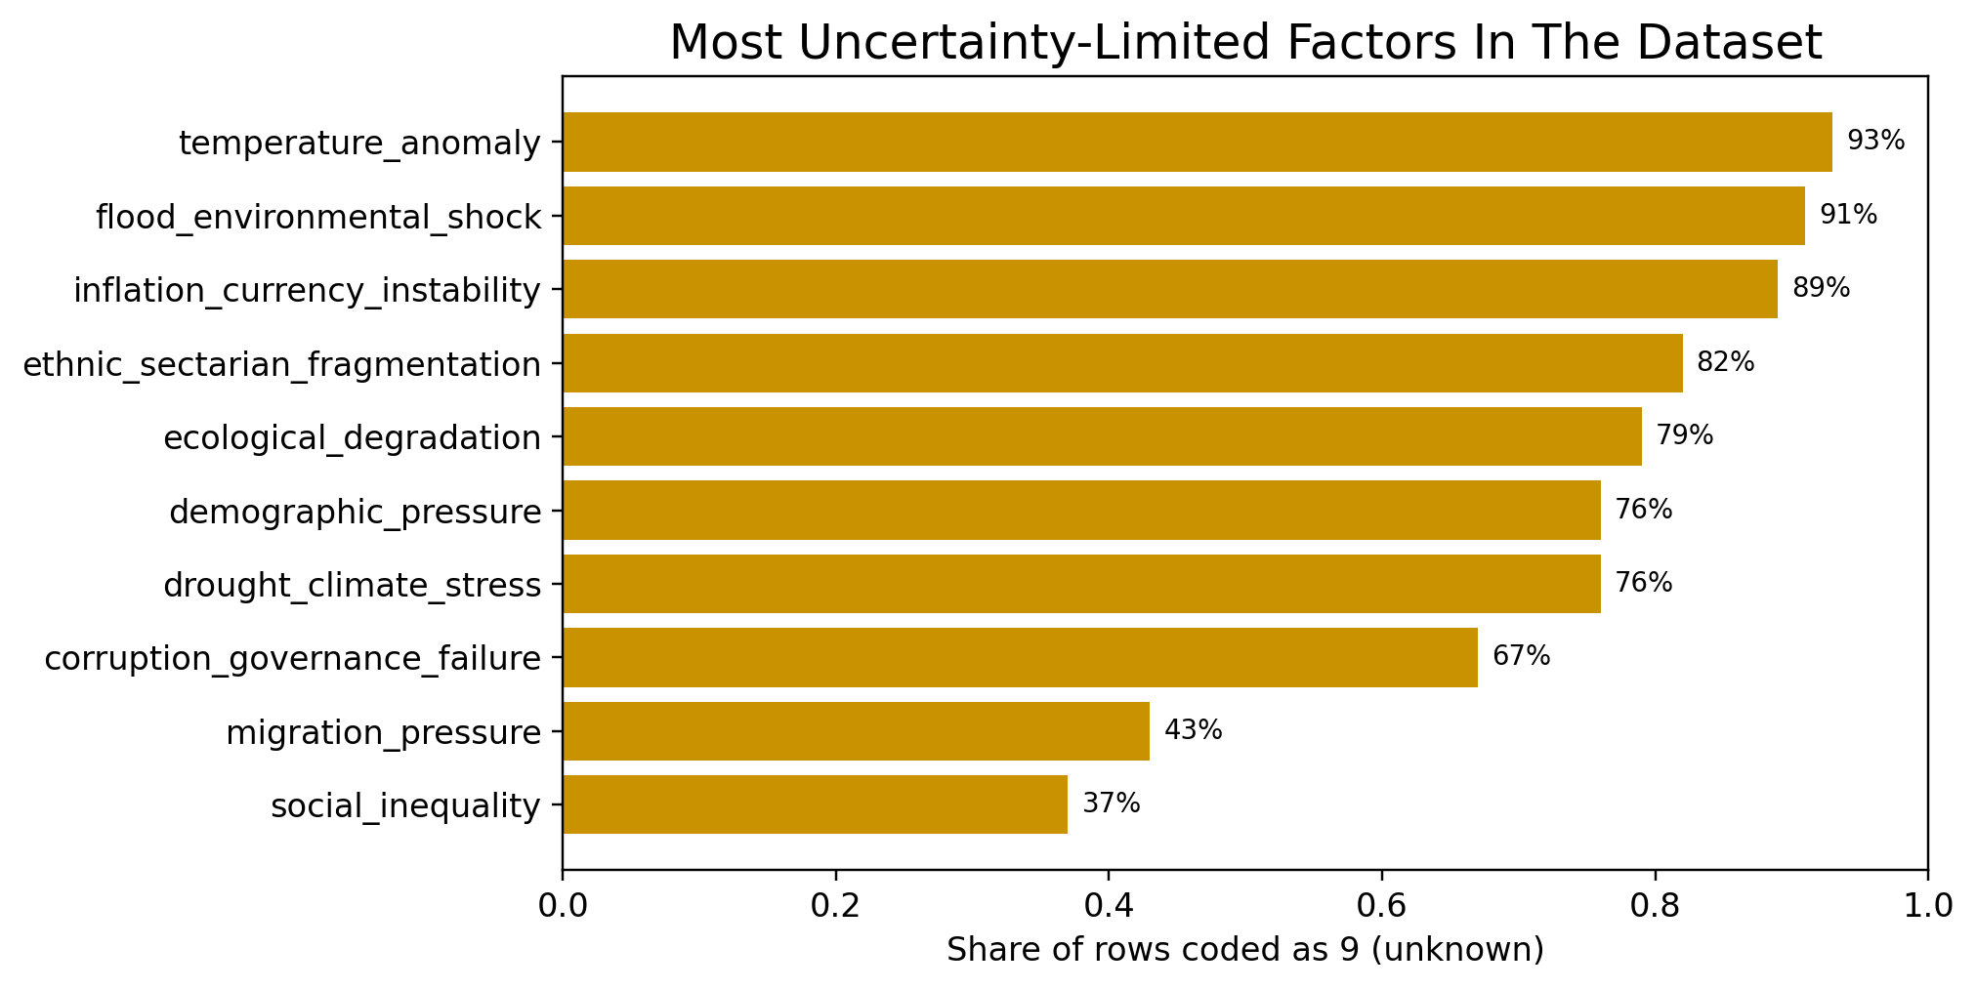
Figure 4. Variables most limited by uncertainty, shown as the share of rows coded 9 = unknown.
- Environmental and demographic variables matter in important cases, but they remain among the most uncertainty-limited parts of the dataset.
- Cases such as Bronze Age Collapse States, Easter Island, Maya, Classic Mesopotamian States, and Inca Empire remain more heterogeneous than modern state-collapse cases.
- The strongest claims should therefore rely most heavily on factors that remain visible despite uncertainty.

7. Present-Day Global Extension
The project includes a manual present-day extension that converts historical findings into a Global Historical Pattern Overlap / Fragility Index. This extension does not predict collapse. Instead, it measures how strongly current global conditions overlap with the types of stress patterns that recur in the historical dataset.

Global scoring framework
- Core present-day factors include legitimacy crisis, geopolitical instability, adaptive capacity/resilience, political fragmentation / polarization, trade disruption, conflict pressure, fiscal stress, urban social stress, institutional rigidity, food insecurity, resource dependency, and environmental stress.
- Historical weights are held fixed; present-day scores are entered manually and interpreted through conservative, baseline, and high-stress scenarios.
- Resilience factors offset, rather than intensify, the net fragility score.
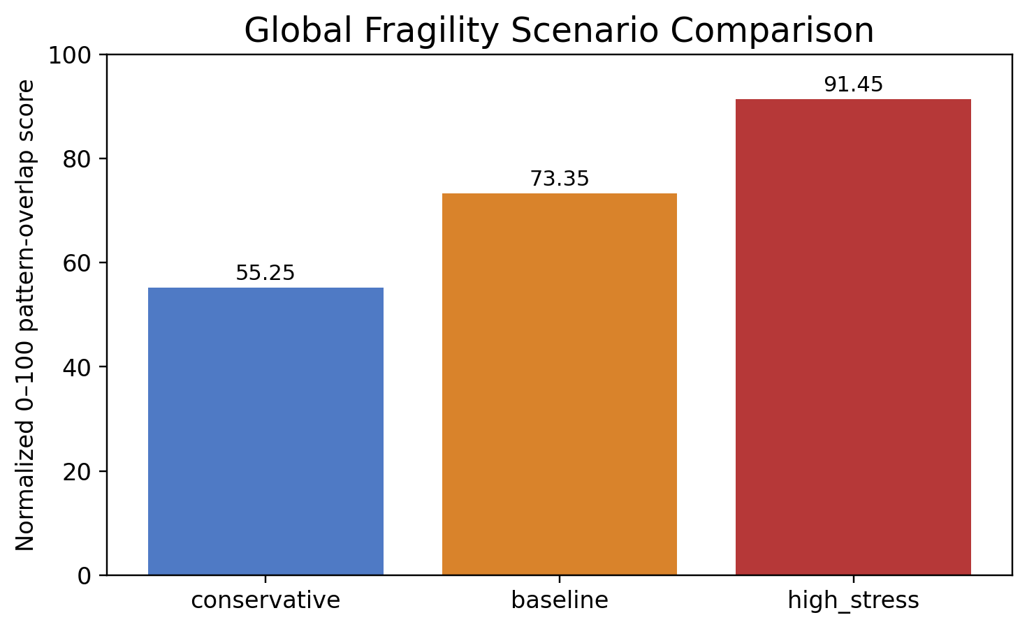
Figure 5. Scenario comparison for the present-day global fragility extension using fixed historical weights and varying current-world scoring assumptions.
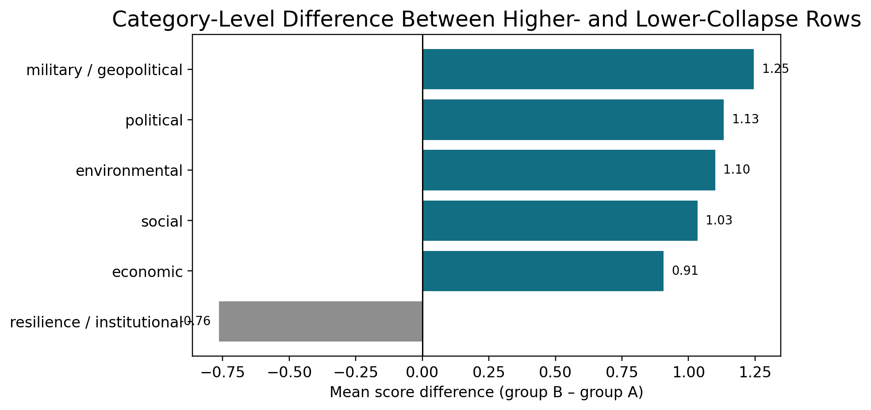
Figure 6. Category-level difference between higher- and lower-collapse rows; positive values rise with more severe collapse, while resilience/institutional factors offset fragility in the global extension.

8. Scenario Results
Scenario | Score | Interpretation
Conservative | 55.25 | Moderate fragility
Baseline | 73.35 | High fragility
High-stress | 91.45 | Severe systemic stress
The scenario spread demonstrates that the framework is best used for structured scenario analysis rather than a single precise “true” number. The baseline score places the current world in a high-fragility overlap range, while the conservative and high-stress cases show how sensitive the output remains to present-day scoring assumptions.

9. What the Project Can and Cannot Support

What it can support
- A transparent comparative account of which historical stress patterns recur across major breakdowns.
- A cautious, uncertainty-aware summary of which variables are most robust versus evidence-limited.
- A scenario-based present-day overlap framework that helps structure discussion of global fragility.

What it cannot support
- A literal prediction of collapse or a timetable for future breakdown.
- A claim that ancient and modern societies are directly interchangeable.
- A final authoritative historical truth table for every case and variable.

10. Bibliography
Selected historical sources used to construct the coding framework and case notes. Full source inventory is available in the repository.

General / project framing
- Britannica. (n.d.). The collapse of the Soviet Union. https://www.britannica.com/event/the-collapse-of-the-Soviet-Union/The-end-of-Soviet-communism
- Freedom House. (2025). Global freedom declined for the 20th consecutive year.
- International Monetary Fund. (2026). World Economic Outlook, January 2026.
- WMO. (2025). State of the Global Climate 2025.
- UNHCR. (2025). Global Trends / displacement reporting.
- UN-Water. (2024). Progress on water stress.

Soviet Union
- Beissinger, M. R. Nationalism and the Collapse of Soviet Communism.
- Solnick, S. Stealing the State: Control and Collapse in Soviet Institutions.
- Friedgut, T., & Siegelbaum, L. Perestroika from Below: The Soviet Miners’ Strike and Its Aftermath.
- Britannica. The Gorbachev Era: Perestroika and Glasnost.
- Britannica. The Soviet Economic Decline.

Western Roman Empire
- Halsall, G. Breakdown and barbarians.
- Heather, P. The western empire, 425–76.
- Sarris, P. Urban and Rural Economies in the Age of Attila.
- McCormick, M., et al. Climate Change During and After the Roman Empire.
- Britannica. The barbarian invasions.

Bronze Age Collapse States
- Knapp, A. B., & Manning, S. W. Crisis in Context: The End of the Late Bronze Age in the Eastern Mediterranean.
- Kemp, L., & Cline, E. Systemic Risk and Resilience: The Bronze Age Collapse and Recovery.
- Middleton, G. D. Getting closer to the Late Bronze Age collapse in the Aegean and Eastern Mediterranean, c. 1200 BC.
- Drake, B. L. The influence of climatic change on the Late Bronze Age Collapse and the Greek Dark Ages.
- Manning, S. W., et al. Severe multi-year drought coincident with Hittite collapse around 1198–1196 BC.

Maya
- Kennett, D. J., et al. (2012). Development and disintegration of Maya political systems in response to climate change.
- Douglas, P. M. J., et al. (2015). Drought, agricultural adaptation, and sociopolitical collapse in the Maya Lowlands.
- Kennett, D., & Hodell, D. (2017). Climate and the Classic Maya collapse.
- Webster, D. The Classic Maya Collapse.
- Mixter, D. (2020). Community Resilience and Urban Planning During the Ninth-Century Maya Collapse.

Akkadian Empire
- Cullen, H. M., et al. (2000). Climate change and the collapse of the Akkadian empire.
- Carolin, S. A., et al. (2019). Precise timing of abrupt increase in dust activity.
- Cookson, E., Hill, D. J., & Lawrence, D. (2019). Impacts of long term climate change during the collapse of the Akkadian Empire.
- Lawrence, D., Palmisano, A., & de Gruchy, S. (2021). Collapse and continuity in the core of the Northern Fertile Crescent.

Khmer Empire
- Buckley, B. M., et al. (2010). Climate as a contributing factor in the demise of Angkor, Cambodia.
- Penny, D., et al. (2018). The demise of Angkor: Systemic vulnerability of urban infrastructure to climatic variations.
- Carter, A., et al. (2019). Temple occupation and the tempo of collapse at Angkor Wat.

Han Dynasty Crisis
- Mansvelt Beck, B. J. The Fall of Han.
- de Crespigny, R. Emperor Huan and Emperor Ling.
- Britannica. Yellow Turbans.

Byzantine Decline
- Haldon, J. Coincidence and Complexity.
- Britannica. Byzantine decline and subjection to Western influences: 1025–1260.
- Britannica. Fall of Constantinople.

Sassanian Empire
- Daryaee, T. Wahram Chobin, the rebel general, and the militarization of the Sasanian Empire.
- Iranica Online. Arab conquest of Iran.
- The Climatic Resilience of the Sasanian Empire.

Easter Island / Rapa Nui
- DiNapoli, R. J., et al. (2021). Population estimates challenge the precontact collapse narrative for Rapa Nui.
- Moreno-Mayar, V., et al. (2024). Ancient genomes and the timing of demographic change on Rapa Nui.
- Rull, V. (2020). Review of Rapa Nui collapse debates.

Classic Mesopotamian States
- Britannica. Ur III in decline.
- Altaweel, M., & Watanabe, C. Salinization resilience in Mesopotamia.
- Cookson, E., et al. Long-term climate change and late third-millennium Mesopotamia.

Ming / Qing Transition
- Climate and population pressure in the late-Ming crisis. (2012).
- Chongzhen drought, famine, and governance failure study. (2024).
- The early Qing dynasty. Britannica.

Aztec Empire
- Britannica. Decline of the Aztec Empire.
- Britannica. Battle of Tenochtitlan.
- Hassig, R. Mexico and the Spanish Conquest.

Inca Empire
- Britannica. Inca.
- Britannica. Atahuallpa.
- Britannica. Conquest of Peru.

11. Closing Note
Collapse Pathways demonstrates a practical way to turn qualitative historical interpretation into a disciplined analytical workflow. Its main contribution is not prediction, but structured comparison: it shows which stress clusters recur historically, where uncertainty remains high, and how those patterns can be translated into a present-day fragility framework without overstating certainty.

