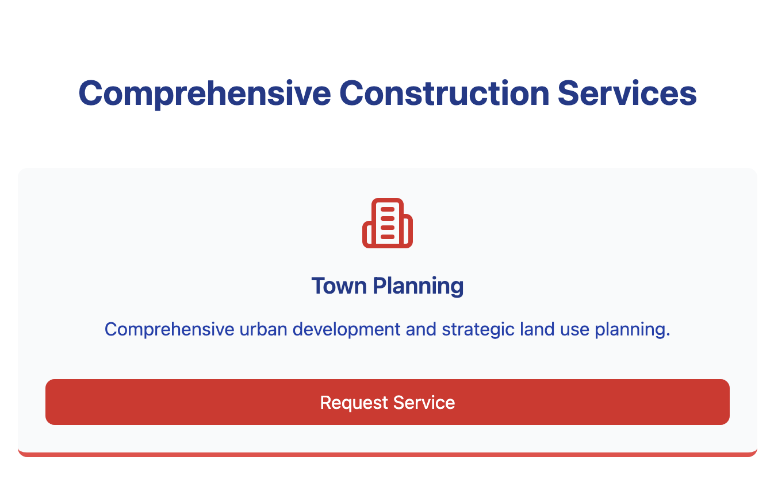



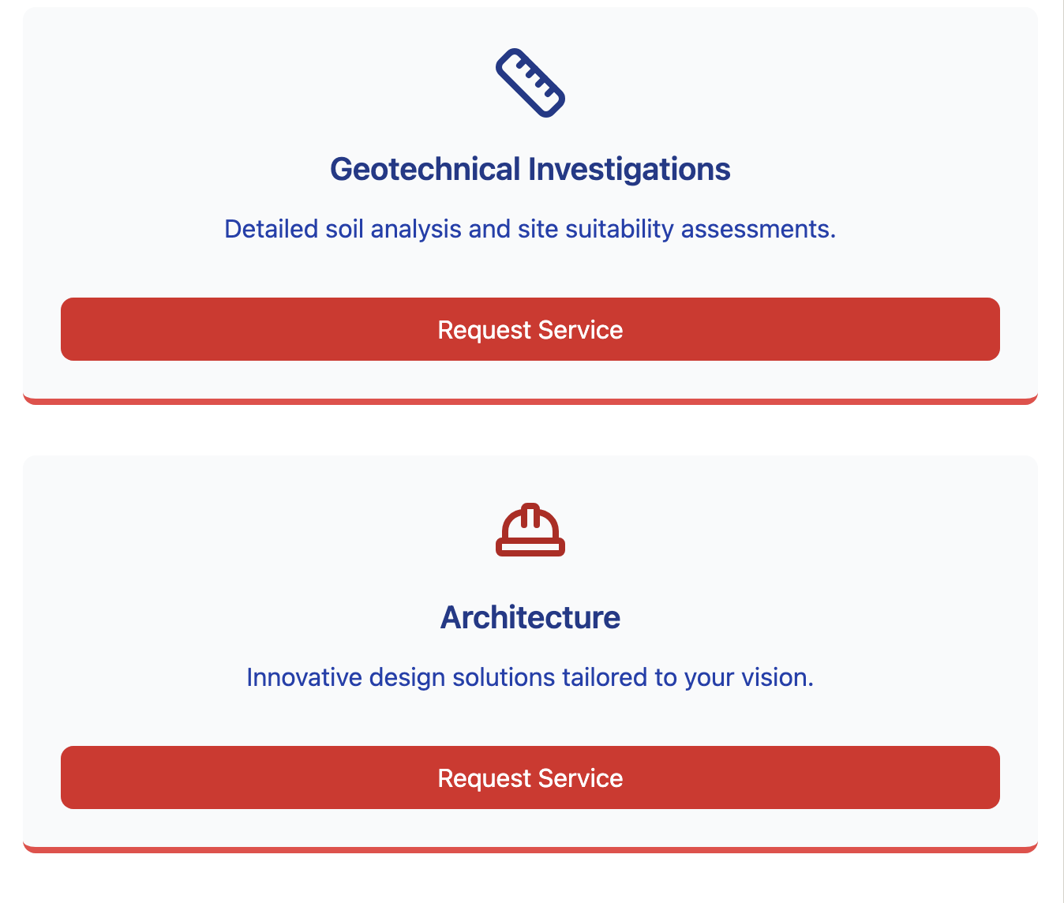

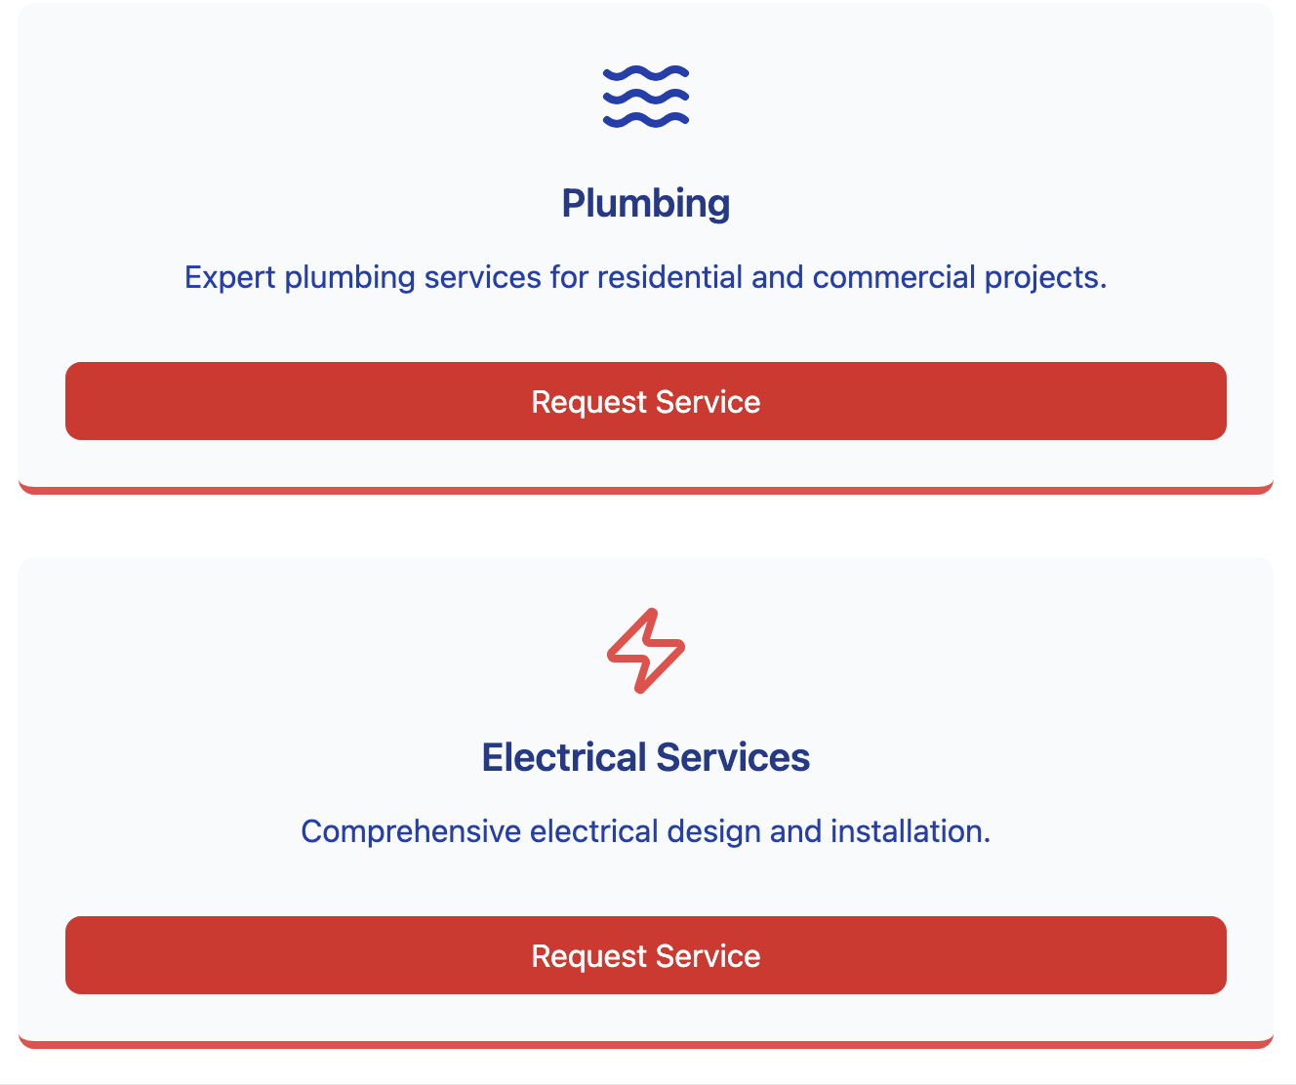

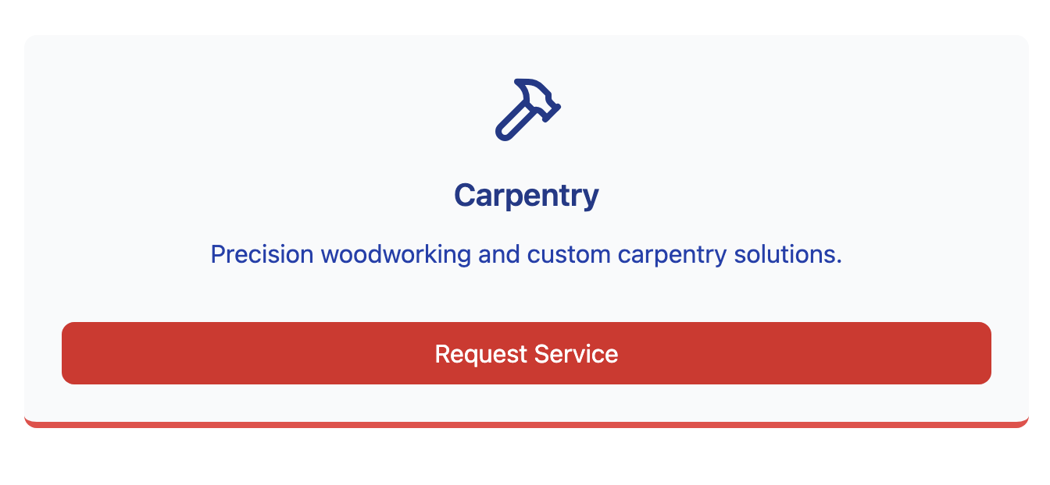

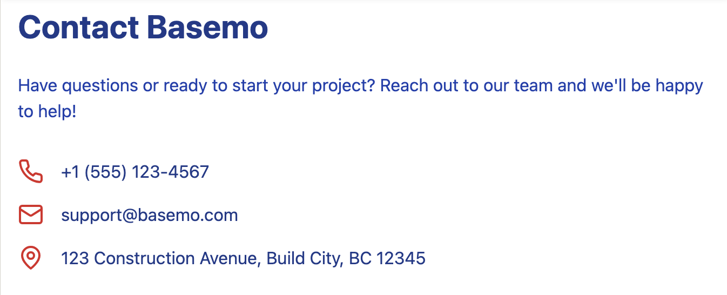

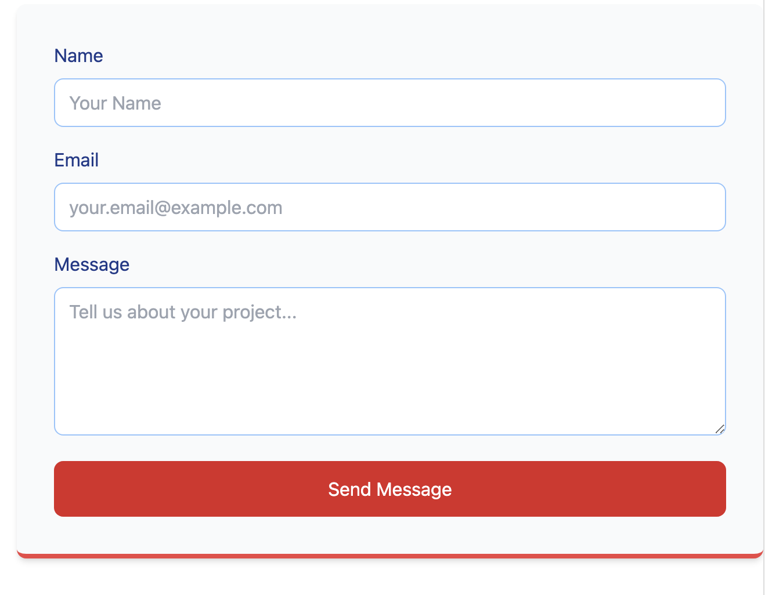



import React, { useState } from 'react';

import { Menu, Building2, HardHat, Hammer, Waves, Zap, Ruler, Mail, Phone, MapPin } from 'lucide-react';

const BasemoLandingPage = () => {

const [mobileMenuOpen, setMobileMenuOpen] = useState(false);

const services = [

{

icon: <Building2 className="w-12 h-12 text-red-600" />,

title: "Town Planning",

description: "Comprehensive urban development and strategic land use planning."

},

{

icon: <Ruler className="w-12 h-12 text-blue-900" />,

title: "Geotechnical Investigations",

description: "Detailed soil analysis and site suitability assessments."

},

{

icon: <HardHat className="w-12 h-12 text-red-700" />,

title: "Architecture",

description: "Innovative design solutions tailored to your vision."

},

{

icon: <Waves className="w-12 h-12 text-blue-800" />,

title: "Plumbing",

description: "Expert plumbing services for residential and commercial projects."

},

{

icon: <Zap className="w-12 h-12 text-red-500" />,

title: "Electrical Services",

description: "Comprehensive electrical design and installation."

},

{

icon: <Hammer className="w-12 h-12 text-blue-900" />,

title: "Carpentry",

description: "Precision woodworking and custom carpentry solutions."

}

];

return (

<div className="min-h-screen bg-gray-50">

{/\* [Previous navigation and other sections remain the same] \*/}

{/\* Services Section \*/}

<section id="services" className="py-16 bg-white">

<div className="max-w-7xl mx-auto px-4 sm:px-6 lg:px-8">

<h2 className="text-3xl font-bold text-center mb-12 text-blue-900">

Comprehensive Construction Services

</h2>

<div className="grid md:grid-cols-3 gap-8">

{services.map((service, index) => (

<div

key={index}

className="bg-gray-50 p-6 rounded-lg text-center hover:shadow-lg transition border-b-4 border-red-500 hover:border-blue-900 flex flex-col"

>

<div className="flex justify-center mb-4">

{service.icon}

</div>

<h3 className="text-xl font-semibold mb-3 text-blue-900">{service.title}</h3>

<p className="text-blue-800 mb-4 flex-grow">{service.description}</p>

<button

className="w-full bg-red-600 text-white py-2 rounded-lg hover:bg-blue-900 transition mt-4"

onClick={() => {

// You can add functionality here, such as opening a modal or scrolling to contact form

document.getElementById('contact').scrollIntoView({ behavior: 'smooth' });

}}

>

Request Service

</button>

</div>

))}

</div>

</div>

</section>

{/\* [Rest of the component remains the same] \*/}

</div>

);

};

export default BasemoLandingPage;