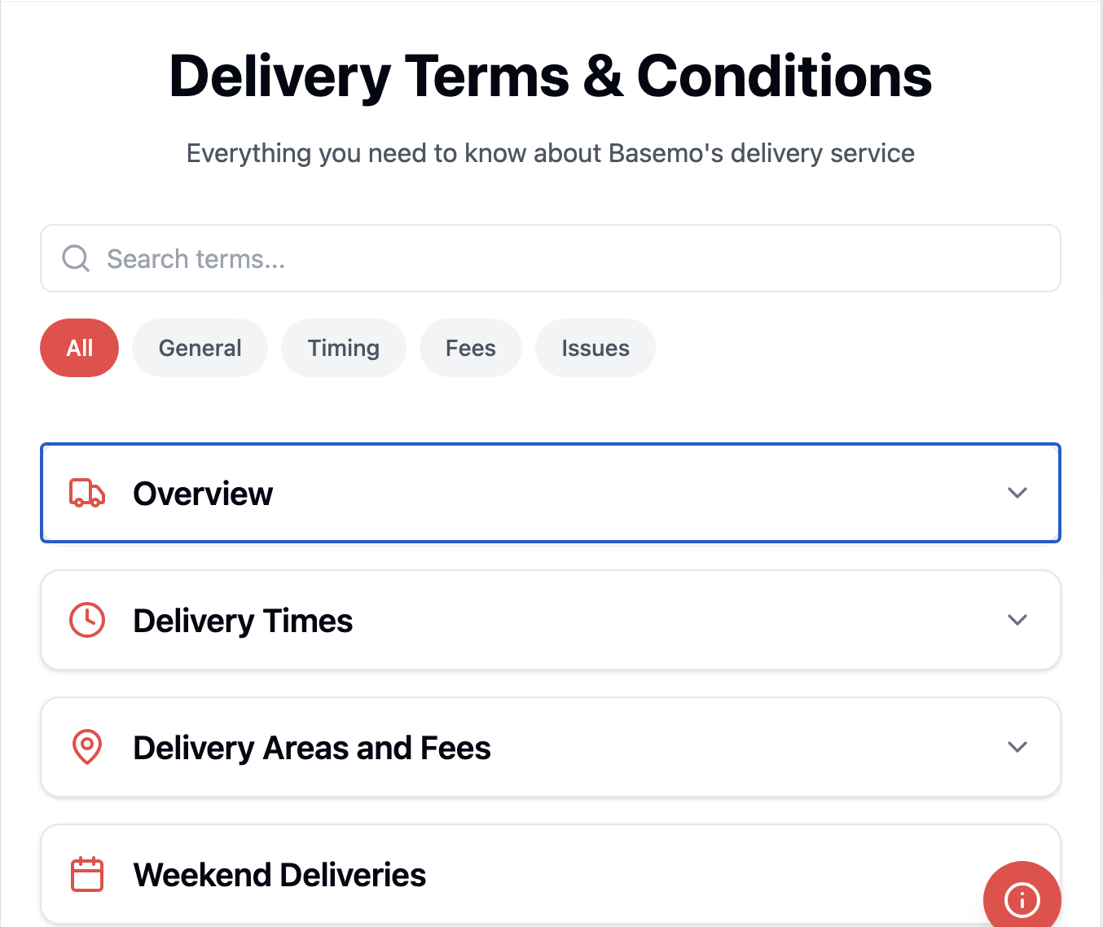

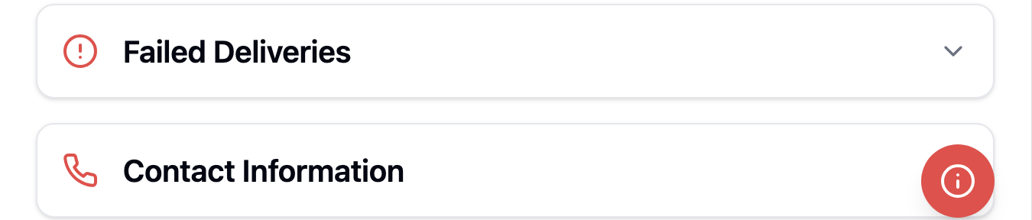

import React, { useState } from 'react';

import { ChevronDown, ChevronUp, Truck, Calendar, MapPin, Clock, AlertCircle, Phone, Search, Info } from 'lucide-react';

import { Card, CardContent } from '@/components/ui/card';

import { Alert, AlertDescription } from '@/components/ui/alert';

const DeliveryTerms = () => {

const [expandedSection, setExpandedSection] = useState('overview');

const [searchTerm, setSearchTerm] = useState('');

const [showTip, setShowTip] = useState(false);

const [activeTab, setActiveTab] = useState('all');

const sections = {

overview: {

icon: <Truck className="w-6 h-6" />,

title: "Overview",

category: "general",

content: (

<div className="space-y-4">

<p>Basemo is committed to providing reliable delivery services for all construction and building materials purchased through our marketplace. This document outlines our delivery terms and conditions to ensure clear communication and expectations for all customers.</p>

<Alert className="bg-red-50 border-red-200">

<Info className="w-4 h-4 text-red-500" />

<AlertDescription>

<strong>Delivery Area Limitation:</strong> We currently only deliver within a 41-kilometer radius of Pretoria.

</AlertDescription>

</Alert>

</div>

)

},

deliveryTimes: {

icon: <Clock className="w-6 h-6" />,

title: "Delivery Times",

category: "timing",

content: (

<div className="space-y-4">

<div>

<h4 className="font-semibold mb-2">Standard Delivery</h4>

<ul className="list-disc pl-5 space-y-2">

<li>Standard delivery is available Monday through Friday, excluding public holidays</li>

<li>Orders are typically delivered within 2-3 working days</li>

<li>Working days are considered Monday through Friday only</li>

<li>Weekend days (Saturday and Sunday) are not counted as working days</li>

</ul>

</div>

<div>

<h4 className="font-semibold mb-2">Same-Day Delivery</h4>

<ul className="list-disc pl-5 space-y-2">

<li>Available for selected items only</li>

<li>Orders must be placed before 10:00 AM on working days</li>

<li>Not available for weekend orders or public holidays</li>

<li>Not available for items marked as "Standard Delivery Only"</li>

</ul>

</div>

</div>

)

},

deliveryAreas: {

icon: <MapPin className="w-6 h-6" />,

title: "Delivery Areas and Fees",

category: "fees",

content: (

<div className="space-y-4">

<div className="bg-red-50 p-4 rounded-lg border border-red-200 mb-4">

<h4 className="font-semibold text-red-700 mb-2">Service Area</h4>

<p>Our delivery service is currently available within a 41-kilometer radius of Pretoria. Please check your delivery address at checkout to confirm if it falls within our service area.</p>

</div>

<p>Delivery fees are calculated based on:</p>

<ul className="list-disc pl-5 space-y-2">

<li>Distance from Pretoria (up to 41 kilometers)</li>

<li>Order weight and volume</li>

<li>Type of materials</li>

<li>Delivery timing selected</li>

</ul>

<p>Additional fees may apply for:</p>

<ul className="list-disc pl-5 space-y-2">

<li>Areas with difficult access</li>

<li>Special handling requirements</li>

<li>Specific time slot requests</li>

</ul>

</div>

)

},

weekendDeliveries: {

icon: <Calendar className="w-6 h-6" />,

title: "Weekend Deliveries",

category: "timing",

content: (

<div className="space-y-4">

<ul className="list-disc pl-5 space-y-2">

<li>Some deliveries may be executed during weekends as special arrangements</li>

<li>Weekend deliveries must be specifically requested and confirmed</li>

<li>Additional charges may apply for weekend deliveries</li>

<li>Availability depends on product type, location, and resource availability</li>

</ul>

</div>

)

},

failedDeliveries: {

icon: <AlertCircle className="w-6 h-6" />,

title: "Failed Deliveries",

category: "issues",

content: (

<div className="space-y-4">

<p>A failed delivery may occur if:</p>

<ul className="list-disc pl-5 space-y-2">

<li>No one is available to receive the order</li>

<li>Site access is restricted or impossible</li>

<li>Delivery address is incorrect</li>

<li>Delivery address is outside our 41-kilometer service radius</li>

</ul>

<p>Additional charges will apply for redelivery attempts. Storage fees may apply for items awaiting redelivery.</p>

</div>

)

},

contact: {

icon: <Phone className="w-6 h-6" />,

title: "Contact Information",

category: "general",

content: (

<div className="space-y-4">

<p>For any delivery-related queries or concerns:</p>

<ul className="list-none space-y-2">

<li>📧 Email: delivery@basemo.com</li>

<li>📱 Phone: (XXX) XXX-XXXX</li>

<li>🕒 Operating Hours: Monday to Friday, 8:00 AM - 6:00 PM</li>

</ul>

</div>

)

}

};

const filteredSections = Object.entries(sections).filter(([key, section]) => {

const matchesSearch = section.title.toLowerCase().includes(searchTerm.toLowerCase());

const matchesTab = activeTab === 'all' || section.category === activeTab;

return matchesSearch && matchesTab;

});

return (

<div className="max-w-4xl mx-auto p-6">

<div className="text-center mb-8">

<h1 className="text-4xl font-bold mb-4">Delivery Terms & Conditions</h1>

<p className="text-gray-600">Everything you need to know about Basemo's delivery service</p>

</div>

{/\* Interactive Features \*/}

<div className="mb-8 space-y-4">

{/\* Search Bar \*/}

<div className="relative">

<Search className="absolute left-3 top-1/2 transform -translate-y-1/2 text-gray-400 w-5 h-5" />

<input

type="text"

placeholder="Search terms..."

className="w-full pl-10 pr-4 py-2 border rounded-lg focus:outline-none focus:ring-2 focus:ring-red-500"

value={searchTerm}

onChange={(e) => setSearchTerm(e.target.value)}

/>

</div>

{/\* Category Tabs \*/}

<div className="flex gap-2 overflow-x-auto pb-2">

{['all', 'general', 'timing', 'fees', 'issues'].map((tab) => (

<button

key={tab}

className={`px-4 py-2 rounded-full text-sm font-medium transition-colors ${

activeTab === tab

? 'bg-red-500 text-white'

: 'bg-gray-100 text-gray-600 hover:bg-gray-200'

}`}

onClick={() => setActiveTab(tab)}

>

{tab.charAt(0).toUpperCase() + tab.slice(1)}

</button>

))}

</div>

{/\* Quick Tip \*/}

{showTip && (

<Alert className="bg-red-50 border-red-200">

<Info className="w-4 h-4 text-red-500" />

<AlertDescription>

Pro tip: Click on any section to expand it. You can also use the search bar to find specific information quickly.

</AlertDescription>

</Alert>

)}

</div>

{/\* Main Content \*/}

<div className="space-y-4">

{filteredSections.map(([key, section]) => (

<Card

key={key}

className={`border border-gray-200 transition-all ${

expandedSection === key ? 'shadow-md' : 'hover:shadow-sm'

}`}

>

<button

className="w-full p-4 flex items-center justify-between hover:bg-gray-50 transition-colors"

onClick={() => setExpandedSection(expandedSection === key ? null : key)}

>

<div className="flex items-center gap-4">

<div className="text-red-500">

{section.icon}

</div>

<h2 className="text-xl font-semibold">{section.title}</h2>

</div>

{expandedSection === key ?

<ChevronUp className="w-5 h-5 text-gray-500" /> :

<ChevronDown className="w-5 h-5 text-gray-500" />

}

</button>

{expandedSection === key && (

<CardContent className="pt-4 pb-6 px-4">

<div className="prose max-w-none">

{section.content}

</div>

</CardContent>

)}

</Card>

))}

{filteredSections.length === 0 && (

<div className="text-center py-8 text-gray-500">

No results found for your search. Try different keywords or clear the search.

</div>

)}

</div>

{/\* Help Button \*/}

<button

className="fixed bottom-6 right-6 bg-red-500 text-white p-3 rounded-full shadow-lg hover:bg-red-600 transition-colors"

onClick={() => setShowTip(!showTip)}

>

<Info className="w-6 h-6" />

</button>

</div>

);

};

export default DeliveryTerms;

