## Subscription Process

The following diagram depicts the master file subscription process. When a consumer's subscription file is received, the file goes through the following process in order to correlate the provided record to a currently subscribed record or a record in the 360 Data Platform if the record is a new subscription.  
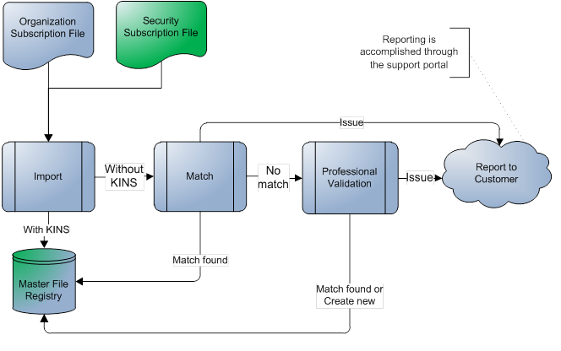

## Subscription File Logistics

### **Organization File Attributes**

The following fields will define the attributes provided in the organization subscription file.

* **Field:** This is the name of the field being provided.
* **Definition:** This provides a description of the data and indicates enumeration lists that are expected.
* **Constants:** This field is used to list a set of named values that are acceptable for enumerated data or acceptable format for the field.
* **Required:** This indicates if the data is required to be provided by the consumer in order to subscribe to a record.
* **Length:** This indicates the maximum character length of data attribute.
* **Example:** This is a sample value representing expected format of attribute

The consumer provides the following attributes through the organization subscription file. The schema is the same for both the subscription file and the registry file, but some fields are reserved for use in the registry file that will not be used in the subscription file. These fields will be identified in the Description of the field.

|  |  |  |  |  |  |
| --- | --- | --- | --- | --- | --- |
| **Field** | **Definition** | **Constants** | **Required (X)** | **LengthAll fields have a string data type.** | **Example** |
| CONSUMER_ID_TYPE | The system identifier type for the unique identifier from the consumer's system. This type is a value mutually agreed by the consumer and KSC. |  | X | 20 | MYID |
| CONSUMER_ID | The unique identifier for the organization in the consumer's system. |  | X | 20 | 895720147014 |
| Hub_IdKINS | The current Kingland Identification Number for the record. The current unique identifier for the record in the Hub. |  |  | 19 | 58048145 |
| PRODUCT | This field indicates the service being requested for the record.   * Organization Hierarchy (OH) * Organization Hierarchy with Securities (OHS) * Organization Active Chain (OAC) * Organization Active Chain with Securities (OACS) * Underlying Securities Monitoring (USM) * Fund Monitoring (FM) * Organization Monitoring (OM) * Entity Monitoring (EM) * Hierarchy Monitoring (HM) Entity Monitoring and Hierarchy Monitoring are deprecated values and will be supported for legacy subscription requests only. | OH  OHS  OAC  OACS  USM  FM  OM  EM  HM | X | 20 | OAC |
| PROCESS The Process field will be supported for legacy subscription requests, but the field will be deprecated and will not be used with the new product types. | This field provides additional processing details for the record.   * Active Chain (AC): The active chain is included in the processing of the record. This is only valid for records subscribed in Entity Monitoring. | AC | X | 20 | AC |
| FREQUENCY | This field indicates the frequency with which the record is monitored. The frequency starts from when the record is initially delivered to the consumer and is updated on this frequency. | DAILY  WEEKLY  MONTHLY  QUARTERLY SEMIANNUAL | X | 20 | DAILY |
| ACTION | Action or command provided in the subscription file, returned as a status in the registry file.   * Subscribe (SUB): The record is a subscribed record. * Unsubscribe (UNSUB): The record is requested as being removed from their subscription. Once received, the record and all auto-enrolled records are delivered one more time with confirmation in the registry file. Unsubscription fees may apply, please contact your support representative with any questions. * Re-match (REMATCH): The record will be processed through KSC matching process. | SUB  UNSUB  REMATCH | X | 20 | SUB |
| STATE | This field is reserved for the registry file. Any data provided by the consumer is ignored |  |  | 20 |  |
| REASON_CODE | This field is reserved for the registry file. Any data provided by the consumer is ignored |  |  | 20 |  |
| SUB_START_DATE | Start date of the subscription. This is the date the record was initially delivered to the consumer. This data is provided by KSC to the consumer; any data provided by the consumer is ignored. | YYYYMMDD |  | 8 | 20100801 |
| SUB_FULFILLED_DATE | Date when the subscription is fulfilled; after this date the consumer has fulfilled their minimum monitoring duration for the record. If the record is unsubscribed prior to this date, it may incur additional cost. This data is provided by KSC to the consumer; any data provided by the consumer is ignored. | YYYYMMDD |  | 8 | 20110129 |
| NAME | The name of the organization. |  | X | 255 | SunTrust Banks Inc. |
| STREET_ADDRESS_ONE | The street address line one. |  |  | 255 | 303 Peachtree St |
| STREET_ADDRESS_TWO | The street address line two. |  |  | 255 |  |
| CITY | The city associated with the address of the organization. |  |  | 255 | Atlanta |
| PROV_STATE | The state or province associated with the address of the organization. |  |  | 255 | Georgia |
| POSTAL_CODE | The postal code associated with the address of the organization. |  |  | 255 | 30308 |
| COUNTRY | The country associated with the address of the organization. |  |  | 255 | US |
| USERDEFINED_TYPE_ONE | The type of value being provided for the user defined field one. |  |  | 40 | CIK |
| USERDEFINED_VALUE_ONE | The user defined value one for the organization. |  |  | 255 | 0000750556 |
| USERDEFINED_TYPE_TWO | The type of value being provided for the user defined field two. |  |  | 40 | DUNS |
| USERDEFINED_VALUE_TWO | The user defined value two for the organization. |  |  | 255 | 9890891401 |
| USERDEFINED_TYPE_THREE | The type of value being provided for the user defined field three. |  |  | 40 | US Tax ID |
| USERDEFINED_VALUE_THREE | The user defined three value for the organization. |  |  | 255 | 79-8752425 |
| USERDEFINED_TYPE_FOUR | The type of value being provided for the user defined field four. |  |  | 40 |  |
| USERDEFINED_VALUE_FOUR | The user defined value four for the organization. |  |  | 255 |  |
| PARENT_CONSUMER_ID_TYPE | The consumer identifier type for the current unique identifier from the consumer's system for the direct parent. |  |  | 20 | MYID |
| PARENT_CONSUMER_ID | The current unique identifier in the consumer's system for the direct parent of the organization. |  |  | 20 | 895720147014 |
| PARENT_NAME | The name of the direct parent of the organization. |  |  | 255 | SunTrust Banks Inc. |
| PARENT_COUNTRY | The country for the direct parent of the organization. |  |  | 255 | US |
| UP_CONSUMER_ID_TYPE | The consumer identifier type for the current unique identifier from the consumer's system for the ultimate parent. |  |  | 20 | MYID |
| UP_CONSUMER_ID | The current unique identifier in the consumer system for the ultimate parent of the organization. |  |  | 20 | 895720147014 |
| UP_NAME | The name of the ultimate parent of the organization. |  |  | 255 | SunTrust Banks Inc. |
| UP_COUNTRY | The country for the ultimate parent of the organization. |  |  | 255 | US |

### **Security File Attributes**

The following fields will define the attributes provided in the security subscription file.

* **Field:** This is the name of the field being provided.
* **Definition:** This provides a description of the data and indicates enumeration lists that are expected.
* **Constants:** This field is used to list a set of named values that are acceptable for enumerated data or acceptable format for the field.
* **Required:** This indicates if the data is required to be provided by the consumer in order to subscribe to a record.
* **Length:** This indicates the maximum character length of data attribute.
* **Example:** This is a sample value representing expected format of attribute

The consumer provides the following attributes through the security subscription file. The schema is the same for both the subscription file and the registry file, but some fields are reserved for use in the registry file that will not be used in the subscription file. These fields will be identified in the Description of the field.

|  |  |  |  |  |  |
| --- | --- | --- | --- | --- | --- |
| **Field** | **Definition** | **Constants** | **Required (X)** | **LengthAll fields have a string data type.** | **Example** |
| CONSUMER_ID_TYPE | The system identifier type for the unique identifier from the consumer's system. This type is a value mutually agreed by the consumer and KSC. |  | X | 20 | MYID |
| CONSUMER_ID | The unique identifier for the organization in the consumer's system. |  | X | 20 | 895720147014 |
| Hub_IdKINS | The current Kingland Identification Number for the record. The current unique identifier for the record in the Hub. |  |  | 19 | 58048145 |
| PRODUCT | This field indicates the service being requested for the record.   * Organization Active Chain (OAC) * Organization Active Chain with Securities (OACS) * Organization Hierarchy (OH) * Organization Hierarchy with Securities (OHS) * Underlying Security Monitoring (USM) * Fund Monitoring (FM) | OAC  OACS  OH  OHS  USM  FM | X | 20 | OAC |
| PROCESS | This field is used for organization subscriptions only. |  |  |  |  |
| FREQUENCY | This field indicates the frequency with which the record is monitored. The frequency starts from when the record is initially delivered to the consumer and is updated on this frequency. | DAILY  WEEKLY  MONTHLY  QUARTERLY SEMIANNUAL | X | 20 | DAILY |
| ACTION | Action or command provided in the subscription file, returned as a status in the registry file.   * Subscribe (SUB): The record is a subscribed record. * Unsubscribe (UNSUB): The record is requested as being removed from their subscription. Once received, the record and all auto-enrolled records are delivered one more time with confirmation in the registry file. Unsubscription fees may apply, please contact your support representative with any questions. * Re-match (REMATCH): The record will be processed through KSC matching process. | SUB  UNSUB  REMATCH | X | 20 | SUB |
| STATE | This field is reserved for the registry file. Any data provided by the consumer is ignored |  |  | 20 |  |
| REASON_CODE | This field is reserved for the registry file. Any data provided by the consumer is ignored. |  |  | 20 |  |
| SUB_START_DATE | Start date of the subscription. This is the date the record was initially delivered to the consumer. This data is provided by KSC to the consumer; any data provided by the consumer is ignored. | YYYYMMDD |  | 8 | 20100801 |
| SUB_FULFILLED_DATE | Date when the subscription is fulfilled; after this date the consumer has fulfilled their minimum monitoring duration for the record. If the record is unsubscribed prior to this date, it may incur additional cost. This data is provided by KSC to the consumer; any data provided by the consumer is ignored. | YYYYMMDD |  | 8 | 20110129 |
| SHORT_DESC | A short description of the security. |  | X The subscription file must contain at least one of the following fields: short_desc or userdefined_type_one and userdefined_value_one. | 3000 | INVSC LTD TRS A2 |
| USERDEFINED_TYPE_ONE | The type of value being provided for the user defined field one. |  | X The subscription file must contain at least one of the following fields: short_desc or userdefined_type_one and userdefined_value_one. | 40 | ISIN |
| USERDEFINED_VALUE_ONE | The user defined value one for the organization. |  | X6 | 255 | US0378331005 |
| USERDEFINED_TYPE_TWO | The type of value being provided for the user defined field two. |  |  | 40 | CUSIP |
| USERDEFINED_VALUE_TWO | The user defined value two for the organization. |  |  | 255 | 459200-10-1 |
| USERDEFINED_TYPE_THREE | The type of value being provided for the user defined field three. |  |  | 40 | SEDOL |
| USERDEFINED_VALUE_THREE | The user defined three value for the organization. |  |  | 255 | B0WNLY7 |
| USERDEFINED_TYPE_FOUR | The type of value being provided for the user defined field four. |  |  | 40 | CINS |
| USERDEFINED_VALUE_FOUR | The user defined value four for the organization. |  |  | 255 | F08000AA7 |
| CLASS | Identifies the classification for the security.  For example, debt, equity, fund, etc. |  |  | 255 | DEBT |
| EXCHANGE_CODE | The exchange code for the security. |  |  | 255 | XNAS |
| TICKER_SYMBOL | Combination of exchange and ticker symbols. |  |  | 255 | SHTIX |
| PARENT_CONSUMER_ID_TYPE | The consumer identifier type for the current unique identifier from the consumer's system for the direct parent. |  |  | 120 | MYID |
| PARENT_CONSUMER_ID | The current unique identifier in the consumer's system for the direct parent of the organization. |  |  | 20 | 895720147014 |
| PARENT_NAME | The name of the direct parent of the organization. |  |  | 255 | SunTrust Banks Inc. |
| PARENT_COUNTRY | The country for the direct parent of the organization. |  |  | 255 | US |

## Registry File Logistics

### **Organization File Attributes**

The following fields will define the attributes that will be provided by KSC in the organization registry file for each delivery.

* **Field:** This is the name of the data being provided.
* **Definition:** This provides a description of the data and indicates enumeration lists that are expected.
* **Constants:** This field is used to list a set of named values that are acceptable for enumerated data or acceptable format for the field.
* **Required:** This indicates if the data is required to be provided by the consumer in order to subscribe to a record.
* **Length:** This indicates the maximum character length of data attribute.
* **Example:** This is a sample value representing expected format of attribute.

The following attributes will be provided by KSC in the organization registry file for each delivery. The schema is the same for both the subscription file and the registry file. Most fields will provide the same data that was provided in the subscription file as noted in the Description. Fields that were identified as reserved for the registry file will contain data provided by KSC as a result of the registration process.

|  |  |  |  |  |  |
| --- | --- | --- | --- | --- | --- |
| **Field** | **Definition** | **Constants** | **Required (X)** | **LengthAll data types are strings** | **Example** |
| CONSUMER_ID_TYPE | This field is reserved for use in the subscription file. The data that was sent in the subscription is provided. |  |  | 20 | MYID |
| CONSUMER_ID | This field is reserved for use in the subscription file. The data that was sent in the subscription is provided. |  |  | 20 | 895720147014 |
| Hub_IdKINS | The current Kingland Identification Number for the record. The current unique identifier for the record in the Hub. |  | X This will not be required in the subscription file for new records that have not been subscribed previously. This will also not be required in the registry file for records that have yet to be delivered or have been rejected. | 19 | 58048145 |
| PRODUCT | This field is reserved for use in the subscription file. The data that was sent in the subscription is provided. | OAC  OACS  OH  OHS  USM  FM  OM  EM  HM | X | 20 | OAC |
| PROCESS | This field is reserved for use in the subscription file. The data that was sent in the subscription is provided. | AC |  |  |  |
| FREQUENCY | This field is reserved for use in the subscription file. The data that was sent in the subscription is provided. | DAILY  WEEKLY  MONTHLY  QUARTERLY  SEMIANNUAL | X | 20 | DAILY |
| ACTION | Action or command provided in the subscription file, returned as a status in the registry file.   * Subscribe (SUB): The record is a subscribed record. * Unsubscribe (UNSUB): The record is requested as being removed from their subscription. Once received, the record and all auto-enrolled records are delivered one more time with confirmation in the registry file. Unsubscription fees may apply, please contact your support representative with any questions. | SUB  UNSUB |  | 20 | SUB |
| STATE | This field is used to indicate the registry state of the record. The states are listed in the order of their precedence When a record may have multiple states, one is delivered with the following order of precedence R, D, E, U, AU, AE, P. .   * Pending (P): The record is a subscribed record that has not been initially delivered. * Enrolled (E): The record is a subscribed record that has been enrolled based on the consumer's subscription. * Auto Enrolled (AE): The record was auto-enrolled by KSC in the consumer's subscription based on the hierarchy rules for the subscription. If an auto-enrolled record is moved out of a subscribed active chain or hierarchy, it will be unsubscribed automatically and delivered one more time. Unsubscription fees may apply, please contact your support representative with any questions. * Rejected (R): The record was malformed and was not imported. * Declined (D): The record was imported successfully but was not in scope * Unsubscribed (U): The record was successfully unsubscribed * Auto Unsubscribed (AU): This record was automatically unsubscribed due to family tree or subscription product type changes. | P  E  AE  R  D  U  AU | X | 20 | AE |
| REASON_CODE | Supplemental information of selected State values. This data is provided by KSC to the consumer; any data provided by the consumer is ignored.  For Rejected:   * Incomplete (INCOMPLETE): The record did not contain all of the required information. * Invalid (INVALID): The record contained all required attributes but was not in the appropriate format or contained unexpected values for enumerated fields. * Invalid Hub IdKINS (INVALIDHUBIDKINS): The record contained a Hub IdKINS that is not valid. * Record Not Subscribed (RECORDNOTSUBSCRIBED): The record contained an unsubscribe request, but an associated subscribed record was not found, so it could not be unsubscribed.   For Declined: * Insufficient Data – Insufficient Address (IDINSUFFICIENTADDR): The address data provided was not sufficient to identify the requested entity. * Insufficient Data – Insufficient Evidence (IDINSUFFICIENTEVID): KSC could not locate enough external/internal evidence to conclude entity's existence. Furthermore, any information found on an entity is old/outdated information (older than 2-3 years old). * Insufficient Data – Missing Legal Name (IDMISSINGLEGALNAME): No legal name was provided to KSC. * Insufficient Data – Nonspecific Entity (IDNONSPECIFICENTITY): Legal entity provided to KSC was not specific enough to determine which legal entity is needed to be processed. * Insufficient Data – Unidentifiable Parentage(IDUNIDENTIFIABLEPAR): KSC could not identify ownership of the fund provided where parentage should be present. * Insufficient Data – Other(IDOTHER): The record does not have adequate data to allow for automated or manual matching, including instances where conflicting data was provided, and none of the other decline reasons accurately describe the reason the data was insufficient. * Out of Scope – Board of Trustees(OOSBOARDOFTRUSTEES): KSC process can only process boards that are a legal entity and not made up of only individuals. * Out of Scope – Family Trust(OOSFAMILYTRUST): Per KSC process, family trusts are not processed. * Out of Scope – Individuals(OOSINDIVIDUALS): Per KSC process, Individuals are not processed. * Out of Scope – IRA (OOSIRA): Per KSC process, IRA's are not processed. * Out of Scope – Other(OOSOTHER): The record does not meet the contract specifications for valid records to be submitted, and none of the other decline reasons accurately describe the reason the record was out of scope.Out of Specification (OUTOFSPEC): The record does not meet the contract specifications for valid records to be submitted. * Insufficient Data (INSUFFICIENTDATA): The record does not have adequate data to allow for automated or manual matching, including instances where conflicting data was provided. | INCOMPLETE  INVALID  INVALIDHUBIDKINS  RECORDNOTSUBSCRIBED IDINSUFFICIENTADDR  IDINSUFFICIENTEVID  IDMISSINGLEGALNAME  IDNONSPECIFICENTITY  IDUNIDENTIFIABLEPAR  IDOTHER  OOSBOARDOFTRUSTEES OOSFAMILYTRUST  OOSINDIVIDUALS  OOSIRA  OOSOTHER OUTOFSPEC  INSUFFICIENTDATA |  | 20 | INCOMPLETE |
| SUB_START_DATE | Start date of the subscription. This is the date the record was initially delivered to the consumer. This data is provided by KSC to the consumer; any data provided by the consumer is ignored. | YYYYMMDD |  | 8 | 20100801 |
| SUB_FULFILLED_DATE | Date when the subscription is fulfilled; after this date the consumer has fulfilled their minimum monitoring duration for the record. If the record is unsubscribed prior to this date, it may incur additional cost. This data is provided by KSC to the consumer; any data provided by the consumer is ignored. | YYYYMMDD |  | 8 | 20110129 |
| NAME | This field is reserved for use in the subscription file. The data that was sent in the subscription is provided. |  |  | 255 | SunTrust Banks Inc. |
| STREET_ADDRESS_ONE | This field is reserved for use in the subscription file. The data that was sent in the subscription is provided. |  |  | 255 | 303 Peachtree St |
| STREET_ADDRESS_TWO | This field is reserved for use in the subscription file. The data that was sent in the subscription is provided. |  |  | 255 |  |
| CITY | This field is reserved for use in the subscription file. The data that was sent in the subscription is provided. |  |  | 255 | Atlanta |
| PROV_STATE | This field is reserved for use in the subscription file. The data that was sent in the subscription is provided. |  |  | 255 | Georgia |
| POSTAL_CODE | This field is reserved for use in the subscription file. The data that was sent in the subscription is provided. |  |  | 255 | 30308 |
| COUNTRY | This field is reserved for use in the subscription file. The data that was sent in the subscription is provided. |  |  | 255 | US |
| USERDEFINED_TYPE_ONE | This field is reserved for use in the subscription file. The data that was sent in the subscription is provided. |  |  | 40 | CIK |
| USERDEFINED_VALUE_ONE | This field is reserved for use in the subscription file. The data that was sent in the subscription is provided. |  |  | 255 | 0000750556 |
| USERDEFINED_TYPE_TWO | This field is reserved for use in the subscription file. The data that was sent in the subscription is provided. |  |  | 40 | DUNS |
| USERDEFINED_VALUE_TWO | This field is reserved for use in the subscription file. The data that was sent in the subscription is provided. |  |  | 255 | 9890891401 |
| USERDEFINED_TYPE_THREE | This field is reserved for use in the subscription file. The data that was sent in the subscription is provided. |  |  | 40 | US Tax ID |
| USERDEFINED_VALUE_THREE | This field is reserved for use in the subscription file. The data that was sent in the subscription is provided. |  |  | 255 | 79-8752425 |
| USERDEFINED_TYPE_FOUR | This field is reserved for use in the subscription file. The data that was sent in the subscription is provided. |  |  | 40 |  |
| USERDEFINED_VALUE_FOUR | This field is reserved for use in the subscription file. The data that was sent in the subscription is provided. |  |  | 255 |  |
| PARENT_CONSUMER_ID_TYPE | This field is reserved for use in the subscription file. The data that was sent in the subscription is provided. |  |  | 20 | MYID |
| PARENT_CONSUMER_ID | This field is reserved for use in the subscription file. The data that was sent in the subscription is provided. |  |  | 20 | 895720147014 |
| PARENT_NAME | This field is reserved for use in the subscription file. The data that was sent in the subscription is provided. |  |  | 255 | SunTrust Banks Inc. |
| PARENT_COUNTRY | This field is reserved for use in the subscription file. The data that was sent in the subscription is provided. |  |  | 255 | US |
| UP_CONSUMER_ID_TYPE | This field is reserved for use in the subscription file. The data that was sent in the subscription is provided. |  |  | 20 | MYID |
| UP_CONSUMER_ID | This field is reserved for use in the subscription file. The data that was sent in the subscription is provided. |  |  | 20 | 895720147014 |
| UP_NAME | This field is reserved for use in the subscription file. The data that was sent in the subscription is provided. |  |  | 255 | SunTrust Banks Inc. |
| UP_COUNTRY | This field is reserved for use in the subscription file. The data that was sent in the subscription is provided. |  |  | 255 | US |

### **Security File Attributes**

The following fields will define the attributes that will be provided by KSC in the security registry file for each delivery.

* **Field:** This is the name of the data being provided.
* **Definition:** This provides a description of the data and indicates enumeration lists that are expected.
* **Constants:** This field is used to list a set of named values that are acceptable for enumerated data or acceptable format for the field.
* **Required:** This indicates if the data is required to be provided by the consumer in order to subscribe to a record.
* **Length:** This indicates the maximum character length of data attribute.
* **Example:** This is a sample value representing expected format of attribute.

The following attributes will be provided by KSC in the security registry file for each delivery. The schema is the same for both the subscription file and the registry file. Most fields will provide the same data that was provided in the subscription file as noted in the Description. Fields that were identified as reserved for the registry file will contain data provided by KSC as a result of the registration process.

|  |  |  |  |  |  |
| --- | --- | --- | --- | --- | --- |
| **Field** | **Definition** | **Constants** | **Required (X)** | **LengthAll data types are strings** | **Example** |
| CONSUMER_ID_TYPE | This field is reserved for use in the subscription file. The data that was sent in the subscription is provided. |  |  | 20 | MYID |
| CONSUMER_ID | This field is reserved for use in the subscription file. The data that was sent in the subscription is provided. |  |  | 20 | 895720147014 |
| Hub_IdKINS | The current Kingland Identification Number for the record. The current unique identifier for the record in the Hub. |  | X This will not be required in the subscription file for new records that have not been subscribed previously. This will also not be required in the registry file for records that have yet to be delivered or have been rejected. | 19 | 58048145 |
| PRODUCT | This field is reserved for use in the subscription file. The data that was sent in the subscription is provided. | OAC  OACS  OH  OHS  USM  FM | X | 20 | OAC |
| PROCESS | This field is used for organization subscriptions only. |  |  |  |  |
| FREQUENCY | This field is reserved for use in the subscription file. The data that was sent in the subscription is provided. | DAILY  WEEKLY  MONTHLY  QUARTERLY  SEMIANNUAL | X | 20 | DAILY |
| ACTION | Action or command provided in the subscription file, returned as a status in the registry file.   * Subscribe (SUB): The record is a subscribed record. * Unsubscribe (UNSUB): The record is requested as being removed from their subscription. Once received, the record and all auto-enrolled records are delivered one more time with confirmation in the registry file. Unsubscription fees may apply, please contact your support representative with any questions. | SUB  UNSUB |  | 20 | SUB |
| STATE | This field is used to indicate the registry state of the record. The states are listed in the order of their precedence When a record may have multiple states, one is delivered with the following order of precedence R, D, E, U, AU, AE, P. .   * Pending (P): The record is a subscribed record that has not been initially delivered. * Enrolled (E): The record is a subscribed record that has been enrolled based on the consumer's subscription. * Auto Enrolled (AE): The record was auto-enrolled by KSC in the consumer's subscription based on the hierarchy rules for the subscription. If an auto-enrolled record is moved out of a subscribed active chain or hierarchy, it will be unsubscribed automatically and delivered one more time. Unsubscription fees may apply, please contact your support representative with any questions. * Rejected (R): The record was malformed and was not imported. * Declined (D): The record was imported successfully but was not in scope * Unsubscribed (U): The record was successfully unsubscribed * Auto Unsubscribed (AU): This record was automatically unsubscribed due to family tree or subscription product type changes. | P  E  AE  R  D  U  AU | X | 20 | AE |
| REASON_CODE | Supplemental information of selected State values. This data is provided by KSC to the consumer; any data provided by the consumer is ignored.  For Rejected:   * Incomplete (INCOMPLETE):The record did not contain all of the required information. * Invalid (INVALID): The record contained all required attributes but was not in the appropriate format or contained unexpected values for enumerated fields. * Invalid Hub IdKINS (INVALIDHUBIDKINS): The record contained a Hub IdKINS that is not valid. * Record Not Subscribed (RECORDNOTSUBSCRIBED):The record contained an unsubscribe request, but an associated subscribed record was not found, so it could not be unsubscribed.   For Declined: * Insufficient Data – Invalid Identifier(IDINVALIDIDENTIFIER): The Security Identifier provided to KSC could not be matched with an identifier of a valid security. * Insufficient Data – Multiple Issuers(IDMULTIPLEISSUERS): Security provided to KSC could not be associated with a single Issuer. * Insufficient Data – Unidentifiable Issuer(IDUNIDENTIFIABLEISSU): KSC could not identify ownership of the security provided where parentage should be present. * Insufficient Data – Other(IDOTHER): The record does not have adequate data to allow for automated or manual matching, including instances where conflicting data was provided, and none of the other decline reasons accurately describe the reason the data was insufficient. * Out of Scope – TBA(OOSTBA): Per KSC process, TBA (To Be Announced) securities will not be delivered. * Out of Scope – Other(OOSOTHER): The record does not meet the contract specifications for valid records to be submitted, and none of the other decline reasons accurately describe the reason the record was out of scope.Out of Specification (OUTOFSPEC): The record does not meet the contract specifications for valid records to be submitted. * Insufficient Data (INSUFFICIENTDATA): The record does not have adequate data to allow for automated or manual matching, including instances where conflicting data was provided. | INCOMPLETE  INVALID  INVALIDHUBIDKINS  RECORDNOTSUBSCRIBED IDINVALIDIDENTIFIER  IDMULTIPLEISSUERS  IDUNIDENTIFIABLEISSU  IDOTHER  OOSTBA  OOSOTHER OUTOFSPEC  INSUFFICIENTDATA |  | 20 | INCOMPLETE |
| SUB_START_DATE | Start date of the subscription. This is the date the record was initially delivered to the consumer. This data is provided by KSC to the consumer; any data provided by the consumer is ignored. | YYYYMMDD |  | 8 | 20100801 |
| SUB_FULFILLED_DATE | Date when the subscription is fulfilled; after this date the consumer has fulfilled their minimum monitoring duration for the record. If the record is unsubscribed prior to this date it may incur additional cost. This data is provided by KSC to the consumer; any data provided by the consumer is ignored. | YYYYMMDD |  | 8 | 20110129 |
| SHORT_DESC | This field is reserved for use in the subscription file. The data that was sent in the subscription is provided. |  | X The subscription file must contain at least one of the following fields: short_desc or userdefined_type_one and userdefined_value_one. | 3000 | INVSC LTD TRS A2 |
| USERDEFINED_TYPE_ONE | This field is reserved for use in the subscription file. The data that was sent in the subscription is provided. |  | X18 | 40 | ISIN |
| USERDEFINED_VALUE_ONE | This field is reserved for use in the subscription file. The data that was sent in the subscription is provided. |  | X The subscription file must contain at least one of the following fields: short_desc or userdefined_type_one and userdefined_value_one. | 255 | US0378331005 |
| USERDEFINED_TYPE_TWO | This field is reserved for use in the subscription file. The data that was sent in the subscription is provided. |  |  | 40 | CUSIP |
| USERDEFINED_VALUE_TWO | This field is reserved for use in the subscription file. The data that was sent in the subscription is provided. |  |  | 255 | 459200-10-1 |
| USERDEFINED_TYPE_THREE | This field is reserved for use in the subscription file. The data that was sent in the subscription is provided. |  |  | 40 | SEDOL |
| USERDEFINED_VALUE_THREE | This field is reserved for use in the subscription file. The data that was sent in the subscription is provided. |  |  | 255 | B0WNLY7 |
| USERDEFINED_TYPE_FOUR | This field is reserved for use in the subscription file. The data that was sent in the subscription is provided. |  |  | 40 | CINS |
| USERDEFINED_VALUE_FOUR | This field is reserved for use in the subscription file. The data that was sent in the subscription is provided. |  |  | 255 | F08000AA7 |
| CLASS | This field is reserved for use in the subscription file. The data that was sent in the subscription is provided. |  |  | 255 | DEBT |
| EXCHANGE_CODE | This field is reserved for use in the subscription file. The data that was sent in the subscription is provided. |  |  | 255 | XNAS |
| TICKER_SYMBOL | This field is reserved for use in the subscription file. The data that was sent in the subscription is provided. |  |  | 255 | SHTIX |
| PARENT_CONSUMER_ID_TYPE | This field is reserved for use in the subscription file. The data that was sent in the subscription is provided. |  |  | 120 | MYID |
| PARENT_CONSUMER_ID | This field is reserved for use in the subscription file. The data that was sent in the subscription is provided. |  |  | 20 | 895720147014 |
| PARENT_NAME | This field is reserved for use in the subscription file. The data that was sent in the subscription is provided. |  |  | 255 | SunTrust Banks Inc. |
| PARENT_COUNTRY | This field is reserved for use in the subscription file. The data that was sent in the subscription is provided. |  |  |  |  |

关于处理无效GMF ID的BP file:///D:/DSRO_FILE/Appropriately Handle Retired GMFID's - DSR Hub Technical Documents - Draft Space - Confluence.html

# Business Process Flow

The business process follows a flow outlined below:

| **Actor** | **Description** |
| --- | --- |
| Integrator | A job that imports and writes the GMF data to the Stage database. |
| Courier | A job that moves data from Stage to Work. |

Integrator identifies a Stage record with a Retired GMFID.

1. **ASK:** Does the Retired GMFID have additional Stage records linked to the same Work Cont ID?
   1. **Yes:**Go to step 3
   2. **No:**There will be no Winner. The Stage record with the Retired GMFID will be considered a Loser. Go to Step 4
2. **ASK:**Are there multiple Active GMFIDs in Stage linked to the same Cont ID in Work?
   1. **Yes:**The Active GMFID with the lowest GMFID will be the Winner. Other records with an Active GMFID will have their is_changed value set to 1000. All other records will be Losers. Continue to step 4.
      1. If one of the records set to 1000 status is updated in Stage at a later date, the is_changed value for that record will be changed to 1002, and the record will be imported per existing functionality.
   2. **No:** The record with an Active GMFID will be the Winner, and any Retired GMFIDs will be Losers. Continue to step 4.
3. The Winner will be assigned an is_changed value of 1002. Losers will be assigned an is_changed value of 1009.
4. 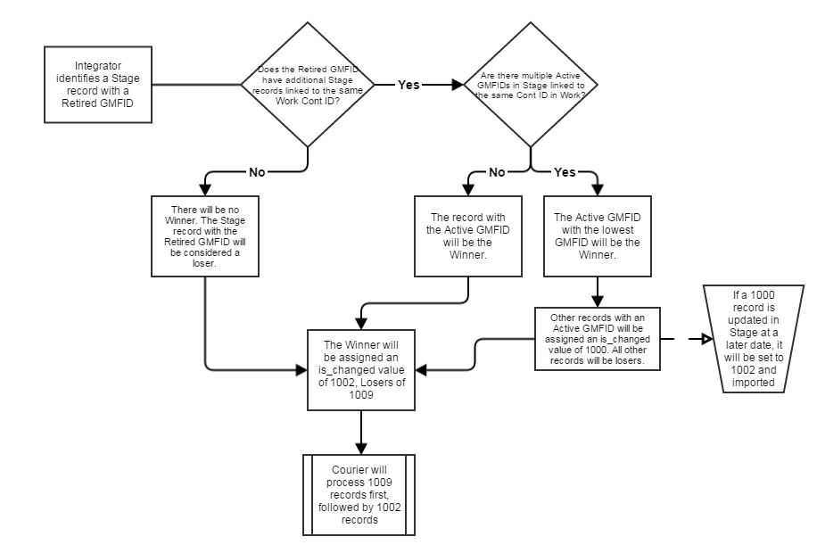Courier will process all 1009 records first, followed by all 1002 records.

file:///D:/DSRO_FILE/CheckList - Trac Wiki - Confluence.html 在360 data下的checkList 学习XML SCHEMA

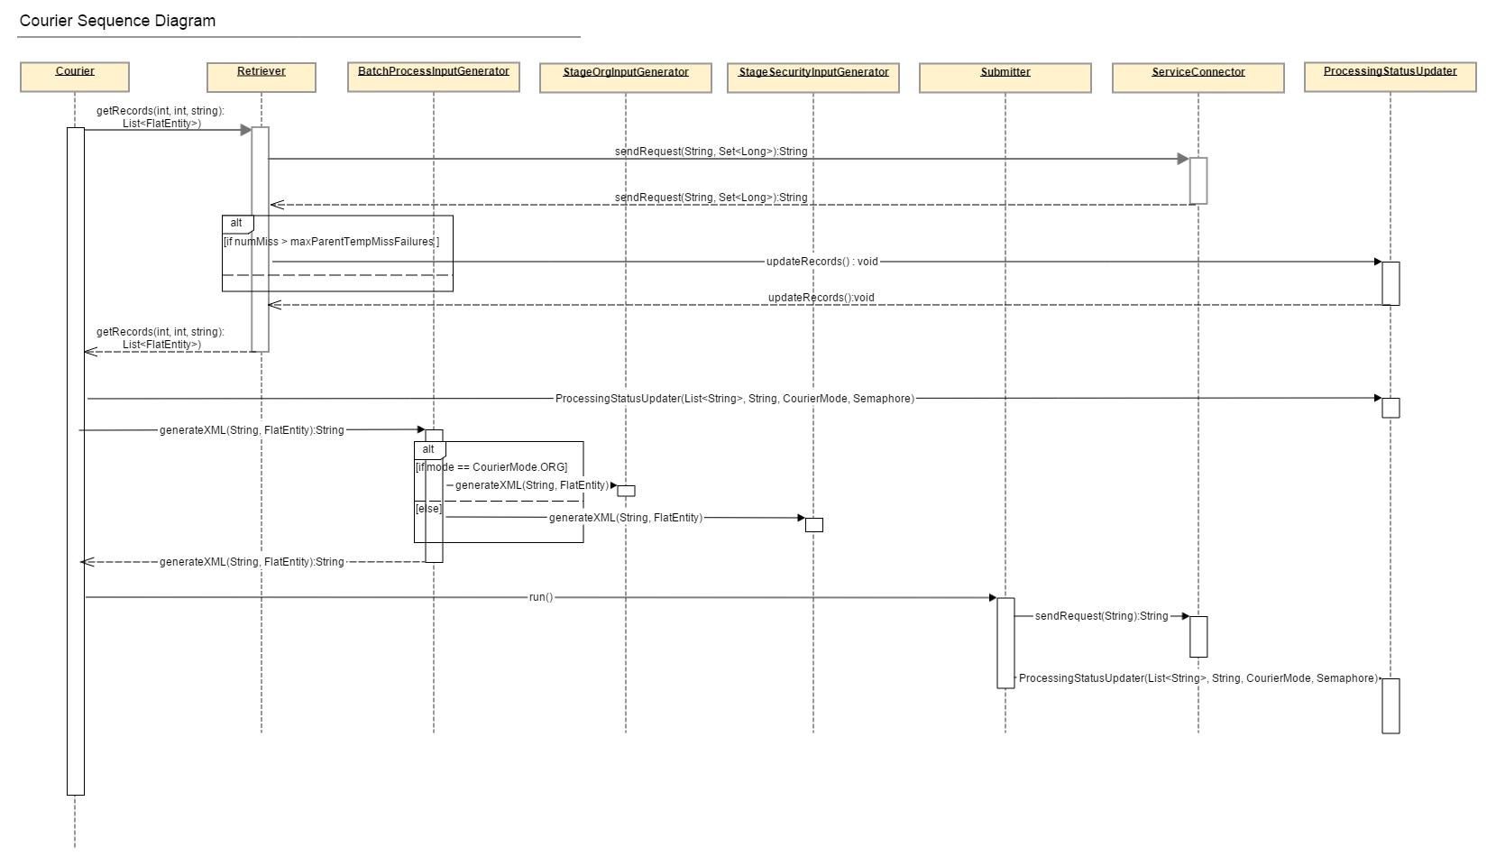

## Configuration Settings

|  |  |  |  |
| --- | --- | --- | --- |
| **start_courier.sh (Below is the parameter)** | | | |
| **Setting Name** | **Value** | **Location** | **Description** |
| chunksize | 50 |  | Determines how many records will be read from Enterprise Hub in one request and given to a Submitter thread for submission to Enterprise Hub. |
| processinterval | 300000 (5 minutes) |  | How long Courier should sleep after processing all outstanding records. It will awaken after this sleep period to see if any new records need processing. |
| perfdelay | 30000 (30 seconds) |  | The number of milliseconds between each performance report. |
| parentretry | 0 |  | The interval between retries of the MISSING_PARENT records. If this value is set to 3, for example, every 3rd chunk of records will be pulled from the MISSING_PARENT pool rather than NEEDS_PROCESSING. Set to 0 to never retry. |
| batchprocessors | 2 |  | Number of concurrent Submitter threads to use for sending requests to Enterprise Hub. Has nothing to do with the Batch Processor application. |
| updaterthreads | 10 |  | Number of concurrent threads to use for updating the statuses of Stage records. |
| needsprocessingcode | 1002 (unprocessed) |  | The IS_CHANGED or PROCESSING_STATUS code for which Courier will pull/process records. This can correspond to any code in the CDKSCPROCESSINGSTATUSTP table in the database. |
| suppresserrorcodes |  |  | A comma-separated list of error reason codes to suppress. Receipt of these errors will result in Courier printing a short message indicating they've been suppressed, rather than a lengthy error report. |
| mode | stageorg/security |  | The type of data Courier will process. |
| maxparentsearchfailures | 3 |  | The maximum number of times a parent lookup can fail before the record is marked with the MISSING_PARENT status. |
| benchmark |  |  |  |

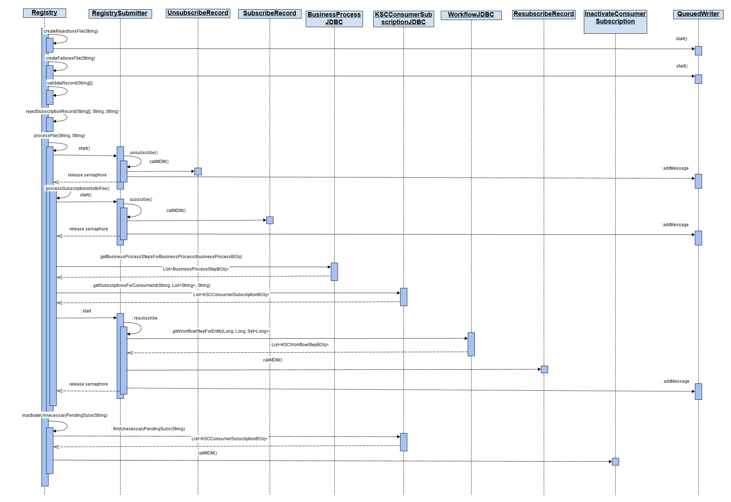

## Configuration Settings

**subscriptionMaster.sh** (Below are parameters)

|  |  |  |  |
| --- | --- | --- | --- |
| **Parameter1** | **Parameter2** | **Parameter2 is required** | **Parameter3** |
| -r: Registry | ALL  10000: BNYM  20000: K300  50000: GS  70000: BNYM_CDR2  80000: NT  90000: NT_GEMS  100000: RJ | YES | ORG/SEC |
| -i: Integrity |  | NO | NOT APPLICABLE |
| -s: Sentry | ALL | NO | NOT APPLICABLE |
| -p: Publish | ALL  10000: BNYM  20000: K300  50000: GS  70000: BNYM_CDR2  80000: NT  90000: NT_GEMS  100000: RJ | YES | NOT APPLICABLE |
| -v: Verification | 10000: BNYM  50000: GS | YES | NOT APPLICABLE |

file:///D:/DSRO_FILE/Component Design - KinglandMasterFileRegister - DSR Hub Technical Documents - Draft Space - Confluence.html

**KinglandMasterFileRegister**

