Libraries used:

1. numpy

NumPy stands for Numerical Python.
NumPy is a Python library used for working with arrays.
It also has functions for working in domain of linear algebra, fourier transform, and matrices.
Pandas is built on top of NumPy, which means the Python pandas package depends on the NumPy package and also pandas intended with many other 3rd party libraries. So we can say that Numpy is required for operating the Pandas.
Functions used:
- np.nan (NAN value)

2. pandas

Pandas is a Python library used for working with data sets.
It has functions for analyzing, cleaning, exploring, and manipulating data.
The name "Pandas" has a reference to both "Panel Data", and "Python Data Analysis" and was created by Wes McKinney in 2008.
Pandas allows us to analyze big data and make conclusions based on statistical theories.
Pandas can clean messy data sets, and make them readable and relevant.
Relevant data is very important in data science.
Functions used:
- read_csv( )
- functions on dataframe objects
  - iloc[]
  - loc[]
  - .values
  - groupby()
  - groupby().mean()
  - groupby().sum()
  - reset_index
  - idxmax
  - idxmin
  - reshape
  - set_index
  - drop
  - apply
  - max

3. sklearn

Scikit-learn (Sklearn) is the most useful and robust library for machine learning in Python.
It provides a selection of efficient tools for machine learning and statistical modeling including classification, regression, clustering and dimensionality reduction via a consistence interface in Python.
This library, which is largely written in Python, is built upon NumPy, SciPy and Matplotlib.

Functions used:
- RandomForestRegressor( )
- SimpleImputer
- train_test_split
- functions on model object:
  - fit
  - transform
  - predict
  - score

4. json

JSON, stands for JavaScript Object Notation, is a lightweight data-interchange format. It is often used for exchanging data between a web server and user agent.
Json is a built-in module in Python, you don’t need to install it with pip.
The json library can parse JSON from strings or files. The library parses JSON into a Python dictionary or list. It can also convert Python dictionaries or lists into JSON strings.
Functions used:
- dumps

Other functions

- argmax
- list()
- append()
- int()
- format()

functions used from Pandas

- read_csv( filepath_or_buffer, sep=NoDefault.no_default)
  - Read a comma-separated values (csv) file into DataFrame.
  - Filepath : path of file
  - sep = seprator in csv , default = ‘ , ’
  - A DataFrame is a data structure that organizes data into a 2-dimensional table of rows and columns, much like a spreadsheet
  - A DataFrame object has two axes: “axis 0” and “axis 1”. “axis 0” represents rows and “axis 1” represents columns. more

- df.iloc[ ]
- gets the part of dataframe by slicing
- Purely integer-location based indexing for selection by position.
- Accessing rows and colums : df.[ row index , column index ]
- eg. df.[ 1: 3 , : ]
- See more
- df.loc[]
- Access a group of rows and columns by label(s) or a boolean array.
- .loc[] is primarily label based, but may also be used with a boolean array.
- See more
- diff between iloc and loc
- df.iloc[].values
- Return a Numpy representation of the DataFrame.
- Returns numpy.ndarray

- df.max(axis =0)
- this returns max values of each column
- df.idxmax(axis = 0 /1)
- dataframe.idxmax() function returns index of first occurrence of maximum over requested axis. While finding the index of the maximum value across any index, all NA/null values are excluded.
- Default axis = 0
- all values must be numeric
- df.idxmin(axis = 0 /1)
- dataframe.idxmin() function returns index of first occurrence of minimum over requested axis. While finding the index of the maximum value across any index, all NA/null values are excluded.
- Default axis = 0
- all values must be numeric

- df.set_index(keys, drop=True, append=False, inplace=False, verify_integrity=False, axis )
- Set the DataFrame index using existing columns.
- Set the DataFrame index (row labels) using one or more existing columns or arrays (of the correct length). The index can replace the existing index or expand on it.

- df.apply(lambda function)
method : DataFrame.apply(func, axis=0, raw=False, result_type=None, args=(), **kwargs)
- Apply a function along an axis of the DataFrame.
- Objects passed to the function are Series objects whose index is either the DataFrame’s index (axis=0) or the DataFrame’s columns (axis=1). By default (result_type=None), the final return type is inferred from the return type of the applied function. Otherwise, it depends on the result_type argument.
- Eg : p=stateindex.apply(lambda x: x.argmax(), axis=1)
- argmax() finds max in column
- df.groupby(‘key’)
- Group DataFrame using a mapper or by a Series of columns.
- A groupby operation involves some combination of splitting the object, applying a function, and combining the results. This can be used to group large amounts of data and compute operations on these groups.

- df.groupby().mean()
- perform mean() on grouped data
- df.groupby().sum()
- perform sum operation on grouped data
- DataFrame.reset_index(level=None, drop=False, inplace=False, col_level=0, col_fill='')
- Reset the index, or a level of it.
- Reset the index of the DataFrame, and use the default one instead. If the DataFrame has a MultiIndex, this method can remove one or more levels.
- df.reshape()

Functions used in sklearn
- RandomForestRegressor( )
- A random forest regressor.
- A random forest is a meta estimator that fits a number of classifying decision trees on various sub-samples of the dataset and uses averaging to improve the predictive accuracy and control over-fitting. The sub-sample size is controlled with the max_samples parameter if bootstrap=True (default), otherwise the whole dataset is used to build each tree.

Parameters :
n_estimators: int, default=100
- The number of trees in the forest.
Criterion: {“squared_error”, “absolute_error”, “poisson”}, default=”squared_error”

- The function to measure the quality of a split.
- Supported criteria are “squared_error” for the mean squared error, which is equal to variance reduction as feature selection criterion, “absolute_error” for the mean absolute error, and “poisson” which uses reduction in Poisson deviance to find splits. Training using “absolute_error” is significantly slower than when using “squared_error”.

random_state : int, RandomState instance or None, default=None

- Controls both the randomness of the bootstrapping of the samples used when building trees (if bootstrap=True) and the sampling of the features to consider when looking for the best split at each node (if max_features < n_features).

Methods

1. fit(X, y, sample_weight=None)
Build a forest of trees from the training set (X, y).

Parameters
X : {array-like, sparse matrix} of shape (n_samples, n_features)
The training input samples. Internally, its dtype will be converted to dtype=np.float32. If a sparse matrix is provided, it will be converted into a sparse csc_matrix.
Y : array-like of shape (n_samples,) or (n_samples, n_outputs)
The target values (class labels in classification, real numbers in regression).
sample_weight : array-like of shape (n_samples,), default=None
Sample weights. If None, then samples are equally weighted. Splits that would create child nodes with net zero or negative weight are ignored while searching for a split in each node. In the case of classification, splits are also ignored if they would result in any single class carrying a negative weight in either child node.
Returns :
self object which is a Fitted estimator.

2. predict(X, y, sample_weight=None)

- Predict regression target for X.
- The predicted regression target of an input sample is computed as the mean predicted regression targets of the trees in the forest.
Parameters
X : {array-like, sparse matrix} of shape (n_samples, n_features)
The input samples. Internally, its dtype will be converted to dtype=np.float32. If a sparse matrix is provided, it will be converted into a sparse csr_matrix.
Returns
y : ndarray of shape (n_samples,) or (n_samples, n_outputs)
i.e The predicted values.

3. score(X, y, sample_weight=None)

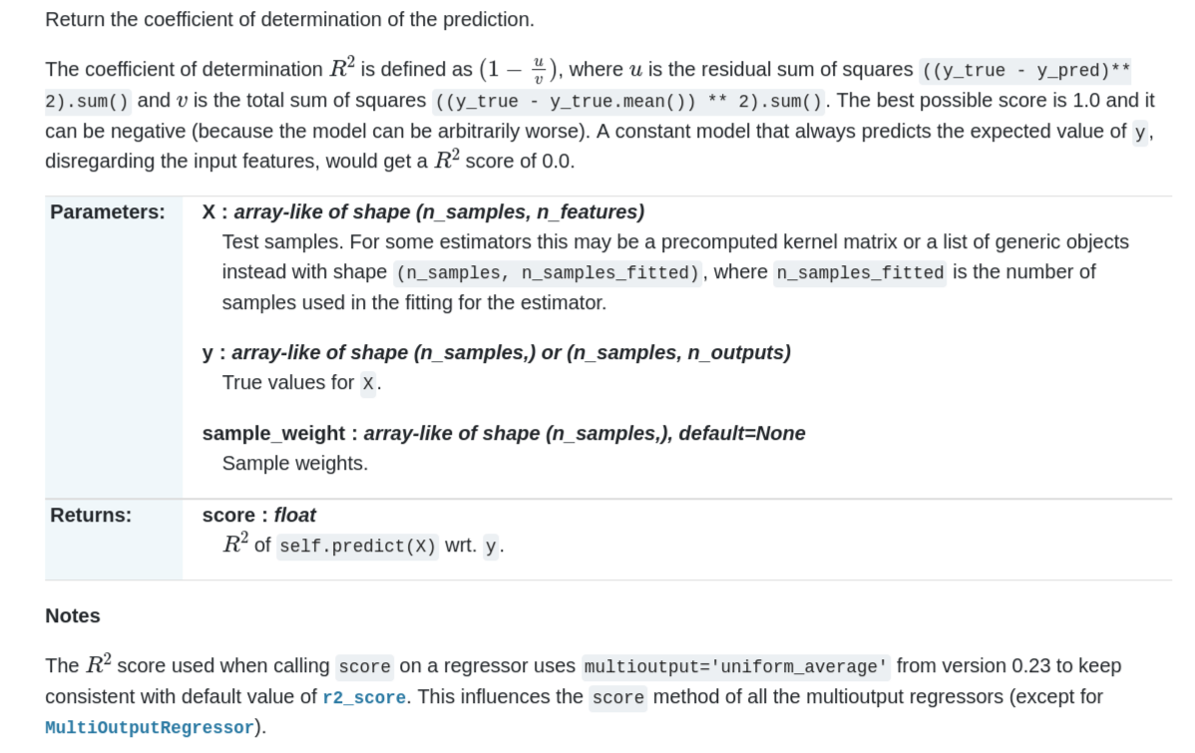

- SimpleImputer
class sklearn.impute.SimpleImputer(*, missing_values=nan, strategy='mean', fill_value=None, verbose='deprecated', copy=True, add_indicator=False)

Imputation transformer for completing missing values.
Parameters:

1. missing_values : int, float, str, np.nan, None or pandas.NA, default=np.nan

2.strategy : str, default=’mean’
The imputation strategy.
- If “mean”, then replace missing values using the mean along each column. Can only be used with numeric data.
- If “median”, then replace missing values using the median along each column. Can only be used with numeric data.
- If “most_frequent”, then replace missing using the most frequent value along each column. Can be used with strings or numeric data. If there is more than one such value, only the smallest is returned.
- If “constant”, then replace missing values with fill_value. Can be used with strings or numeric data.

Methods :

1. fit
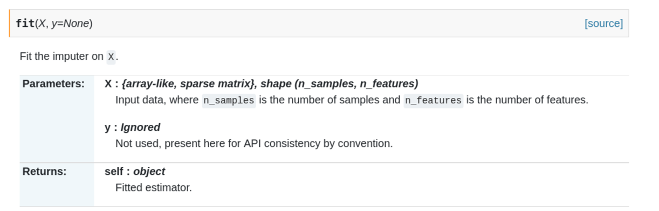

2. fit_transform
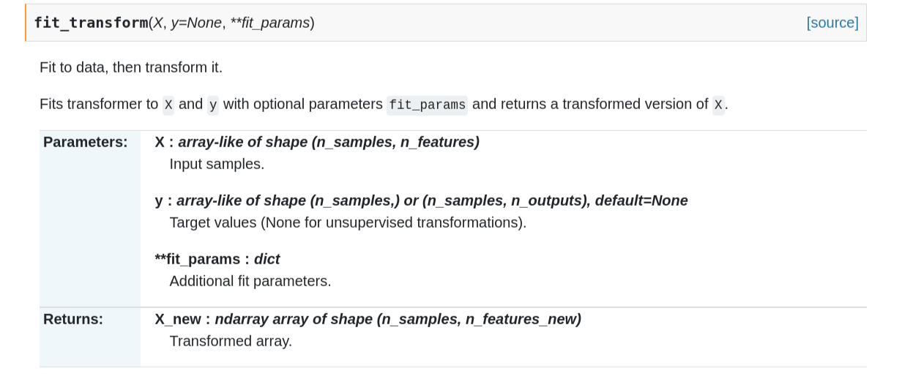

3. transform
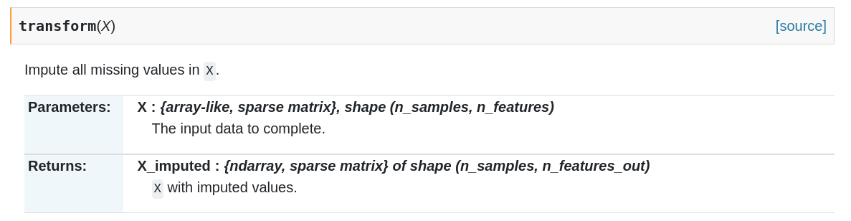
note : transform() is used on test data,
fit_transform() is used on training data why?

- train_test_split()
sklearn.model_selection.train_test_split(*arrays, test_size=None, train_size=None, random_state=None, shuffle=True, stratify=None)

Split arrays or matrices into random train and test subsets.
Quick utility that wraps input validation and next(ShuffleSplit().split(X, y)) and application to input data into a single call for splitting (and optionally subsampling) data in a oneliner.
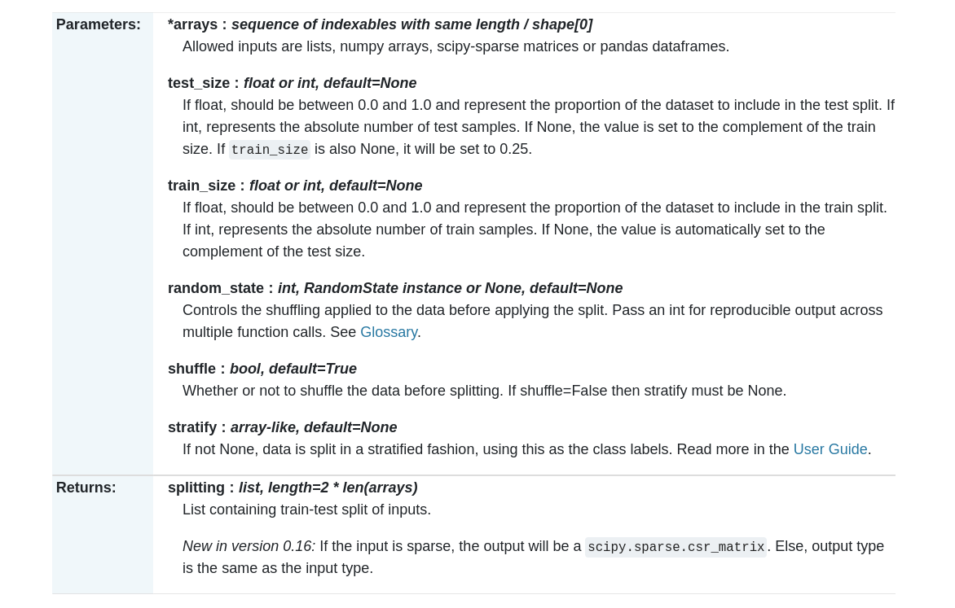

Numpy
numpy.ndarray.reshape()
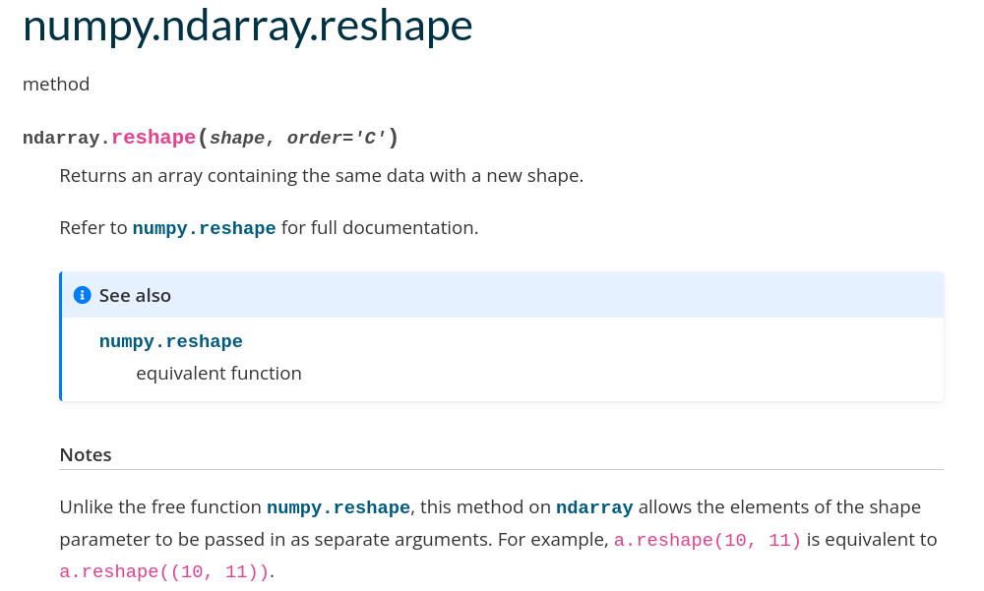

ndarray.reshape(-1,1)
-1 indicate that ndarray is to be reshpaped such that 'The new shape should be compatible with the original shape'
1 denotes the number of column i,e 1
eg . New shape (2, -1). Row 2, column unknown. we get result new shape as (2,6)
see more
note : Reshape your data using array.reshape(-1, 1) if your data has a single feature
model.fit() method expects 2D array

JSON methods :
1. json.dumps(python object)
json.dumps() function converts a Python object into a json string.
2.json.loads(jsonstring)
json.loads() method can be used to parse a valid JSON string and convert it into a Python Dictionary. It is mainly used for deserializing native string, byte, or byte array which consists of JSON data into Python Dictionary.

