Basics:

- std is namespace
- “<<” ,”>>” are overloaded
- ‘&’ can be used to create reference in cpp
  - int &a = x
  - cout<<a prints x

- In CPP , classes , functions or variables need to be declared before they are used i.e forward declaration is required
- char * is not used as a string in CPP, instead use const char *

References

refrence works as alternative name for a variable.
it is internally a pointer but we do not need to dereference it/
it helps as we do not need to create another copy of same object while passing it to a function.
refernce is used in copy constructor.
it can also be used in for each loop, it saves memory
refernce cannot be updated.
reference has only single level of indirection.
it cannot be NULL

more : https://www.geeksforgeeks.org/references-in-c/

Inline function

Inline Function are those function whose definitions are small and be substituted at the place where its function call is happened.

C++ provides an inline functions to reduce the function call overhead. Inline function is a function that is expanded in line when it is called. When the inline function is called whole code of the inline function gets inserted or substituted at the point of inline function call.

inlining is only a request to the compiler, not a command. Compiler can ignore the request for inlining.

used when function is small and memory of program can be increased.

all the functions defined inside the class are implicitly inline.

MACRO

A macro is a piece of code in a program that is replaced by the value of the macro.
types:
1. object : #define DATE 31
2. chain : #define INSTAGRAM FOLLOWERS
#define FOLLOWERS 138
3. multiline : #define ELE 1, \
2, \
3

4. function: #define min(a, b) (((a) < (b)) ? (a) : (b))

Acess specifier in inheritence:

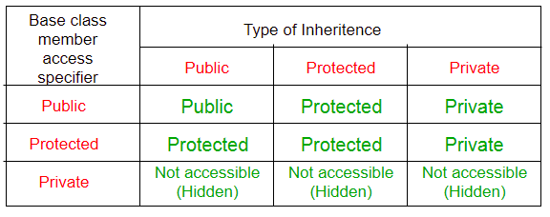

- In CPP, default access specifier is private

pg.classes/p4

If constructor is not defined by user, then it is public by default. If constructor is defined then it is private unless changed.

- This program crashes due to null pointer.
Const char* str;
cout<<str;

size of string = 32 bytes
size of const char* = 12 bytes

Copy constructor is a constructor which is by defalt defined in every class as
ClassName(ClassName &obj){
//all fields are copied
}

the work of copy contructor is to copy all the data of an object to another object when it is passed to a method. i.e when an object is passed to a method, a new object is created, copy constructor is called to copy all the data from old object to new object. Any changes made to new object wont reflect in original object.

Copy constructor can be overloaded in class but then we have to manually copy all the fields so that no error occurs while passing an object to a method.

Structure
- structure elments cannot be initialized inside structure
- it can be type def in two ways

typedef struct demo demo;
struct demo{
int a ;
int b;
};

typedef struct demo{
int a ;
int b;
}demo;

Static in C

- static variables are located in data segment, not in stack segment
- they are only initialized once and remain in memory for lifetime of program
- they are initialized to zero if not initialized explicitly
- In C, static variables can only be initialized using constant literals. For example, following program fails in compilation
- static cannot be used in a structure
- global static function or variables are used to limit their usage to current file

Static in CPP

- static variables are located in data segment, not in stack segment
- they are only initialized once and remain in memory for lifetime of program
- static variables of class are shared by all objects of class and stored in separate static storage.can be called as ClassName::element
- static variables of class cannot be initialized by constructor
- they are initialized to zero if not initialized explicitly
- class objects declared as static remain in memory till the program runs

Memory
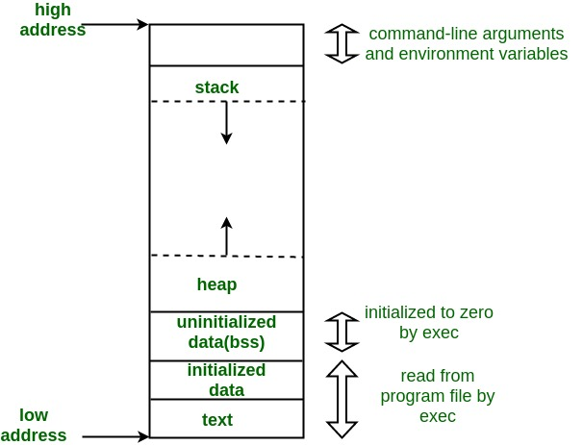

- text contains instructions i.e code
- initialized / Data segment : initialized global or static vaiable
- BSS(block start by symbol): uninitialized global or static vaiable
- heap : dyanamically created data using malloc , realloc, calloc
- stack : local variables of methods

Friend function & class in CPP

A friend class can access private and protected members of other class in which it is declared as friend. It is sometimes useful to allow a particular class to access private members of other class. For example, a LinkedList class may be allowed to access private members of Node.

Following are some important points about friend functions and classes:
1) Friends should be used only for limited purpose. too many functions or external classes are declared as friends of a class with protected or private data, it lessens the value of encapsulation of separate classes in object-oriented programming.
2) Friendship is not mutual. If class A is a friend of B, then B doesn’t become a friend of A automatically.
3) Friendship is not inherited (See this for more details)
4) The concept of friends is not there in Java.

