Database Analysis Worksheet

# Step 1: Identify Entities, Attributes, and Primary Keys

|  |  |  |  |  |
| --- | --- | --- | --- | --- |
| Entity |  | Attributes |  | Primary Key |
| Students |  | **SSN**, DOB, FN, MI, LN, Address, Zip, Phone, Gender |  | ID |
| Courses |  | **Code**, Title, Difficulty |  | ID |
| Subjects |  | **Code**, Description |  | ID |

# Step 2: Define Relationships Between the Entities

|  |  |  |  |
| --- | --- | --- | --- |
| Entity 1 | Entity 2 | How Related?  (2 sentences) | Relationship Type (1:1, 1:N, M:N) |
| Students | Courses | Each student can be enrolled in several courses.  A course can be taken by several students. | M:N |
| Students | Subjects | There does not appear to be a direct relationship between students and subjects (although one might be inferred via other relationships). | -- |
| Courses | Subjects | A course belongs to more than one subject area.  A subject can have several courses fall under it. | M:N |

# Step 3: Draw your Entity-Relationship Diagram (Hand-drawn is okay!!!)

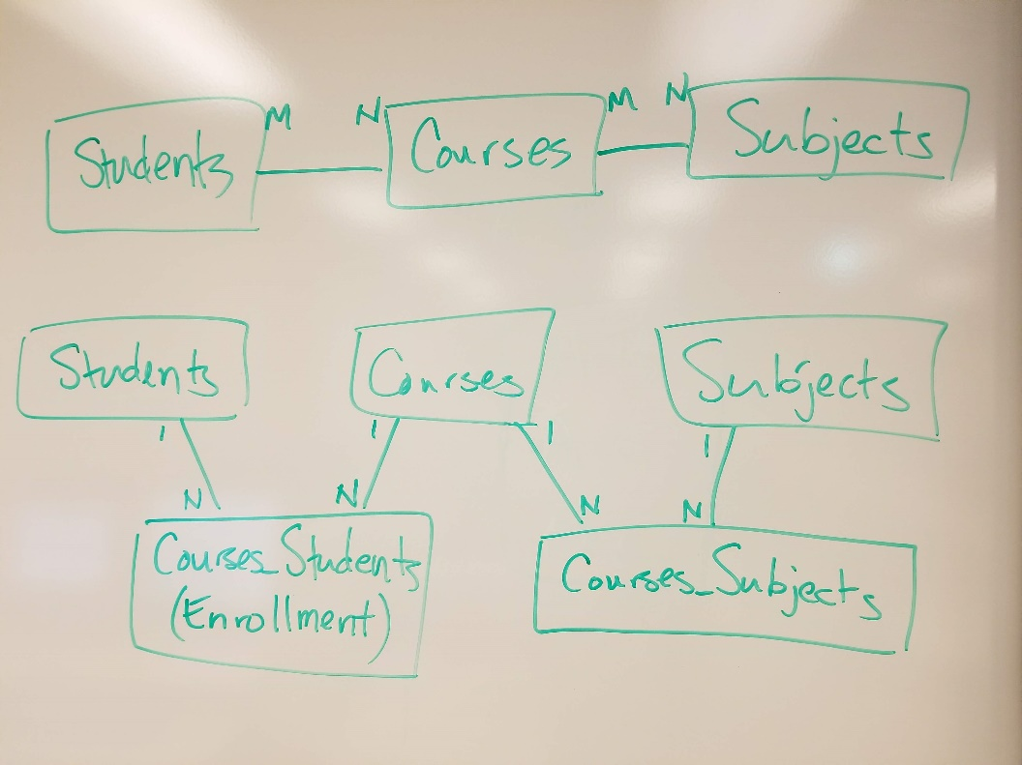

# Step 4: Specify Tables, Fields, and Data Types

Fill out a chart for each table to be included in the database.

Name of 1st Table: **students**

|  |  |
| --- | --- |
| Field Name | Data Type |
| ID** | integer (auto-increment) |
| SSN | string(9) |
| dob | string(28) (ISO 8601) |
| first_name | string(15) |
| middle_initial | string(1) |
| last_name | string(20) |
| address | string(100) |
| zip | string(5) |
| phone | string(10) |
| gender | string(15) |

Name of 2nd Table: **courses**

|  |  |
| --- | --- |
| Field Name | Data Type |
| ID** | integer (auto-increment) |
| code | string(10) |
| title | string(30) |
| difficulty | enum(‘Introductory’, ‘Intermediate’, ‘Advanced’) |

Name of 3rd Table: **subjects**

|  |  |
| --- | --- |
| Field Name | Data Type |
| ID** | integer (auto-increment) |
| code | string(10) |
| description | string(100) |

Name of 4th Table: **courses_students**

|  |  |
| --- | --- |
| Field Name | Data Type |
| student_id** (fk) | integer |
| course_id** (fk) | integer |

Name of 5th Table: **courses_subjects**

|  |  |
| --- | --- |
| Field Name | Data Type |
| subject_id** (fk) | integer |
| course_id** (fk) | integer |