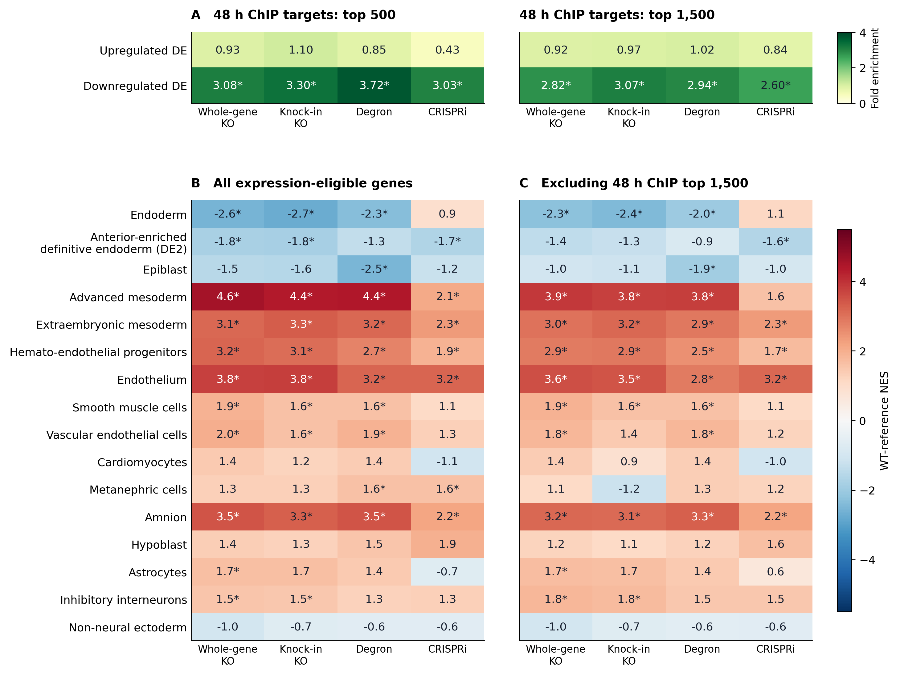
Figure 1. 48-hour EOMES ChIP targets and cell-fate programs after EOMES perturbation. (A) Enrichment of upregulated and downregulated DE genes among the fixed top 500 (left) and top 1,500 (right) 48-hour ChIP targets. Values are observed/expected overlaps; * one-sided Fisher BH q < 0.05 across 20 tests. (B, C) Unweighted GSEA of cell-type signatures using all expression-eligible genes (B) or excluding the 48-hour top 1,500 targets (C). Values are NES calibrated against 1,566 source-adjusted WT-versus-WT 3v3 assignments from nine selected EOMES control libraries. The expression filter is q75_pass and maximum KO/control mean CPM ≥ 1; each comparison's gene list is fixed across WT assignments. Red indicates higher and blue lower expression after perturbation. * WT-reference BH q < 0.05 across all tested signatures and five contrasts, separately per panel. References: [Tyser et al. 2021], human gastrula; [Cao et al. 2020], human fetal atlas. DE2 denotes anterior-enriched definitive endoderm. Whole-gene and knock-in KO share WT samples; Degron denotes the comparison with matched uninduced controls. The parental-control degron comparison is omitted from this display. Reference similarity does not assign a cell fate; genes outside the target list are not proven indirect targets. This four-column display uses the updated five-contrast statistics and correction families.

ChIP-seq sources
The 48-hour EOMES ChIP-seq data (paired-end) come from HUES8 human embryonic stem cells differentiating toward definitive endoderm [Luo et al. 2023], GEO GSE213394: replicate 1 is GSM6585561 (SRR21586161) and replicate 2 is GSM6585562 (SRR21586115). Raw reads were downloaded from the ENA run pages for these SRA accessions. The input control is a single-end library, GSM3381961 (SRR7814534), from [Li et al. 2019].
Read processing and reproducible peaks
Reads were aligned to GRCh38 (no-alt analysis set) with Bowtie2 2.5.5 [Langmead and Salzberg 2012] at default settings. Alignments were name-sorted, mate-repaired, coordinate-sorted and deduplicated with SAMtools 1.24 [Danecek et al. 2021], then filtered to MAPQ ≥ 30, chromosomes 1–22, X and Y, and no overlap with the hg38 blacklist v2. MACS2 2.2.9.1 [Zhang et al. 2008] called peaks for each replicate and for the pooled ChIP, each against the input, with -f BAM --nomodel --extsize 200 --shift 0 --keep-dup all -g hs -p 0.001. Under -f BAM, paired-end ChIP reads were treated as single-end read-1 tags with a fixed 200-bp extension, matching how the single-end input was processed. Peaks overlapping the blacklist were removed, and irreproducible discovery rate (IDR) 2.0.4.2 [Li et al. 2011] compared the two replicates, ranked by MACS2 p-value, using the pooled peaks as the oracle set. Peaks with global IDR ≤ 0.05 and pooled-sample q ≤ 0.05 were retained (43,700 peaks).
EOMES target definition
Each retained peak summit was linked to every gene-level TSS within 50 kb, using GENCODE v44 basic protein-coding and lncRNA genes. A gene’s score is the sum, over its linked peaks, of peak fold enrichment × (1 − |summit − TSS| / 50,000), so genes with several nearby peaks accumulate score. When a symbol maps to more than one locus, the highest-scoring locus is kept; ties are broken alphabetically by symbol. The top 500 and top 1,500 unique uppercase symbols form two fixed target sets. Targets missing from the RNA data, or failing the expression filter below, are dropped rather than replaced from further down the ranking. These sets are candidate targets defined by proximity alone.
MorPhiC DE inputs
Gene-level differential expression (DE) results were taken from the MorPhiC analysis and reused without refitting. That analysis used TMM normalization, limma-voom with group-mean models, empirical-Bayes moderated contrasts and, where applicable, duplicateCorrelation with clone as the blocking factor. A gene was expression-eligible if the 75th percentile of its counts across all samples in the original count matrix was positive (q75_pass) and its maximum group-mean TMM-normalized CPM was ≥ 1. A gene was called DE at Storey q < 0.05 and |log2 FC| > 1, with log FC defined as perturbation over control. Degron contrasts compare IAA-treated tagged clones with their matched DMSO controls; CRISPRi contrasts compare doxycycline-induced with uninduced cells; the two KO methods share wild-type controls.
Enrichment of EOMES targets among DE genes
Within each contrast, the background was all expression-eligible genes from the RNA data, matched to targets by exact uppercase symbol; genes without a symbol were represented by their Ensembl ID. For each target-set size and DE direction, a one-sided (enrichment) Fisher exact test compared target membership with DE status. Fold enrichment is the observed overlap divided by the expected overlap, (eligible targets × directional DE genes) / background size. P-values were BH-adjusted across all perturbation strategies, target-set sizes and DE directions.
Cell-type program enrichment by DE signals
The signature library is fixed at 96 gene sets: 21 human gastrula signatures, each the first 50 published markers from supplementary tables 1, 8, 11 and 13 of [Tyser et al. 2021], and 75 main fetal cell-type signatures from [Cao et al. 2020] as distributed in MSigDB C8 v2025.1.Hs.
For each contrast, all expression-eligible genes were ranked by decreasing signed log FC. Eligibility required q75_pass and max(mean KO CPM, mean control CPM) ≥ 1; DE significance was not required. For repeated symbols, the eligible locus with highest AveExpr was retained, with Ensembl ID breaking ties. Unweighted GSEA (gseaParam = 0) tested signatures with 10–1,000 represented genes. These observed rankings were preserved and WT coefficients were matched by Ensembl gene ID.
The empirical reference used the nine selected EOMES WT libraries and 1,566 usable WT-versus-WT 3v3 assignments from GSEA_expanded_WT_3v3. Each six-library subset was TMM-normalized on the original 23,100-gene q75 universe; limma-voom fitted source group plus pseudo-condition. There were 783 fitted assignments, scored in both label orientations after reranking. Each contrast’s observed expression mask was fixed across all assignments. Reference reconstruction reproduced all 7,830 saved upstream custom-ChIP scores.
For observed enrichment score ES, the p-value was (1 + number of WT scores at least as extreme)/(1 + number of same-sign WT scores). NES was ES divided by the mean absolute same-sign WT score. Positive/negative NES indicates enrichment toward increased/decreased expression. For target-excluded GSEA, the top-1,500 ChIP symbols were removed from both observed and WT rankings before scoring. BH correction included all tested signatures and all five contrasts, separately for all genes (441 tests) and target exclusion (436 tests); figure stars use BH_q < 0.05.
Random-gene-set fgseaMultilevel results and balanced-only/residual-df ≥ 2 WT sensitivities are retained in the tables. The WT reference is empirical, not permutation of actual KO/control labels: WT samples were PCA-selected, assignments overlap, and six-library reference variance may differ from full observed comparisons. Enrichment of a marker program does not establish a cell fate.
Reference
[Cao et al. 2020] Cao, J., O’Day, D. R., Pliner, H. A., et al. (2020). A human cell atlas of fetal gene expression. Science, 370(6518), eaba7721.
https://doi.org/10.1126/science.aba7721
[Danecek et al. 2021] Danecek, P., Bonfield, J. K., Liddle, J., et al. (2021). Twelve years of SAMtools and BCFtools. GigaScience, 10(2), giab008.
https://doi.org/10.1093/gigascience/giab008
[Langmead and Salzberg 2012] Langmead, B., and Salzberg, S. L. (2012). Fast gapped-read alignment with Bowtie 2. Nature Methods, 9, 357–359.
https://doi.org/10.1038/nmeth.1923
[Li et al. 2011] Li, Q., Brown, J. B., Huang, H., and Bickel, P. J. (2011). Measuring reproducibility of high-throughput experiments. The Annals of Applied Statistics, 5(3), 1752–1779.
https://doi.org/10.1214/11-AOAS466
[Li et al. 2019] Li, Q. V., Dixon, G., Verma, N., et al. (2019). Genome-scale screens identify JNK–JUN signaling as a barrier for pluripotency exit and endoderm differentiation. Nature Genetics, 51, 999–1010.
https://doi.org/10.1038/s41588-019-0408-9
[Luo et al. 2023] Luo, R., Yan, J., Oh, J. W., et al. (2023). Dynamic network-guided CRISPRi screen identifies CTCF-loop-constrained nonlinear enhancer gene regulatory activity during cell state transitions. Nature Genetics, 55, 1336–1346.
https://doi.org/10.1038/s41588-023-01450-7
[Tyser et al. 2021] Tyser, R. C. V., Mahammadov, E., Nakanoh, S., et al. (2021). Single-cell transcriptomic characterization of a gastrulating human embryo. Nature, 600, 285–289.
https://doi.org/10.1038/s41586-021-04158-y
[Zhang et al. 2008] Zhang, Y., Liu, T., Meyer, C. A., et al. (2008). Model-based Analysis of ChIP-Seq (MACS). Genome Biology, 9, R137.
https://doi.org/10.1186/gb-2008-9-9-r137

