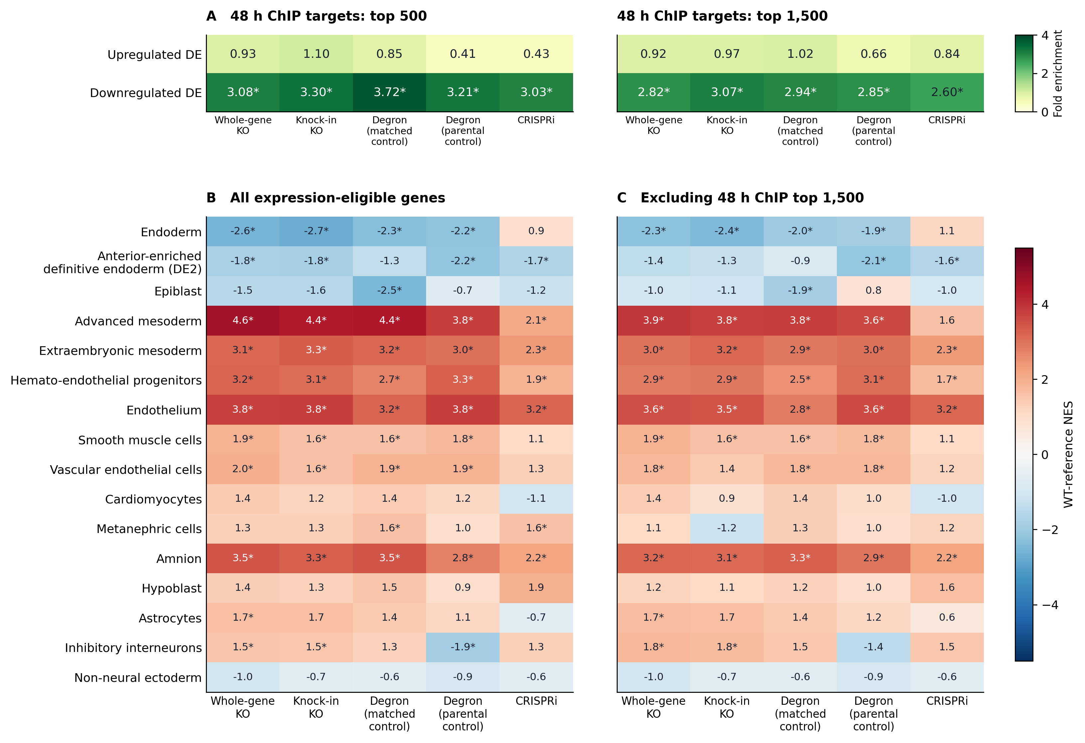
Figure 1. 48-hour EOMES ChIP targets and cell-fate programs after EOMES perturbation. (A) Enrichment of upregulated and downregulated DE genes among the fixed top 500 (left) and top 1,500 (right) 48-hour ChIP targets. Values are observed/expected overlaps; * one-sided Fisher BH q < 0.05 across 20 tests. (B, C) Unweighted GSEA of cell-type signatures using all expression-eligible genes (B) or excluding the 48-hour top 1,500 targets (C). Values are NES calibrated against 1,566 source-adjusted WT-versus-WT 3v3 assignments from nine selected EOMES control libraries. The expression filter is q75_pass and maximum KO/control mean CPM ≥ 1; each comparison's gene list is fixed across WT assignments. Red indicates higher and blue lower expression after perturbation. * WT-reference BH q < 0.05 across all tested signatures and five contrasts, separately per panel. References: Tyser et al. (2021), human gastrula; Cao et al. (2020), human fetal atlas. DE2 denotes anterior-enriched definitive endoderm. Whole-gene and knock-in KO share WT samples; both degron comparisons share perturbed samples, with matched uninduced or auxin-treated parental controls. Reference similarity does not assign a cell fate; genes outside the target list are not proven indirect targets.

