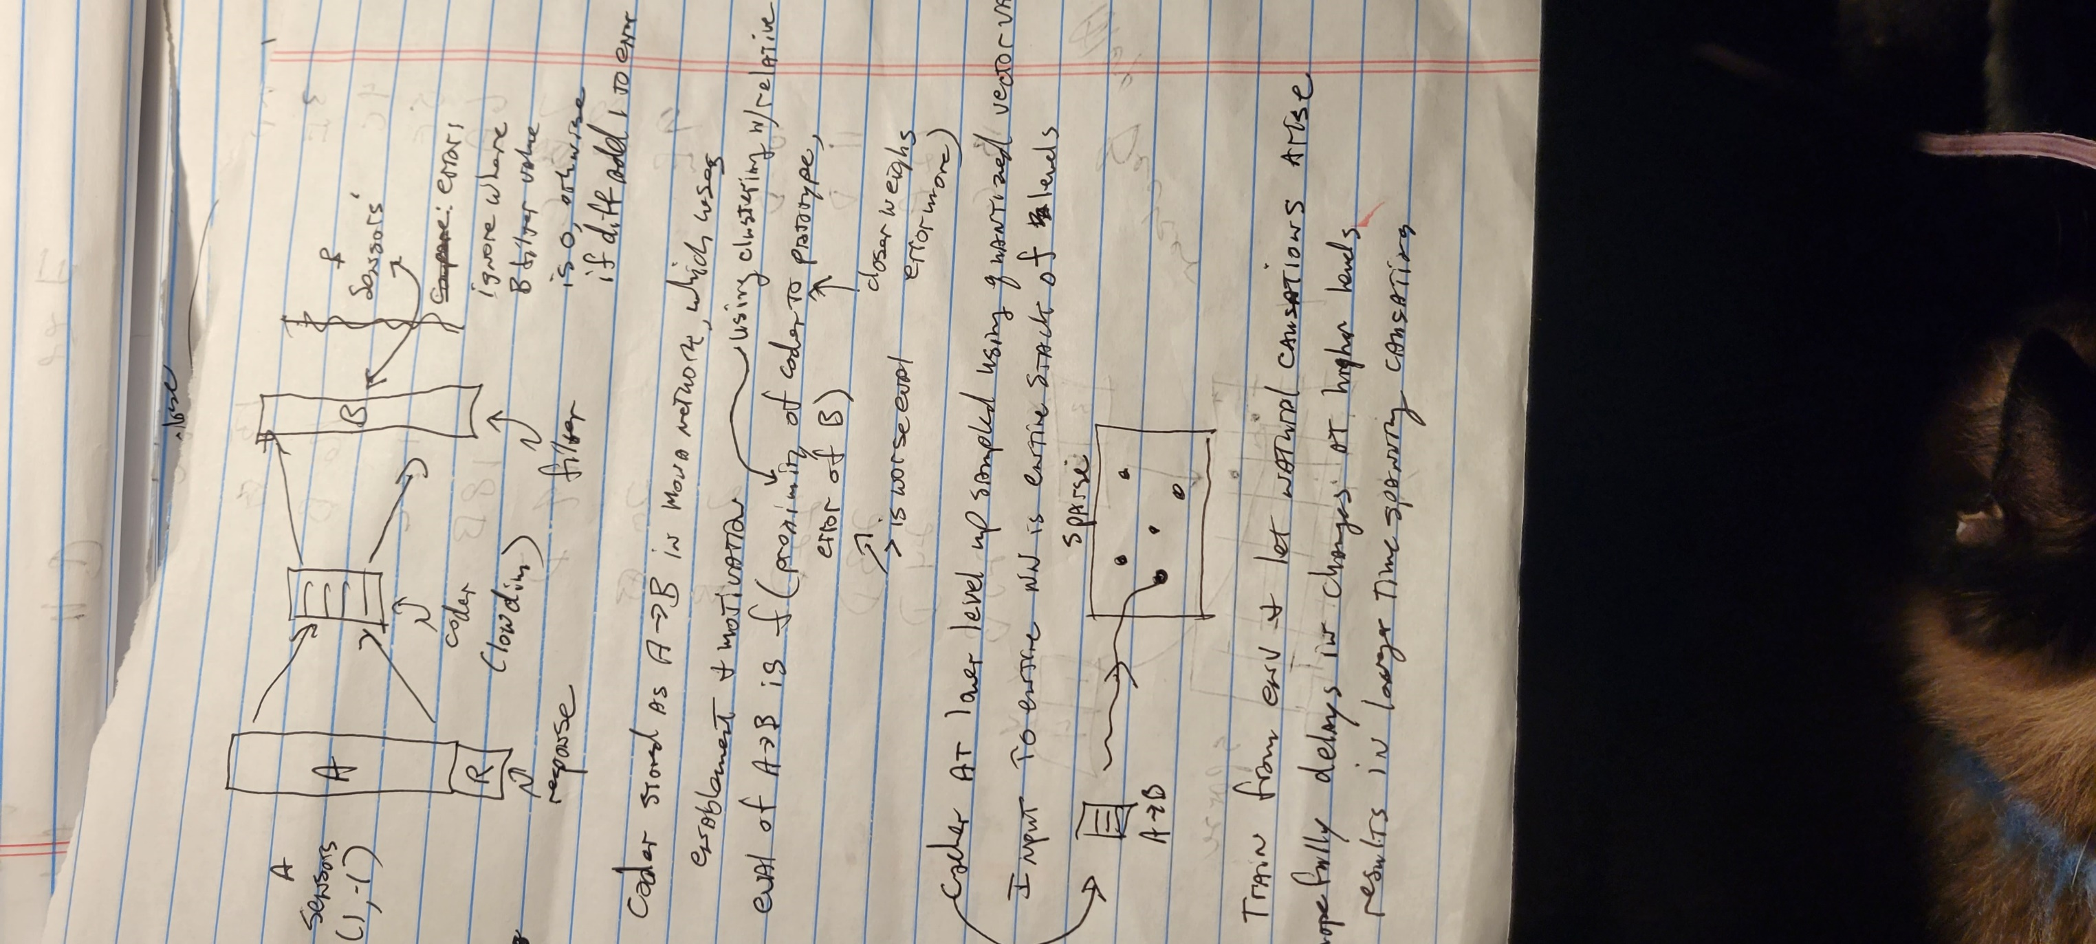
Note: sparse example: A: (3,5) with two dimensions after dimension reduction from input, B: (1,4). Plot points into a 10x10 space. Repeat process going up each level. So a dimension value pivots to a range of dimension in the higher space (similar to DB pivot).
How to achieve variable causation latencies at levels. Causations in higher levels will have greater time spans than lower levels. One method for this would be to vary the proximity parameter for the code centroid spaces. Centroids that can be close together will capture small changes; centroid that are farther apart will each be mapped to by a wider variation of codes and thus require more changes to map to a different centroid.
Addressing the A->B, X->Y co-occurrence event, in this case the code may lie between the A->B and the X->Y centroids. So why not process both of them? Neither will show up as strongly as if they were the sole causation event, but they should prove significant also.
2/13/2022
Let there be two computations:
Sensors at all levels -> response (not including need, as this is a model-based system as opposed to a model-free system aka Q-learning).
Per level + response -> effect (this will create the code to be incorporated at higher level)
Can this scheme dispense with the Mona network and centroids? (no)
2/14/2022
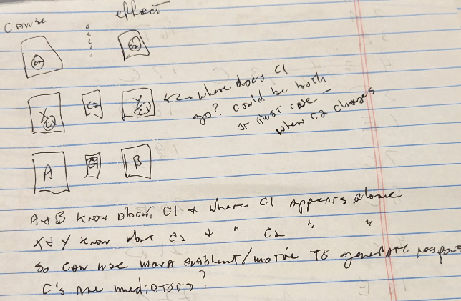
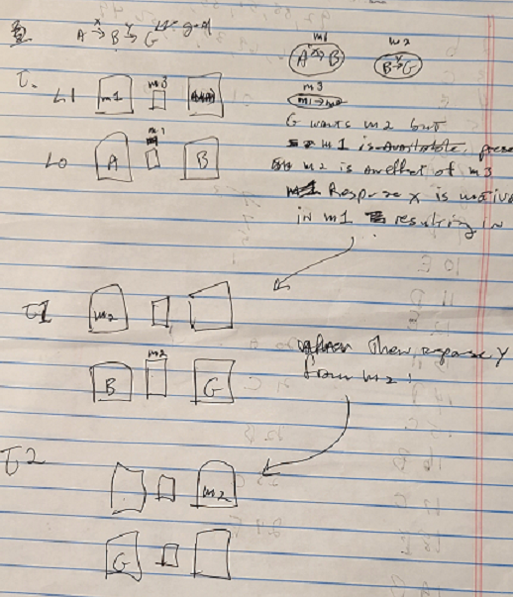

Ref:
Exploratory State Representation Learning
Astrid Merckling*, Nicolas Perrin-Gilbert, Alex Coninx and Stéphane Doncieux
Model-based scheme to explore and map env followed by RL on learned space.
Note: look up Reber learning comparison between humans and machines. Notes how humans appear to learn it piecemeal like Mandala.
Instead of using centroids, might use an RBF network to classify against prototype vectors.
Instead of generating random grammars, generate them according to rules:
- Breadth: e.g. A, AB, ABC
- Depth: A=A1 A2 A3
- Repetition: AA, ABAB, ABCABC
At the edge of the tree, terminals are produced.
This will provide more reliable performance measurements.
Mandala prototyping with grammar. Instead of encoding causations, sum the occurrences, so if a and b occur in the lower level in the level’s time duration, the one-hot representations of a and b are summed.
What sort of statistical analysis can be done on the mutual info/Baysian probs of the grammar that help explain performances?
Spruce up TDNN as a prototype test. Try testing entire length, accumulated values, copying values into multiple layers, and subsumption. These things helped for the maze project.

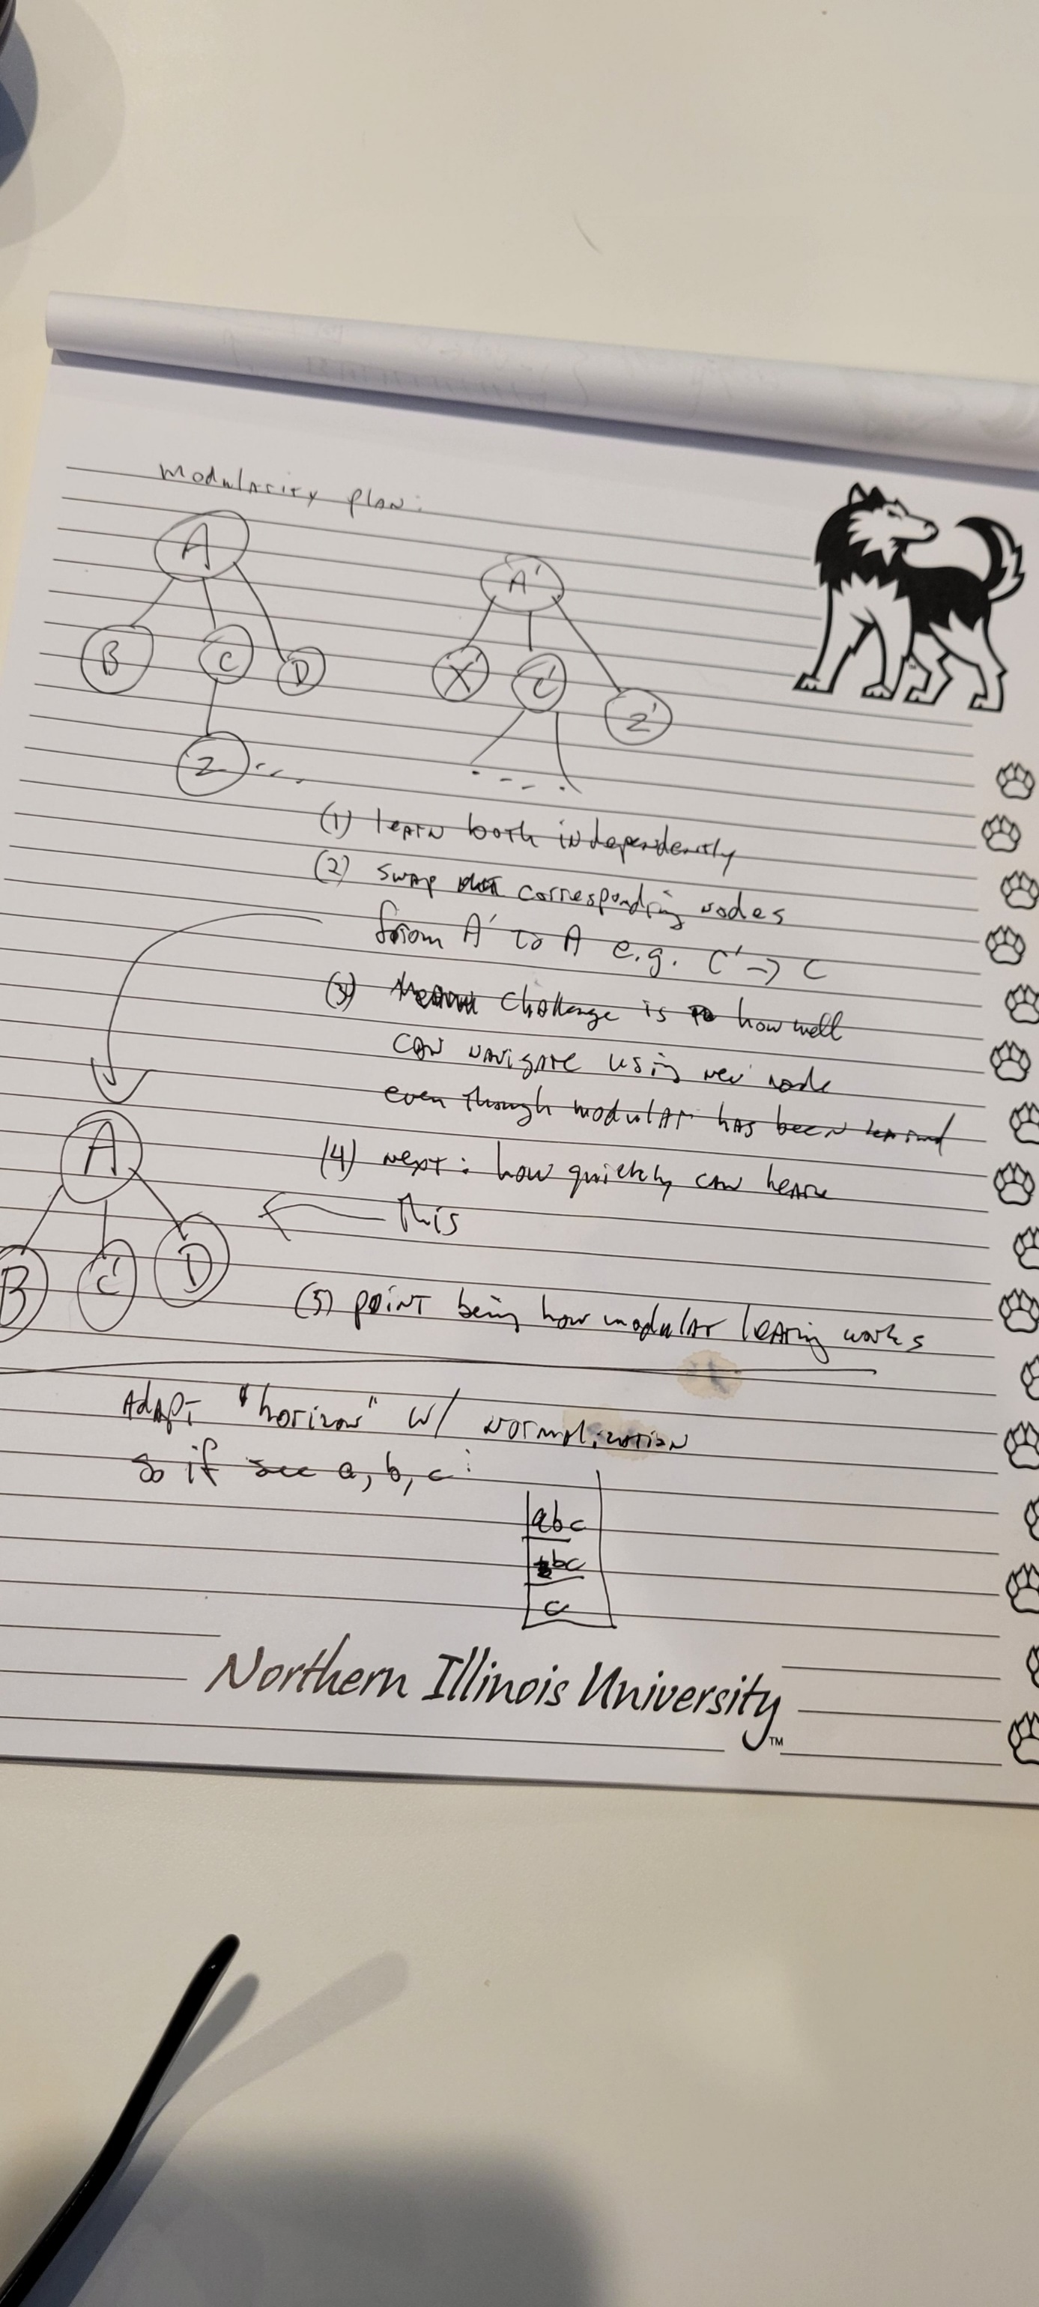
A simplification:
Start -> Goal. In between are a number of subgoals in sequence. These can be learned separately/modularly. String some of them together and learn the whole stream. Then life intervenes and adds and subtracts subtasks from the stream. Test and measure this.
Let the Start -> Goal be one monolithic learning stream. Then the task is to complete it given deletion and insertions of other modules.
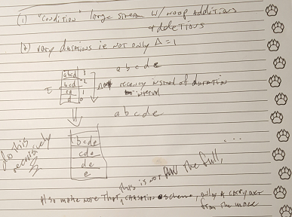
Hierarchical Reinforcement Learning:
Assignment of Behaviours to Subpolicies by Self-Organization
Wilco Moerman
Cognitive Artificial Intelligence, Utrecht University
wilcom@phil.uu.nl, wilco.moerman@gmail.com
https://www.geeksforgeeks.org/deep-learning/sparse-autoencoders-in-deep-learning/
Remember to check EverNote and Melendey for refs.
Mona:
A pair of cooperating nest-building and foraging birds.
See: http://tom.portegys.com/research.html#nestingbirds
Morphognosis:
Honey bees forage for flower nectar cooperatively.
See: http://tom.portegys.com/research.html#honey_bees

