## Open surface

.stl, .ply, .vtk surfaces can be open via this menu. ISE-MeshTools does not manage textures associated with meshes; still, you can open .obj files, but associated textures will not be loaded.

## Save surface

Selected surfaces can be saved into files. If no surface is selected, the following message appears:

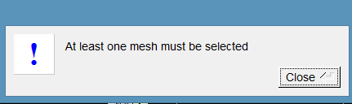

If more than one mesh are selected, the following message shows up:

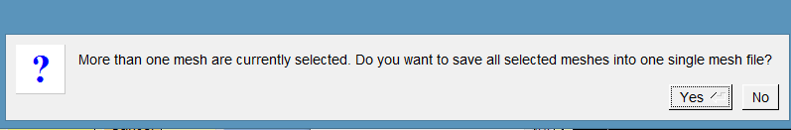

### Save .ply

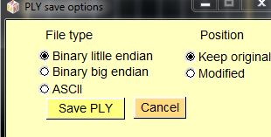

Options:

* File type: you can save .ply data in binary (little or big endian) or ASCII formats.
* Position : you can keep object original coordinate system or save the surface in its current position

### Save .stl

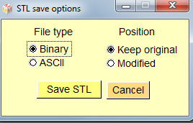

Options:

* File type: you can save .stl data in binary (little endian) or ASCII formats.
* Position : you can keep object original coordinate system or save the surface in its current position

### Save .vtk

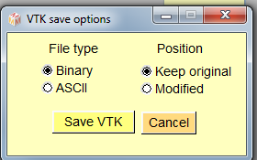

Vtk mesh file format is by far not as widespread as stl or ply format. However, it is extremely useful as it allows to store scalar and tag values at each vertex or at each triangle.

Options:

* File type: you can save .vtk data in binary (little endian) or ASCII formats.
* Position : you can keep object original coordinate system or save the surface in its current position

### Save .obj

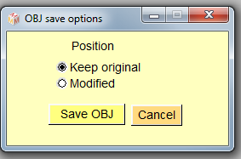

ISE-MeshTools does not manage textures associated with meshes. Still, you can save meshes in .obj format, but textures will not be saved.

Options:

* Position : you can keep object original coordinate system or save the surface in its current position

## Position

In MeshTools, mesh position consists in two 4\*4 square matrices: one matrix is used as the aspect matrix (by default the identity matrix), and the other one as the position matrix. These matrices can be opened and saved in “.pos” format.

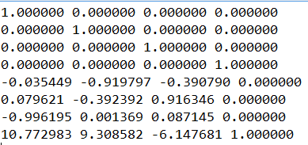

Example of .pos position file. The first four lines correspond to the aspect matrix, and the four last lines correspond to the position matrix.

### Load position

If no surface is selected, the following message appears:

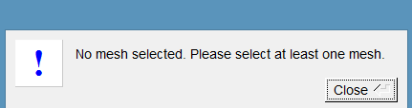

If more than one mesh are selected, the following message shows up:

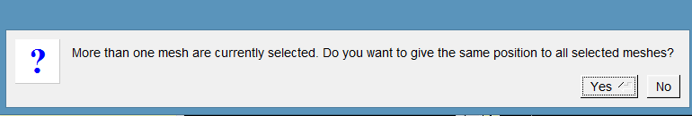

### Load transposed position

This option may be useful in the following case:

* Let us suppose that you did modify the position of a given surface and saved its position
* Then you have saved the surface in its current modified position (that is : the original position of the surface is lost).
* For some reason, you may need to open the surface in its original position. To do so, you may apply this option (apply transposed position matrix to the modified surface).
* Note : this option only works if the aspect matrix was not modified.

### Save position

Mesh aspect and position matrices can be saved in “.pos” format.

If no surface is selected, the following message appears:

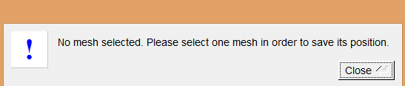

If more than one mesh are selected, the following message shows up:

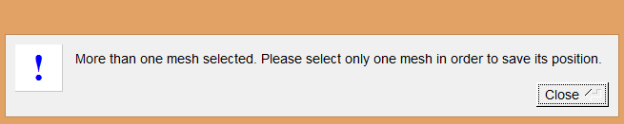

### Editing manually aspect and position matrices.

There are two ways to access the object matrix editor.

* Either select one surface and click on “”(edit first selected object position and aspect matrices).
* Or select one surface and click on “edit selected surfaces->Rendering modifications-> edit first selected object position and aspect matrices”.

This opens the “Object Matrix” window, in which the aspect and position matrices can be edited.

See “Edit selected surfaces” corresponding section (Rendering modifications-> edit first selected object position and aspect matrices) for further information.

## Project

When working with multiple surface objects, loading surfaces and associated positions one by one becomes fastidious. You may open and save series of meshes and associated position matrices using this menu.

“project” files (.ntw) files are organized the following way :   
- Name of surface 1 file   
- Name of position 1 file associated to surface 1  
- Surface 1 RGB colour and transparency  
- Name of surface 2 file   
- Name of position 2 file associated to surface 2  
- Surface 2 RGB colour and transparency  
(etc...)

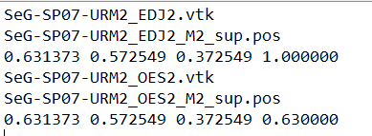  
Example of .ntw file

Surface files can be of the following types : .stl, .vtk, .ply and .obj  
“.ntw” files can be constructed manually, providing that the refered surface and position files exist.

### Open project

Loads a .ntw file

### Save project

Saves a .ntw file implicating all selected surfaces. Though ISE-MeshTools can open .ntw files implicating .stl, .ply and .obj surfaces, when saving a .ntw project, surface files will be saved in .vtk format in order to keep potential tag / scalars associated to each saved surface. Each surface file will be given the name of the original file. Each position file will be given a name which starts with the name of the associated surface and ends with the name of the project. In the .ntw file example shown above, the surface files are “SeG-SP07-URM2\_EDJ2.vtk” and “Seg-SP07-URM2\_OES2.vtk”, and the project name is “M2\_Sup.ntw”. The advantage of naming position files that way is you may construct different .ntw files with different associated surface files using a same set of surfaces.

Requirement : all selected surfaces saved via this option need to have distinct names

Note :

When working with “project” files, you may need at some point to rename some of the object surfaces. To do so, select one surface, click on : the following window appears:

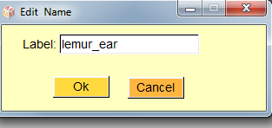

Press ok to modify the name of that surface object.

See tutorial “working with projects” for further information.

## Landmarks

As mentioned earlier, landmarks can be set on surfaces by pressing “L” + left mouse click.

Two series ofconventional landmarks can be set : “normal” and “target” landmarks. As mentioned earlier, in the “normal” landmark mode (button  active), pressing “L” + left mouse click results in the creation a “normal” landmark (a red one). In the “target” landmark mode (button  active), pressing “L” + left mouse click will create a “target” landmark (a yellow one). “Normal” and “target” landmarks can be loaded and saved.

Selected “normal”/”target” landmarks can be reordered using the following buttons. Pressing “” will place the selected landmarks earlier in the “normal”/”target” landmark list, while pressing “” will place them one step further, respectively.

ISE-MeshTools can manage two types of landmark files: “.LMK” “.VER” files.

.LMK files contain a series of lines, each line being constructed the following way: landmark name (without space or tab character), landmark coordinates.

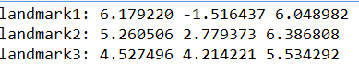

Example of “.LMK” file.

Note that each landmark name does not need to be of the form “landmark”+landmark number. Meanwhile, the name should not hold space or tab characters.

.VER files contain a series of lines, each line being constructed the following way: landmark name (without space or tab character), landmark coordinates, landmark orientation.

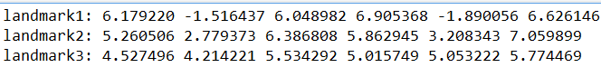

Example of “.VER” file

### Load landmarks

Landmarks opened using this option will be put in the “normal” landmark list (red landmarks)

### Load target landmarks

Landmarks opened that way will be put in the “target” landmark list (yellow landmarks)

### Save landmarks

Contrary to surface objects, which need to be selected in order to be saved, all selected and unselected “normal” landmarks (the red ones) are saved when using this options.

### Save target landmarks

Contrary to surface objects, which need to be selected in order to be saved, all selected and unselected “target” landmarks (the yellow ones) are saved when using this options.

The section “Menu: Edit Selected Landmarks” and the tutorial “working with landmarks” contain further information regarding landmark digitization with ISE-MeshTools

## Curves

3D Curves are constructed in ISE-MeshTools using 2 series of landmarks : a series of “normal” landmarks, and a series of “target” landmarks of equal sizes. “Target” landmarks are referred to as “curve handles”, when they are used to construct curves (“Target” landmarks can also be used to achieve TPS deformation, see later in this documentation).

By default, curves are not drawn in the main 3D window : curves start being drawn when the checkbox “draw curves” is checked in the menu “Viewing opt.” (Draw_curves.png)

Two different cases are considered:

Case 1: the numbers of “normal” and “handle/target” landmarks differ. In that case, a curve is a series of lines passing through “normal” landmarks.

Case 2: the numbers of “normal” and “handle/target” landmarks differ. In that case, a curve is a series of cubic Bezier curves passing through “normal” landmarks. For a given set of 2 “normal” consecutive landmarks (Ln and Ln+1) and their associated curve “handles” (Hn and Hn+1), a mirror image of Hn+1 relative to Ln+1 (H’n+1) is constructed. The Bezier curve involving Ln, Ln+1, Hn and Hn+1 starts from Ln, going toward Hn, and arrives at Ln+1 coming from the direction of H’n+1.

The explicit form of the curve is :

B(t) = (1-t) 3**Ln** + 3(1-t)²t**Hn** + 3(1-t)t²**H’n+1** +t3**Ln+1**, t ∈[0,1]

In order to be able to digitize several curves using a given set of normal and target landmarks, “normal” landmarks curves can be given 4 flags (see section ”Edit Selected landmarks”-> Landmarks involved into curves for further details):  
Flag “0” : landmark is placed inside the curve (drawn “red”).  
**Flag “1”** : landmark is a curve start (drawn “green”).  
Flag “2” : landmark is placed inside the curve, and is a curve **“milestone”** (drawn blue).  
Flag “3” : landmark is placed inside the curve, and should be connected to the preceding curve starting point. When landmark n is flagged that way, landmarkn+1 will be set as a curve starting point.

Flag “2” is used to decompose a given curve into curve segments (see “export curves as landmark file”). By default, a curve comprises 1 segment

Flag “3” is used to close a curve (by default, curves are open).

3D curves are loaded and saved into .CUR files, which contain a series of lines, each line being constructed the following way: name (without space or tab character), curve “normal” landmark coordinates, curve “handle” coordinates, flag.

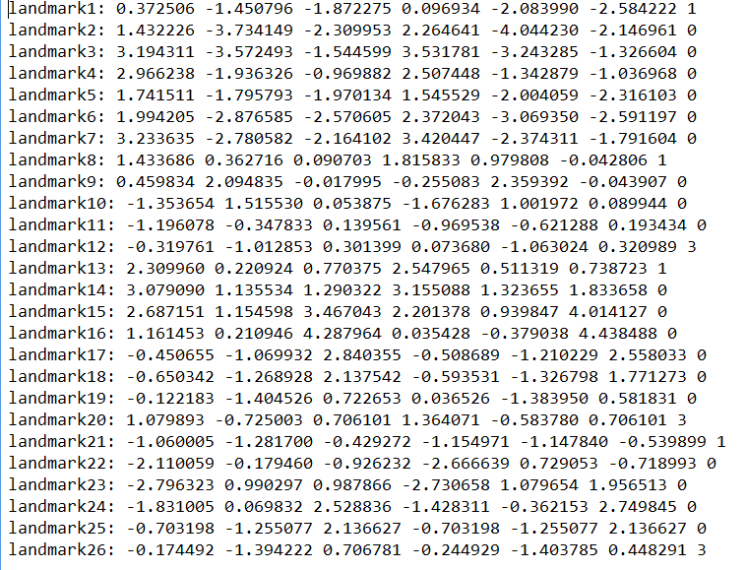

Example of “.CUR” file.   
In this example, 4 curves are defined :   
- an open curve starting from landmark 1 and ending at landmark 7  
- a closed curve involving landmarks 8 to 12  
- a closed curve involving landmarks 13 to 20  
- a closed curve involving landmarks 21 to 26  
These four curves contain only one segment (no curve milestone was set within those 4 curves).

Note that each name does not need to be of the form “landmark”+ number. Meanwhile, the name should not hold space or tab characters.

### Load curves

This menu allows the user to load a .CUR file.

### Save curves

This menu allows the user to save current landmarks and curve handles as a .CUR file. This action is ony allowed if the number of “normal” landmarks and “target” landmarks is the same. If not, the following message appears:

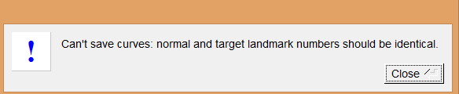

### Export curves as landmark file

Curves can be transformed in a series of equidistant landmarks using this option. The following window appears:

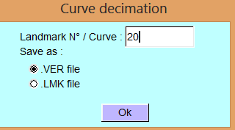

Each curve / curve segment is saved as a number of equidistant landmarks. In the present example, each curve / curve segment is saved as 20 equidistant landmarks.

When pressing “Ok”, if the numbers of “normal” landmarks and “target” landmarks differ, the following message appears:

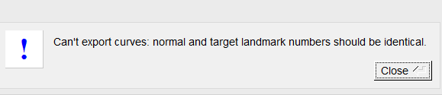

### Save curve infos (length per curve …)

Each curve /curve segment length can be saved as a .txt file using this option.

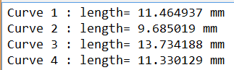

Example of curve info file.

The section “Menu: Edit Selected Landmarks” and the tutorial “Working with curves” contain further important information regarding curve digitization with ISE-MeshTools.

## Tags and flags

* Tag colours and names can be edited interactively by clicking on , which opens the tag window (see the section “Menu Tags” and the tutorial “Working with tags” for further information).
* By default, Tags are not visible. To activate/deactivate tag display, click on 
* Using “Tag display mode” ( ) is useful when editing surface tags.

25 Tag names and associated colours can be defined in ISE-MeshTools. Tag colours files (.TAG) consist of 25 pairs lines, each pair being constructed following way :  
line 2\*n: Tag name  
line 2\*n+1: Tag colour and transparency

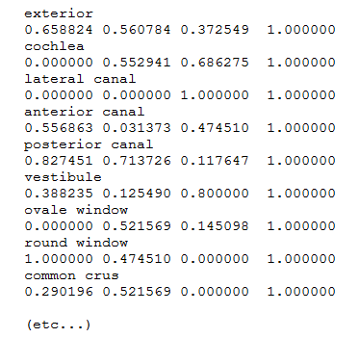

Example of .TAG file

Regarding flags, as stated earlier, one series of “flag landmarks” can be set in ISE-MeshTools (button  should be pressed). To edit flag labels, select one flag landmark, click on  . The following window should appear :

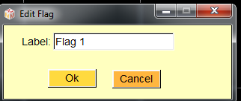

Pressing ok will update the label associated to the selected flag, which in turn will be unselected.

Flags are saved using the .FLG file format, which consists of n pairs of lines constructed the following way :

line 2\*n: Flag name  
line 2\*n+1: Flag coordinates and Flag orientation.

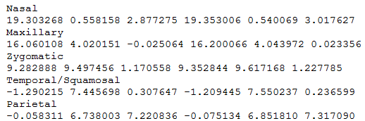

Example of .FLG file

### Load tag colours and labels

Select a .TAG file using this menu => Then open the tag window () : Tag labels, colours and transparencies should have been updated.

### Save tag colours and labels

This option saves the current state of tag labels, colours and transparencies in a .TAG file.

### Load flags

Select a .FLG file using this menu

### Save flags

This option saves the current flag landmarks into a .FLG file, regardless their selection status.

## Save infos (surface area, volume...).

Surface area, volume, triangle number and vertex number of selected surface objects can be saved in a .txt file using this option.



Example of info file

Note: surface objects should be closed in order to provide a correct estimation of object volume.