# Menu « ? »

## About

This option shows the current version of ISE-MeshTools.

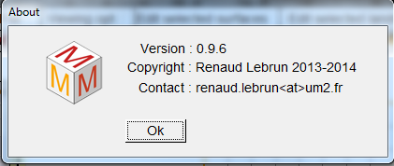  
ISE-MeshTools’ about window