Camera

Camera options
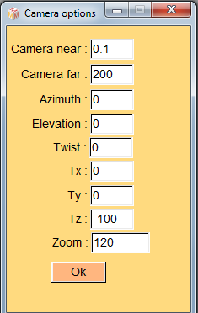

Camera rotation centre at
Camera rotation centre can be modified at the origin (x=0, y=0, z=0) or at the location of one of the first 10 “normal” landmarks.

Set 100 pixels in mm
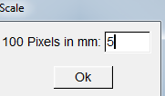
Camera zoom can be modified in order to reach a desired display pixel size. This is useful to produce scaled images.

Reset camera
You may use this option to reinitialize camera parameters.

Object rendering options

Gouraud shading (smooth rendering)
This is the default rendering mode. Object rendering is performed using vertices’ normals.
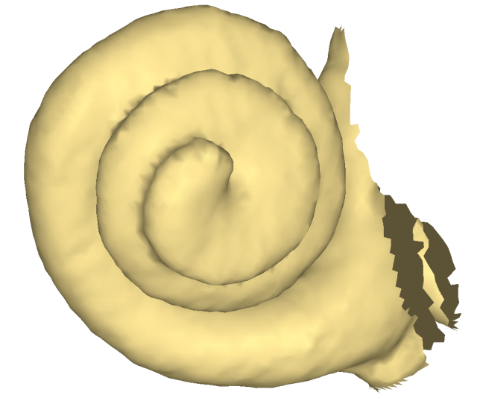
Example of Gouraud shading rendering.

Draw wireframe
This option can be useful to inspect the structure of the surface.
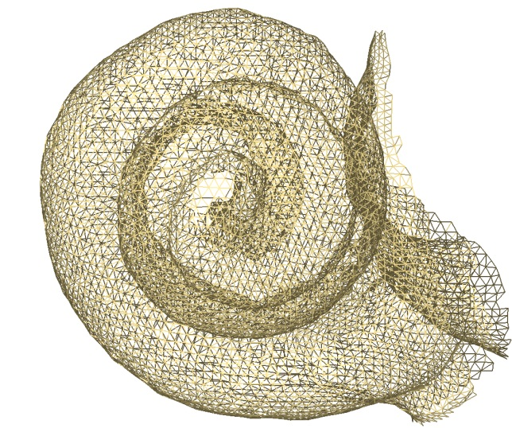
Example of wireframe rendering.

Sort vertices from back to front (beware: slow rendering)
This option is (only) useful when working with transparent surfaces, in the case you want to display all surface inner structures. When active, whenever the camera of the object is moved, vertices will be sorted in order to be displayed from back to front. This is the way transparency is achieved in OpenGL. As a consequence, rendering fluidity becomes slow when working with heavy surfaces and/or a large number of objects. To change the transparency of an object, select an object, and reach “Edit selected surfaces -> Rendering modifications -> Set alpha value”.
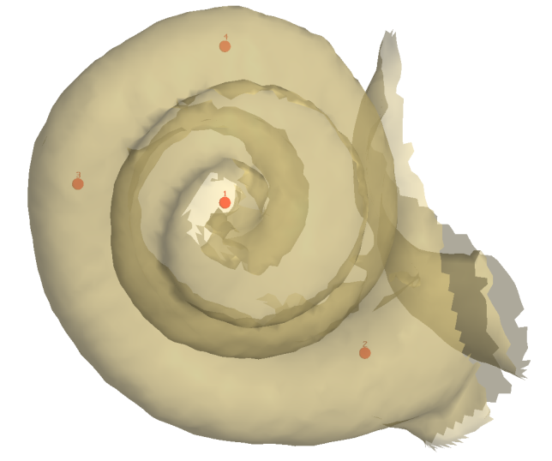
In this example, vertices are displayed from back to front. Four landmarks placed within this structure can be visualized.
Alternatively, in order to increase rendering fluidity, you may chose not to use the “Sort vertices from back to front (beware: slow rendering)” rendering option, but sort episodically the vertices from back to front by pressing the button.
Working with transparency is useful to observe inner structures and/or when digitizing landmarks inside structures.

Sort vertices from front to back (beware: slow rendering)
This option is (only) useful when working with transparent surfaces, and when you do not want to display too many inner structures. When active, whenever the camera of the object is moved, vertices will be sorted in order to be displayed from front to back. As a consequence, rendering fluidity becomes slow when working with heavy surfaces and/or a large number of objects.
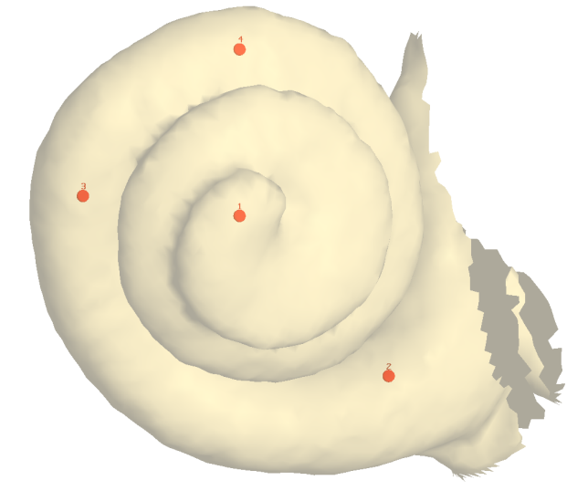
In this example, vertices are displayed from front to back. Four landmarks placed within this structure can be visualized. Landmark localization is better achieved than when using the preceding display mode, because the inner structure of the objects are not shown.
Alternatively, in order to increase rendering fluidity, you may chose not to use the “Sort vertices from front to back (beware: slow rendering)” rendering option, but sort episodically the vertices from front to back by pressing the button.

Flat triangles
Using this option improves the perception of surface structure.
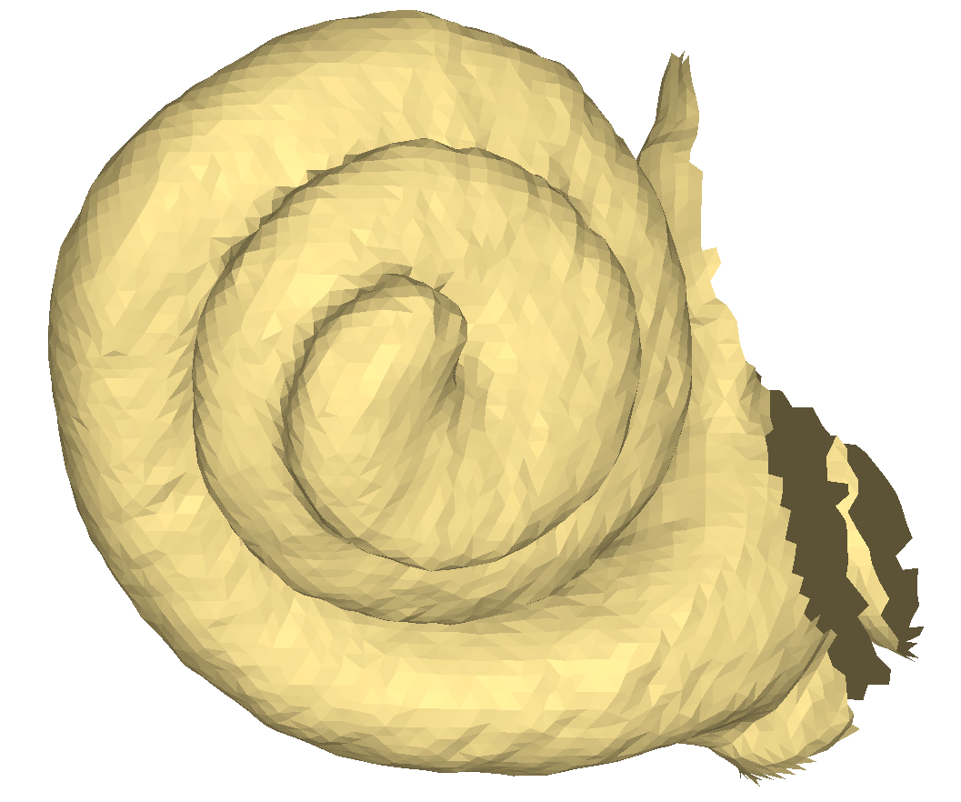
Example of flat triangle surface rendering.

Wireframe and flat triangles
Using this option further improves the perception of surface structure.
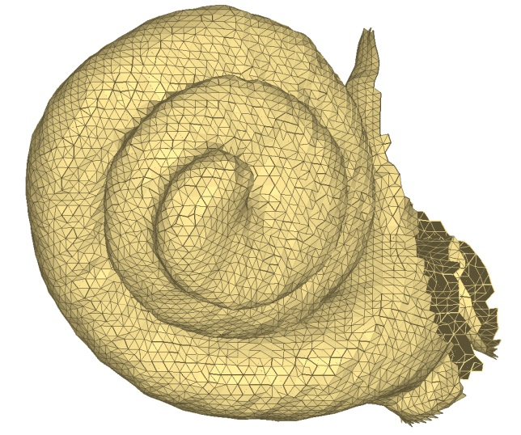
Example of flat triangles + wireframe surface rendering.

Backface culling
Surface’s back faces are hidden when using this option.
Gouraud shading rendering without backface culling | 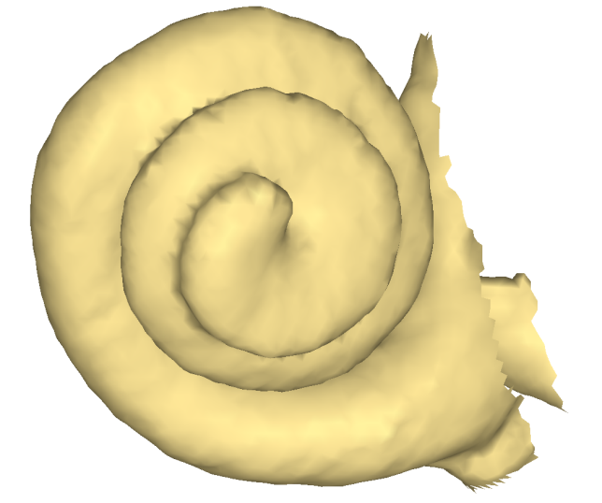  Gouraud shading rendering with backface culling

Display vertices ids
For surface inspection purposes, you may sometimes need to visualize vertices ids.
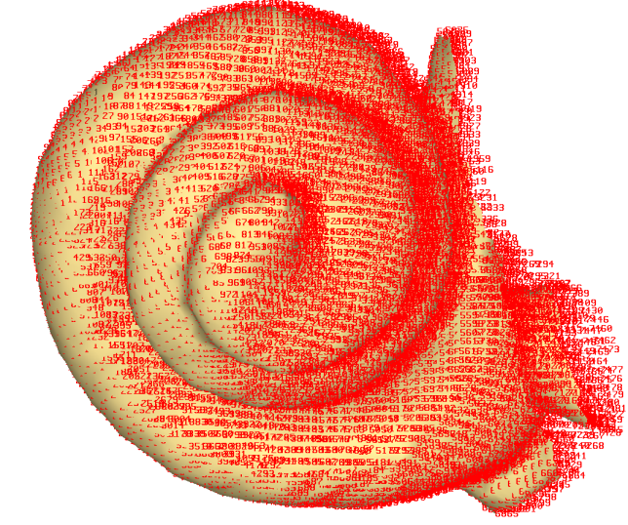
Example of Gouraud shading rendering + vertices ids.
Note : this option affects rendering fluidity even when using relatively light surfaces.

Display triangle ids
For surface inspection purposes, you may sometimes need to visualize triangle ids.
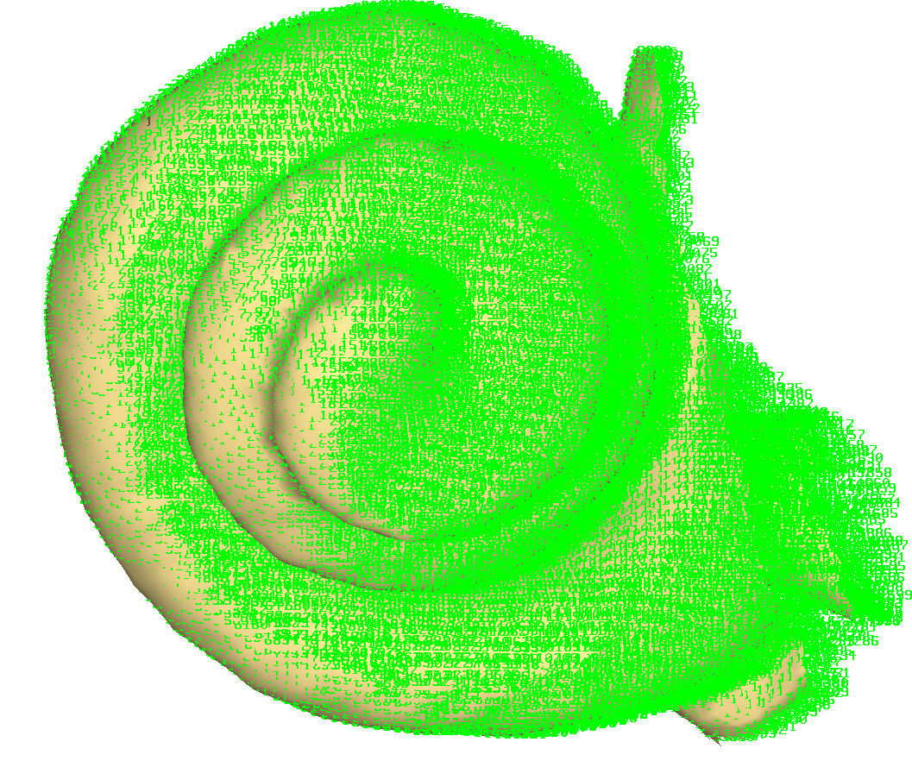
Example of Gouraud shading rendering + triangle ids.
Note : this option affects rendering fluidity even when using relatively light surfaces.

Grid size
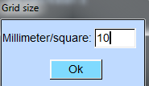
Grid size window
Grid rendering can be edited to reach the desired size/square

Display landmark numbers
“Normal” and “target” landmark numbers are displayed by default. For illustration purposes, you may sometimes need to hide landmark numbers.

Draw curves
Activate/deactivate this option to draw/hide 3D bezier curves passing through “normal” landmarks. See the tutorial “working with curves” section for further details regarding curve digitization with ISE-MeshTools.

