As stated above, landmarks can be set on surfaces by pressing “L” + left mouse click. Several actions can be performed on selected (grey) landmarks.

Push back selected landmarks on closest surface
When set via pressing “L” + left click, landmarks are positioned on one surface’s vertex. Selected landmarks can be subsequently moved manually to other locations (for instance, if you want to place a given landmark in the middle of a canal or a foramen, or between two unfused bones). However, you may sometimes want to push back automatically some selected landmarks to the position of the closest surface’s vertex available. This can be achieved using this option.

Change selected landmarks orientation according to surface normals
When set via pressing “L” + left surfaces, landmark orientation is that of the vertex on which it is placed. Selected landmarks’ orientation can be subsequently moved manually. However, you may sometimes want to reset one or several landmarks’ orientation automatically to that of the closest surface’s vertex available. This can be achieved using this option.

Landmarks involved into curves

Move curve handles (selected yellow landmarks) semi-automatically
This option allows saving a lot of time when creating 3D Bezier curves with ISE-MeshTools (see “working with curves” section for further details regarding curve implementation and digitization in ISE-MeshTools).
Requirement : at least a handle landmark (“target” landmark) must be selected.
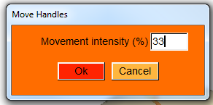
Move Handles window
Depending on whether selected curve handles lie within the curve, at the start of the curve or at the end of the curve, their displacements differ:
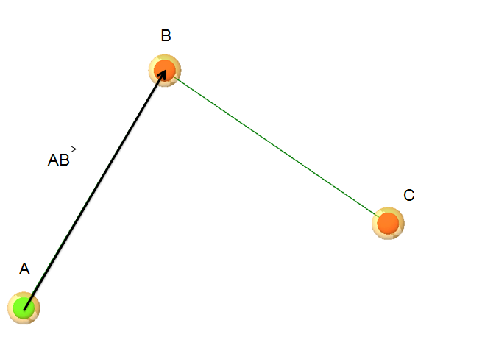  Case 1: curve handle is associated to a curve starting point (A), and a following point (B) exists. Vector is computed, as well as its length |AB|. | 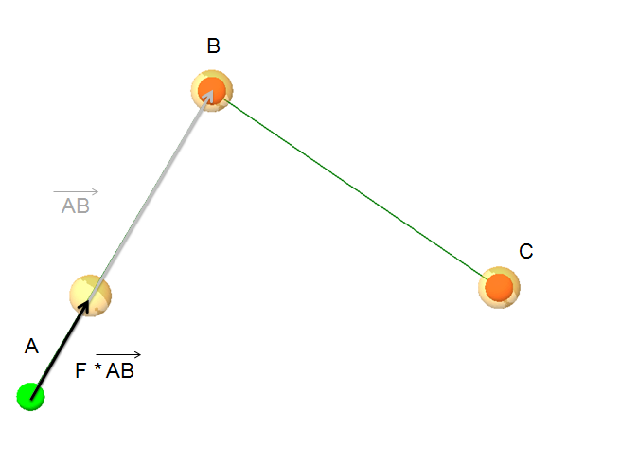  Curve handle associated to A is moved from point A along . Displacement length=movement intensity/|AB|.
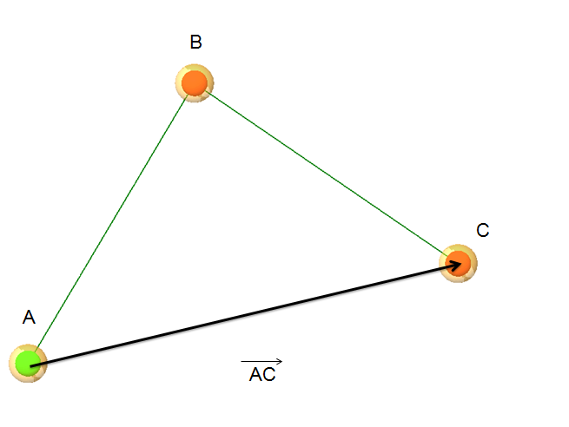  Case 2: curve handle is associated to a point B lying between two points (A and C). Vector is computed, as well as its length |AC|. | 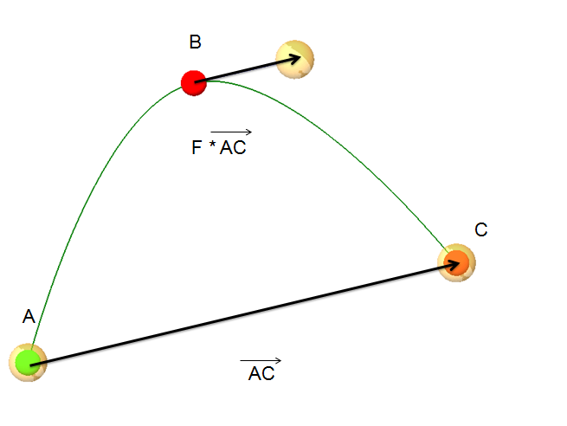  Curve handle associated to B is moved from point B along . Displacement length=movement intensity/|AC|.
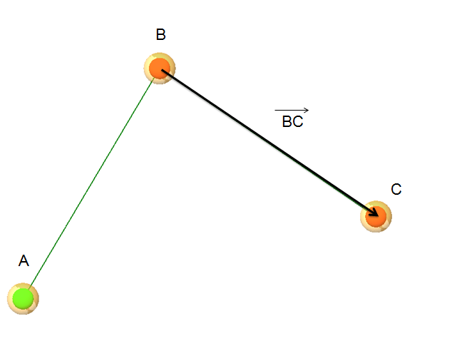  Case 3: curve handle is associated to a curve ending point (C), and a preceding point (B) exists. Vector is computed, as well as its length |BC|. | 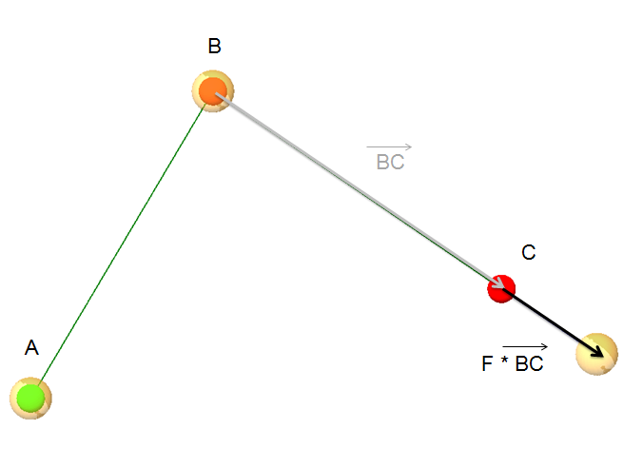  Curve handle associated to C is moved from point C along . Displacement length=movement intensity/|BC|.

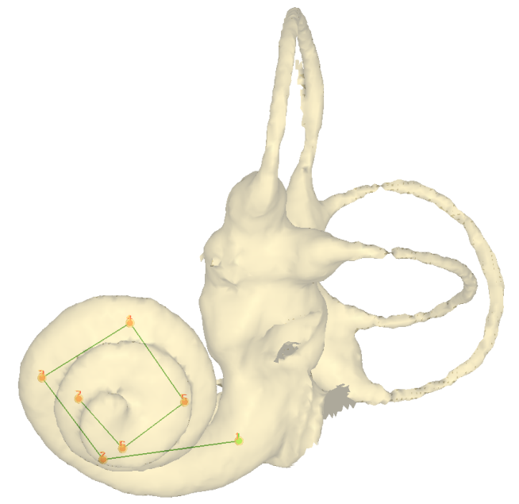 | 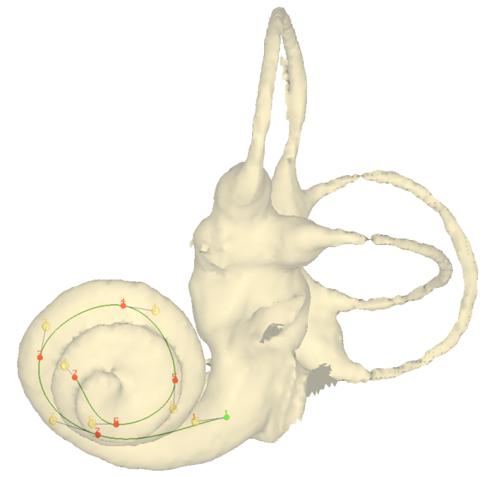
Example of curve handles semi-automatic displacement (movement intensity: 25%).

Normal landmarks (red): define as curve starting points (green)
Selected landmark will be given flag “1”.

Normal landmarks (red): connect to preceding starting points (violet)
Selected landmark will be given flag “3”.

Normal landmarks (red): define as curve milestones (blue)
Selected landmark will be given flag “2”.

Green, blue, violet landmarks: set back to normal landmarks (red)
Selected landmark will be given flag “0”.
Further information regarding curve use in ISE-MeshTools is available in the section “Menu File -> Curves” section and in the tutorial “working with curves”.

