Scalar values can be associated to each vertex. Scalar values can be displayed when scalar display mode is active. To activate/deactivate scalar display mode, click on “”. When active, the rainbow colour scale shows up in the bottom-right part of the 3D rendering window.
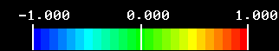
Rainbow colour scale, showing a “min” range display value of -1, a “max” range display value of 1, and a middle range display value of 0.

Show scalar rendering options window
Displayed scalars and scalar associated colour scales can aslo be onpend by clicking on
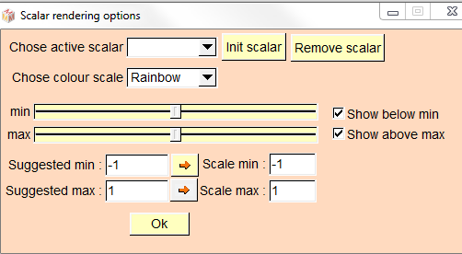
Scalar rendering options window
Available controls:
Chose active scalar : please chose among the available scalars (see below for further information).
Chose colour scale : please chose among the available colour scales (see below for further information).
Init scalar : set current active scalar values to “0” for all selected objects.
Remove scalar : removes active scalar for all selected objects. This option is useful if you plan to save surfaces in the .vtk format and do not want ISE-MeshTools to save associated scalar values (this will save some disk space).
min : changes the minimal value of the active colour scale.
max : changes the maximal value of the active colour scale.
Show below min: if active, all vertices with an associated active scalar value below “min” will be drawn using the colour situated at the leftmost part of the active colour scale. If not, these vertices will be transparent.
Show below max: if active, all vertices with an associated active scalar value above “max” will be drawn using the colour situated at the rightmost part of the active colour scale.
Suggested min: suggested “min” range display value. This value is computed in order to use the colour scale at its best.
Suggested max: suggested “max” range display value. This value is computed in order to use the colour scale at its best.
“”: Set min/max to suggested min/max, respectively.
Scale min: current “min” range display value.
Scale max: current “max” range display value.
Ok: applies changes.

Scalars: distance from camera (Depth)
Computes distance from camera for all vertices of all selected objects. This option may offer a better perception of the 3D structure of an object on a 2D screen representation.
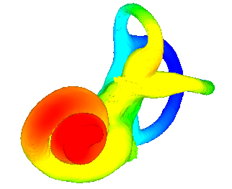
Example of 3D rendering of “Depth” scalars. Scalar mode is active, the rainbow colour scale is used.

Scalars : compute vertice curvature
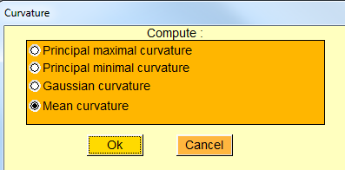
Curvature window.
vtkCurvatures filter is implied in this option. vtkCurvatures filter offers 4 ways to compute surface’s curvature at each vertex :
- Principal maximal curvature
- Principal minimal curvature
- Gaussian curvature
- Mean curvature
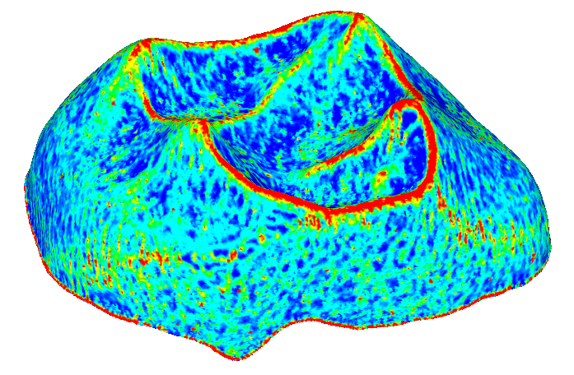  Principal maximal curvature | 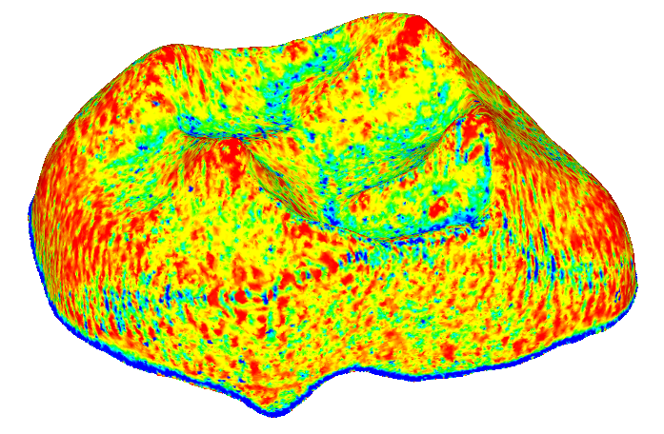  Principal minimal curvature
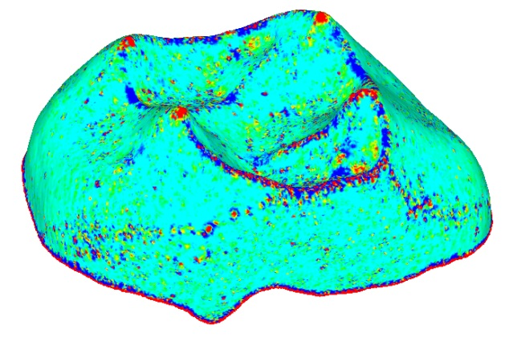  Gaussian curvature | 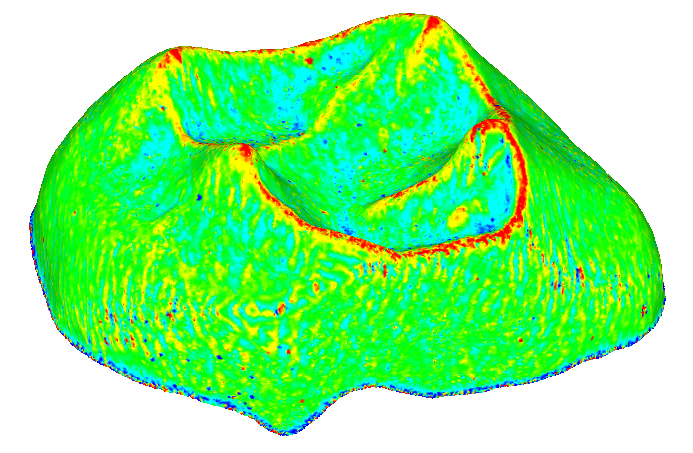  Mean curvature
Examples of 3D rendering of “Curvature” scalars. Scalar mode is active, the rainbow colour scale is used.
See vtkCurvatures’ documentation for further details.

Scalars: compute thickness
Thickness within an object is defined the following way: for a given vertex, the minimal distance between this vertex and other vertices in the direction opposite to that of the surface’s normal is computed. In order to minimize computation time, a maximal distance (Maximal thickness (mm) ) is asked to the user, in order to reduce the amount of vertices investigated at a given location.
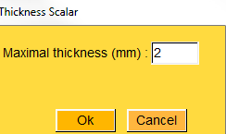
Thickness scalar window

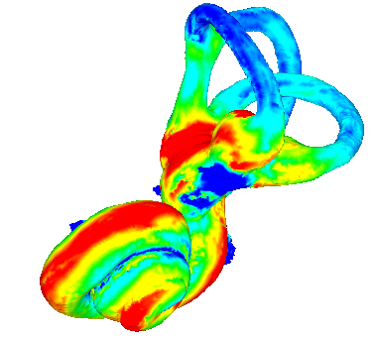
Example of 3D rendering of “Thickness” within object’s scalars. Scalar mode is active, the rainbow colour scale is used.

Scalars: compute thickness between two objects
Thickness between tow objects is defined the following way: for a given vertex of the impacted object, the minimal distance between this vertex and other vertices of the observed surface in the direction opposite to that of the impacted surface’s normal is computed. Again, in order to minimize computation time, a maximal distance (Maximal thickness (mm) ) is asked to the user, in order to reduce the amount of vertices investigated at a given location.
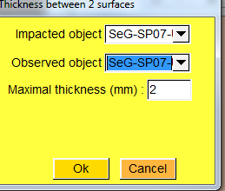
Thickness between 2 surfaces window.
Only selected surfaces appear in the impacted object and observed object lists.
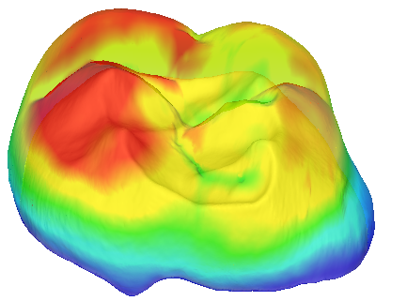
Example of 3D rendering of “Thickness” between two objects’ scalars. Scalar mode is active, the rainbow colour scale is used. Impacted object : enamel surface. Observed object : enamel-dentine junction’s surface.

Smooth active scalars (Gaussian blur)
Active scalars are “smoothed” the following way : for each vertex, a new scalar value is computed as the mean of the scalar values of all neighbouring vertices.
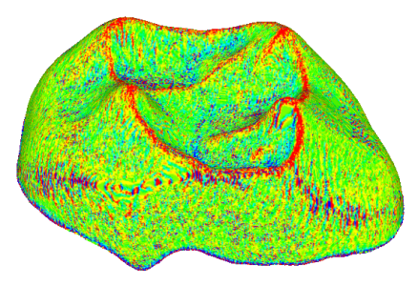 | 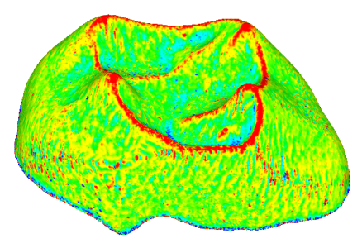 | 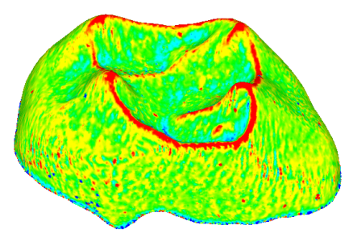
Examples of 3D rendering of “Mean Curvature” scalars. Scalar mode is active, the rainbow colour scale is used. Left : “raw” mean curvature. Middle : mean curvature scalars smoothed once. Right : mean curvature scalars smoothed twice.

Saving and loading scalars.
Computed scalars can be saved inside the .vtk surface files. In order to access scalar values into other software (such as a text editor), save the .vtk files in ASCII format. Saved scalars can be reloaded into ISE-MeshTools. Saving surfaces into .vtk format provides an efficient means to store and exchange computed scalars.

