Tagging surfaces with ISE-MeshTools
25 tags (ordered between 0 and 24) can be given a label, a colour, a transparency, and be manually delimitated. A greater number of tags can be given to a surface using automatic tagging tools such as the “Tag connected regions” tool, but these additionnal tags can not be labelled or manually edited. As stated earlier, in order to edit tags, it is avisable to activate the “tag mode” (press “” button). In this mode, selected surfaces (on which you can interact and tag) can be drawn according to tag values at each vertex if “tag display mode” is active. Press to activate “tag diplay mode”. When active, the tag colour scale shows up in the bottom-right part of the 3D rendering window.
Example of tag colour scale.
Selected surfaces can be tagged using the pencil tag tool (), the magic wand tag tool (), the paint bucket tag tool () or the lasso tag tool ().

Pencil tag tool ()
Pencil tag tool controls:
T pressed + left mouse click : tags the selected surface using currently active tag.
T pressed + right click : tags the selected surface using tag 0 (usually used as “exterior” tag). This option is often used to “clear” a wrongly tagged part.
Pencil tag special option :
pencil tag size can be modified in the Tag option window.
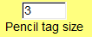
Pencil tag size option.
This option defines the tag propagation extension level, which starts at the vertex on which the mouse click is performed.

Magic wand tag tool ()
Magic wand tag tool controls:
T pressed + left mouse click : tags the selected surface using currently active tag.
T pressed + right click : tags the selected surface using tag 0 (usually used as “exterior” tag). This option often is used to “clear” a wrongly tagged part.
Magic wand special option :
Magic wand limit angle size can be modified in the Tag option window.
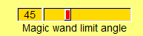
Magic wand limit angle.
This option defines the tag propagation extension level, which starts at the vertex on which the mouse click is performed : propagation stops if the angle between the notmal of current vertex and the normal of the vertex on which the mouse click was done is found is greater than the defined angle.

Paint bucket tag tool ()
Paint bucket tag tool controls:
T pressed + left mouse click : tags the selected surface using currently active tag.
T pressed + right click : tags the selected surface using tag 0 (usually used as “exterior” tag). This option is often used to “clear” a wrongly tagged part.
Note : the paint bucket tag tool works exactly like the magic wand tag tool when the magic wand limit angle is set to 180°.

Pencil tag, magic wand and paint bucket common option
These 3 tools share a common option, available in the Tag option window:
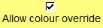
Allow colour override option.
If checked : no attention is paid to the colour of the vertex on which the left/right click was done during tag propagation.
If unchecked: tag propagation will stop if a tag colour different from 0 (exterior tag) and from that of the vertex on which the mouse click was done is found.
Important note : Be careful when using “allow colour override” option checked with the paint bucket tag tool or with the magic wand, as it will paint a large region uniformly (minutes or even hours of work may be lost in a single click, if you did not save your tagged surface in .vtk format earlier).

Lasso tag tool ()
The lasso tag tool can be used alone (option 1) or in combination with the pencil, the magic wand or the paint bucket (option 2).
Once “lasso tag tool” button is pressed, the mouse cursor changes to a cross in the 3D window. Additional mouse and keyboard controls become available

Left click | Adds a segment to polygon (segments are drawn yellow)
Right click | Connects last segment to first segment. If two segments cross each other, lasso tag action is canceled. Otherwise, the closed polygon is drawn red.
Option 1: once polygon is closed : Middle click or “C” + right click. | when click falls inside/outside the closed red polygon: the region falling inside the polygon is tagged/ is not tagged using the active tag colour, respectively. The region falling ousitde the polygon is not tagged/is tagged using the active tag colour , respectively.
Option 2: once polygon is closed: Press “T” + left or Press “T” +right click | The selected tag tool among the pencil, magic wand or paint bucket will be used, but tag propagation will not cross over polygon edges.
Once option 1 or option 2 is achieved, the usual mouse and keyboard controls become available again.

Show tag options window
The “Tag options” window can aslo be onpened by clicking on .
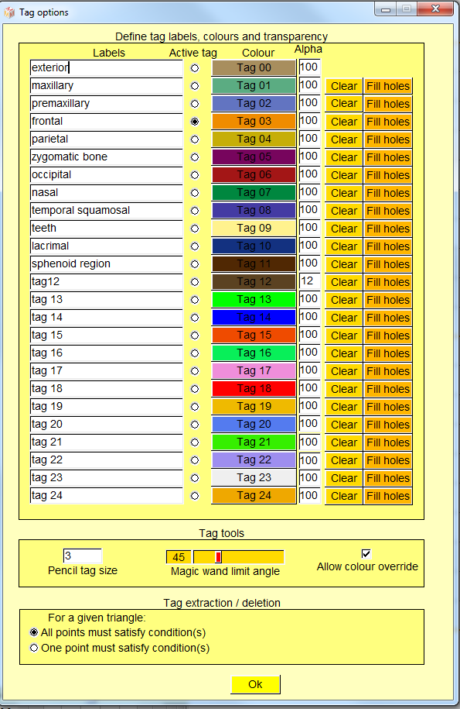
Tag options window
Available controls :
Define tag labels, colours and transparency group:
Labels : you may define tag labels for all 25 available tags.
Active tag : you may define the currently active tag.
Colour : you may define the colour for all 25 available tags.
Alpha : you may define the transparency for all 25 available tags.
Clear : clears the tag region (all vertices of this region will be set to 0 = Tag 00).
Fill holes : opens the following window:
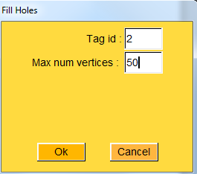
Fill Holes window
Pressing ok will fill all regions adjacent to the concerned tag region (Tag id) containing less than “Max num” vertices.
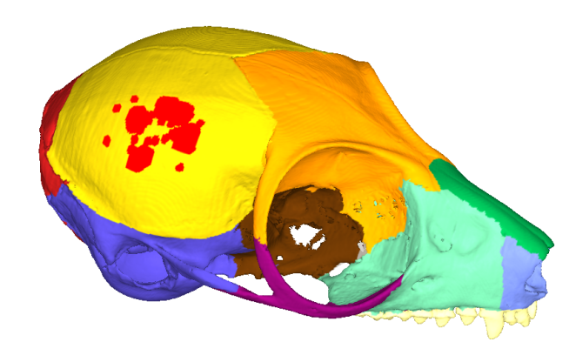 | 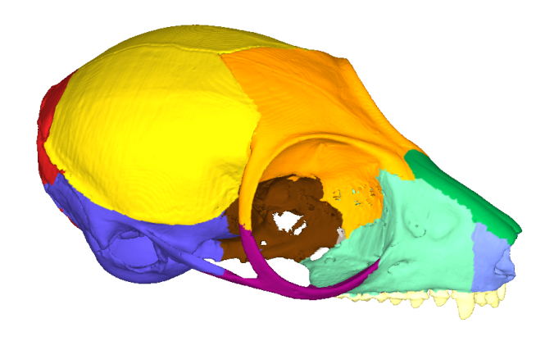
Exemple of tag hole filling. Left : cranium of Microcebus murinus presenting a parietal region tagged mostly in yellow, and presenting red “holes”. Right : “holes” present in the yellow region were filled using “Max num vertices” = 4000 option.
Tag tools group:
Pencil tag size : This option defines the tag propagation extension level of the pencil tag tool.
Magic wand limit angle : This option defines the tag propagation extension level of the magic wand tag tool (see above for further explanations).
Allow colour override : The pencil, magic wand and paint bucket tag tools share this option. If active, tag propagation will stop if a tag colour different from 0 (exterior tag) and from that of the vertex on which the mouse click was done is found.
Tag extraction/deletion:
For a given triangle : All points must satisfy condition / One point must satisfy condition.
This option defines the extent to which region extraction or deletion is performed at the boundaries of the concerned tagged region.

Merge tags
Two tagged regions can be merged into a single one
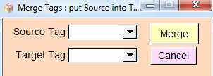
Merge tag windows.
All source tags will be put into target tags.
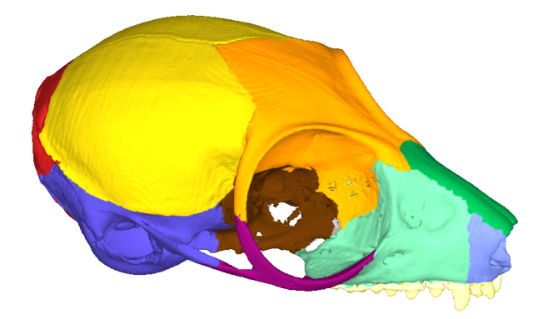 | 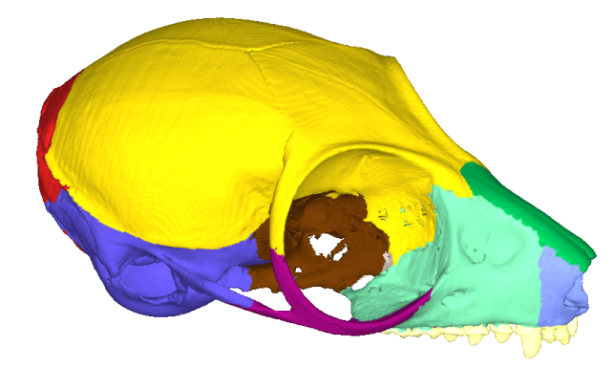
Exemple of tag merging. Left : cranium of Microcebus murinus presenting the parietal region tagged in yellow, the frontal region tagged in orange. Right : frontal tag region was merged into the parietal region.

Tag connected regions
This option implies vtkPolyDataConnectivityFilter.
This filter will tag all non-connected regions of the selected input surface into different colours.
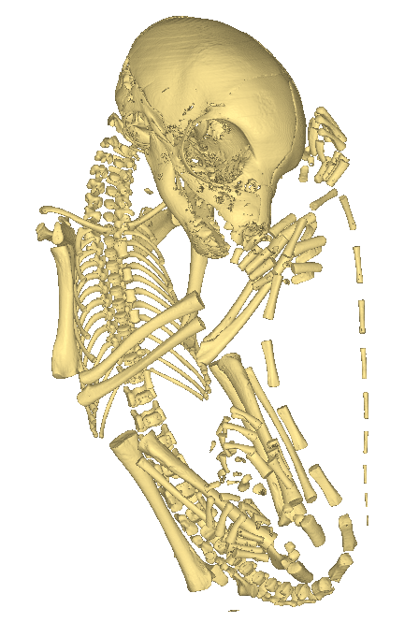 | 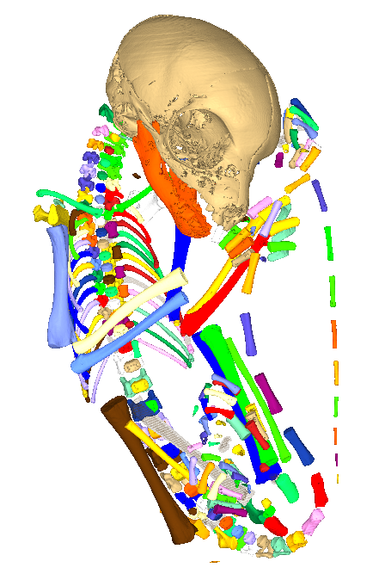

Left: original surface. Right: the same mesh automatically tagged into 304 non connected regions.

Extract
Note: The “Tag extraction/deletion” option in the Tag options window will affect the boundaries of the extracted regions.

Extract active tag corresponding region
Using this option, a single mesh will be created out of the active tag corresponding region of the selected object.
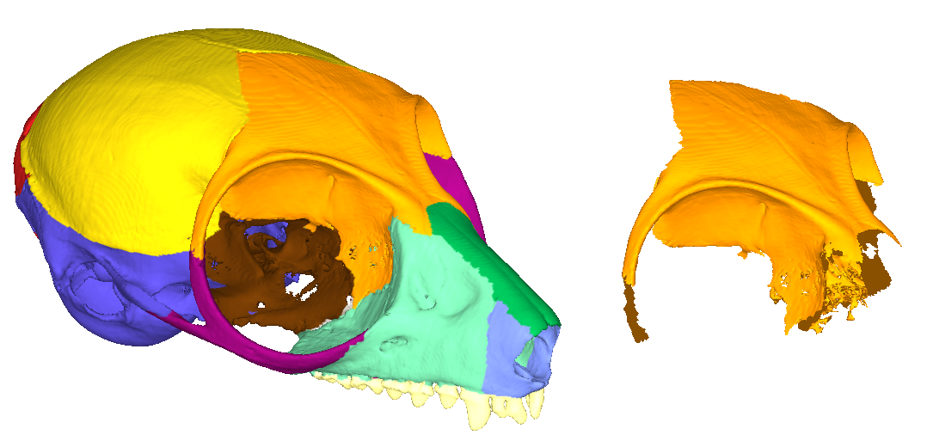
Exemple of tag extraction. Left : cranium of Microcebus murinus presenting the frontal region tagged in orange. Right : frontal tag region was extracted into a new surface object.

Extract all tagged regions as several new objects
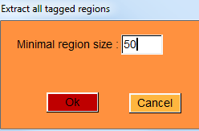
Extract all tagged regions window.
In order to prevent extremely small surface objects to be created, a minimal region size parameter for tag extraction is asked.
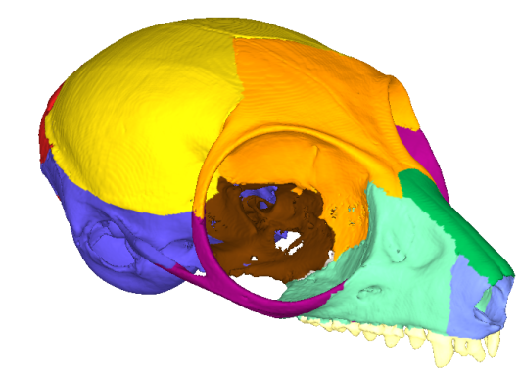 | 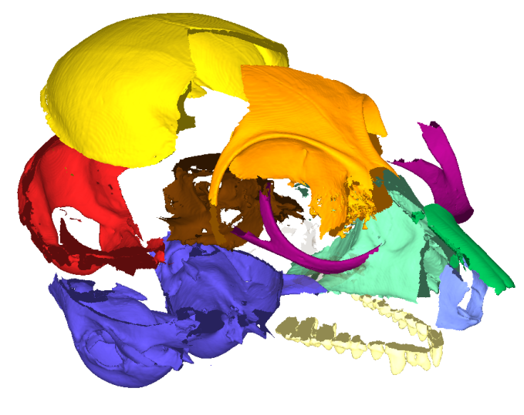

Left: original tagged surface. Right: all tagged regions were extracted into single independent surface objects

Extract one tagged region as 1 new object
This option works similarly as the “Extract active tag corresponding region” option mentioned above, except that you can reach tag id values beyond the 25 reachable in the Tag options window.
The following window shows up :
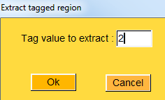

Extract tag or other scalar range as 1 new object
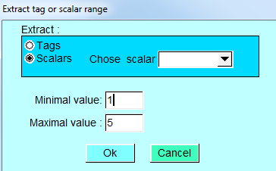
Extract scalar range window.
Using this option, you may extract several tagged regions into one single mesh, or all regions ranging from a minimal value up to a maximal value for a given scalar into a single new mesh.
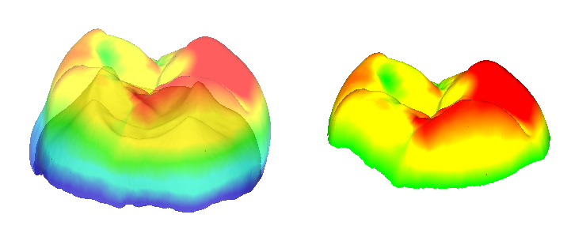
Extraction of the region showing an enamel thickness greater than 1 mm.

Delete
Note: The “Tag extraction/deletion” option in the Tag options window will affect the boundaries of the deleted regions.

Delete one tagged region
This option works similarly as the “Extract one tagged region” option mentioned above, except that it deletes the selected tag region.
The following window shows up :
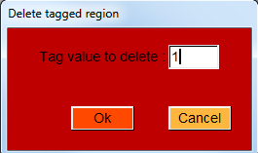

Delete active tag corresponding region
This option works similarly as the “Extract active tag corresponding region” option mentioned above, except that it deletes the corresponding active tag region.

Delete all tagged regions except TAG 00
This option deletes all tagged region except the vertices tagged with TAG 00 (exterior).

