General options
The general options window contains the following sections

Windows
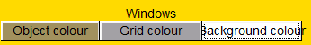
These controls affect the default colour of objects opened within ISE-MeshTools, the colour of grid elements, and the background colour.

Light
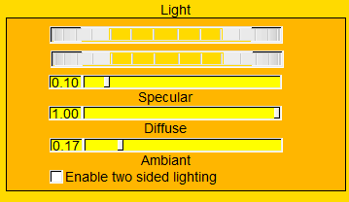
These controls affect the orientation of the light and specular, diffuse and ambient light parameters. By default surface back faces are not shown. Back face lighting can be enabled if the checkbox “enable two sided lighting” is checked

Behaviour when opening surfaces
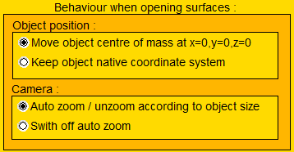
Object position:
Move object centre of mass at x=0, y=0, z=0: when active, the position matrix of a newly opened surface is set in order to display the object at the origin of the coordinate system (x=0, y=0, z=0). This option is useful when surface native coordinate system is far from the origin (this is often the case if you see nothing in the 3D rendering window after opening a surface).
Keep object native coordinate system: when active, the position matrix of a newly opened surface is set to the identity matrix.
Camera:
Auto zoom / unzoom according to object size: when active, the zoom of the camera is modified in order to match the object global size.
Switch off auto zoom: switches off the preceding option.

Object rendering when moving object/camera
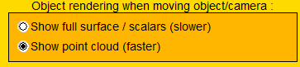
Show full surface / scalars (slower): when active, surfaces are fully drawn when moving the object or the camera. This results in a better perception of object / camera movements. This option is convenient when working with light surfaces.
Show point cloud (faster): 3D surface rendering can be slow using the preceding option when working with:
- large number of surfaces simultaneously
- heavy surfaces (large number of triangle / vertices)
Also, rendering is slower when tag rendering mode is active () or when scalar rendering mode is active () .
In order to increase rendering spedth, surfaces can be rendered as a schematic point cloud when moving the object or the camera.

Surface edition involving filters
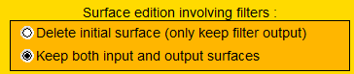
The following “filters” are available in ISE-MeshTools (see “Edit selected surfaces” section):
- Connectivity filters
- Lasso cut
- TPS deformation
- Mesh mirroring / smoothing /decimation / densification / hole filling
Delete initial surface (only keep filter output): when active, when using one of the previously mentioned filters, the initial object is deleted. Only the filter output is kept. This option is useful to avoid object multiplication.
Keep both input and output surfaces : when active, when using one of the previously mentioned filters, the initial object is kept. This option is useful to compare the initial object and the filter output.
Note that filter output object’s name differs from filter input objects’ name.

Landmarks
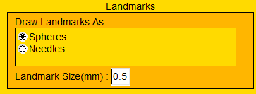
“Normal” and “Target” landmarks can be drawn as spheres or as needles. Landmark display size can be also edited in this section.

Ok
Pressing “Ok” will also update the MehsTools.ini file placed at the same folder as ISE-MeshTools executable file.

Show object display order
This option shows in the output window the list of objects (landmarks, target landmarks, flag landmarks, logical objects, surfaces) loaded into ISE-MeshTools, as well as their display order.
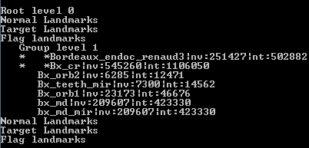
Example of object list loaded into ISE-MeshTools

Area and volume of selected objects
This option shows in the output window the list of surface objects which are selected.

