About
This option shows the current version of ISE-MeshTools.
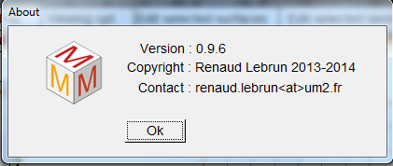
ISE-MeshTools’ about window

