Theme 2 Report
Morris Kim 1TE21131T

1. Explanation of theme 2 & theme 3

In theme 2, we implement semaphores so that we could start creating a kernel capable of multi-tasking. In this theme, we create several new functions and data structures in both assembly and C language in order to facilitate this new additional feature. Mainly, the semaphores, user and supervisor stacks, the timer interrupts, P/V mechanisms, etc.

In theme 3, we are tasked to create some more changes in order to facilitate 2 ports. These changes are done in the csys68k.c, outchr.s, and inchrw.s files. For the individual task, I have made Battleship, a board game where 2 players has to first set up and position a fleet of 5 ships of varying sizes on a 10x10 grid before going into war and guessing where the opposing player has put their ships. Traditionally, this battle phase is done one turn at a time, but in order to showcase the multi-tasking capabilities, I have made them occur in real-time.

2. Explanation of the positioning of the theme in the whole experiment

A lot of the functionality necessary to create theme 3 was done in theme 2, mainly the new functions and data structures. Some of these will be explained in more detail below. In theme 3, we put everything we’ve learned and created over themes 1 and 2 into our own individual programs, with the addition of multitasking.

3. Explanation on programs and programs’ list
3. 1. Theme 2

In theme 2, I am in charge of multitask, along with 1 other member. I will first briefly explain the other members’ tasks.

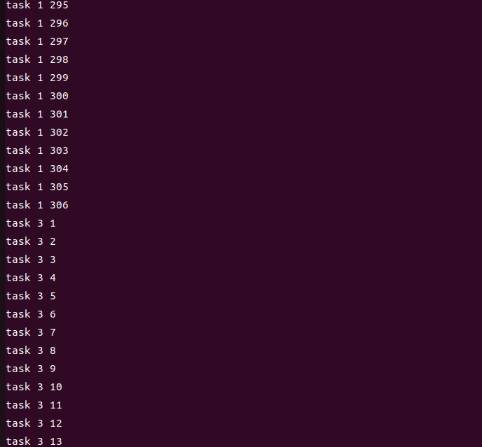

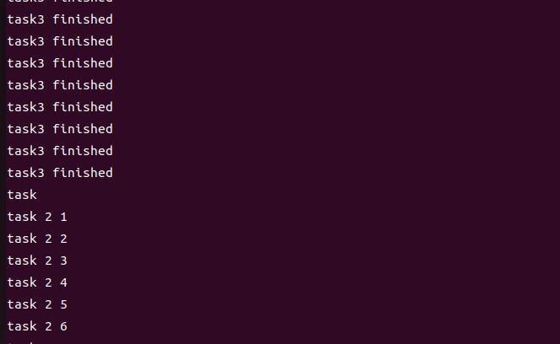

3. 2. Theme 3
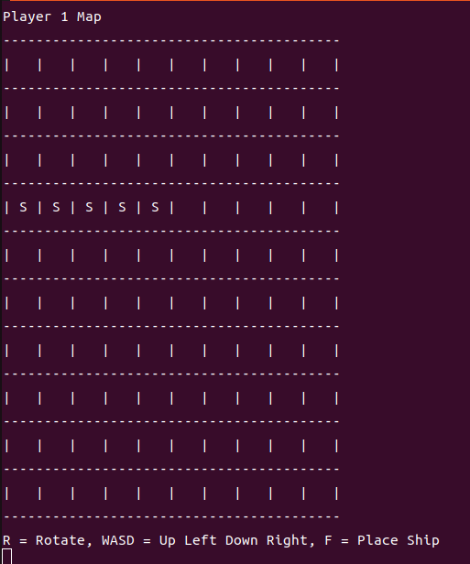
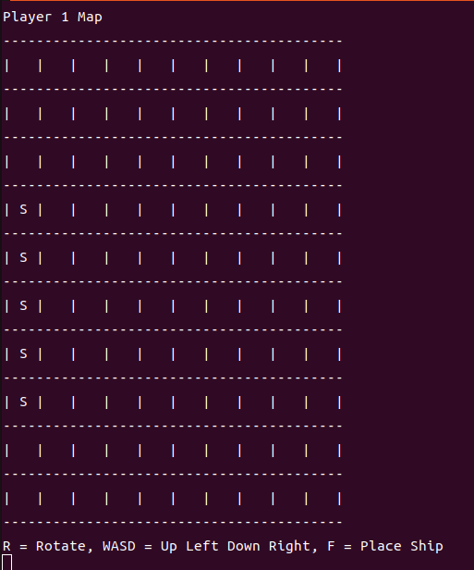

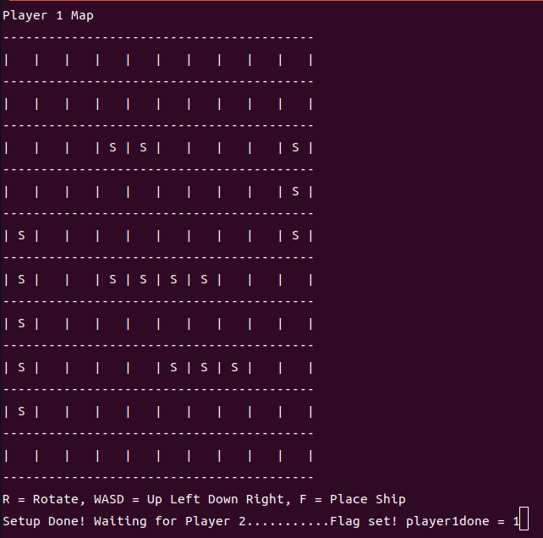

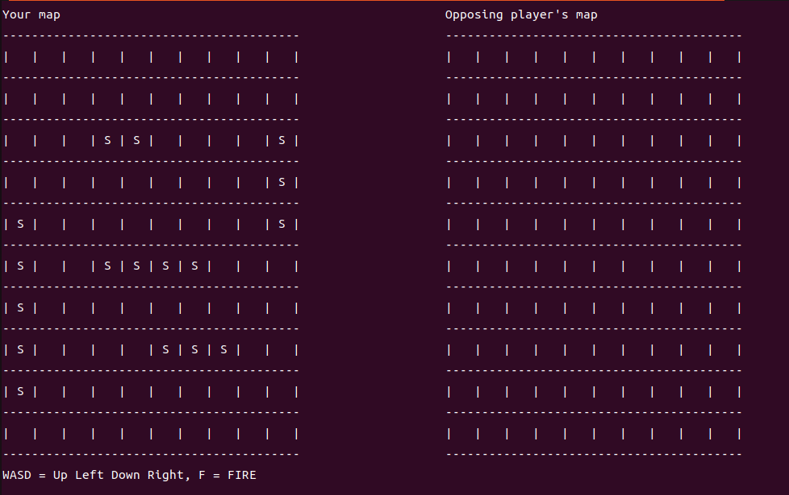
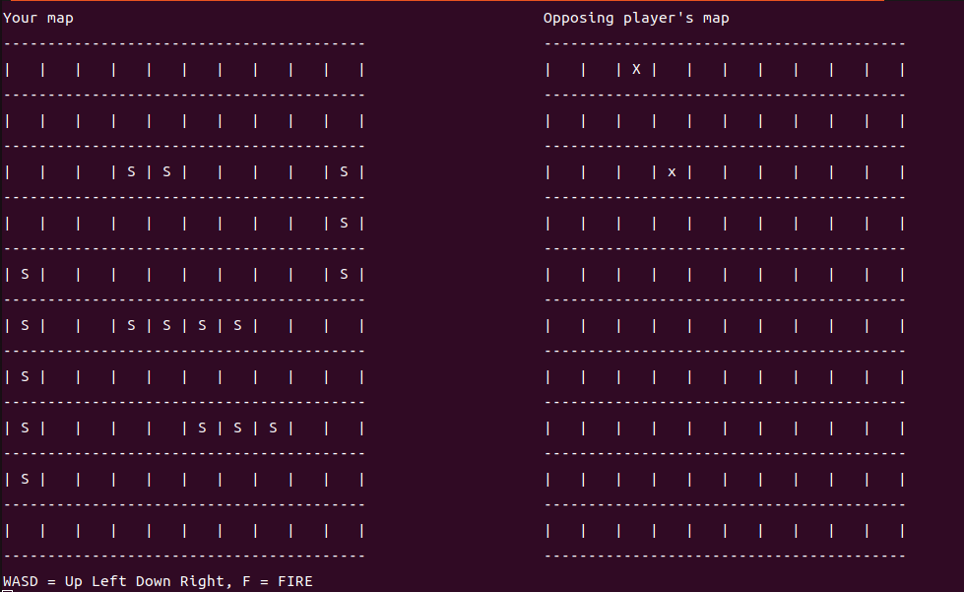

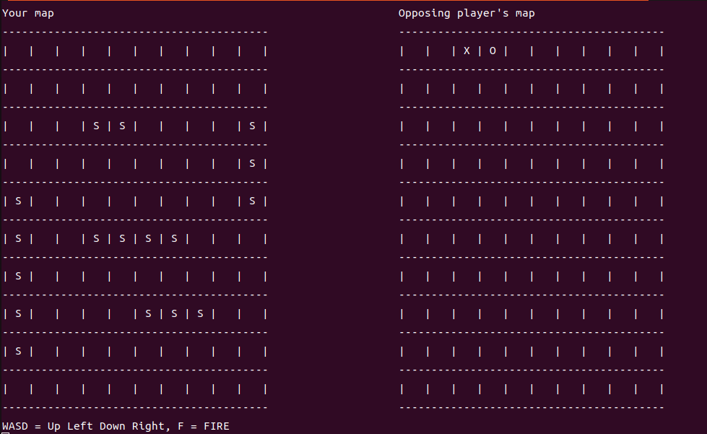
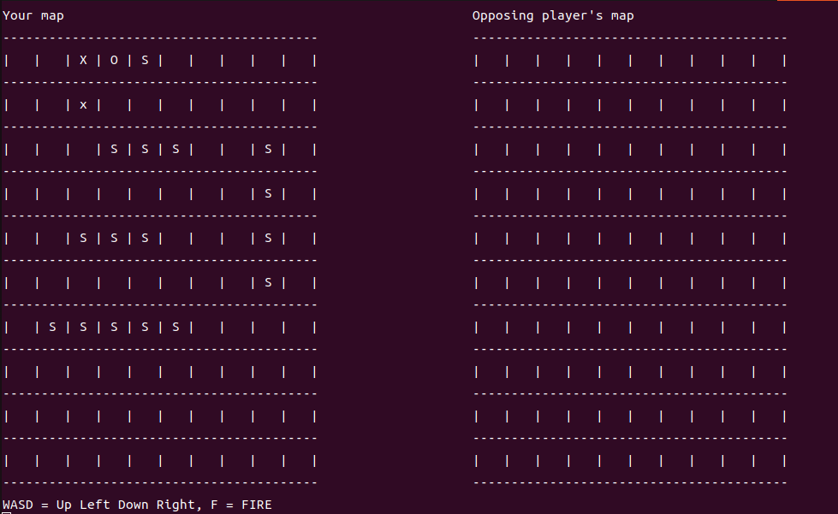

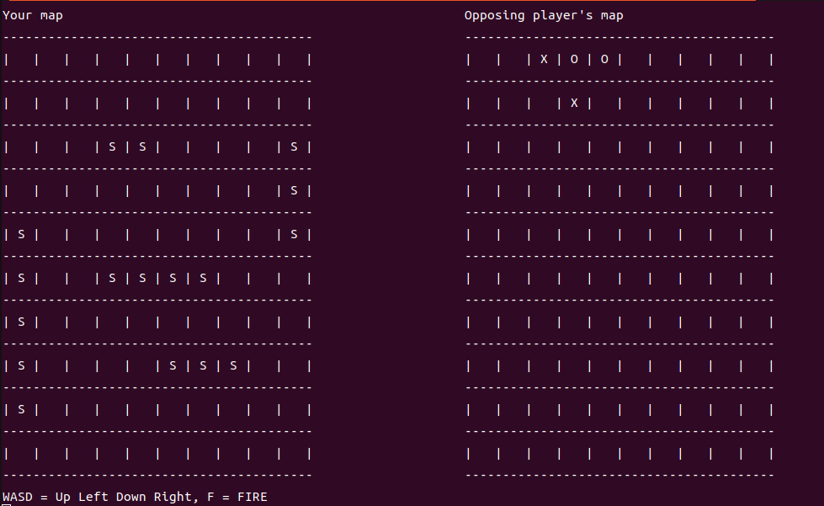

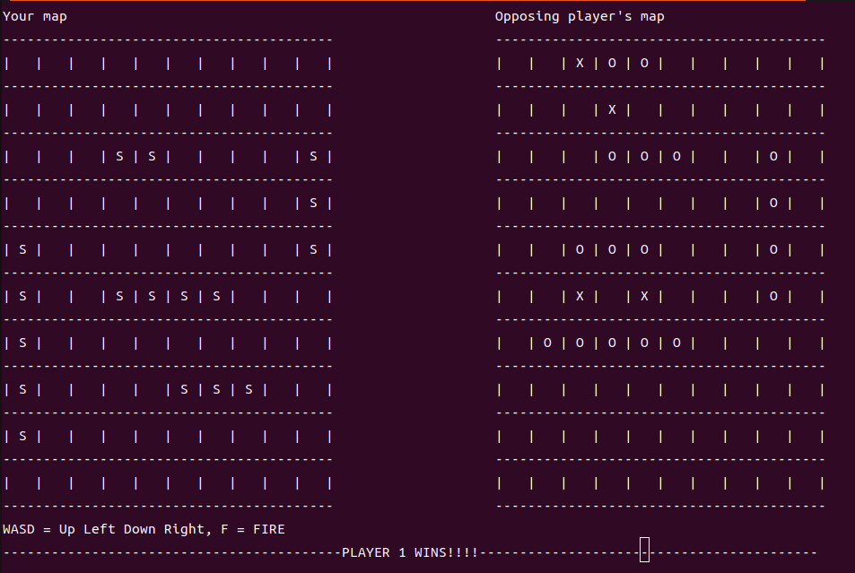

4. Important points in your programming

5. Problems occurred in the programming, their causes and solutions

6. Discussions

