Effects of Observing a Robot Expressing Approach-Avoidance Conflict on Observers' Self-Evaluations of Personal Courage
Yuki Shimizu^{1,*}, Midori Ban², Hideyuki Takahashi³ and Hiroshi Ishiguro¹
¹ Department of Engineering Science, Graduate School of Engineering Science, Osaka University, Toyonaka, Osaka, Japan
² Faculty of Global Studies, Kyoto Tachibana University, Kyoto, Japan
³ Faculty of Science and Engineering, Otemon Gakuin University, Ibaraki, Osaka, Japan
*Correspondence:
Yuki Shimizu
simizu.yuki@irl.sys.es.osaka-u.ac.jp
Word count: 8,869; Figures: 7; Tables: 5
Abstract
Courage involves pursuing a valued action despite fear, hesitation, or competing motives. However, the pre-action conflict relevant to judging an act as courageous is difficult to observe directly and manipulate systematically when another human serves as the model. Robots provide a means of representing such otherwise covert motives in a controlled and reproducible form. We therefore examined how a robot’s expression of approach-avoidance conflict is perceived and how it relates to observers’ immediate self-evaluations of personal courage. Speech bubbles were projected near the head of a cylindrical robot to present approach and avoidance motives in a scenario in which the robot encountered a person littering in a park. Study 1 compared conflict and no-conflict conditions and sequential and simultaneous presentation methods to determine whether a robot expressing approach-avoidance conflict was perceived as courageous. Study 2 varied whether the robot expressed one motive direction or both approach and avoidance motives and whether it admonished the litterer, and examined whether post-stimulus courage self-evaluations differed according to observers’ preexisting courage tendency. In Study 1, the conflict condition yielded higher courage and conflict ratings than the no-conflict condition. In Study 2, the predicted three-way interaction was not supported. Instead, we observed a significant two-way interaction between preexisting courage tendency group and conflict expression that was not specified in the primary hypothesis. The low-courage group showed a marginal trend toward higher self-evaluations in the conflict condition, whereas the high-courage group reported significantly lower self-evaluations in the conflict condition. Admonishing behavior had no clear effect. This contrasting pattern suggests that robot-expressed conflict may be received differently depending on observers’ preexisting courage tendency. The study provides a controlled HRI paradigm for examining how robot-expressed motives are perceived and highlights the importance of considering user characteristics when designing robots that display cues to internal processes.
Keywords: personal courage, approach-avoidance conflict, observational learning, human-robot interaction, internal state, robot expression, observer responses.
Introduction
In everyday life, people sometimes must pursue valued actions even when those actions involve fear or anxiety. In this study, we refer to this capacity as personal courage. Courage has been conceptualized not as the absence of fear but as moving toward meaningful action in the presence of fear (Rachman, 1984; Woodard and Pury, 2007). Personal courage is important because it situates the difficulty of an action within the actor’s own context. Pury et al. (2007) distinguished between general courage, which is evaluated as courageous by most people, and personal courage, which is courageous in light of a person’s life context and personal constraints. From this perspective, a child with a learning disability going to school on the day of a major test, or a person wrapping Christmas presents for the first time after being unable to do so for many years because of a history of post-traumatic stress disorder, can be understood as performing actions that involve high fear and difficulty within that person’s context (Pury et al., 2007). Furthermore, actions such as speaking up, seeking help, or pointing out a problem may be valuable for the person or for others, but they also involve social and psychological risks, such as negative evaluation and rejection. These actions are therefore meaningful targets for investigation from the perspective of personal courage (Milliken et al., 2003; Vogel et al., 2007; Howard et al., 2017).
However, people do not always act even when they recognize that an action is valuable. For example, expressing an opinion in front of others often involves anxiety about how one will be evaluated (Watson and Friend, 1969; Dickerson and Kemeny, 2004). Consulting others or seeking help can also involve concern about being viewed negatively (Vogel et al., 2007). In workplaces, many employees report having noticed problems or concerns but not communicating them to supervisors, mainly because they fear being viewed negatively or damaging important relationships (Milliken et al., 2003). Thus, speaking up and seeking help can benefit oneself and others, yet they involve social and psychological risks, such as negative evaluation, damaged relationships, reduced status, and damage to self-image. Therefore, supporting personal courage requires more than helping people understand that an action is valuable; it also requires supporting the process of moving toward action despite perceived risk.
As one way to support this process, this study focuses on observational learning, in which observing another agent’s behavior or success can change expectations about one’s own ability to act (Bandura, 1977). Prior research has shown both changes in externally observable motor performance following model observation (Weiss et al., 1998) and motor-related neural activity during action observation (Chaisaen et al., 2020). Observational learning can also influence psychological processes such as self-efficacy and persistence (Schunk and Hanson, 1985; Leonard et al., 2017). Self-efficacy and personal courage are distinct constructs: self-efficacy concerns beliefs about one’s capacity to perform an action, whereas personal courage concerns movement toward a valued action despite fear or risk. Nevertheless, process models of courage include an evaluation of action feasibility before an action decision (Chowkase et al., 2024). Observing a model struggle and then act may therefore provide vicarious information that action remains possible despite difficulty. The present study treats this as a candidate mechanism linking observational learning to immediate self-evaluations of personal courage, rather than as direct evidence that effects on self-efficacy generalize to courage.
However, fear, hesitation, and motivational conflict are covert processes that are difficult to observe directly and manipulate systematically when a human serves as the model. A robot can display representations of attributed pre-action motives while its appearance and nonmanipulated aspects of its overt behavior are held relatively constant across conditions, thereby providing a controlled HRI stimulus for examining observer responses to represented pre-action motives. The primary aim of this research was to investigate how a robot’s expression of approach-avoidance conflict—the coexistence of motives to pursue a valued action and to avoid its risks—is perceived and how it relates to observers’ immediate self-evaluations of personal courage. The robot thus served both as a methodological tool for making representations of covert pre-action motives observable and controllable and as an HRI stimulus whose expressions may be associated with different responses across users.
We conducted two studies with distinct roles. In Study 1, H1 predicted that the conflict condition, which displayed both approach and avoidance motives, would yield higher robot-courage ratings than the no-conflict condition, which displayed approach motives only. As a manipulation check, we also examined whether the coexistence of approach and avoidance motives was perceived as conflict. The comparison between sequential and simultaneous presentation was exploratory and was used to select the presentation format for Study 2. In Study 2, H2 predicted a three-way interaction among preexisting courage tendency, displayed conflict, and final action. Specifically, within the low-courage group, self-evaluation scores were expected to be highest in the conflict-with-action condition among the four conditions. By distinguishing how the robot is perceived from how its expression relates to observers’ responses, we position this work as a foundational HRI study of robot expression design, using personal courage as the psychological context for examining how responses to pre-action motive cues vary across users.
Related Work
Personal Courage and Internal States Before Action
Research on courage has treated courage not as the absence of fear but as moving toward action while experiencing fear. Rachman (1984) argued that even people with strong fear can perform courageous acts. Norton and Weiss (2009) examined the relationship between behavioral approach and courage in a fear-eliciting situation. Woodard and Pury (2007) also conceptualized courage as a construct involving action for a meaningful purpose in a situation involving threat or fear. These studies provide a basis for understanding courage not as mere risk preference or low fear but as approach behavior in the presence of fear.
Within this literature, Pury et al. (2007) distinguished between general courage, which is evaluated as courageous by most people, and personal courage, which is courageous in light of a person’s life context and personal constraints. Actions involving high personal courage are characterized by fear, difficulty, and personal constraints. According to this distinction, the same action may or may not be courageous depending on the fear or difficulty the actor experienced. Therefore, research on personal courage needs to consider not only externally visible behavior but also the internal states preceding that behavior.
Recent process models of courage also focus on these internal states before action. Chowkase et al. (2024) describe courage as a sequence involving situation perception, evaluation of value or meaning, evaluation of action feasibility, and action decision. In this process, reasons to move toward a valued action and reasons to avoid risks or disadvantages associated with the action may coexist. This coexistence can be understood as approach-avoidance conflict, in which approach and avoidance motives operate simultaneously (Lewin, 1931; Miller, 1944). However, these studies clarify the definition and process of courage; they do not directly examine whether observing another agent’s internal state changes observers’ self-evaluations of personal courage.
Observational Learning and Dependence on Observers’ Prior Characteristics
Beyond a model’s final behavior, the process displayed before an outcome may also shape observational learning.
Schunk et al. (1987) compared mastery models who succeeded easily from the beginning with coping models who showed difficulty and gradually coped with it, and found that observing coping models increased self-efficacy and task performance. Schunk and Hanson (1989) also showed that models who cope while displaying difficulty and negative affect influence learners’ self-efficacy. Leonard et al. (2017) found that infants who observed an adult persist in attempting to achieve a goal made more attempts on a subsequent difficult task than infants who observed an adult succeed easily. However, the relative advantage of coping models over mastery models has not been consistently observed. Schunk and Hanson (1985) found that children who observed a peer model showed higher self-efficacy and achievement than those who observed a teacher model or no model, but reported no significant differences between the mastery- and coping-model conditions. Taken together, these findings suggest that observing a process involving difficulty and effort can support observers’ self-efficacy and persistence, although coping models do not necessarily outperform mastery models.
At the same time, the same model may be interpreted differently depending on observers’ prior characteristics. Braaksma et al. (2002) showed that model–observer similarity and the model’s level of expertise are important in observational learning. More broadly, prior capability beliefs may moderate responses to social information under difficult conditions. In a mathematical judgment task, Lucas et al. (2006) found that participants with high mathematical self-efficacy remained more independent from erroneous social information when the task was difficult. Although this finding does not directly concern courage or observational modeling, it supports the general possibility that observers’ prior capability beliefs shape their responses to social cues. Together, these findings motivate consideration of observer characteristics without treating preexisting courage and self-efficacy as equivalent constructs.
Modeling by Robots and Artificial Agents
Models in observational learning are not limited to humans. Studies using artificial agents and avatars have shown that visually present agents and self-similar avatars can influence observers’ attitudes, self-efficacy, and subsequent behavior (Rosenberg-Kima et al., 2008; Fox and Bailenson, 2009). Research on social robots has also shown that people can treat robots as social models and engage in modeling based on their behavior and social roles (Xu, 2023). Prior research has further revealed that the way a robot encourages participants influences how participants subsequently encourage others (Higashino et al., 2023). Even relatively constrained robot behavior can affect task engagement: Ishikawa et al. (2026) found that verbal time updates from both a social robot and a human increased young children’s persistence in a challenging task relative to a no-update condition. This finding does not establish that robot influence is generally equivalent to human influence, but it demonstrates that controlled robot behavior can have measurable consequences for users.
These studies indicate that robots and artificial agents can function as social models that influence observers. However, the studies reviewed here targeted attitudes, self-efficacy, movement, and encouragement behavior, not personal courage itself. Within the scope of the literature reviewed in this manuscript, few past reports have explicitly represented a model’s fear or conflict before action and examined how observing that representation relates to observers’ self-evaluations of personal courage. Therefore, using a robot to present representations of pre-action motives related to personal courage provides a foundation for examining whether such a robot can function as a social model.
Representing Internal States Through Robots
Robots offer two methodological advantages for studying the social consequences of covert pre-action processes. First, their appearance, behavior, speech, and timing can be reproduced consistently across experimental conditions, thereby reducing unintended variability between presentations. Second, representations of states attributed to a robot can be communicated explicitly through visual or verbal expressions, allowing the displayed motivational structure to be manipulated separately from the robot’s overt action. These advantages are not unique to robots, because human actors, avatars, and text-based agents can also be used to display representations of covert states. Nevertheless, robots are especially relevant to HRI because they can function as embodied social agents whose expressions and behavior may influence users. In this study, we therefore used speech bubbles in addition to the robot’s movement and speech to present approach and avoidance motives attributed to the robot in a controlled and directly observable form.
Regarding this display format, Nitada et al. (2021) proposed a method in which a speech bubble is displayed near a robot’s head in a video-conferencing situation, with the user’s face drawn inside the bubble. They found that the speech-bubble condition increased the sense that the robot was looking at the user. Their study suggests that speech bubbles can function as a means of visually representing the robot’s attention or mental focus. However, that study addressed the direction of attention, not the conflict between approach and avoidance motives related to courage.
Taken together, prior studies have shown that personal courage involves actions accompanied by fear or difficulty, that observational learning can influence self-efficacy and perceived action possibility, and that robots and artificial agents can function as social models. However, within the scope of the literature reviewed in this manuscript, research has not sufficiently examined whether using a robot to represent pre-action motives related to personal courage, especially conflict between approach and avoidance motives, is associated with observers’ self-evaluations of personal courage. The present study focuses on this unexplored issue and examines how observing a robot expressing approach-avoidance conflict relates to observers’ self-evaluations of personal courage.
Design of the Video Stimuli
Robot and Projection Environment
The robot used in this study had the same body design as the switch-based robot interface proposed by Omichi et al. (2026). This robot has a cylindrical body; when it is not speaking, an agent with a face is retracted inside the body, and when it speaks, the agent emerges from the top of the body (Omichi et al., 2026). Figure 1 shows the robot used in both studies in its non-speaking and speaking states. As this study examined how presenting representations of pre-action motives through speech bubbles relates to observers’ self-evaluations of personal courage, it was necessary to minimize interpretive variability arising from the robot’s appearance or bodily movements. Unlike humanoid robots, this robot does not have complex facial expressions or limb movements; its expressive modalities are primarily the displayed face and speech. This design made it suitable as a stimulus medium for presenting approach motives, avoidance motives, and the presence or absence of admonishing speech in a relatively controlled manner. The admonishing speech was prerecorded and triggered by the experimenter using keyboard input.
In the video stimuli, the robot was filmed such that it appeared in the lower-right corner of the frame, and representations of its attributed pre-action motives were displayed in speech bubbles projected onto the wall behind it. The speech bubbles were positioned near the robot’s head and served as visual expressions of attributed motives rather than as the robot’s spoken output.
Stimulus Scenario
In this study, we used video stimuli depicting a scene in which a robot observes a person littering in a park. Littering in a park is readily understood as a violation of shared norms in a public space. Indeed, littering has been used as a representative task for examining the effects of descriptive and injunctive norms (Cialdini et al., 1990). Observational research in public spaces has also shown that the presence of existing litter increases littering, whereas the availability of trash bins reduces it. Thus, littering can be positioned as an everyday norm violation affected by environmental and normative cues (Schultz et al., 2013). In addition, cues of disorder, such as litter and graffiti, can induce other norm violations (Keizer et al., 2008). Therefore, admonishing the person in this scene has value because it may help keep the park clean, create an opportunity for the person to stop littering, and reaffirm the norm that littering is unacceptable. At the same time, admonishing a stranger involves social and psychological risks, such as being yelled at, ignored, or viewed negatively. Littering in a park has also been used as a stimulus scenario in prior research on social control behavior, supporting its validity as a scenario involving intervention in a stranger’s norm violation (Chekroun and Brauer, 2002). Field research has further shown that sanctions against strangers’ norm violations include not only direct admonition but also indirect methods, and direct admonition can involve costs, including possible retaliation (Balafoutas et al., 2014). Research on social courage has identified moving toward valued action while facing interpersonal risk as an important feature (Howard et al., 2017). Therefore, admonishing a person for littering in a park is suitable as a stimulus scenario for examining personal courage because it involves both valued action and interpersonal risk and can elicit hesitation or conflict for the actor, although it does not involve extreme physical danger.
An example of the scenario description in the video stimulus is shown in Figure 2.
Common Structure of the Video Stimuli
The video stimuli did not present the park scene itself as live-action footage; instead, the scene was constructed using a textual scenario description and speech-bubble expressions. At the beginning of the video, the following scenario description was presented: “The robot saw a person littering in a park.” The robot then displayed situation recognition in the speech bubble, such as “Oh, there is a person littering,” followed by a statement indicating that admonition was required. The subsequent presentation of motives and the presence or absence of admonishing speech were manipulated according to the conditions in each study. All videos were created at a resolution of 1280 × 720 pixels. The duration of each segment was set to allow participants sufficient time to read the on-screen text at a natural pace. Minor differences in total duration arose from differences in the wording and presentation format of the condition-specific motive statements. Consequently, the videos lasted approximately 50–54 s in Study 1 and 49–51 s in Study 2.
Approach Motives and Avoidance Motives
In this study, reasons for moving toward a valued action were defined as approach motives, and reasons for avoiding the risks or disadvantages associated with the action were defined as avoidance motives. The specific motive statements are shown in Table 1. The approach motives indicated the possibility that desirable outcomes would result from admonishing behavior, whereas the avoidance motives indicated social and psychological risks that could result from admonishing behavior. By combining these approach and avoidance motives, we expressed a state in which reasons for moving toward a valued action and reasons for avoiding that action coexist. We operationalized this state as approach-avoidance conflict, in which approach and avoidance motives operate simultaneously (Lewin, 1931; Miller, 1944).
An example in which the approach and avoidance motives were presented simultaneously is shown in Figure 3.
By applying this common design, representations of pre-action motives were presented in a form that observers could interpret visually. The details of the condition manipulations in each study are described in the respective method sections.
Study 1: Is a Robot Expressing Approach-Avoidance Conflict Perceived as Courageous?
Purpose
In Study 1, we examined whether the presentation intended for use in Study 2 would be perceived as courageous. Specifically, we examined whether a robot displaying approach-avoidance conflict through attributed motives would be perceived as more courageous than a robot not displaying conflict. We also used conflict ratings to confirm whether the displayed motives were perceived as approach-avoidance conflict and conducted an exploratory comparison of the effects of sequential and simultaneous presentation on courage and conflict ratings.
Approach-avoidance conflict is described as a state in which approach and avoidance motives compete with respect to the same goal (Lewin, 1931; Miller, 1944; Gray and McNaughton, 2000). Based on this view, simultaneous presentation was considered a candidate method for representing the coexistence of both motives at the same point in time. Ambivalent affect, meanwhile, has been argued to arise not only from the simultaneous co-occurrence of positive and negative affect but also from rapid alternation between them (Vaccaro et al., 2020). Although ambivalent affect and approach-avoidance motives are not identical constructs, this account informed the presentation design. In the present study, however, the switching speed was reduced so that observers could visually identify each motive. Sequential presentation therefore represented temporal alternation rather than rapid alternation per se. Because these prior studies did not directly compare presentation methods for robots, the two methods were compared exploratorily in Study 1.
Based on this reasoning, we predicted that the conflict condition would yield higher robot courage ratings than the no-conflict condition (H1). As a manipulation check, we also predicted that the conflict condition would yield higher conflict ratings than the no-conflict condition. The comparison between sequential and simultaneous presentation was exploratory and was conducted to examine which method would be perceived as more courageous.
Method
Conditions
Study 1 used a within-participant design with conflict and presentation method as factors. Conflict had two levels: no conflict and conflict. Presentation method also had two levels: sequential presentation and simultaneous presentation. To avoid confounding the effects of conflict and presentation method with the presence or absence of final action, all Study 1 conditions showed the robot performing the admonishing action.
In the stimulus videos, after the robot observed a person littering in a park, it displayed situation recognition and motives through a speech bubble. In the conflict condition, approach and avoidance motives were presented; in the no-conflict condition, only approach motives were presented. In the simultaneous presentation condition, the relevant motives were presented simultaneously and alternately enlarged and reduced. In the sequential presentation condition, the relevant motives were presented in sequence. Finally, in all conditions, the agent with a face emerged from the top of the body and said, “Excuse me, this is not a place to throw away trash.” The four stimulus conditions used in Study 1 are summarized in Table 2.
Representative frames illustrating the presentation methods in the conflict conditions of Study 1 are shown in Figure 4. In Figure 4, the scenario description, situation recognition, and statement indicating that the situation required admonition are omitted; only the portions presenting the approach and avoidance motives are shown. In the sequential presentation condition, the avoidance motive “I would hate it if they yelled at me after I warned them” and the approach motive “If I warn them, the park might become cleaner” were presented in separate frames in sequence. In the simultaneous presentation condition, the same avoidance and approach motives were presented simultaneously within a single speech bubble and alternately emphasized.
Measurement
The dependent variables were robot courage ratings and conflict ratings. Each rating was obtained on a 7-point scale after participants observed each video, and the mean of the items was used as the scale score. Courage ratings were created by modifying the six items of the Japanese version of the Courage Measure (CM-J) to rate the robot (Shimotsukasa et al., 2023). The CM-J measures the tendency to act despite fear or anxiety, and its reliability and validity have been confirmed (Shimotsukasa et al., 2023). In Study 1, to measure the extent to which the robot appeared courageous rather than the observer’s own courage, the subject of each item was changed to “This robot,” and the item endings were changed to observational rating expressions like “appeared to” and “was.” In the analysis, the mean of the six items shown in Table 3 was used as the courage rating score.
Conflict ratings were measured using study-specific items to assess the extent to which the robot appeared to waver between approach and avoidance motives. Based on the definition of approach-avoidance conflict (Lewin, 1931; Miller, 1944), we formulated items to capture observable aspects of this conflict: wanting to act but hesitating because of fear, showing hesitation or fluctuation in action, having mixed feelings about acting, and being unable to decide on an action. In the analysis, the mean of the four items shown in Table 4 was used as the conflict rating score. In addition, to confirm whether ratings based on these four items corresponded to a direct judgment of conflict, we also included a direct item: “This robot appeared to be experiencing conflict.”
Procedure
Study 1 was conducted via Yahoo! Crowdsourcing. Participants viewed videos from the four conditions, and after each video, completed the robot courage and conflict rating items. The order of video presentation was randomized for each participant. The questionnaire also asked about prior participation in the same survey. To assess attentive responding, we used the instructed-response format of the Directed Questions Scale (DQS; Maniaci and Rogge, 2014), which directs respondents to select a specified response option. To assess comprehension of the scenario and the robot’s displayed thoughts and behavior, four three-alternative, single-choice video-comprehension items were used. Reporting previous participation, leaving a check item unanswered, failing to select the instructed response, or failing to meet the all-correct criterion for the four video-comprehension items constituted exclusion.
Participants
To assess the adequacy of the final sample size, we conducted a sample-size calculation in G*Power 3.1.9.7 (Faul et al., 2009) for the main effect of conflict, which tested the primary hypothesis. Because this main effect was a two-level comparison between the conflict and no-conflict conditions averaged across presentation methods, we selected “ANOVA: Repeated measures, within factors” under F tests and specified one group and two measurements. The “as in Cohen (1988) – recommended” effect-size specification was used, with f(V) = 0.25, α = 0.05, power (1 − β) = 0.80, and nonsphericity correction ε = 1. The resulting required sample size was 128 participants.
A total of 211 responses were recorded. Of these, 26 with missing responses to the check items were excluded. Among the remaining 185 responses, 54 met at least one of the following exclusion criteria: prior participation in the same survey (n = 20), failure of a DQS-format instructed-response check (n = 29), or failure to meet the all-correct criterion for the four video-content comprehension items (n = 28; at least one incorrect response); these criteria overlapped. Thus, 80 responses were excluded in total, yielding a final analytic sample of 131 participants.
Participants were 18–29 years old, with a mean age of 24.26 years (SD = 3.36). The sample included 76 women, 52 men, and 3 participants who selected “do not know/prefer not to answer.”
Statistical Analysis
In Study 1, robot courage rating scores and conflict rating scores were treated as dependent variables. Two-way repeated-measures analyses of variance were conducted with conflict (no conflict vs. conflict) and presentation method (sequential vs. simultaneous) as within-participant factors. Partial η<sup>2</sup> was reported as the effect size. For the courage ratings and conflict ratings, internal consistency was examined using Cronbach’s α, and the validity of treating the mean of each item set as a scale score was further examined using factor analysis with a one-factor solution. When an interaction was significant, the normality of the difference scores for paired comparisons between conditions was examined using the Shapiro–Wilk test; when normality was rejected, Wilcoxon signed-rank tests were used. Analyses were conducted using the Python packages pandas, pingouin, and SciPy.
Results
First, we examined whether the courage ratings and conflict ratings could each be treated as a unidimensional scale score. Because the sign of factor loadings obtained in factor analysis is arbitrary, factor loadings are reported as absolute values. Cronbach’s α for the six courage-rating items was 0.925. In the factor analysis with a one-factor solution, factor loadings ranged from 0.727 to 0.855, and the variance explained was 68.0%. The first eigenvalue was 4.396, and all subsequent eigenvalues were below 1. Therefore, the mean of the six items was used as the courage rating score. Cronbach’s α for the four conflict-rating items was 0.928. In the factor analysis with a one-factor solution, factor loadings ranged from 0.845 to 0.898, and the variance explained was 76.5%. The first eigenvalue was 3.293, and all subsequent eigenvalues were below 1. Furthermore, a high positive correlation was found between the factor score calculated from the four items and the direct item (r = 0.887, p < 0.001). Therefore, the mean of the four items was used as the conflict rating score.
For courage ratings, the conflict condition was rated higher than the no-conflict condition. The main effect of conflict was significant (F(1, 130) = 12.216, p < 0.001, partial η<sup>2</sup> = 0.086). In contrast, the main effect of presentation method was not significant (F(1, 130) = 2.657, p = 0.106, partial η<sup>2</sup> = 0.020), and the interaction was also not significant (F(1, 130) = 0.906, p = 0.343, partial η<sup>2</sup> = 0.007).
Condition means are shown in Figure 5.
For conflict ratings, the conflict condition was rated higher than the no-conflict condition, and simultaneous presentation was rated higher than sequential presentation. The main effect of conflict was significant (F(1, 130) = 79.558, p < 0.001, partial η<sup>2</sup> = 0.380). The main effect of presentation method was also significant (F(1, 130) = 46.448, p < 0.001, partial η<sup>2</sup> = 0.263), and the interaction was significant (F(1, 130) = 4.924, p = 0.028, partial η<sup>2</sup> = 0.036).
Because the interaction was significant, paired comparisons between conditions were conducted. Shapiro–Wilk tests indicated significant departures from normality for all difference scores (all p < 0.001); therefore, Wilcoxon signed-rank tests were used. Under sequential presentation, conflict ratings were higher in the conflict condition (M = 4.964) than in the no-conflict condition (M = 3.615; W = 671.5, p < 0.001). The same pattern was observed under simultaneous presentation (conflict M = 5.344, no-conflict M = 4.303; W = 882.5, p < 0.001). Simultaneous presentation also yielded higher ratings than sequential presentation in both the no-conflict condition (W = 1069.0, p < 0.001) and the conflict condition (W = 1467.0, p < 0.001).
Condition means are shown in Figure 6.
Discussion
In Study 1, the robot expressing approach-avoidance conflict was rated as more courageous than the robot in the no-conflict condition, supporting H1. This indicates that even when the overt behavior was the same, showing conflict between approach and avoidance motives before action made the behavior more likely to be interpreted as involving fear or difficulty for the actor. This interpretation is consistent with the view that actions involving high personal courage are accompanied by fear or difficulty (Pury et al., 2007). Therefore, displaying pre-action motives attributed to the robot may help observers interpret its behavior as courageous.
Conflict ratings were also higher in the conflict condition than in the no-conflict condition. This indicates that the presentation of approach and avoidance motives through speech bubbles was perceived by observers as approach-avoidance conflict. Regarding presentation method, no clear difference in courage ratings was found between sequential and simultaneous presentation. By contrast, conflict ratings were higher under simultaneous than sequential presentation in both the conflict and no-conflict conditions. Thus, simultaneous presentation may have made the robot appear generally more conflicted, but the results do not indicate that it strengthened the distinction between the conflict and no-conflict conditions.
In Study 1, the robot in the conflict condition was perceived as more courageous than the robot in the no-conflict condition within the Study 1 stimulus configuration. On this basis, Study 2 used simultaneous presentation, which yielded the highest mean conflict rating within the conflict condition, to examine how observers’ self-evaluations differed across robot-expression conditions.
Study 2: Personal Courage Self-Evaluations Following Robot Expressions of Conflict and Action
Purpose
Building on Study 1, Study 2 examined whether observers’ post-stimulus self-evaluations of personal courage differed across the robot’s conflict and action conditions and whether these differences varied with observers’ preexisting courage tendency. Perceived courage of the robot was not reassessed in Study 2.
Study 2 crossed motivational structure (univalent vs. conflicted) with behavioral outcome (admonition vs. no admonition). This design reflected the view that courage involves both internal difficulty and movement toward valued action (Rachman, 1984; Woodard and Pury, 2007; Norton and Weiss, 2009). Courage has also been described as a sequential process involving situation perception, value evaluation, evaluation of action feasibility, and action decision (Chowkase et al., 2024). In the univalent conditions, motive direction was congruent with the final behavior: approach motives preceded admonition, whereas avoidance motives preceded non-action. In the conflicted conditions, both approach and avoidance motives were presented regardless of the final behavior. The resulting conditions allowed us to compare univalent and conflicted motivational structures within each behavioral outcome and to examine the added role of action when the robot expressed conflict.
In Study 2, H2 predicted a three-way interaction among preexisting courage tendency, approach-avoidance conflict, and action. This hypothesis integrated a process account of courage with evidence from observational learning. Courageous decision-making has been described as involving an evaluation of action feasibility before an action decision (Chowkase et al., 2024). In a different, task-learning context, studies of coping models have shown that observing a model display difficulty and then succeed can enhance task-specific self-efficacy and performance (Schunk et al., 1987; Schunk and Hanson, 1989). Observational learning may also depend on model–observer similarity (Braaksma et al., 2002). These findings do not establish that self-efficacy and personal courage are equivalent. Rather, they suggest a candidate observational mechanism: seeing a model display hesitation yet move toward a valued action may provide vicarious information that action remains possible despite difficulty. We hypothesized that this mechanism might extend to observers’ immediate self-evaluations of personal courage and be especially self-relevant to those with low preexisting courage. Accordingly, among participants with a low preexisting courage tendency, personal courage self-evaluation scores were expected to be highest in the conflict-with-action condition among the four conditions.
Method
Conditions
In Study 2, we used a three-factor mixed design with preexisting courage tendency group as a between-participant factor and conflict and action as within-participant factors. Participants were classified into low-courage and high-courage groups based on their pre-stimulus CM-J scores. The no-conflict conditions presented a single motive direction congruent with the robot’s final behavior, whereas the conflict conditions presented approach and avoidance motives simultaneously. Action was manipulated according to whether the agent with a face emerged from the top of the body and delivered the admonishing speech.
As in Study 1, the stimulus videos presented a scene in which the robot observed a person littering in a park. After displaying situation recognition, the robot presented the relevant motive statements in the speech bubble. In the conflict conditions, approach and avoidance motives were presented simultaneously and alternately enlarged and reduced. In the no-conflict conditions, motive content was congruent with the final behavior: only approach motives were presented in the action-present condition, whereas only avoidance motives were presented in the action-absent condition.
In the action-present condition, after the motive presentation, the agent emerged from the top of the body and said, “Excuse me, this is not a place to throw away trash.” In the action-absent condition, after the motive presentation, the agent remained retracted inside the body and did not speak. The four stimulus conditions used in Study 2 are summarized in Table 5.
Measurement
In Study 2, we measured pre-stimulus personal courage tendency, post-stimulus self-evaluations of observers’ own personal courage, and robot conflict ratings. Responses to the CM-J and conflict-rating items used in the analyses were provided on a 7-point scale. Personal courage was measured using the six items of the Japanese version of the Courage Measure (CM-J) (Shimotsukasa et al., 2023). The CM-J measures trait-level individual differences in courage to act despite fear or anxiety, and its reliability and validity have been confirmed (Shimotsukasa et al., 2023). In Study 2, we used the pre-stimulus CM-J score as an index of observers’ preexisting courage tendency. By contrast, the post-stimulus CM-J score was treated not as a change in long-term courage trait itself but as the observer’s self-evaluation of personal courage immediately after stimulus presentation. In the analysis, the mean of the six items was used as the personal courage self-evaluation score.
Conflict ratings were measured using the same four items as in Study 1. In the analysis, the mean of the four items was used as the conflict rating score. In addition, to confirm whether conflict ratings based on these four items corresponded to a direct judgment of conflict, the same direct item used in Study 1, “This robot appeared to be experiencing conflict,” was also included.
Procedure
Study 2 was conducted via Yahoo! Crowdsourcing using SurveyMonkey. Participants first completed the CM-J before stimulus presentation. The four stimulus-response blocks were then presented in a randomized order for each participant. Each block contained one video followed by the self-evaluation items for the participant’s own personal courage and the robot conflict-rating items. The questionnaire also asked about prior participation in the same survey. To assess attentive responding, we used the DQS instructed-response format (Maniaci and Rogge, 2014). To assess recognition of the condition-specific content presented in each video, a three-alternative, single-choice video-comprehension item was administered after each video. Reporting previous participation, leaving a check item unanswered, failing to select an instructed response, or failing to meet the all-correct criterion for the four video-comprehension items constituted exclusion.
Participants
To assess the adequacy of the sample size, we conducted a power analysis in G*Power 3.1.9.7 (Faul et al., 2009) for the primary test: the three-way interaction among preexisting courage tendency group, conflict, and action. This interaction was specified as a one-degree-of-freedom effect comparing the within-participant conflict × action contrast between the low- and high-courage groups. Using “ANOVA: Fixed effects, special, main effects and interactions” under F tests, with f = 0.25, α = 0.05, power (1 − β) = 0.80, numerator df = 1, and two groups, the required sample size was 128 participants.
Anticipating missing data and exclusions, we recruited 212 participants. Of these, 13 did not complete the survey and were excluded. Among the remaining 199 participants, 73 met at least one of the following exclusion criteria: prior participation in the same survey (n = 19), failure of a DQS-format instructed-response check (n = 31), or failure to meet the all-correct criterion for the four video-content comprehension items (n = 53; at least one incorrect response); these criteria overlapped. Thus, 86 participants were excluded in total, yielding a final analytic sample of 126.
Participants were 18–29 years old, with a mean age of 24.11 years (SD = 3.62). The sample included 55 men and 71 women. Based on pre-stimulus CM-J scores, participants with scores below 4 were classified as the low-courage group, and participants with scores of 4 or higher were classified as the high-courage group. The cutoff of 4 corresponded to the midpoint of the 7-point scale and distinguished scores below the scale midpoint from those at or above it. The low-courage group included 69 participants, and the high-courage group included 57 participants.
Statistical Analysis
In Study 2, post-stimulus personal courage self-evaluation scores were analyzed as the main outcome, and conflict rating scores were analyzed as a manipulation check. We conducted a three-way mixed analysis of variance with preexisting courage tendency group, based on pre-stimulus CM-J scores (below 4 vs. 4 or higher), as a between-participant factor and conflict (no conflict vs. conflict) and action (no action vs. action) as within-participant factors. Partial η<sup>2</sup> was reported as the effect size. When interactions were significant, simple effects were examined as needed. For simple-effects tests, the normality of paired differences was examined using the Shapiro–Wilk test; paired t-tests were used when normality was satisfied, and Wilcoxon signed-rank tests were used when normality was not satisfied. Conflict rating scores were analyzed using the same factor structure to confirm the success of the conflict manipulation. Analyses were conducted using the Python packages pandas, statsmodels, and SciPy.
Results
A three-way mixed analysis of variance on observers’ personal courage self-evaluation scores revealed a significant main effect of preexisting courage tendency group (F(1, 124) = 124.884, p < 0.001, partial η<sup>2</sup> = 0.502). By contrast, neither the main effect of conflict (F(1, 124) = 0.067, p = 0.796, partial η<sup>2</sup> < 0.001) nor the main effect of action (F(1, 124) = 2.487, p = 0.117, partial η<sup>2</sup> = 0.020) was significant. Among the two-way interactions, the interaction between preexisting courage tendency group and conflict was significant (F(1, 124) = 7.513, p = 0.007, partial η<sup>2</sup> = 0.057). By contrast, neither the interaction between preexisting courage tendency group and action (F(1, 124) = 0.009, p = 0.925, partial η<sup>2</sup> < 0.001) nor the interaction between conflict and action (F(1, 124) = 2.613, p = 0.109, partial η<sup>2</sup> = 0.021) was significant. The primary three-way interaction was also not significant (F(1, 124) = 0.046, p = 0.831, partial η<sup>2</sup> < 0.001). Thus, the predicted three-way interaction was not significant, and H2 was not supported. Although the significant two-way interaction between preexisting courage tendency group and conflict was not specified in H2, it was examined further as a secondary finding.
To characterize this secondary interaction, we examined the simple effect of conflict within each group. Shapiro–Wilk tests of the paired difference scores indicated no significant departure from normality in the low-courage group (W = 0.974, p = 0.152) but indicated a significant departure in the high-courage group (W = 0.928, p = 0.002). Accordingly, a paired t-test was used for the low-courage group, whereas a Wilcoxon signed-rank test was used for the high-courage group. The simple-effects analyses showed a marginal trend toward higher personal courage self-evaluation scores in the conflict condition in the low-courage group (conflict M = 3.104, no-conflict M = 2.982, t(68) = 1.980, p = 0.052, d = 0.238). In contrast, participants in the high-courage group reported significantly lower personal courage self-evaluation scores in the conflict condition (conflict M = 4.757, no-conflict M = 4.858, W = 404.0, p = 0.038, d = −0.271).
These simple effects are shown in Figure 7.
As a manipulation check, conflict ratings were higher in the conflict condition than in the no-conflict condition. The main effect of conflict was significant (F(1, 124) = 52.939, p < 0.001, partial η<sup>2</sup> = 0.299). A supplemental check also showed that the conflict condition was rated higher than the no-conflict condition (W = 1128.0, p < 0.001, conflict M = 5.151, no-conflict M = 4.209). Therefore, the conflict manipulation was successful in Study 2 as well.
Discussion
In Study 2, the predicted three-way interaction was not significant; therefore, H2 was not supported. H2 predicted that, for the low-courage group, the conflict-with-action condition would yield the highest personal courage self-evaluation because a model that makes difficulty visible and nevertheless acts might provide vicarious information that action remains possible despite hesitation. However, neither the main effect of action nor any interaction involving action was significant. Thus, the data did not support the action-dependent observational mechanism proposed in H2. This null result should not be treated as a direct test of whether coping models improve self-efficacy, because the present stimuli did not reproduce the gradual coping sequence used in that literature and the outcome was personal courage self-evaluation rather than task-specific self-efficacy or performance.
However, a significant interaction between preexisting courage tendency group and approach-avoidance conflict, which was not specified in H2, indicated that the conflict contrast differed between groups. In the low-courage group, there was a marginal trend toward higher self-evaluation scores in the conflict condition. Importantly, there was no significant evidence that this interaction differed according to whether the robot acted; it therefore does not support the coping-model pathway proposed in H2, which required conflict to be followed by action. Instead, the pattern suggests a different possibility: conflict expression itself, rather than the action outcome, may relate to immediate courage self-evaluation differently according to observers’ preexisting courage. For low-courage observers, explicitly showing that approach and avoidance motives can coexist may have made hesitation more compatible with movement toward valued action and therefore more self-relevant. The psychological process underlying this group difference remains to be tested.
By contrast, participants in the high-courage group reported significantly lower personal courage self-evaluation scores in the conflict condition. Chowkase et al. (2024) theorized that courageous decisions involve weighing potential valued outcomes against the perceived risks associated with action. In an approach-avoidance task, Bach et al. (2014) experimentally showed that greater potential threat was accompanied by greater passive avoidance and behavioral inhibition. In the present conflict condition, the robot simultaneously expressed an approach motive indicating the value of admonishing the litterer and avoidance motives indicating risks such as being yelled at or ignored. These avoidance motives may therefore have been interpreted as information about the risks of acting, leading the high-courage group to consider not only the value of the action but also its associated risks and to evaluate their own courage more cautiously. However, neither of these prior studies directly showed that observing another agent’s conflict lowers self-evaluation specifically among individuals with high preexisting courage. They therefore provide only a possible general mechanism for interpreting the present result.
Taken together, this two-way interaction revealed opposing directions of the conflict contrast: a marginal trend toward a positive difference in the low-courage group and a significant negative difference in the high-courage group. This was not the action-dependent pattern predicted in H2 and therefore does not support the original hypothesis. Nevertheless, the result suggests that the same robot-expressed conflict may be associated with observers’ self-evaluations in different ways according to their preexisting courage tendency. Conflict ratings were higher in the conflict condition than in the no-conflict condition, indicating that participants perceived the intended conflict expression.
General Discussion
The studies of robot-based social modeling reviewed in this manuscript have examined how observable behaviors, social roles, and forms of encouragement affect observers (Xu, 2023; Higashino et al., 2023). In contrast, the present study used a robot to represent approach and avoidance motives before action in a controlled manner, as a foundational step toward examining whether such a robot can function as a social model. The manipulation check in Study 1 confirmed that presenting both motives in speech bubbles was perceived as approach-avoidance conflict. This extends the use of speech bubbles from representing attention or mental focus (Nitada et al., 2021) to representing conflicting motives. In Study 1, manipulating these motive representations while holding the robot’s appearance and final behavior constant also enabled comparisons of pre-action cues that are difficult to observe and control directly in human models. Thus, the contribution of this study is not to establish the superiority of robots over other presentation media, but to demonstrate an experimental approach for human–robot interaction research in which representations of pre-action motives can be presented under controlled conditions.
Taken together, the two studies indicate that how a robot is perceived and how users respond after observing it should be considered separately when designing robot displays of pre-action motives. In Study 1, conflict expression increased ratings of the robot’s courage. In Study 2, the predicted three-way interaction was not supported; instead, an unexpected interaction between preexisting courage tendency group and conflict expression showed opposing directions of the conflict contrast across the two groups. Furthermore, simultaneous presentation made the robot appear more conflicted, but it increased conflict ratings not only in the conflict condition but also in the no-conflict condition. Thus, strengthening the impression of conflict is not the same as making the difference between the conflict and no-conflict conditions clearer. Accordingly, when designing such displays, researchers should separately evaluate how strongly the intended motive structure is perceived, whether it can be distinguished from other structures, and how users respond following the expression. Because the same conflict expression may not produce the same outcome for all users, expressions that take users’ prior characteristics into account warrant further investigation. However, because the result for the low-courage group was only marginal and actual behavior was not measured, the present study does not establish the effectiveness of personalized expressions.
Limitations
This study has several limitations. First, although we measured observers’ self-evaluations of personal courage in this study, we did not measure whether observers actually moved toward valued action. Furthermore, the CM-J was originally developed and validated as a measure of trait-level individual differences in courage (Shimotsukasa et al., 2023), and its construct validity and sensitivity as a measure of acute, state-like shifts following brief experimental stimuli have not been established. Therefore, post-stimulus CM-J scores should be interpreted cautiously as transient self-evaluations rather than as verified state changes or durable shifts in courage traits. Moreover, because the pre-stimulus CM-J was administered once before all four videos, it provided a common baseline rather than a condition-specific baseline. The present design therefore cannot isolate stimulus-specific pre-to-post change. Accordingly, the Study 2 findings concern relative differences among post-stimulus self-evaluations across robot-expression conditions and should not be interpreted as evidence that observing conflict expression produced a state-like increase in personal courage self-evaluation from baseline.
Second, the factorial design of Study 2 involved an inherent confounding between motive valence and final action in the no-conflict conditions. Specifically, to make motive content congruent with the behavioral outcome, the univalent action condition presented only approach motives, whereas the univalent no-action condition presented only avoidance motives. Consequently, the contrast between action and non-action in the no-conflict conditions simultaneously varied the valence of the displayed motives (approach vs. avoidance). While this design ensured natural congruence between expressed thoughts and subsequent behavior, it means that the conflict and action factors cannot be interpreted as entirely orthogonal, independent manipulations of motive presence and behavioral execution.
Third, the Study 1 manipulation check established that participants perceived the displayed motive structure as conflict; it did not establish that the display directly manipulated an internal state of the robot. Moreover, simultaneous presentation increased conflict ratings in both the conflict and no-conflict conditions. The resulting impression may therefore have reflected the presentation format itself, including a general impression of hesitation or conflict, rather than only the intended coexistence of approach and avoidance motives. The findings should accordingly be interpreted as responses to a designed representation of conflict, not as evidence that the robot possessed or experienced conflict.
Fourth, the rationale for H2 extended findings on task-specific coping models and self-efficacy to observers’ self-evaluations of personal courage. The proposed bridge was that observing difficulty followed by action might influence appraisals of action feasibility, a process theorized to contribute to courageous decisions. However, we did not measure action-feasibility appraisals, self-efficacy, model–observer similarity, whether the robot in each Study 2 condition was perceived as courageous or construed as a self-relevant social model, or participants’ interpretations of hesitation and risk information. The study therefore could not establish that social modeling occurred, directly test the pathway proposed in H2, or determine the psychological process underlying the unexpected interaction between preexisting courage tendency group and conflict.
Fifth, in this study, we used only video stimuli involving a robot and did not compare other presentation media, such as a physical robot, human model, avatar, animation, or text presentation. Therefore, it is not possible to determine whether the present results are attributable to the robot as a nonhuman agent, the video format, or the explicit presentation of approach-avoidance conflict through a speech bubble.
Sixth, the stimulus scenario in this study was limited to a robot admonishing a person littering in a park. This scenario has some validity as a stimulus for examining personal courage because valued action and interpersonal risk coexist. However, in this study, we examined a scene in which the robot directly admonished a stranger’s norm violation. Personal courage may include diverse situations, such as speaking up in interpersonal contexts, seeking help, challenging learning tasks, social reintegration, and prosocial behavior (Pury et al., 2007; Vogel et al., 2007; Howard et al., 2017). Therefore, it remains unclear whether the present findings generalize to situations involving different types of risk or action value.
Future Work
Future research should proceed in two directions: basic and applied approaches. Basic research should examine the psychological process through which presenting approach-avoidance conflict affects observers’ self-evaluations of personal courage. Specifically, future studies should measure the extent to which observers perceive the robot as a self-relevant model or as a model coping with difficulty, perceived similarity to the robot, perceived action feasibility, self-efficacy, perceived threat and difficulty, and the added value of action information. Such studies should also clarify the conditions under which the interaction between preexisting courage tendency and approach-avoidance conflict emerges. Future studies of how pre-action motives are represented should manipulate simultaneous versus sequential presentation, the degree of emphasis, and presentation timing, and should assess not only how strongly the intended motive structure is perceived but also whether it can be correctly distinguished from other structures. In addition, using the same scenario and motive representation, a physically present robot, a robot presented in a video, a human model, an avatar or animation, and text-only presentation should be compared in future studies. This comparison would help clarify the conditions in which a nonhuman robot functions as a social model and the roles played by physical embodiment, co-presence, and movement.
Applied research should examine how the outcomes associated with robot-expressed conflict vary across users and situations. In contexts such as education, counseling or social reintegration, and everyday prosocial behavior, future studies should measure not only self-evaluation but also actual behavior, including speaking up, asking questions, seeking help, pointing out problems, and helping others, as well as sustained changes in such behavior. In addition, designs that present the same conflict expression to all users should be directly compared with designs that adjust the content or intensity of the expression according to user characteristics such as preexisting courage tendency, thereby testing the effectiveness of personalized expressions.
Conclusion
This study examined how a robot’s representation of pre-action approach-avoidance conflict was related to perceptions of the robot’s courage and observers’ self-evaluations of personal courage. In Study 1, the robot received higher courage ratings when it expressed conflict. In Study 2, the predicted three-way interaction was not supported; however, an unexpected interaction between preexisting courage tendency group and conflict expression was characterized by a marginal trend toward a positive conflict contrast in the low-courage group and a significant negative contrast in the high-courage group. This study provides a controlled HRI paradigm for examining whether robots that present representations of otherwise difficult-to-observe pre-action motives can function as social models and suggests that the same expression may be associated with different responses across users. However, these findings do not demonstrate an effect unique to robots or a change in actual courageous behavior. Future work should compare robots with other presentation media and test the effects of personalized expressions on actual behavior.
Funding
This work was supported by the joint research funding based on the comprehensive partnership agreement between DAIKIN INDUSTRIES, LTD. and Osaka University.
References
Bach, D. R., Guitart-Masip, M., Packard, P. A., Miró, J., Falip, M., Fuentemilla, L., and Dolan, R. J. (2014). Human hippocampus arbitrates approach-avoidance conflict. Curr. Biol. 24, 541–547. doi: 10.1016/j.cub.2014.01.046
Balafoutas, L., Nikiforakis, N., and Rockenbach, B. (2014). Direct and indirect punishment among strangers in the field. Proc. Natl. Acad. Sci. U.S.A. 111, 15924–15927. doi: 10.1073/pnas.1413170111
Bandura, A. (1977). Self-efficacy: toward a unifying theory of behavioral change. Psychol. Rev. 84, 191–215. doi: 10.1037/0033-295X.84.2.191
Braaksma, M. A. H., Rijlaarsdam, G., and van den Bergh, H. (2002). Observational learning and the effects of model-observer similarity. J. Educ. Psychol. 94, 405–415. doi: 10.1037/0022-0663.94.2.405
Chaisaen, R., Autthasan, P., Mingchinda, N., Leelaarporn, P., Kunaseth, N., Tammajarung, S., et al. (2020). Decoding EEG rhythms during action observation, motor imagery, and execution for standing and sitting. IEEE Sens. J. 20, 13776–13786. doi: 10.1109/JSEN.2020.3005968
Chekroun, P., and Brauer, M. (2002). The bystander effect and social control behavior: the effect of the presence of others on people’s reactions to norm violations. Eur. J. Soc. Psychol. 32, 853–867. doi: 10.1002/ejsp.126
Chowkase, A. A., Parra-Martínez, F. A., Ghahremani, M., Bernstein, Z., Finora, G., and Sternberg, R. J. (2024). Dual-process model of courage. Front. Psychol. 15:1376195. doi: 10.3389/fpsyg.2024.1376195
Cialdini, R. B., Reno, R. R., and Kallgren, C. A. (1990). A focus theory of normative conduct: recycling the concept of norms to reduce littering in public places. J. Pers. Soc. Psychol. 58, 1015–1026. doi: 10.1037/0022-3514.58.6.1015
Cohen, J. (1988). *Statistical Power Analysis for the Behavioral Sciences*. 2nd ed. Hillsdale, NJ: Lawrence Erlbaum Associates.
Dickerson, S. S., and Kemeny, M. E. (2004). Acute stressors and cortisol responses: a theoretical integration and synthesis of laboratory research. Psychol. Bull. 130, 355–391. doi: 10.1037/0033-2909.130.3.355
Faul, F., Erdfelder, E., Buchner, A., and Lang, A.-G. (2009). Statistical power analyses using G*Power 3.1: tests for correlation and regression analyses. Behav. Res. Methods 41, 1149–1160. doi: 10.3758/BRM.41.4.1149
Fox, J., and Bailenson, J. N. (2009). Virtual self-modeling: the effects of vicarious reinforcement and identification on exercise behaviors. Media Psychol. 12, 1–25. doi: 10.1080/15213260802669474
Gray, J. A., and McNaughton, N. (2000). *The Neuropsychology of Anxiety: An Enquiry into the Functions of the Septo-Hippocampal System*. 2nd ed. Oxford: Oxford University Press.
Higashino, K., Kimoto, M., Iio, T., Shimohara, K., and Shiomi, M. (2023). Is politeness better than impoliteness? Comparisons of robot’s encouragement effects toward performance, moods, and propagation. Int. J. Soc. Robot. 15, 717–729. doi: 10.1007/s12369-023-00971-9
Howard, M. C., Farr, J. L., Grandey, A. A., and Gutworth, M. B. (2017). The creation of the Workplace Social Courage Scale (WSCS): an investigation of internal consistency, psychometric properties, validity, and utility. J. Bus. Psychol. 32, 673–690. doi: 10.1007/s10869-016-9463-8
Ishikawa, M., Matsumura, S., Mahzoon, H., Yoshikawa, Y., and Kanakogi, Y. (2026). Social robots’ verbal time updates facilitate children’s persistence in challenging tasks: a comparison with humans. Child Dev. aacag125. doi: 10.1093/chidev/aacag125
Keizer, K., Lindenberg, S., and Steg, L. (2008). The spreading of disorder. Science 322, 1681–1685. doi: 10.1126/science.1161405
Leonard, J. A., Lee, Y., and Schulz, L. E. (2017). Infants make more attempts to achieve a goal when they see adults persist. Science 357, 1290–1294. doi: 10.1126/science.aan2317
Lewin, K. (1931). “Environmental forces in child behavior and development,” in *A Handbook of Child Psychology*, ed. C. Murchison (Worcester, MA: Clark University Press), 94–127. doi: 10.1037/13524-004
Lucas, T., Alexander, S., Firestone, I. J., and Baltes, B. B. (2006). Self-efficacy and independence from social influence: discovery of an efficacy–difficulty effect. Soc. Influ. 1, 58–80. doi: 10.1080/15534510500291662
Maniaci, M. R., and Rogge, R. D. (2014). Caring about carelessness: participant inattention and its effects on research. J. Res. Pers. 48, 61–83. doi: 10.1016/j.jrp.2013.09.008
Miller, N. E. (1944). “Experimental studies of conflict,” in *Personality and the Behavior Disorders: A Handbook Based on Experimental and Clinical Research*, vol. 1, ed. J. McV. Hunt (New York, NY: The Ronald Press Company), 431–465.
Milliken, F. J., Morrison, E. W., and Hewlin, P. F. (2003). An exploratory study of employee silence: issues that employees don’t communicate upward and why. J. Manag. Stud. 40, 1453–1476. doi: 10.1111/1467-6486.00387
Nitada, Y., Yoshikawa, Y., Meneses, A., and Ishiguro, H. (2021). “Enhancing sense of attention from a communication robot by drawing the user’s face on its thought bubble in the video conferencing system,” in *Proceedings of the 9th International Conference on Human-Agent Interaction (HAI ’21)* (New York, NY: Association for Computing Machinery), 443–447. doi: 10.1145/3472307.3484689
Norton, P. J., and Weiss, B. J. (2009). The role of courage on behavioral approach in a fear-eliciting situation: a proof-of-concept pilot study. J. Anxiety Disord. 23, 212–217. doi: 10.1016/j.janxdis.2008.07.002
Omichi, M., Takahashi, H., Ban, M., Yoshikawa, Y., Ishiguro, H., Ishizuka, H., et al. (2026). “Development and preliminary validation of an empathetic and explaining robot interface for proactive indoor environment control,” in *Social Robotics + AI*, eds. M. Staffa, J.-J. Cabibihan, B. Siciliano, S. S. Ge, L. Bodenhagen, A. Tapus, et al., Lecture Notes in Computer Science (LNAI), vol. 16133 (Singapore: Springer Nature Singapore), 516–543. doi: 10.1007/978-981-95-2398-6_35
Pury, C. L. S., Kowalski, R. M., and Spearman, J. (2007). Distinctions between general and personal courage. J. Posit. Psychol. 2, 99–114. doi: 10.1080/17439760701237962
Rachman, S. (1984). Fear and courage. Behav. Ther. 15, 109–120. doi: 10.1016/S0005-7894(84)80045-3
Rosenberg-Kima, R. B., Baylor, A. L., Plant, E. A., and Doerr, C. E. (2008). Interface agents as social models for female students: the effects of agent visual presence and appearance on female students’ attitudes and beliefs. Comput. Hum. Behav. 24, 2741–2756. doi: 10.1016/j.chb.2008.03.017
Schultz, P. W., Bator, R. J., Large, L. B., Bruni, C. M., and Tabanico, J. J. (2013). Littering in context: personal and environmental predictors of littering behavior. Environ. Behav. 45, 35–59. doi: 10.1177/0013916511412179
Schunk, D. H., and Hanson, A. R. (1985). Peer models: influence on children’s self-efficacy and achievement. J. Educ. Psychol. 77, 313–322. doi: 10.1037/0022-0663.77.3.313
Schunk, D. H., and Hanson, A. R. (1989). Influence of peer-model attributes on children’s beliefs and learning. J. Educ. Psychol. 81, 431–434. doi: 10.1037/0022-0663.81.3.431
Schunk, D. H., Hanson, A. R., and Cox, P. D. (1987). Peer-model attributes and children’s achievement behaviors. J. Educ. Psychol. 79, 54–61. doi: 10.1037/0022-0663.79.1.54
Shimotsukasa, T., Yoshino, S., and Oshio, A. (2023). Development and validation of the Japanese version of Courage Measure (CM-J): scale development using item response theory. Jpn. J. Psychol. 94, 43–53. doi: 10.4992/jjpsy.94.21234
Vaccaro, A. G., Kaplan, J. T., and Damasio, A. (2020). Bittersweet: the neuroscience of ambivalent affect. Perspect. Psychol. Sci. 15, 1187–1199. doi: 10.1177/1745691620927708
Vogel, D. L., Wade, N. G., and Hackler, A. H. (2007). Perceived public stigma and the willingness to seek counseling: the mediating roles of self-stigma and attitudes toward counseling. J. Couns. Psychol. 54, 40–50. doi: 10.1037/0022-0167.54.1.40
Watson, D., and Friend, R. (1969). Measurement of social-evaluative anxiety. J. Consult. Clin. Psychol. 33, 448–457. doi: 10.1037/h0027806
Weiss, M. R., McCullagh, P., Smith, A. L., and Berlant, A. R. (1998). Observational learning and the fearful child: influence of peer models on swimming skill performance and psychological responses. Res. Q. Exerc. Sport 69, 380–394. doi: 10.1080/02701367.1998.10607712
Woodard, C. R., and Pury, C. L. S. (2007). The construct of courage: categorization and measurement. Consult. Psychol. J. Pract. Res. 59, 135–147. doi: 10.1037/1065-9293.59.2.135
Xu, K. (2023). A mini imitation game: how individuals model social robots via behavioral outcomes and social roles. Telemat. Inform. 78:101950. doi: 10.1016/j.tele.2023.101950
Figure Captions & Figures
Figure 1. Appearance of the robot used in the video stimuli in both studies. (A) Non-speaking state, with the agent with a face retracted inside the cylindrical body. (B) Speaking state, with the agent extending above the body.
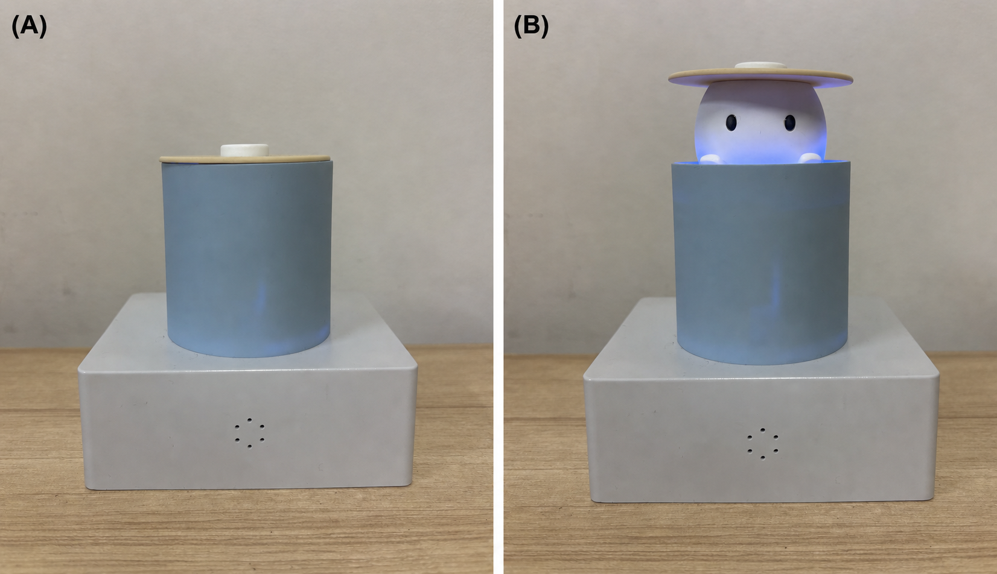
Figure 2. Example of the scenario description in the video stimulus. The text presents a situation in which the robot sees a person littering in a park.
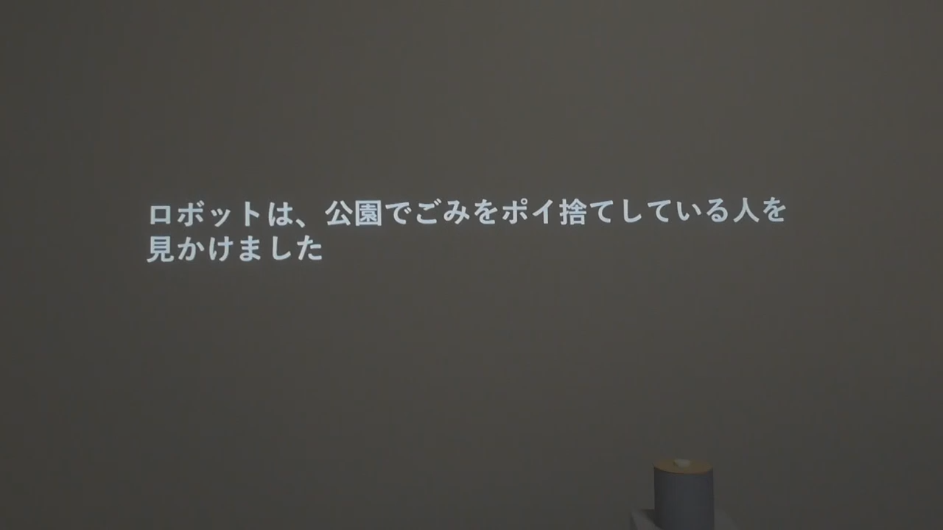
Figure 3. Example of simultaneous presentation of approach and avoidance motives. The speech bubble simultaneously displays a desirable consequence of admonition and a concern about admonition.
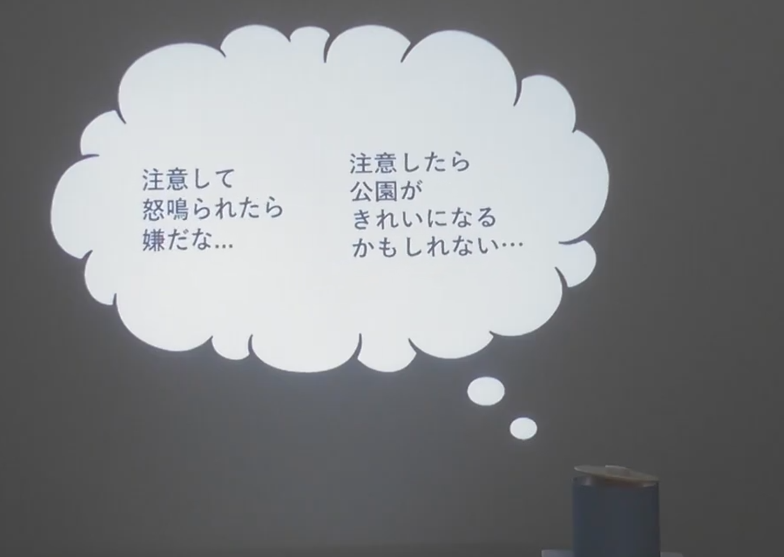
Figure 4. Comparison of conflict presentation methods in Study 1. (A) In the sequential presentation condition, the avoidance and approach motives were shown in separate frames. (B) In the simultaneous presentation condition, both motives were shown within a single frame.
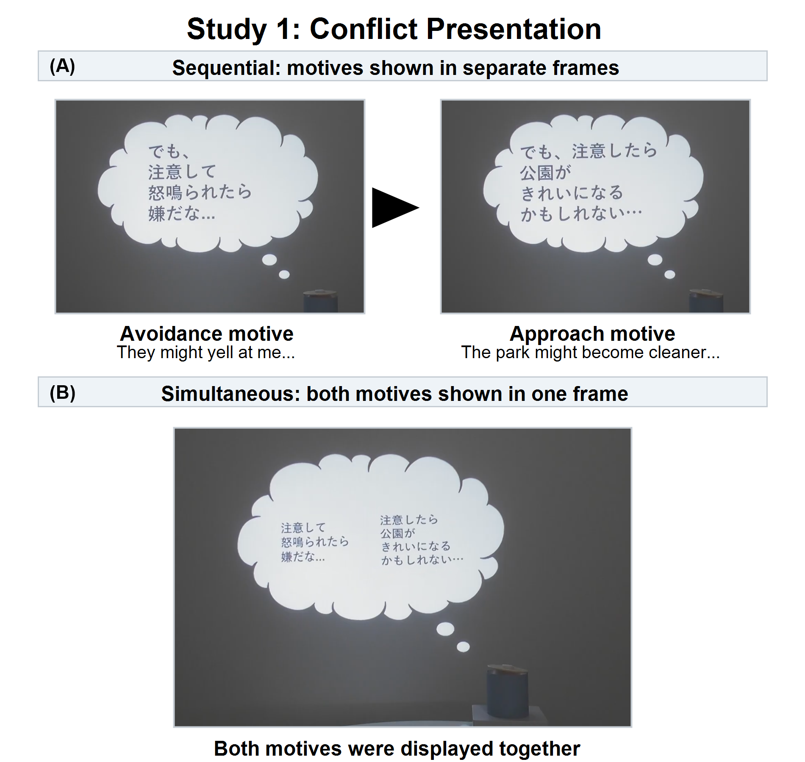
Figure 5. Condition means of courage ratings in Study 1.
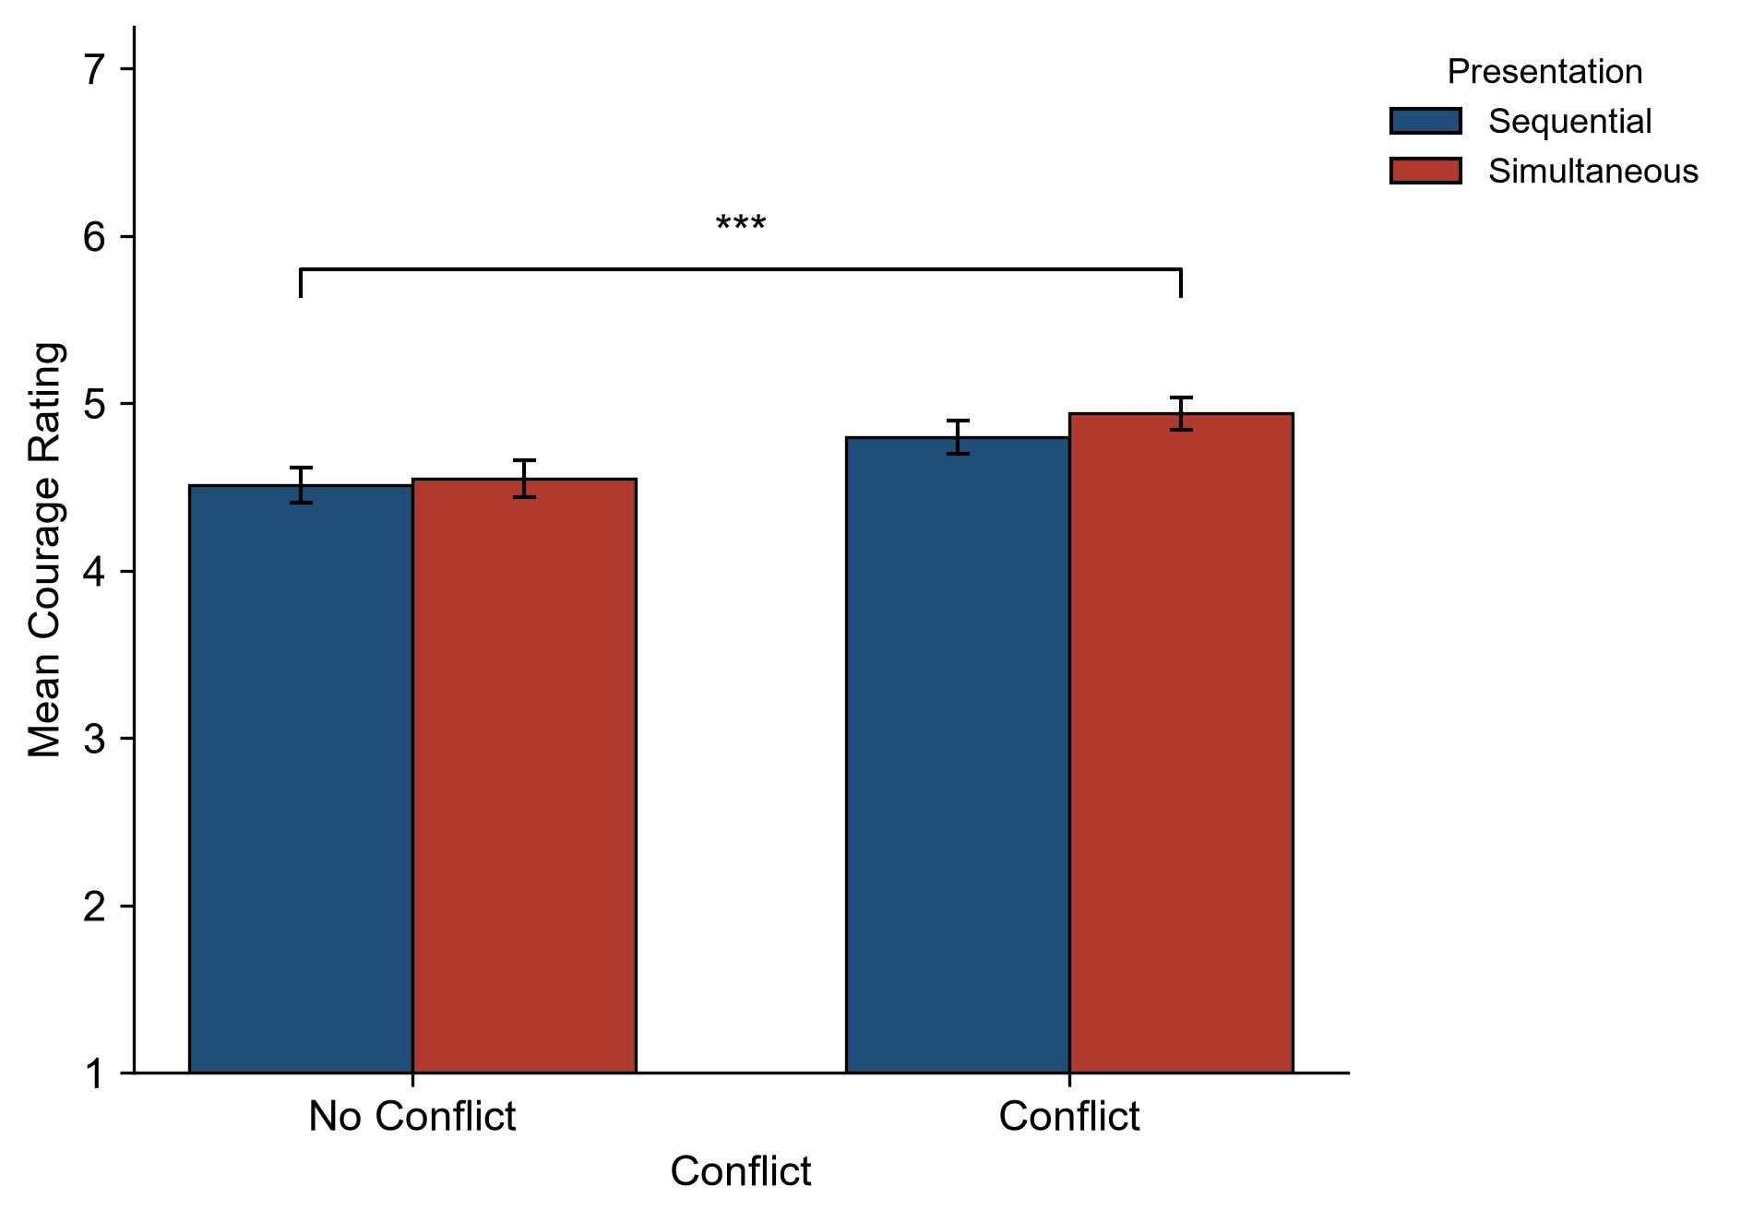
Figure 6. Condition means of conflict ratings in Study 1.
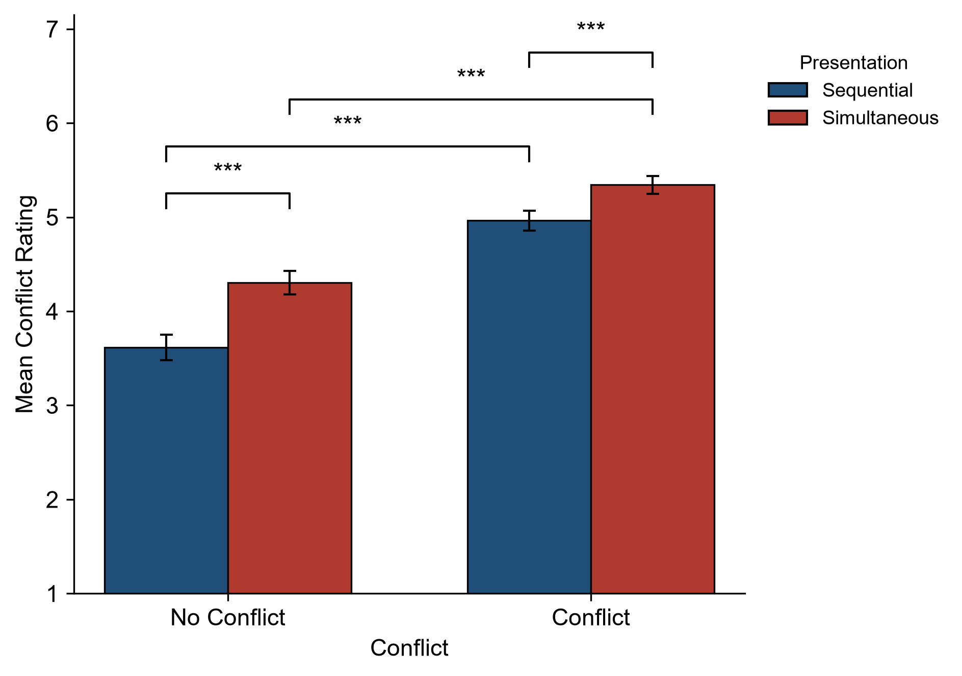
Figure 7. Simple effects of personal courage self-evaluations in Study 2. Means for the no-conflict and conflict conditions by preexisting courage tendency group. The dagger denotes a marginal trend (p = 0.052), and the asterisk denotes p < 0.05.
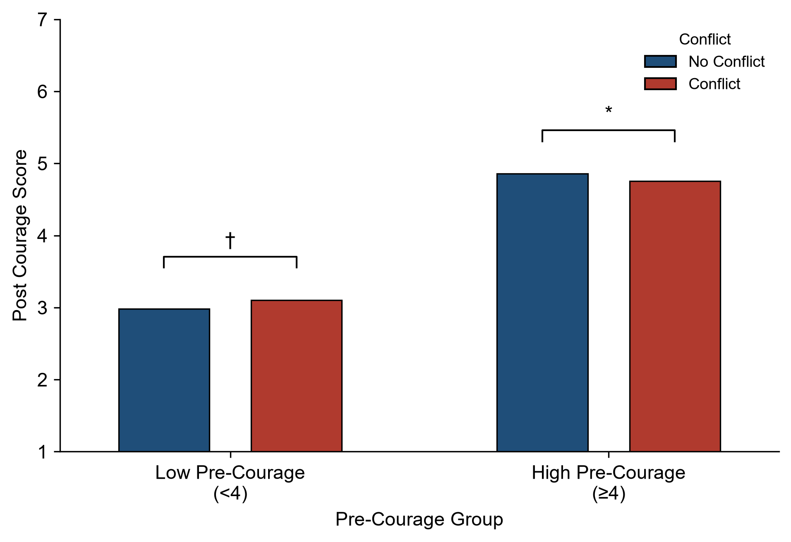
Tables
Table 1. Approach and avoidance motive statements used in the video stimuli.
Type of motive | Motive statement | Content
Approach motive | “If I warn them, the park might become cleaner.” | Possibility that admonishing behavior improves the public space
Approach motive | “If I warn them, it might prompt that person to stop littering.” | Possibility that admonishing behavior changes the other person's behavior
Avoidance motive | “I would hate it if they yelled at me after I warned them.” | Risk of receiving an aggressive response from the other person because of admonishing behavior
Avoidance motive | “Even if I warn them, they might ignore me and not take me seriously.” | Risk that the admonition is not accepted and is ignored

Table 2. Stimulus conditions in Study 1.
Study 1 condition | Displayed motive structure | Motive statements used | Presentation method | Final admonishing speech
No conflict, sequential presentation | Approach motives only | Approach motives: “If I warn them, the park might become cleaner”; “If I warn them, it might prompt that person to stop littering” | Approach motives presented in sequence | Present
No conflict, simultaneous presentation | Approach motives only | Approach motives: “If I warn them, the park might become cleaner”; “If I warn them, it might prompt that person to stop littering” | Multiple approach motives presented simultaneously and alternately emphasized | Present
Conflict, sequential presentation | Approach and avoidance motives | Approach motives: “If I warn them, the park might become cleaner”; “If I warn them, it might prompt that person to stop littering”  Avoidance motives: “I would hate it if they yelled at me after I warned them”; “Even if I warn them, they might ignore me and not take me seriously” | Approach and avoidance motives presented in sequence | Present
Conflict, simultaneous presentation | Approach and avoidance motives | Approach motives: “If I warn them, the park might become cleaner”; “If I warn them, it might prompt that person to stop littering”  Avoidance motives: “I would hate it if they yelled at me after I warned them”; “Even if I warn them, they might ignore me and not take me seriously” | Approach and avoidance motives presented simultaneously and alternately emphasized | Present

Table 3. Robot courage-rating items used in Study 1.
Item | Courage-rating item
1 | This robot appeared to confront its own fear.
2 | This robot appeared not to run away until it did what it had to do, even if it felt strong fear.
3 | This robot did something even though it seemed dangerous.
4 | This robot took action or confronted the situation anyway, even though it had some worry or anxiety.
5 | This robot confronted something frightening when there was an important reason to confront it.
6 | This robot appeared not to back down, even when something threatened it.

Table 4. Robot conflict-rating items used in Studies 1 and 2.
Item | Conflict-rating item
1 | This robot appeared to want to do what was in front of it but to hesitate because of fear.
2 | This robot appeared to have hesitation or fluctuation in its own action.
3 | This robot appeared to have mixed feelings of wanting and not wanting to act.
4 | This robot appeared unable to decide its own action.

Table 5. Stimulus conditions in Study 2.
Study 2 condition | Displayed motive structure | Motive statements used | Presentation method | Final admonishing speech
No conflict, no action | Avoidance motives only | Avoidance motives: “I would hate it if they yelled at me after I warned them”; “Even if I warn them, they might ignore me and not take me seriously” | Avoidance motives presented and emphasized | Absent
No conflict, action | Approach motives only | Approach motives: “If I warn them, the park might become cleaner”; “If I warn them, it might prompt that person to stop littering” | Approach motives presented and emphasized | Present
Conflict, no action | Approach and avoidance motives | Approach motives: “If I warn them, the park might become cleaner”; “If I warn them, it might prompt that person to stop littering”  Avoidance motives: “I would hate it if they yelled at me after I warned them”; “Even if I warn them, they might ignore me and not take me seriously” | Simultaneous presentation with alternating emphasis | Absent
Conflict, action | Approach and avoidance motives | Approach motives: “If I warn them, the park might become cleaner”; “If I warn them, it might prompt that person to stop littering”  Avoidance motives: “I would hate it if they yelled at me after I warned them”; “Even if I warn them, they might ignore me and not take me seriously” | Simultaneous presentation with alternating emphasis | Present

