**Resurrection**

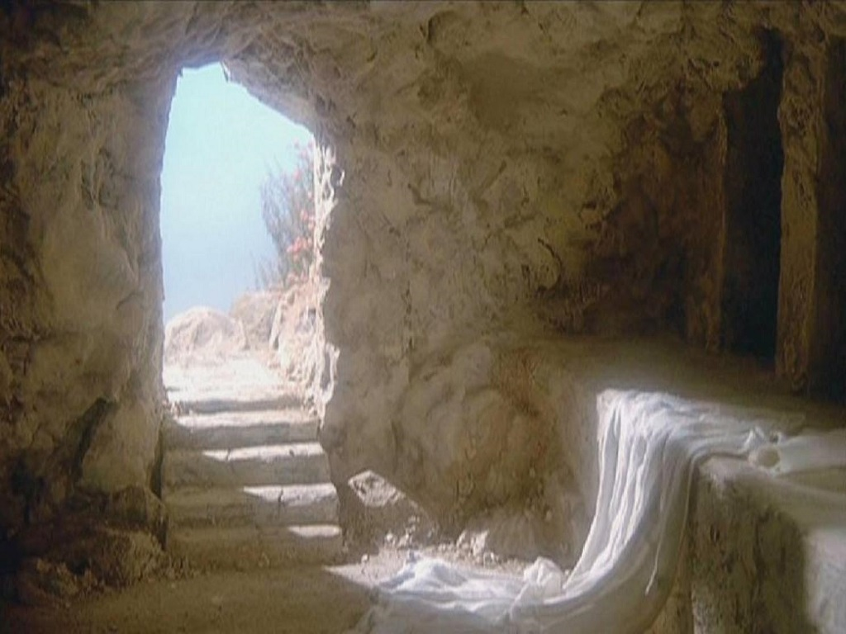

Setting:

In 2021, due to the rise of ISIS in 2014, they have been an incredible force in the world. The ISIS recruited a huge amount of people all around the world. And the number is still rising rapidly. Almost 20% of the people in the world follow ISIS’ lead. While ISIS has been more and more powerful, the population of the world have been also decreased to 5000 million. The members of ISIS have always indicated that “there is no real justice in the world. The justice is in neither America nor ISIS”. Their goal is originally to build their own country, but the ambition has come up big to destroy and re-create the world.

Knowing that the view of the world has been tilted, the world needs a new powerhouse to stabilize the insurrection. The heads of the world, literally based on America, China, Russia, France, Germany and England, are on the way to prepare for the World War III to destroy ISIS and its terrorism. In order to prevent a major population loss to the whole world, they have united to start working on a veiled project to vanish the ISIS without marks. The project S3, Selection for Societal Sanity.

The first step of the project was to get ISIS’ classified information and try to prevent lethal act as possible. The union tried to train a special military team to sneak into Afghanistan to join ISIS as spies. Eventually, six agents were selected to go on the mission. The new Team TED, Terrorism Eliminating Division, was sent to Afghanistan in October, 2021.

Frank Muhammad, the captain of TED, was basically from Iraq. But he moved to America when he was born, the time of The First Persian Gulf war. He was picked up by an American soldier in war. The soldier felt guilty by killing Muhammad’s parents. So he broke the rule and brought back the child to his homeland America. Before Muhammad knowing this fact, the soldier was missing in The Second Persian Gulf war in 1990, the time Muhammad was at age of 10.

Muhammad had gradually gained his loyalty of America because of the environment he was in. He knew he should be an American. But he always has the contradiction that he should have the fury toward the U.S. The army education effectively shook this thought off his mind continuously. When the time came to 2021, he was already the elite of U.S. army. And he had a chance to go back to his homeland to see these crazy things happening…

**Chapter 1 – The Escape**

Plot:

Once TED landed in Afghanistan, they joined ISIS individually as planned. Not finding any “special” records on them, the first sneak-in was a success. But they were asked to get injected by an unknown liquid. ISIS members said that it was necessary to join their organization; otherwise people would get shot. Not willing to take the risk of failure, they were all injected.

Muhammad still went for all the information. Hearing all residents’ loyal rationale toward ISIS and getting familiar with the environment, he finally started to find anything classified. So he did another sneak-in, and it was a trespassing into the government building.

The building was full of guards with firearms. So it was very obvious that there had to be something inside. After passing all the guards silently into the top floor, there was no one there surprisingly.

Muhammad found a document with “classified” stamped on it. He knew it was the thing he needed to find. The document indicated that ISIS had a lot of novel technologies working on. And biological weapons had been all in experimental process for a long time. Unfortunately, one of the biological weapon’s experimental targets were ISIS members. It was the liquid they had been injected. It would gradually control people’s mind to follow “system’s” lead and fight for their ISIS. There was still a lot of detail to be read.

At the moment Muhammad turned the page, the alarm sound loudly. The guards surrounded him and decided to send him to the jail. Black out.

When he woke up, he was in jail. The wall and fence were all made by metal. All the things in jail looked unbreakable. Muhammad was in despair. Seeing the guards patrolling the aisle, there was no air space to get through even he got out of his room. The situation had sustained for 3 days. And the judgement of ISIS came to his ear.

“Cut his head off by tomorrow”

And his last night had come. Suddenly, he heard a sound of metal. It was a key in the corner of the jail. Not knowing what was happening, he saved this key into his pocket. It was the best chance to escape. And the escape started in a questionable fashion…

Section 1:

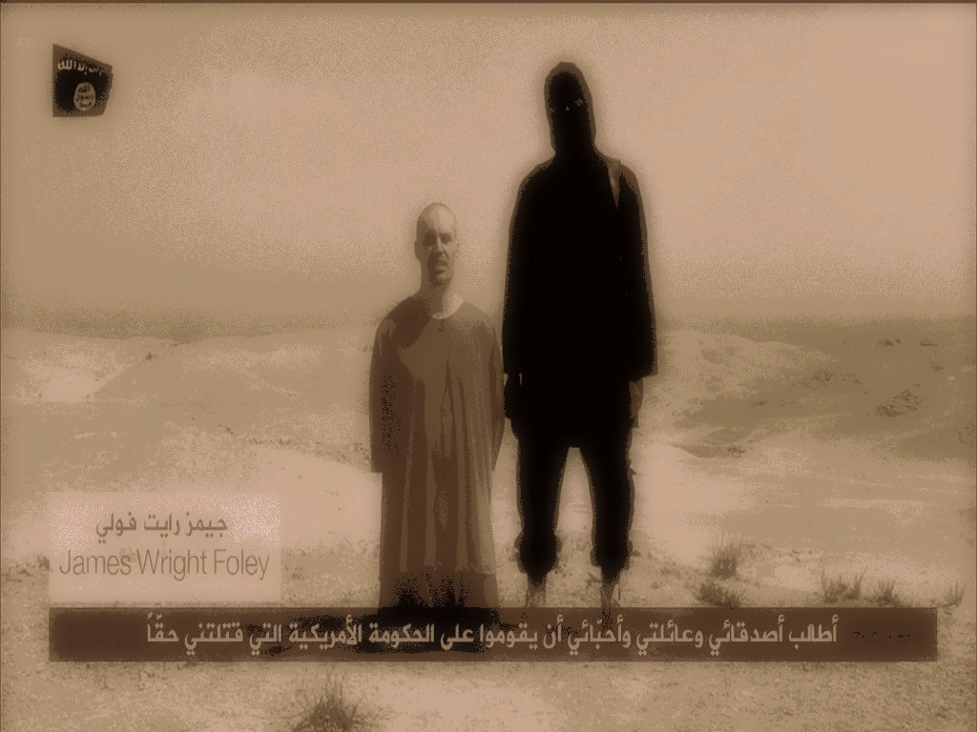

In October, 2021, Frank Muhammad was sent by the U.S. government as a special team’s agent to investigate ISIS in Afghanistan. The terrorism of ISIS has been a major threat to the whole world since their rise in 2014. On the verge of another huge war between ISIS and other major countries, the U.S. and the other countries still tried to form a special team to destroy ISIS without lethal act. Therefore, TED, Terrorism Eliminating Division, was created to obtain much classified ISIS information as they could.

However, as the captain of TED, Frank is facing one of the biggest danger due to his sneak-in’s failure…

Section 2:

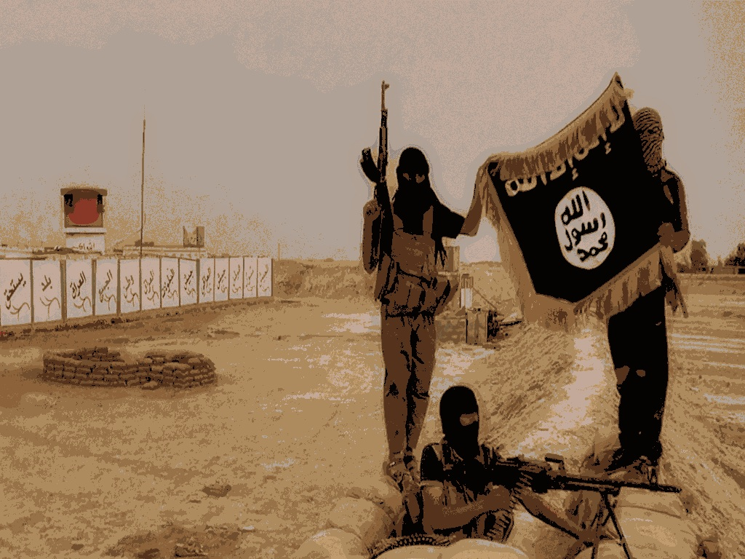

Why could Frank start his escape? Frank doesn’t know the answer. He just knew that he heard a sound of metal when he was in this unbreakable jail. Then a mysterious key appeared in the corner of the room. This kind of mysterious thing reminded him of the strange injection he got when he first tried to join ISIS to spy on them. ISIS members insisted that it’s a “must” to show the loyalty to ISIS; otherwise people would be shot.

Confusing of what the injection was about, Frank recalled a fact that he will never forget, especially in this mission…

Section 3:

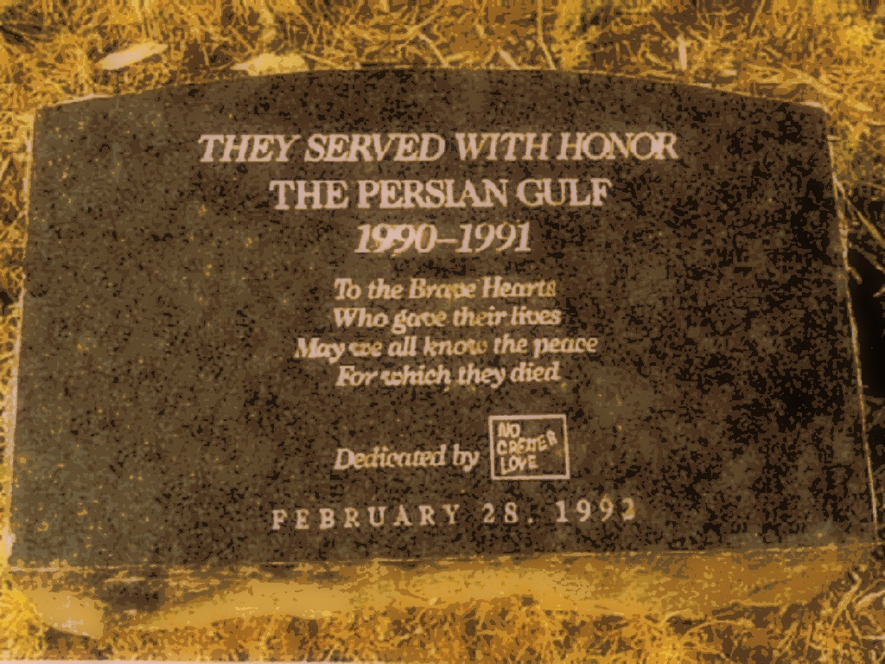

Should Frank feel guilty about battling with Islam? He shouldn’t because he is a U.S. elite soldier to save the world by any mean. But his blood won’t lie. He was born in Iraq by Islam parents. During The First Persian Gulf War in 1980, his parents were killed by an American soldier. However, the soldier eventually picked him up and took him back to America because of the guilty the soldier couldn’t relieve. After The Second Persian Gulf War in 1990, the U.S. lost contact with the soldier and considered him as a dead man. Frank was 10 at that time.

He started to feel the contradiction about his own identity after knowing this fact. And the contradiction kept going stronger…

Section 4:

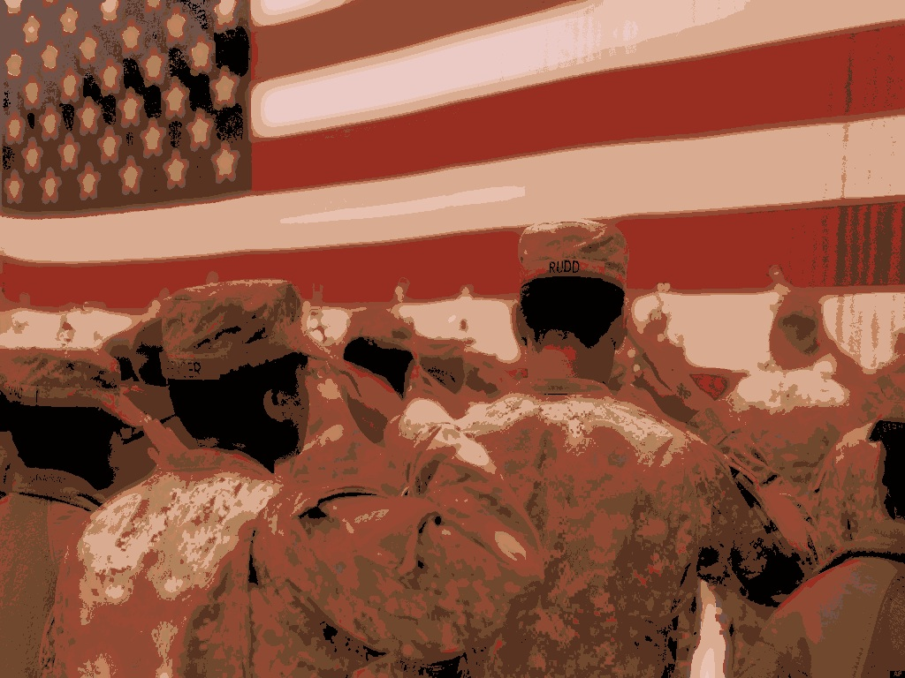

Through the harsh training of U.S. military for years, Frank knew that he should fight for his loyalty toward America. America is the symbol of justice. America is world’s powerhouse. America takes care of everything. Frank makes sure that what he has done is right and sees the exit little by little. ISIS is the organization that cuts people’s heads off. God can’t bear this kind of cruel, inhumane behavior.

After stealing most of the classified information of ISIS, Frank just wants to see other agents alive and brings the documents back to the U.S…

Section 5:



Finally, Frank reaches the exit of the jail. He feels dazzling when he opens the gate slowly and carefully. The sun is rising from the horizon. Though there are several guards out there patrolling this forbidden area, it’s still possible for Frank to escape and make contact with other TED teammates. So many unsolved questions motivate him to strive for a successful mission. Gathering all the equipment, Frank steps out of the jail. Suddenly, an unrecognizable voice comes to his head from the radio.

“Frank Muhammad, stay out of this…”