**Interactive Computer Graphics Mid-term Exam, 18 Nov. ,2013**

1. (5%) Suppose that we render Bezier patches by adaptive subdivision so that each patch can be subdivided a different number of times. Do we maintain geometric continuity along the edges of the patches? Draw a picture and explain your answer.

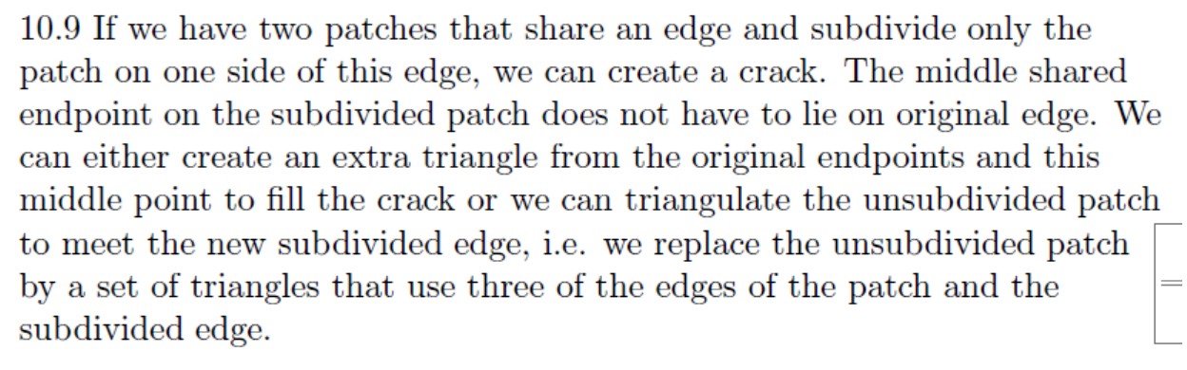

1. **Clipping (10%)**

Clip the line segment from (-1,4) to (2,-1) to the rectangle defined by (0,1) and (1,0). Use a parametric technique to find line intersections. You can give the parameter values for the starting and ending points of the clipped lines (instead of the actual coordinates) if you want to. You do not need to follow any particular algorithm – just show that you can find where the line should be clipped.

**3. (15%) Frustum Clipping**

Define the frustum of vision to be centered on the z-axis with the viewpoint (eye) at   
and with the window on the x, y-plane having its center at, and. The far clipping plane is to be parallel to the window and intersect the z-axis at.

1. (6%) Give the equations (in the window coordinate system) of the six clipping planes. Adjust the signs in your equations (if necessary) so that a positive value denotes "visible” and a negative value denotes "invisible".
2. (9%) How to derive the perspective matrix appropriate for this formulation of the problem. Explain your answer in steps, for example, step 1, step 2, etc.
3. **BSP tree** (15%)
   * 1. (8%) Construct the Binary Space Partitioning (BSP) tree of the model in Fig 1. Please use the right part of node 3 as the root. Split any line segment as you wish, and mark them as a, b, c, d etc., then choose the smallest polygon as the next sub-root (children) when you have multiple candidates.
     2. (7%) From the BSP tree in (a), derive the display sequence in terms of the viewing position “the eye”, where the eye is at the back-side of (behind) polygon 3.

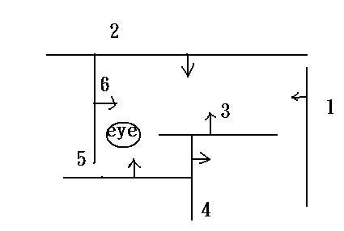 Figure 1.

5. **Transformation (10%)**

Let **M** denote the matrix to transform object space to world space, **V** denote the matrix to transform world space to camera space. There is a normal vector **N** but is described in object space. Please derive a matrix in terms of **M** and **V** thattransforms **N** to camera coordinate **N’**. You can define other variables to make the derivation more understandable.

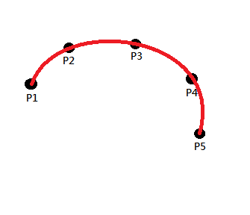

1. Curves and Surfaces (10%)
2. (5%) Please give a brief comparison (advantages) between Bezier curve and B-spline.
3. (5%) If we have control points,P1,P2…P5, how to draw a curve through start point P1 and end point P5 using B-spline (that is let the curve pass through P1 and P5)?

Write down the shortest control points sets to draw.(just like (P1,P2,P2,P3,P4,P5)

Answer: (P1,P1, P1, P1, P2, P3, P4, P5, P5, P5, P5, P5)

1. Ray tracing (15%)
2. (5%) What is the shadow ray in Ray Tracing, why is it needed?
3. (5%) Which part is the most computational expensive in Ray Tracing? Why?
4. (5%) Consider a ray passing through a sphere. Find the point on this ray closest to the center of the sphere. For example, a ray through (0, 0, 0) and (1, 1, 1) passing through a sphere with a center of (3, 4, 5) with a radius of 10, find the point on this ray closest to the center of the sphere

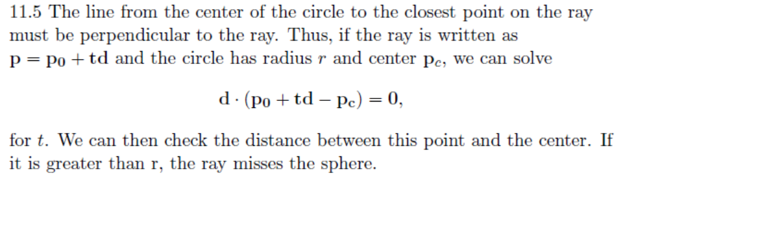

8. (5%) What is your term project for this semester? What are the technical difficulties involved in the project? (You can refer to the project listing).

1. **Illumination Models (15%)**

A popular illumination model is called Phong model, which is developed in 1975. The formula of this model for each color channel is (please refer to textbook):

.

(1) (5%) Could you give two examples of materials that definitely can not be approximated by the Phong model? And simply explain why.

(2) (5%) A general depiction of illumination model is called bidirectional reflectance distribution function (BRDF) (please refer to textbook, bidirectional reflectivity):

.

The idea of this function is that given a viewing and lighting (single light source) direction, the BRDF function returns its reflectance (or precisely, the ratio between the incident flux and reflected intensity). Please design a platform to capture BRDF of materials. You will have the following equipments:

* 1. Spheres of different materials
  2. A digital camera
  3. A light source with a 1DOF rotational arm that allows you to move the light direction horizontally.

(3)(5%) The function I, if stored as a database, can be quite big (much larger than 1 Gaga bytes). This can be a problem for ordinary PC graphics card in real-time graphics. Can you think of a way to compress the data of function I? (Assume viewing and lighting direction is in division of one degree, say in spherical coordinate system, per sample in theta and phi direction.).