Embedded Linux Homework 5 Memo

To: Dr. Yoder
From: Mark Morrison
Date: 6 October 2014
Subject: Embedded Linux Homework 5

Makefiles are not new to me, but some of the built-in variables were interesting to use. Cross compiling was also interesting, and especially useful to know because it is probably how we will program our development board for our senior design project. Installing the 3.8 kernel went smoothly. The 3.15 kernel appeared to build correctly, but when I tried to install and boot in it, the beaglebone never connected to the computer.

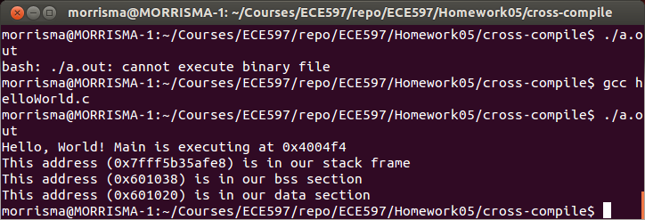Illustration 1: Native x86 compile
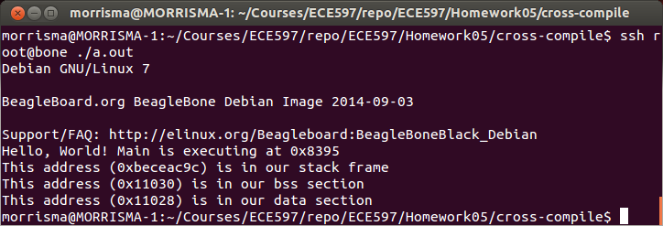Illustration 2: ARM cross-compile

