SECTION A.
1.)Univariate Analysis Report For Dataset “nlsw8”
(i).Dependent variable:Hourly wage(wage)
Count - 2242.000000
Mean - 0.246232
Mode - 0.125805
Std - 0.355022
Min - 0.017411
Lower Quantile - 0.121543
Median - 0.176127
Upper quantile - 0.261675
Max - 9.098225
Range – 9.080813
Variance – 0.126045
Inter Quartile Range - 0.140131
Name: hourly wage, dtype: float6
Distribution shape
Skewness - 12.425393
This means that hourly data is highly skewed and it is positively skewed.
This is extremely skewed and indicates that the right tail is extremely long,meaning
that a few values are much larger than the rest.
The mean is pulled way to the right of the median and it is greater than both the median
and the mode.
Kurtosis - 238.274996
Extremely leptokurtic meaning very heavy tails and extremely sharp peak.
Meaning most data points are very close to the mean,but there are extreme outliers
far away from the mean

Histogram
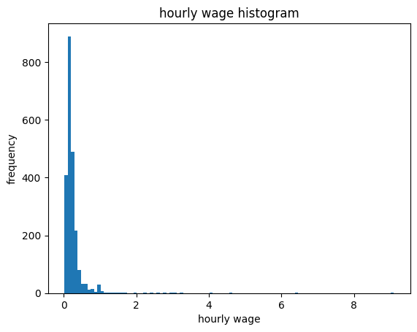

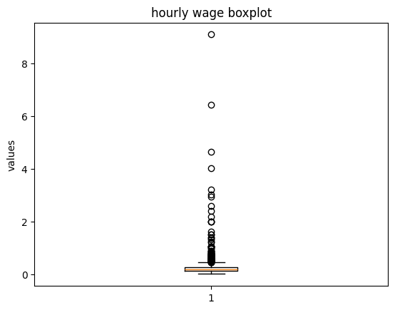

(ii).Univariate Analysis Of Educational Attainment(Grade)
Count – 1849.0000
Mean – 13.1714
Mode – 12.0000
Std – 2.5500
Min – 0.0000
Lower Quantile – 12.0000
Median – 12.0000
Upper quantile – 15.0000
Max – 18.0000
Range – 18.0000
Variance – 6.5025
Inter Quartile Range -3.0000
Name: grade, dtype: float64
Distribution Shape
Skewness- 0.00748
Grade’s distribution is approximately symmetric,as indicated by a skewness of
0.00748,which is very close to zero.
Kurtosis-0.6348
Indicates a mildly leptokurtic distribution.Meaning it has somewhat heavier tails and a more peaked shape compared to a normal distribution

HISTOGRAM
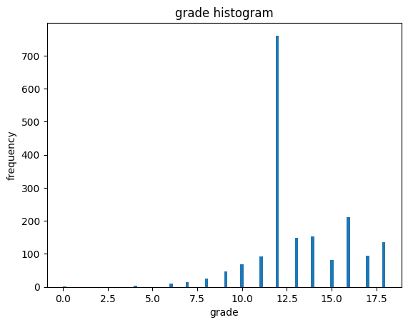
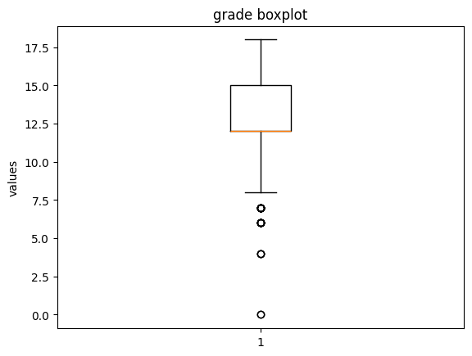

SECTION B.ANOVA
ANOVA Table for effects of race and Union membership on wages
 | df | Sum_sq | Mean_sq | F | PR(>F)
C(race) | 2.0 | 2.326511 | 1.163255 | 8.955477 | 0.000135
C(union) | 1.0 | 0.224062 | 0.224062 | 1.724972 | 0.189218
C(race):C(union) | 2.0 | 0.227766 | 0.113883 | 0.876742 | 0.416310
Residual | 1843.0 | 239.393092 | 0.129893 | NaN | NaN

Race(p=0.000135)
.Race has a statistically significant effect on hourly wage at alpha=0.05 since it is less than alpha.
This indicates that mean hourly wages differ significantly across racial groups.
.Union membership(p=0.189218)-union membership does not have a statisitically significant main effect
on hourly wages.This suggests that on average,union and non union workers earn similar hourly wages
after accounting for race.
.Race x Union interaction (p=0.416310):The interaction between race and union membership is not statistically significant.This means that the effect of union membership on wages does not differ significantly across racial groups and vice versa

SECTION C. LOGISTIC REGRESSION
Logit Regression Results
==============================================================================
Dep. Variable: Union
No. Observations: 1479
Model: Logit
Df Residuals: 1473
Method: MLE
Df Model: 5
Date: Thu, 15 Jan 2026
Pseudo R-squ.: 0.005235
Time: 12:57:47
Log-Likelihood: -805.05
converged: True
LL-Null: -809.28
Covariance Type: nonrobust
LLR p-value: 0.1320
===============================================================================
coef std err z P>|z| [0.025 0.975]
---------------------------------------------------------------------------------------------------------------------------------
hourly wage 0.2365 0.148 1.597 0.110 -0.054 0.527
grade -0.0607 0.011 -5.407 0.000 -0.083 -0.039
tenure 0.0322 0.011 3.044 0.002 0.011 0.053
Married -0.3710 0.125 -2.957 0.003 -0.617 -0.125
race_Other 0.1125 0.483 0.233 0.816 -0.833 1.058
race_White -0.5148 0.137 -3.745 0.000 -0.784 -0.245
===============================================================================
Interpretation-The logistic regression results indicate that union membership among women is
Significantly associated with educational attainment,job tenure,marital status,and race_White.In contrast,
Hourly wage ,race_Other is not a statistically significant predictor of union membership.

SECTION D. SURVIVAL ANALYSIS
P-VALUE= (5.411527994726185e-08)
P<0.05 meaning,Union status significantly affects job tenure
lifelines.StatisticalResult: logrank_test
t_0 = -1
Null_distribution = chi squared
degrees_of_freedom = 1
Test_name = logrank_test
Test_statistic p -log2(p)
29.56 <0.005 24.14

SECTION E:SYNTHESIS
The results from multiple analytical approaches provide a consistent picture of women’s labor-market
Outcomes.Univariate analysis reveals inequality in hourly wages.Most women earn very low wages,a small number earn high wages.
Education is fairly spread.
Two-way ANOVA results show that race significantly race significantly affects hourly wage ,while union membership does not,suggesting that unions do not function as wage-equalizing institutions for women in this labor market.
Logistic Regression analysis further shows that union membership is not driven by wage and race_White levels but rather by marital status and race_other.
Finally,survival analysis demonstrates that union membership significantly increases job tenure ,highlighting the role of unions in promoting employment stability rather than higher wages.
Taken together,the findings suggest that women’s labor market outcomes are shaped by structural inequalities related to race and job stability with unions offering protection against job loss but doing little to reduce wage inequality.

