**Morris Vanegas; mvanegas@alum.mit.edu; morrisvanegas.com**

08

**Fall**

**SAVE SPACE Tool: Manual**

**and**

**Tutorial**

The Statistics Assistant, Volume Enumerating, Segment and Position Automator of Choroid Edges (SAVE SPACE) Tool is a matlab GUI (Graphical User Interface) for automatically detecting the edges of the choroid layer of an OCT (Optical Coherence Tomography) scan using the Heidelberg Engineering Spectralis camera and Eye Explorer software. The SAVE SPACE tool parses XML data exported from Eye Explorer, automatically detects choroid edges of scans, allows a user to manually edit these lines for visual confirmation, and saves volumetric data of scans of all poses to facilitate statistical analysis.

Last Edited: January 26th, 2016

|  |  |  |
| --- | --- | --- |
| Version | Date | Comments |
| 2.2 | January 16th, 2016 | * Fixed bug in matlab that only saved the unedited spline of the first image * Updated Manual to emphasize that MATLAB 2015a is needed. |
| 2.1 | October 8th, 2015 | - Adding ability to save volumes using unedited spline values. Saving spline values. |
| Beta | September 14th, 2015 | First release! |

Table of Contents

2 How the SAVE SPACE Tool is organized 2-4

2.1 Root Folder 2-4

2.2 XMLOutput Subfolder 2-5

3 Altering the Heidelberg Eye Explorer Software 3-7

3.1 Check to see if XMLOutput plugin is already setup 3-7

3.2 Setup the Eye Explorer Software 3-8

4 Getting data off of Eye Explorer Software 4-10

5 Running Poses for the first time 5-11

6 How to use the super-awesome,-wow-this-is-incredible,-seriously-whoever-built-this-is-probably-going-to-be-an-astronaut-someday GUI 6-14

6.1 Information Panels 6-15

6.2 Cycling through poses and images 6-15

6.3 Editing the choroid lines 6-15

7 Exporting data for Statistical Analysis 7-17

# How the SAVE SPACE Tool is organized

The Statistical Assistant, Volume Enumerating, Segment and Position Automatically of Choroid Edges (SAVE SPACE) Tool is a tool for automatically detecting the edges of the choroid layer of an OCT (Optical Coherence Tomography) scan using the Heidelberg Engineering Spectralis camera and Eye Explorer software.

## Root Folder

The root folder is titled “SAVE SPACE” and contains both subfolders and files seen below. The table below provides a description of each element inside the root folder SAVE SPACE.

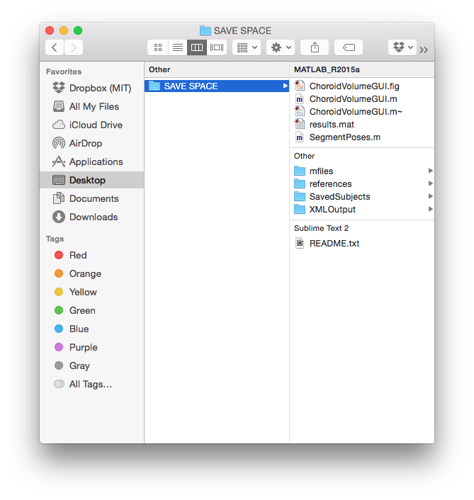

|  |  |
| --- | --- |
| **subfolder or file inside SAVE SPACE root folder** | **Description** |
| README.txt | The first file you should open, giving a quick description of the entire SAVE SPACE tool and how to set up Eye Explorer and Matlab for quick use of the tool. |
| SegmentPoses.m | Matlab script for processing xml data and organizing images. The first time this is run on a pose, this process takes about 10 minutes per pose for a pose with 25 scans. |
| ChoroidVolumeGUI.m | Matlab script for editing the choroid lines and saving pose data. |
| ChoroidVolumeGUI.fig | Figure that defines placement of all items, as well as action listeners used by the users. |
| results.mat | A binary .mat file with information of all saved poses. To export, use matlab to load the .mat file, and use xlswrite() to export to excel or csv file. |
| Subfolder: mfiles | Contains all the matlab files for doing all the fancy-schmancy, nobel prize winning, grant obtaining automatic segmentation. There should be no need to alter any of this by you. |
| Subfolder: references | Contains this manual for using the tool, an hraviewer.ini file for setting up the Heidelberg Eye Explorer software, and a white paper on the automatic segmentation tool from 2013 that this GUI utilized. |
| Subfolder: XMLOutput | This folder holds the subject poses, grouped by folder, of the images, xml output, and meta data. If you want more detail in a subject pose, you can load the subject’s _meta.mat file using matlab. |
| Subfolder: SavedSubjects | A (currently) empty folder where you can copy paste processed and saved subjects used in the tool. The tool automatically loads all folders in XMLOutput. If you already saved a subject, you could move it to SaveSubjects folder so it doesnt automatically open so many folders at once when you open the tool. |

## XMLOutput Subfolder

The XMLOutput subfolder is where you place each subject pose you want to automatically segment. The folder names can be anything you want them to be. Create names that you and your teams understand. All .mat files created inside each folder will automatically take the name of the subject pose you picked. Given that choroid volumes calculated are for each pose a subject performs, you should organize subfolder (poses) inside XMLOutput based on poses, not subjects (do NOT nest poses inside a subject folder). An example of an organization for two subjects (one with two poses, one with three poses) is shown below.

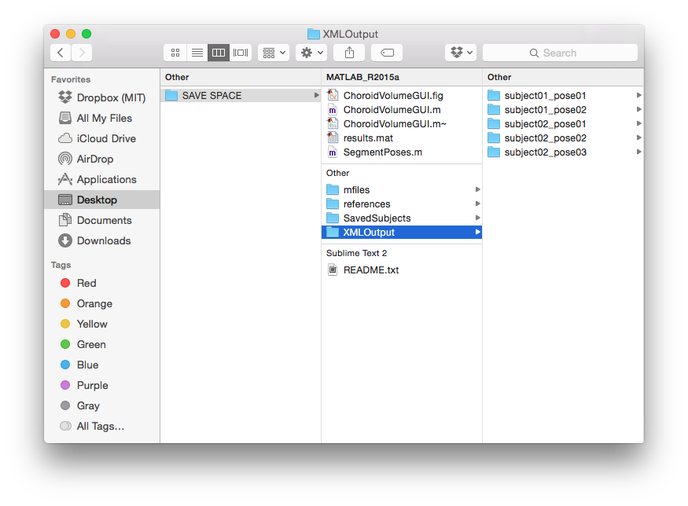

When launching the tool, all five poses will be loaded and available to edit. If you finished subject02, but went to lunch, and wanted to come back to edit subject01, you wouldn’t need to load all five poses. Instead, copy and paste all subject02 poses into the SaveSubjects folder so they do not load next time you are editing (just be sure you hit “save” button when you are done with subject02 so the results.mat file is updated).

# Altering the Heidelberg Eye Explorer Software

## Check to see if XMLOutput plugin is already setup

If you are unsure if the computer running the Eye Explorer software was already setup by someone, follow these steps.

1. Navigate to C:\HEYEK\plugins\hraviewer.ini, and open it with notepad (or wordpad)
2. Under [PortalExport], ensure ExportDataXML=1
3. Under [XMLExport], ensure that
   1. EXE=C:\Program Files\Internet Explorer\iexplore.exe
   2. Workspace=C:\Users\HE\Desktop\XMLOutput (or any directory on the local computer where you want the output to be saved. Feel free to change this to any directory you want).

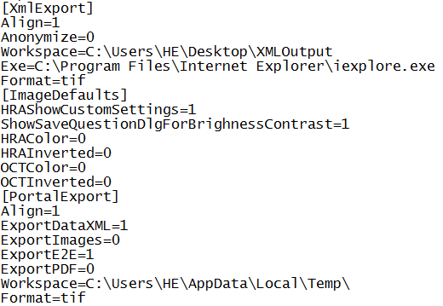

## Setup the Eye Explorer Software

You cannot verify the steps in 3.1, it means the Eye Explorer software is not ~~hacked~~ altered yet. No fear! Use the steps below to set it up. You will only have to follow these steps once.

1. Navigate to C:\HEYEK\plugins
2. Copy the hraviewer.ini and save it as hraviewer_old (or similar) onto the desktop in case a snafu occurs
3. Replace the file with the hraviewer.ini file found in SAVE SPACE\references\hraviewer.ini in the SAVE SPACE folders.
4. Restart the Eye Explorer software.
5. While in the main Database Window (yellow stack of coins icon on top left) of the Heidelberg Eye Explorer, click *Setup-> Options*

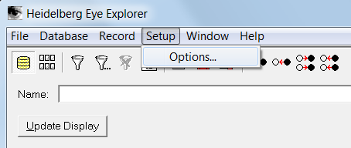

1. Under the *Plug Ins* tab, click hraviewer, then click Setup…

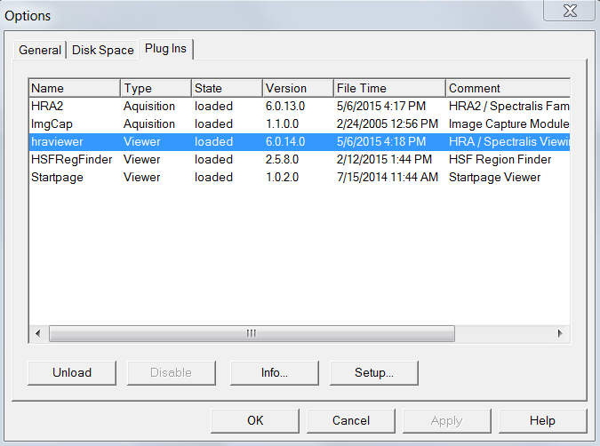

1. On left hand side, navigate to XML Data Export under Data Export Options

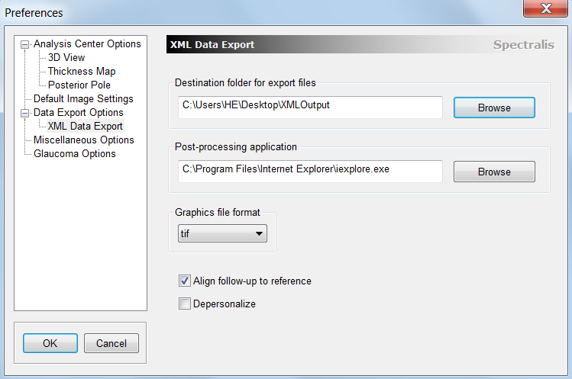

1. Click Browse under Destination folder to pick a destination folder where files will be exported to.
2. Under Post-Processing application, point to Internet Explorer on your computer.
3. Graphics file format should be tif.
4. Check the box next to Align follow-up to references
5. Uncheck Depersonalize box
6. Click OK to close.
7. Click OK to close the options dialog box
8. Restart the Heidelberg Eye Explorer to update changes

# Getting data off of Eye Explorer Software

This section is assuming you already know how to capture images from the Heidelberg Spectralis camera. Sorry, this document wont have a tutorial for that. However, it will show you how to export the data from this software so you can edit choroid layers. Let’s get started.

1. Open the pose you would like to export to edit in the SAVE SPACE Tool.
2. Right click and move the pose to the lower part of the screen.
3. Finally, right click the pose (the bundle of scans), and navigate to Export XML
   1. This command will export a .xml file, and .tif files for each of the scans in this pose. These items will be saved to the Destination Folder you defined in section 3.
4. Navigate to the folder where the .xml and .tif files were saved. Here, create a new folder and name it whatever you want (subject01_pose04 for example).
   1. Move all the .xml and .tif files into this new folder
5. You can now go back to Eye Explorer and export a new pose. Repeat this until you have all the poses you want.
   1. NOTE: Be sure to create a new folder and move the .tif and .xml files into that newly created folder between every time you export a new pose!
6. Use a thumb drive (or email or dropbox if connected to the internet) to get these poses onto the computer in which you will run the SAVE SPACE tool
   1. Place the poses inside the SAVE SPACE\XMLOutput folder.

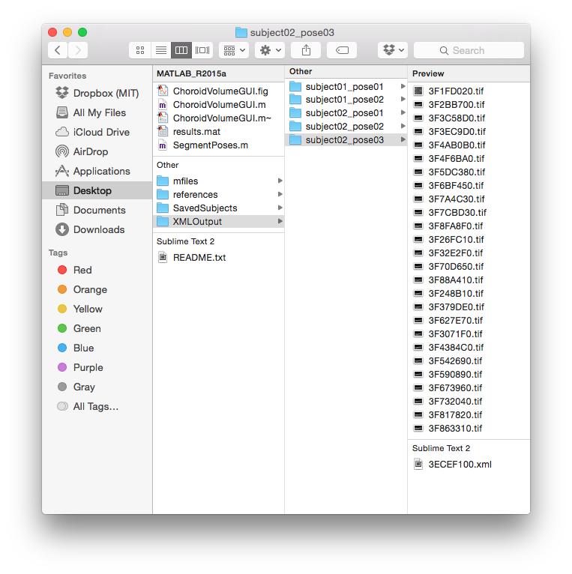

# Running Poses for the first time

Once you have your .xml and .tif files in folders representing different poses, you are ready to process this data. Processing the data uses the .xml file to obtain meta data, map the settings used when capturing scans to organize images, and create .mat files of the layers to visualize and edit scans and edges of lines. ***These files have only been tested with MATLAB 2015a***.

1. Ensure all your poses are inside the XMLOutput folder with an .xml file, and all the .tif files inside the folder, as seen in the screenshot in section 4 above.
2. Open matlab
   1. If you haven’t done so already, add the appropriate paths to your search path.
      1. Click “set path”
      2. Click “Add with Subfolders…”
      3. Navigate to …/SAVE SPACE
3. Run “SegmentPoses.m.”
   1. Segment poses might take a while to run, especially if this is the first time you are processing a pose. Poses typically take 10 minutes to process the first time, but about 10 seconds if they were already run to ensure certain parameters are in place. The script will try to process all the poses in XMLOutput one after the other. So if you have 6 poses that have never been processed, expect to wait 6*10=60 minutes for all 6 poses to finish processing.

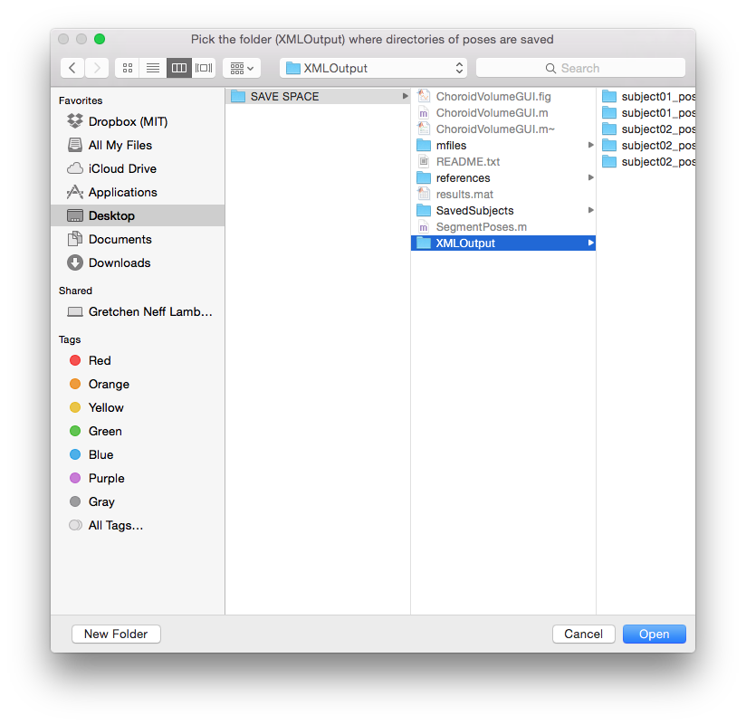

1. A dialog box will open, prompting you to pick the folder where the poses are stored. This folder should be SAVE SPACE\XMLOutput
2. One of two things will happen depending on whether a pose was already processed or not (processed means that .mat files were created inside the pose by SegmentPoses.m). Either (a) the pose was already processed, or (b) the pose needs to be processed.
   1. A pose was already processed
      1. In the command window, you will see “Folder_name (.xml file) was already processed”
   2. A pose needs to be processed
      1. A dialog bar will appear, giving you an indication of how much processing is left to do.

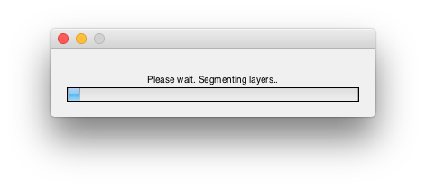

* + 1. A dialog bar will appear for EACH POSE that needs to be processed. So if a six poses need to be processes, six different dialog bars will appear, one after the other. To get an idea, of which poses have been processed and which remain, take a look at the command window in Matlab.
       1. “Folder_name (.xml file) was already processed” means this pose took a few seconds to complete, because it was already processed once. If you are reading this sentence, email me at mvanegas [at] alum [dot] mit [dot] edu. I am just curious how many people will actually read into this depth =p
       2. “Folder_name (.xml file) finished processing” means that the pose was processed for the first time, meaning it took about 10 minutes to complete.

1. Once all poses are finished processing, you should see three .mat files appear inside their directories, just like the image below. This means the pose was successfully processed.

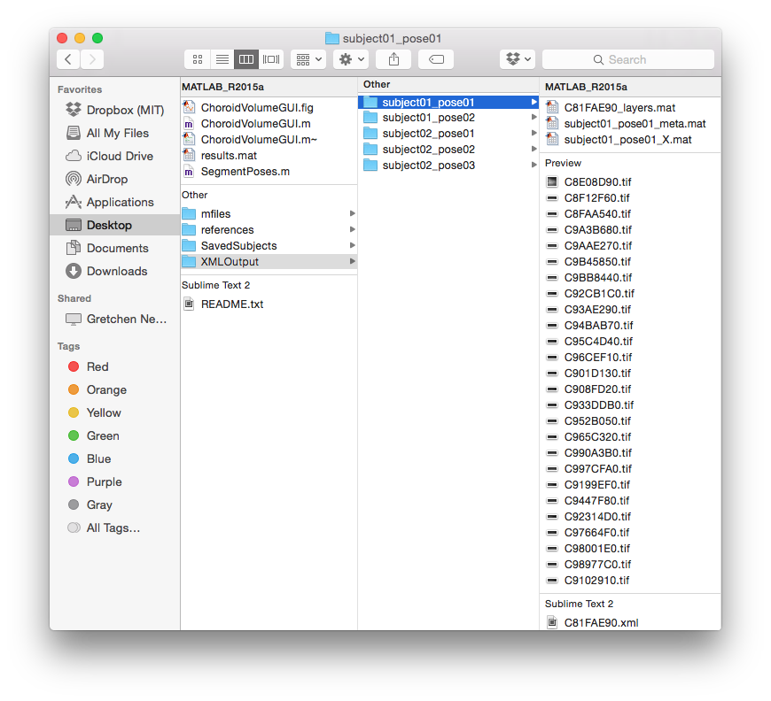

# How to use the super-awesome,-wow-this-is-incredible,-seriously-whoever-built-this-is-probably-going-to-be-an-astronaut-someday GUI

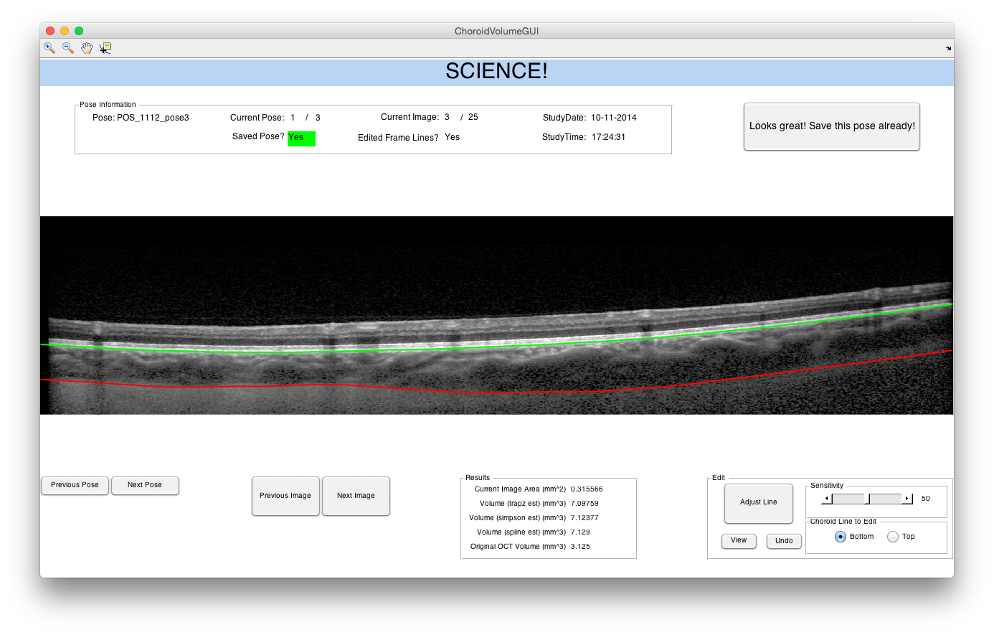

The image above shows the layout of the SAVE SPACE gui. In the center, a single scan is shown overlayed with two lines representing the edges of the choroid. Information about the current image and pose is shown above the image, while the editing and viewing controls are below the image. Matlab toolbar plugins on the top left allow for zooming in and out, as well as panning, and obtaining point data. A large button on the top right exports the data and appends it to a growing table of pose information. To start using this GUI, run the ChoroidVolmeGUI.m script in matlab and choose the appropriate folder (XMLOutput) where all the poses are being held.

## Information Panels

On the top group called Pose Information, information about the current pose (folder) is displayed. This information is populated from the XML file exported from Eye Explorer. *Pose* is the name of the current folder inside XMLOutput. *Current pose* shows you which pose you are viewing, out of how many total poses (folders) are inside XMLOutput. *Saved Pose*? Indicated where this pose has already been saved to the results.mat summary. If it has been saved, the word Yes is highlighted in green. *Current Image* tells you which image you are looking at, and how many total images (or scans) there are inside the specific pose you are viewing. *Edited Frame Lines* is just an internal indicator. It was used to determine how “good” the algorithm was doing. If the user did not edit many lines, then the algorithm was doing great. *StudyDate* and *StudyTime* are populated from the XML file exported.

In the bottom center, you see a group of data titled Results. It displays one area and four volumes. The *Current Image Area* refers to the area (in mm^2) in between the two lines (ie, the area of choroid). *Original OCT Volume* is a volume obtained from the XML file. It is the choroid volume calculated by the Heidelberg Eye Explorer software. The other three volumes represent volume estimations, using the area of each scan. The volume is estimated with three approximations: the trapezoidal method, the simpson rule, and a spline.

## Cycling through poses and images

When the GUI first opens up, it will automatically load the first pose in the XMLOutput folder. The natural thing for a user to do would then be to view all the sans inside one pose, make any edits if they need to, and then save the pose.

To cycle between images (scans) inside a pose, click the *Previous Image* and *Next Image* buttons on the button center of the screen. You can also use the right and left arrow keys on your keyboard to cycle a little quicker. As you view different images, notice that the *Current Image* in the *Pose Information* panel is also updated.

To cycle between poses (folders inside the XML folder), use the *Previous Pose* and *Next Pose* buttons on the bottom left of the screen. There is a small lag in display when switching between poses, mostly because all the new information needs to be updated and displayed. When you change poses, notice that the *Current Pose* in the *Pose Information* panel is also updated.

## Editing the choroid lines

As you cycle through the images and poses, there may be times when you want to tweak the automatically segmented lines for a better fit. This can be done using the *Edit* group of buttons on the bottom left of the GUI.

To begin editing, press the *Adjust Line* button on the bottom right. Your cursor will change into cross hairs to guide where you want to make changes. As you click on the image, the corresponding line (bottom/red, or top/green) will shift, depending on which radio button is active. When in editing mode (ie, when your cursor is crosshairs), other buttons become inactive. To switch which line you want to edit, exit the edit mode, press the appropriate *radio button*, and then enter edit mode again. (NOTE: as of 9/9/2015, this function is not active. Only the bottom (red) line can be edited).

When you make an edit, the GUI will make changes that are based on your distance from the line you are trying to edit. That is, changes are more heavily weighted to when you make small changes near the existing line, rather than large changes of the line itself. The *Sensitivity Slider* defines how much of a spline to create between the location where you clicked with the crosshairs and the line you are editing. A low value of sensitivity will make a narrower spline between the line and the crosshair, affecting only a small portion of the line in the vicinity of the cross hair click. A large sensitivity will be “wider” and affect a larger portion of the choroid line.

At times, it may be difficult to know if an edit you made was useful or not. The only button that remains active in edit mode is the *View* button. This button toggles the choroid line on and off in order to view the image more clearly. When not in edit mode, you can also use the toolbar on the top left to zoom in, zoom out, and pan the image for more detailed edits.

Finally, if you did not like the edit you just made, just press the *Undo* button when not in edit mode. This undoes ONE, the last, edit you made. In this sense, it is more of a “prev” button on your tv, rather than an undo button on your computer.

As you are editing the line in edit mode, when you click out of edit mode using the same button, you should see the first four values in the Results group update. The Original OCT Volume will not update as that is just a static value obtained from the Eye Explorer software.

# Exporting data for Statistical Analysis

If you have finished making all the edits you wanted to make, or you looked through all the images inside one pose and decided they were great, you are now ready to save this pose. Saving a pose will take its data, and add it to the results.mat file in the root folder. As you are editing and viewing more poses, the .mat file will begin to accumulate. Eventually, any posed that has gone through this GUI and has been saved, will be visible by loading results.mat.

To save the current pose, press the *Looks Great! Save this pose already!* button on the top right of the GUI. Be sure to only click this button when you are not editing an image. You can confirm that the pose was saved when you notice the background of *Saved Pose* in the Pose Information group turn green. If the pose was already saved previously (the background was already green), saving again will overwrite the entry in the results.mat folder of that pose. So if you already saved a pose, but decided to make edits later on, you can still save again! In this case, when you press save, the background of *Saved Pose* with flash twice to let you know it was resaved.

The reason I made the background of *Saved Pose* green was two fold. For one, it is a simple confirmation that the save button worked without having to load the results.mat folder. Secondly, if you are too lazy to move the poses from XMLOutput to SavedSubjects folders or, you are working on 10 poses, but only doing them 3 poses at a time with a break to watch Airplane! The Movie (my favorite movie!), this you wouldn’t necessarily know which poses you had saved already. This is a quick indication that there is no need to look at the images in this pose anymore because they are done. To make your life easier, I suggest moving the poses that have been saved from XMLOutput to the SavedSubjects folder.

Viewing the results.mat file or entries is fairly straightforward. The easiest way is to navigate to results.mat in the “Current Folder” pane in matlab. Double clicking it will add the command “load(‘results.mat’)” (or some variation of that) to your command window. The cell matrix called *results* should now be in your Workspace variables. Double clicking the variable will show you what is inside that matrix.

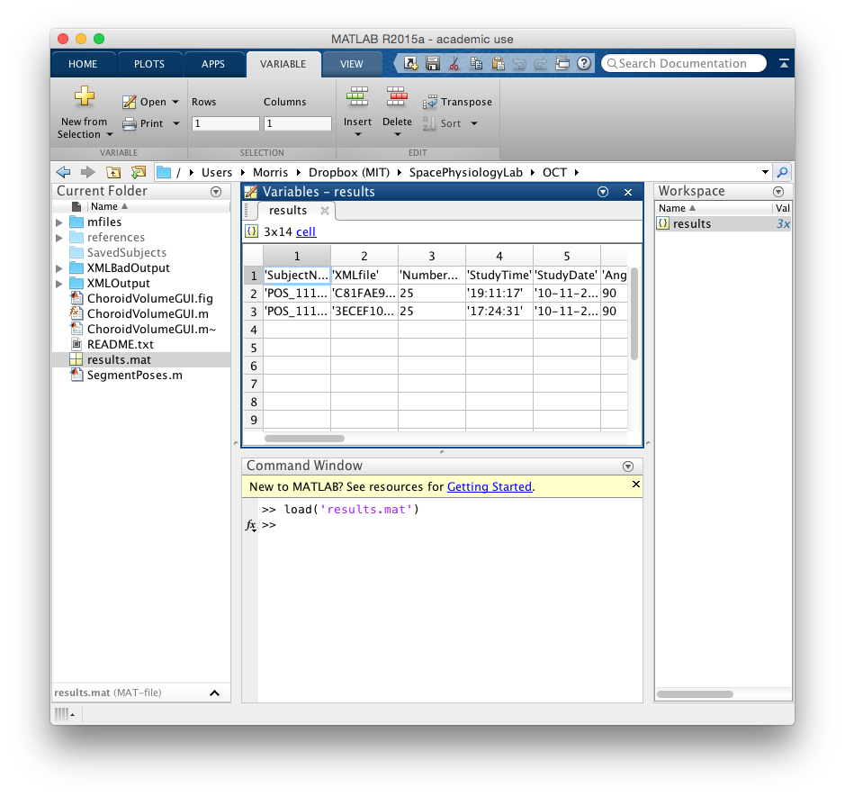

I saved all this information as a .mat file because (1) windows and mac use different xlswrite() and csvwrite() methods to create excel and csv files, and I don’t know which computer you are using, and (2) different statistical software packages take in different formats of tables, so I will leave it up to you to decide what format to export this in for statistical analysis.

For Mac:

* Use T=cell2table(results) to convert cell array to a table
* writetable(T,'file_name_you_want.csv','WriteVariableNames',false)
  + No need to write the variable titles since the .mat file already has them.

For Windows

* Use xlswrite(‘file_name_you_want.xlsx’, results)