WP3
HDLC/PPP over TDM
Application Note
Issue No. 1: February 2012

Legal Information

Copyright
Copyright 2012 PMC-Sierra, Inc. All rights reserved.
The information in this document is proprietary and confidential to PMC-Sierra, Inc., and for its customers’ internal use. In any event, no part of this document may be reproduced or redistributed in any form without the express written consent of PMC-Sierra, Inc.

Disclaimer
None of the information contained in this document constitutes an express or implied warranty by PMC-Sierra, Inc. as to the sufficiency, fitness or suitability for a particular purpose of any such information or the fitness, or suitability for a particular purpose, merchantability, performance, compatibility with other parts or systems, of any of the products of PMC-Sierra, Inc., or any portion thereof, referred to in this document. PMC-Sierra, Inc. expressly disclaims all representations and warranties of any kind regarding the contents or use of the information, including, but not limited to, express and implied warranties of accuracy, completeness, merchantability, fitness for a particular use, or non-infringement.
In no event will PMC-Sierra, Inc. be liable for any direct, indirect, special, incidental or consequential damages, including, but not limited to, lost profits, lost business or lost data resulting from any use of or reliance upon the information, whether or not PMC-Sierra, Inc. has been advised of the possibility of such damage.

Trademarks
For a complete list of PMC-Sierra’s trademarks and registered trademarks, visit: http://www.pmc-sierra.com/legal/

Revision History
Issue No. | Issue Date | Details of Change
1 | Feb 2012 | WDDS version 4.2.2

Contacting PMC-Sierra
PMC-Sierra  8555 Baxter Place  Burnaby, BC  Canada V5A 4V7  Tel: +1 (604) 415-6000  Fax: +1 (604) 415-6200 | PMC-Sierra, WIN Div.  6850 Austin Center Blvd.  Suite 215  Austin, TX 78731  USA  Tel: +1 (512) 345-3808 | PMC-Sierra, WIN Div.  Taya Center  6 Hamasger St.  Ra'anana 43653  Israel  Tel: +972 (9) 743-9998 | PMC-Sierra, WIN Div.  International House, Stanley Blvd.  Hamilton Int. Technology Park  Blantyre, Glasgow. G72 OBN.  United Kingdom  Tel: +44 (0) 1698-404889
Document Information: document@pmc-sierra.com
Corporate Information: info@pmc-sierra.com
Technical Support: apps@pmc-sierra.com
Web Site: http://www.pmc-sierra.com
Table of Contents
Legal Information 2
Copyright 2
Disclaimer 2
Trademarks 2
Revision History 2
Contacting PMC-Sierra 2
1 Overview 4
1.2 Software Requirement 4
2 System Setup 5
2.1 Egress set-up 5
2.2 Ingress Set-up 7
3 Application Description 11
3.1 App_InitConfig() 11
3.2 App_DeviceAndPortCreate() 11
3.3 App_MemPoolNodeAndSchedCreate() 11
3.4 App_ChannelAndPQBlockCreate() 11
3.5 App_EnableSystem() 11
3.6 App_CreateEnetHdlcBridgeForIP() 12
3.7 App_CreateHdlcEnetBridgeForIP() 12
3.8 App_CreateEnetHdlcBridgeForMPLS() 13
3.9 App_CreateHdlcEnetBridgeForMPLS() 13
3.10 App_CreateEnetPPPBridgeForIP() 14
3.11 App_CreatePPPEnetBridgeForIP() 15
3.12 App_CreateEnetPPPBridgeForMPLS() 15
3.13 App_CreatePPPEnetBridgeForMPLS() 16
3.14 App_perform_freerun() 17
4 Building the Application 18
5 Running the Application 19

Overview
The scope of this project is to create a simple HDLC/PPP application example that uses winpath3. TDM links are used in loop-back for traffic and control flows testing. This application note is based on:
This application note is based on:
- WDDS release version 4.2.2
- Winmon 4.2.5

- HW Requirement
- 1 WDS3 board
- 1 TDM Comet card

Software Requirement
By default, this application is configured to run under WinMon. This application can be configured to run either VxWorks or Linux as well.

System Setup
HDLC/PPP hardware setup has one WDS3 board and one Comet card. The TDM links are connected in external loopback. The data flow also allows regular PPP control packets such as LCP and NCP to maintain a PPP session. HDLC/PPP flow allows control packets such as IPCP and traffic in the data path.
The setup is available with QoS options in Egress and Ingress. Whole HDLC/PPP application is divided into 4 different applications in same system set-up. These 4 applications are as given below
- HDLC over IP
- HDLC over MPLS
- PPP over IP
- PPP over MPLS

Egress set-up
Enet to HDLC/PPP (TDM) flow is shown in Figure 1. Enet port, Enet device and Enet channels are created for receiving the traffic as the traffic is generated from the Host.
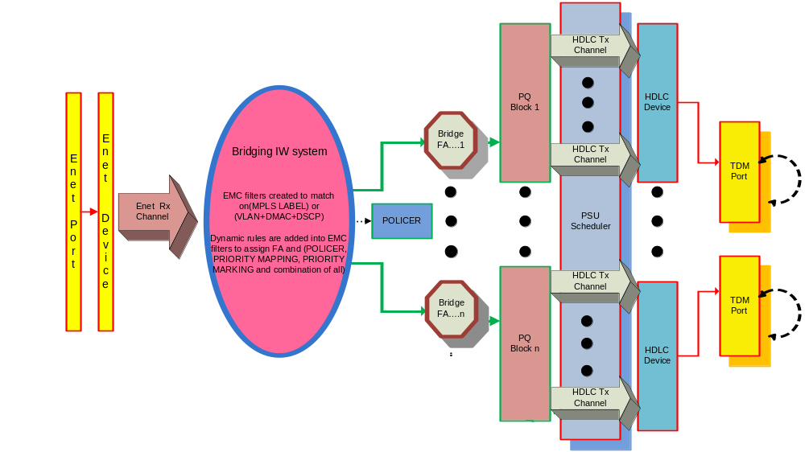
Figure 1 ENET to HDLC/PPP TDM flow
This traffic flows through the Bridging interworking system where an EMC filter is added to classify traffic. In the bridging flow aggregation Ethernet headers are extracted from the frames and HDLC/PPP header is inserted. For each configuration EMC filter and FA actions are as given as below
- HDLC over IP
EMC filter based on DST MAC, VLAN ID, DSCP. Bridge flow aggregation will remove the Ethernet and VLAN header and insert HDLC header.
- HDLC over MPLS
EMC filter based on MPLS label. Bridge flow aggregation will remove the Ethernet and VLAN header and insert HDLC header.
- PPP over IP
EMC filter based on DST MAC, VLAN ID, DSCP. Bridge flow aggregation will remove the Ethernet and VLAN header and insert PPP header.
- PPP over MPLS
EMC filter based on MPLS label . Bridge flow aggregation will remove the Ethernet and VLAN header and insert PPP header.

Along with the forwarding action the QoS related actions, POLICING, PRIORITY_MAPPING and PRIORITY_REMARKING are created with EMC flow. PRIORITY_REMARKING is based on DSCP value. After required QoS actions are performed the packet is forwarded to the bridge FA using the forwarding action in the DFC Flow action.
Priority Queue Block, PQBlock, is created over the CHDLC/PPP system, with some channels (2 in this application) associated with the PQBlock. The forwarding mechanism determines to which PQBlock a packet belongs, and then the priority classification mechanism determines the specific channel within that PQBlock.
The channels are configured with default tx_tq values of 0,1,2 and 3. These values can be modified by the user. Also scheduling is done with simple weighted fair queue (WFQ) method. The weight and weight fraction values are configurable for WFQ scheduling.

Ingress Set-up
TDM to Enet flow is shown in Figure 2. Two interworking systems are created: PPP switch interworking system and VLAN aware Bridging interworking system. HDLC Rx channels are created over the HDLC devices. In this set-up packet will flow from TDM device to Enet2 device through the 2 interworking system.
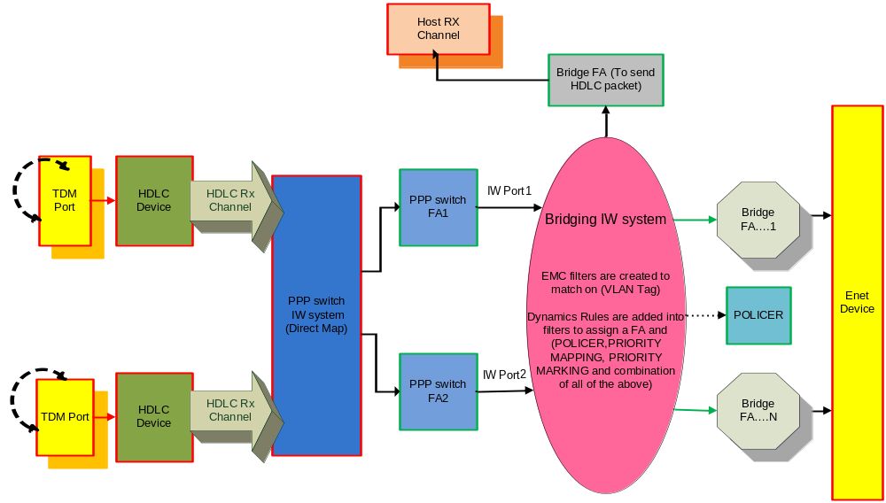
Figure 2 HDLC/PPP to Enet flow
Dummy Ethernet header including VLAN is added to the packet at PPP switch flow aggregation. PPP switch flow aggregations points to the Bridging interworking system. Address and Protocol Field compression are enabled on the PPP switching RX BINDING. So a packet that starts with the PPP header will have AFC/PFC applied to it.
Any packet that does not have a PPP header (HDLC packet) will assumed to have it compressed and will be accepted as it is. This is the only way to accept HDLC packets into the PPP Switching since they don't have a PPP header (0xFF03).
* PPP header 0xFF03C021 is received back into the PPP Switching system as 0xC021 after applying AFC and PFC
* PPP header 0xFF030021 is received back into the PPP Switching system as 0x21 after applying AFC and PFC
* PPP header 0xFF038021 is received back into the PPP Switching system as 0x8021 after applying AFC and PFC
Based on Dummy Ethernet header’s VLAN ID, filter will classify the packet. In the application VLAN ID is inserted as follows
- VLAN ID value 0x0a is for traffic packet
- VLAN ID value 0x0b is for control(IPCP in case of PPP) packet
- VLAN ID value 0x0c is for LCP (in case of PPP) packet
EMC filters are created in the bridging interworking system. The EMC flow will forward the packet to a flow aggregation. All EMC filters and flow aggregation actions are given below for the 4 configurations.
- HDLC over IP
EMC filter based on VLAN ID and IW Port value.
If VLAN ID is 0xb( for HDLC LCP packet (0x0F008035)), the filter will forward packet to the Bridge flow aggregation, which remove the Dummy Ethernet and VLAN header and send the rest of the packet to host as it is.
If VLAN ID is 0xa (for CHDLC DATA packet (0x0F000800)), the filter will match the DSCP value and forward packet to Bridge flow aggregation which remove the Dummy Ethernet, VLAN header and CHDLC header. Then add the Ethernet header and send the packet to Enet2 device.
- CHDLC over MPLS
EMC filter based on VLAN ID and IW Port value.
If VLAN ID is 0xb (for CHDLC LCP packet (0x0F008035)), the filter will forward packet to the Bridge flow aggregation, which remove the Dummy Ethernet and VLAN header and send the rest of the packet to host as it is.
If VLAN ID is 0xa( for CHDLC DATA packet (0x0F000800)), the filter will forward packet to Bridge flow aggregation, which remove the Dummy Ethernet, VLAN header and HDLC header. Then it will add the Ethernet header and the MPLS header and send the packet to Enet2 device.
- PPP over IP
EMC filter based on VLAN ID and IW Port value.
If VLAN ID is 0xb (for PPP IPCP packets (0x8021) )the filter will forward packet to the Bridge flow aggregation, which remove the Dummy Ethernet and VLAN header and send the rest of the packet to host as it is.
If VLAN ID is 0xc (for PPP LCP packets (0xc021)) the filter will forward packet to the Bridge flow aggregation, which remove the Dummy Ethernet and VLAN header and send the rest of the packet to host as it is.
If VLAN ID is 0xa(For IP DATA packets (0x21) )the filter will forward packet to Bridge flow aggregation, which remove the Dummy Ethernet, VLAN header and PPP header. Then add the Ethernet header and send the packet to Enet2 device.

- PPP over MPLS
EMC filter based on VLAN ID and IW Port value.
If VLAN ID is 0xb (for PPP IPCP packets (0x8021)) the filter will forward packet to the Bridge flow aggregation, which remove the Dummy Ethernet and VLAN header and send the rest of the packet to host as it is.
If VLAN ID is 0xc (for PPP LCP packets (0xc021)) the filter will forward packet to the Bridge flow aggregation, which remove the Dummy Ethernet and VLAN header and send the rest of the packet to host as it is.
If VLAN ID is 0xb (for IP DATA packets (0x21)) the filter will forward packet to Bridge flow aggregation, which remove the Dummy Ethernet, VLAN header and PPP header. Then add the Ethernet header and MPLS header then send the packet to Enet2 device.

Along with the forwarding action the QoS related actions, POLICING, PRIORITY_MAPPING and PRIORITY_REMARKING are created with EMC filter. PRIORITY_REMARKING is based on VLAN tag. After the required QoS actions are performed the packet is forwarded to ENET2 device.
The txfunc is Enet device. Four channels are created with default tx_tq as 0,1,2 and 3. These priority values can be modified/configured on the fly.

Application Description
Application consist of 4 files
- ppp_hdlc_tdm.c
This file contains main function and all necessary functions for building the system.
- ppp_hdlc_tdm.h
All function and global variables declarations are done here.
- ppp_hdlc_tdm_stats.c
All statistics related functions are defined this file.
- ppp_hdlc_tdm_util.c
All test related functions are defined in this file.
Specified below are the important functions in the application and their key description.

App_InitConfig()
Contains functions which initializes Enet physical ports and create/initializes the clocks and initializes the system.

App_DeviceAndPortCreate()
Create the Enet, TDM port and devices and initializes TDM card device.

App_MemPoolNodeAndSchedCreate()
Creates memory pool and scheduler system.

App_ChannelAndPQBlockCreate()
Creates host, Enet and TDM (HDLC) channels. PQblock and associated ENET2 channels are created in this function.

App_EnableSystem()
Enet, TDM ports and channels are enabled in this function.

App_CreateEnetHdlcBridgeForIP()
This function create interworking system bridge1 (h_iw_sys_bridge1) for traffic HDLC OVER IP.
Bridge1:
Host sends a packet on ENET1 (port is in internal loopback mode) The packet is received into Bridge1. A DFC classifier rule based on DEST_MAC, VLAN and DSCP is applied and that forwards the PACKET to one of the TDM ports.
This example TDM [ii] is taken. ....TDM [ ii] was picked based on FOR LOOP index, it could have been any TDM. For this flow priority mapping, priority remarking and policing is done. Priority remarking is based on DSCP.
TDM is used based on for loop index. it could have been any TDM. Note that the flow aggregation that forwards the packet on TDM ( through PQ Block)strips off the Ethernet header and prefixes a 4 byte HDLC header to the packet before sending it out on the TDM (hdlc_prefix_header). The TDM port is in loopback mode so the packet is received back into the PPP Switching System.

App_CreateHdlcEnetBridgeForIP()
This function create two interworking system PPP Switch (h_iw_sys_pppsw) and Bridge2 (h_iw_sys_bridge2) for traffic HDLC OVER IP.
PPP Switch:
The PPP SWITCHING default flow aggregation (1 per TDM port) adds a dummy 18 byte Ethernet header (including VLAN) and forwards the packet to Bridge2.
In Dummy Ethernet header VLAN id is configured as follows
- 0x0a for traffic
- 0x0b for control
Bridge2:
The one filter (Filter0) is used for recognizing VLAN id of dummy ethernet header..
Two DFC rules are added for Filter0:
(1) If VLAN id 0x0b, this packet is sent to a flow aggregation named h_flow_agg_control and host terminated
(2) If VLAN id 0x0a, this packet is sent to a flow aggregation named h_flow_agg_enet2 and sent out of ENET2.
For this flow priority mapping priority remarking and policing is done. Priority remarking is based on VLAN.
Flow agg h_flow_agg_control will removed dummy Ethernet Mac header and send rest of the packet. Flow agg h_flow_agg_enet2 will remove dummy Ethernet header and HDLC header, add Ethernet header, send packet. Since ENET2 is in loopback mode, all packets sent out will be received back on ENET2 RX channel

App_CreateEnetHdlcBridgeForMPLS()
This function create one interworking system Bridge1 (h_iw_sys_bridge1) for traffic HDLC OVER MPLS
Bridge1:
Host sends a packet on ENET1 (port is in internal loopback mode)
The packet is received into Bridge1. A DFC classifier rule based on MPLS_LABEL1 is applied that forwards the PACKET to one of the TDM ports (TDM #ii in this example). TDM [ ii] was picked based on FOR LOOP index, it could have been any TDM. For this flow priority mapping, priority remarking and policing is done. Priority remarking is based on DSCP.
Note that the flow aggregation that forwards the packet on TDM [ii], strips off the Ethernet header and MPLS header, then prefixes a 4 byte HDLC header to the packet before sending it out on the TDM (hdlc_prefix_header). If you want to change the hdlc_prefix_header, you will have to recompile the test.( two configuration choice is given with this app)
The TDM port is in loopback mode so the packet is received back into the PPP Switching System.

App_CreateHdlcEnetBridgeForMPLS()
This function create two interworking system PPP Switch and Bridge2 for traffic HDLC OVER MPLS
PPP Switch:
The PPP SWITCHING default flow aggregation (1 per TDM port) adds a dummy 18 byte Ethernet header (including VLAN) and forwards the packet to Bridge2.
In Dummy Ethernet header VLAN id is configured as follows
- 0x0a for traffic
- 0x0b for control

Bridge2:
The one filter (Filter0) is used for recognizing VLAN id of dummy ethernet header..
Two DFC rules are added for Filter0:
(1) If VLAN id 0x0b, this is sent to a flow aggregation named h_flow_agg_control and host terminated
(2) If VLAN id 0x0a, this is sent to a flow aggregation named h_flow_agg_enet2 and sent out of ENET2.
For this flow priority mapping priority remarking and policing is done. Priority remarking is based on VLAN.
Flow agg h_flow_agg_control will remove dummy Ethernet Mac header and send rest of the packet. Flow agg. h_flow_agg_enet2 will remove dummy Ethernet header and HDLC header, add Ethernet header and MPLS header send packet
Since ENET2 is in loopback mode, all packets sent out will be received back on ENET2 RX channel

App_CreateEnetPPPBridgeForIP()
This function create one interworking system Bridge1 for traffic PPP OVER IP
Bridge1:
Host sends a packet on ENET1 (port is in internal loopback mode). The packet is received into Bridge1. A DFC classifier rule based on DEST_MAC, VLAN and DSCP is applied that forwards the PACKET to one of the TDM ports. TDM is used based on FOR LOOP index. It could have been any TDM. For this flow priority mapping, priority remarking and policing is done. Priority remarking is based on DSCP. Note that the flow aggregation that forwards the packet on TDM ( through PQ Block)strips off the Ethernet header and prefixes a 4 byte PPP header to the packet before sending it out on the TDM (ppp_prefix_header)
If you want to change the ppp_prefix_header, you will have to recompile the test. Here choice of three header configuration is given. The TDM port is in loopback mode so the packet is received back into the PPP Switching System.

App_CreatePPPEnetBridgeForIP()
This function create two interworking system PPP Switch and Bridge2 for traffic PPP OVER IP
PPP Switch:
The PPP SWITCHING default flow aggregation (1 per TDM port) adds a dummy 18 byte Ethernet header (including VLAN) and forwards the packet to Bridge2.
In Dummy Ethernet header VLAN id is configured as follows
- 0x0a for traffic
- 0x0b for control (IPCP)
- 0x0c for LCP

Bridge2:
Three DFC rule is added for filter 0:
(1) If VLAN id 0x0b (for PPP IPCP packets (0x8021)). This is sent to a flow aggregation named h_flow_agg_control and host terminated
(2) If VLAN id 0x0c(For PPP LCP packets (0xc021)). This is sent to a flow agg named h_flow_agg_lcp and host terminated
(3) If VLAN id 0x0b( For IP DATA packets (0x21)). This is sent to the flow agg named h_flow_agg_enet2 and sent out on ENET2
For this flow priority mapping priority remarking and policing is done. Priority remarking is based on VLAN.
Flow agg h_flow_agg_control will removed dummy Ethernet Mac header and send rest of the packet. Flow agg h_flow_agg_enet2 will remove dummy Ethernet header and PPP header, add Ethernet header, send packet h_flow_agg_lcp will remove dummy Ethernet header, send packet
Since ENET2 is in loopback mode, all packets sent out will be received back on ENET2 RX channel

App_CreateEnetPPPBridgeForMPLS()
This function create one interworking system Bridge1 for traffic PPP OVER MPLS
Bridge1:
Host sends a packet on ENET1 (port is in internal loopback mode)
The packet is received into Bridge1. A DFC classifier rule based on MPLS Label is applied that forwards the PACKET to one of the TDM ports. TDM is used based on FOR LOOP index. It could have been any TDM. For this flow priority mapping, priority remarking and policing is done. Priority remarking is based on DSCP.
Note that the flow aggregation that forwards the packet on TDM ( through PQ Block)strips off the Ethernet header and prefixes a 4 byte PPP header to the packet before sending it out on the TDM (ppp_prefix_header). If you want to change the ppp_prefix_header, you will have to recompile the test. Here choice of three header configuration is given
The TDM port is in loopback mode so the packet is received back into the PPP Switching System.

App_CreatePPPEnetBridgeForMPLS()
This function create two interworking system PPP Switch and Bridge2 for traffic PPP OVER MPLS
PPP Switch:
The PPP SWITCHING default flow aggregation (1 per TDM port) adds a dummy 14 byte Ethernet header and forwards the packet to Bridge2.
In Dummy Ethernet header VLAN id is configured as follows
- 0x0a for traffic
- 0x0b for control (IPCP)
- 0x0c for LCP
Bridge2:
Three DFC rule is added for filter 0:
(1) If VLAN id 0x0b (for PPP IPCP packets (0x8021)). This is sent to a flow aggregation named h_flow_agg_control and host terminated
(2) If VLAN id 0x0c(For PPP LCP packets (0xc021)). This is sent to a flow agg named h_flow_agg_lcp and host terminated
(3) If VLAN id 0x0b( For IP DATA packets (0x21)). This is sent to the flow agg named h_flow_agg_enet2 and sent out on ENET2
For this flow priority mapping priority remarking and policing is done. Priority remarking is based on VLAN.
Flow agg h_flow_agg_control will remove dummy Ethernet Mac header and send rest of the packet. Flow agg h_flow_agg_enet2 will remove dummy Ethernet header and PPP header, add Ethernet header and MPLS header, send packet h_flow_agg_lcp will remove dummy Ethernet header, send packet.
Since ENET2 is in loopback mode, all packets sent out will be received back on ENET2 RX channel

App_perform_freerun()
This function performs a free run mode of application, which do not need interface with users. Several packets are automatically sent from the host CPU, go through the same data path as packets from command line. After packets terminated, it automatically checks statistics and error counters of device, channel, flow aggregation, bridging port, etc. and report test result.

Building the Application
Unzip the application and go to ppp_hdlc_tdm directory. Open the makefile given with the test examples and change following parameters.
- WDDI_DIR : give path of the current WDDI directory
After setting the WDDI path, enter following make command on system prompt.
- make TEST= ppp_hdlc_tdm.c
The executable = ppp_hdlc.exe can be found in ppp_hdlc_tdm /bin directory
Note: For WP3 SLB board disable the macro BOARD_WP3 and compile. For WP3 REVB board enables the macro BOARD_WP3 and compile.

Running the Application
Easily configurable menu options are provided to run the application. Enter the following commands to load and run the application from the WinMon.
- eld <host_ip_address> ppp_hdlc_tdm.exe
- go
With the above commands the following menu is printed in the console
Choose the configuration you want to build
1. HDLC_OVER_IP
2. HDLC_OVER_MPLS
3. PPP_OVER_IP
4. PPP_OVER_MPLS
Enter Configuration No:
This menu will give user choice to build any desired configuration
If configuration choice is 1 or 2 then you’ll get choice of two header configuration as follows
Enter HDLC Header config :
1. 0x0f000800 (Traffic)
2. 0x0f008035 (LCP)
Enter desired header value.
If configuration choice is 3 or 4 then you’ll get choice of two header configuration as follows
PPP Header config:
1. 0xff03c021 (LCP)
2. 0xff030021 (Traffic)
3. 0xff038021 (IPCP)
Enter desired header value.

Next menu will be displayed as below for giving you option of debugging and validating the application
a. Stats
d. Debug
p. Send Packet
s. Simulate Interrupts
x. Exit
Enter ‘p’ for generating and sending the packet. In this application, the classification is done based on the DEST_MAC, VLAN Id and DSCP.
Upon selection and generation of the packet, the data goes through the classifications of Egress and Ingress. The statistics can be viewed from the menu given below.
MENU
Enter 1 to print Device Stats
Enter 2 to print Bport Stats
Enter 3 to print FlwAgg Stats
Enter 5 to print All Stats
Enter 6 to previous menu
Choose option to view stats.
End of Document

