Supplementary Material

Supplementary Methods S1. Data sources and cohort construction
S1.1. MIMIC-IV
MIMIC-IV is a large, de-identified electronic health record database of patients admitted to the Beth Israel Deaconess Medical Center (Boston, MA, USA) [16]. Older patients (age ≥65 years) undergoing orthopedic surgery were identified using ICD-9/10 procedure codes for orthopedic procedures (ICD-10: 0SR/0SQ/0SB/0SH/0SP; ICD-9: 79/815/816). Patients who were already in the ICU within 24 hours before surgery or who underwent emergency surgery were excluded. The postoperative ICU transfer event was defined as transfer from a general ward to the ICU within 24 hours after surgery or direct ICU admission immediately after surgery.
S1.2. INSPIRE
INSPIRE (Inpatient database for Perioperative Research) is a publicly available perioperative medicine dataset from Seoul National University Hospital, Seoul, Korea [17]. Older patients undergoing orthopedic surgery were identified through the orthopedic department and surgical procedure records. The ICU transfer event was defined in the same manner as for MIMIC-IV, and the same exclusion rules were applied.
S1.3. eICU Collaborative Research Database
The eICU Collaborative Research Database is a multi-center intensive care database from more than 200 hospitals in the United States [18]. Because all patients in this database received ICU-level care, a postoperative ICU transfer event could not be defined in the same way as in MIMIC-IV and INSPIRE. eICU patients were therefore excluded from model development and retained only for descriptive comparison of baseline characteristics.
S1.4. Local validation cohort
The independent validation cohort was assembled at the Qianxinan Prefecture Hospital of Traditional Chinese Medicine (Qianxinan Prefecture, Guizhou, China) between 2018 and 2023. Patients aged ≥65 years undergoing orthopedic surgery with complete preoperative laboratory data were eligible. Seventy-seven patients transferred to the ICU within 24 hours after surgery were included as cases; controls were selected by 1:4 matching on age (±2 years), sex, and surgical type from patients without ICU transfer. The primary analysis cohort comprised 395 patients (77 cases and 318 controls). Five additional patients who died in hospital without ICU transfer were added for the mortality sensitivity analysis (400 patients in total).
Supplementary Methods S2. Variable and outcome definitions
S2.1. Geriatric Nutritional Risk Index (GNRI)
GNRI was calculated according to the formula proposed by Bouillanne et al. [8]:
GNRI = 1.489 × serum albumin (g/L) + 41.7 × (actual body weight / ideal body weight)
The ideal body weight was derived from a body mass index of 22 kg/m²: ideal body weight = 22 × height² (m). Nutritional risk categories were defined as: severe risk (GNRI &lt; 82), moderate risk (82–91), mild risk (92–97), and normal (≥98).
S2.2. Neutrophil-to-lymphocyte ratio (NLR)
NLR was calculated as the absolute neutrophil count divided by the absolute lymphocyte count, both measured on the most recent routine complete blood count before surgery. The cutoff of 2.806 for the stratified analysis was determined by the Youden index in the development cohort.
S2.3. Outcomes
The primary outcome was postoperative ICU transfer, defined as transfer from a general ward to the ICU within 24 hours after surgery or direct ICU admission immediately after surgery. Because planned and unplanned ICU admissions could not be consistently distinguished across databases, postoperative ICU transfer was interpreted as the need for ICU-level postoperative monitoring rather than exclusively as unexpected postoperative deterioration. The secondary outcome was in-hospital death, defined as death from any cause during the index hospitalization.
S2.4. Comorbidity burden
Comorbidity burden was quantified with the Charlson comorbidity index (CCI). CCI was available in the local validation cohort but was largely missing in the development databases; therefore, it was used only in the extended validation sensitivity model and was not included in the primary fixed-coefficient common model.
Supplementary Methods S3. Statistical analysis details
S3.1. Model development
The primary model was a common five-variable multivariable logistic regression model including GNRI, NLR, age, sex, and BMI, selected a priori because these variables were available in both the development and validation cohorts and can be routinely assessed before surgery. Continuous predictors were entered as linear terms; the proportional odds assumption was not applicable because the outcome was binary. The model coefficients estimated in the development cohort were fixed and applied unchanged to the independent validation cohort (fixed-coefficient validation). Extended models additionally including hemoglobin, C-reactive protein, and hip fracture (development cohort) or the CCI (validation cohort) were refitted within the corresponding cohorts and reported only as sensitivity analyses; they were not used for the primary fixed-coefficient independent validation.
S3.2. Discrimination, calibration, and clinical utility
Discrimination was quantified by the area under the receiver operating characteristic curve (AUC), and AUCs were compared using the DeLong test [19]. Calibration was assessed by grouping predicted probabilities into ten bins of equal size and plotting the observed outcome rate against the mean predicted probability in each bin, together with the 45° reference line. Clinical utility was evaluated by decision curve analysis (DCA) [20], in which the net benefit of the model was compared with two reference strategies: treat all patients and treat none. Net benefit was calculated as TP/n − FP/n × pt/(1 − pt), where TP and FP are the numbers of true and false positives at threshold probability pt. In the matched case-control validation cohort, calibration, predictive values, and decision-curve analysis were considered exploratory because the sampling design altered the outcome prevalence.
S3.3. Missing data and sensitivity analyses
For the primary common model, patients with missing data on any of the five model variables or their components—GNRI components including serum albumin, height, and weight; NLR components including neutrophil and lymphocyte counts; age; sex; or BMI (calculated from height and weight)—were excluded. For the extended-model sensitivity analysis, patients were additionally required to have hemoglobin, C-reactive protein, and hip fracture data. Complete-case analysis was used. In the local cohort, 5 patients with in-hospital death but no ICU transfer were excluded from the primary analysis and analyzed separately in a sensitivity analysis with in-hospital death as the outcome. All analyses were performed in R software (version 4.6.0) using the pROC package, and a two-sided P &lt; 0.05 was considered statistically significant.
Supplementary Table S1. Cohort construction
Table S1. Cohort construction in the development (common model and extended subset) and validation stages
Step | Common model development cohort | Extended model subset | Validation cohort
Initial patients | 7,203 (MIMIC-IV, n = 748; INSPIRE, n = 5,682; eICU, n = 773) | 7,203 | &gt; 7,000 screened
Excluded: eICU database | 773 | 773 | —
Excluded: missing common model variables | 964 | — | —
Final common model cohort | 5,466 | — | —
Excluded: missing extended variables | — | 1,106 | —
Final extended model subset | — | 5,324 | —
Excluded: ineligible after matching | — | — | 5 (death without ICU transfer, analyzed in sensitivity analysis)
ICU transfer | 685 (12.5%) | 639 (12.0%) | 77 cases + 318 controls

The common model cohort (n = 5,466) was used for the primary model development and fixed-coefficient independent validation. The extended subset (n = 5,324) additionally required hemoglobin, C-reactive protein, and hip fracture data and was used only for extended-model sensitivity analyses.
Note: Missing-variable exclusions for the common model and extended model were applied in parallel after excluding eICU, not sequentially. Therefore, the extended subset of 5,324 patients was not obtained by subtracting 1,106 from the common model cohort of 5,466 patients.
Supplementary Table S2. Secondary outcome sensitivity analysis (in-hospital death)
Table S2. Multivariable logistic regression for in-hospital death in the local cohort (n = 400)
Variable | OR | 95% CI | P
NLR | 1.220 | 1.087–1.390 | 0.001
GNRI | 0.959 | 0.909–1.011 | 0.105

Supplementary Table S3. Final common five-variable model and performance metrics
Table S3. Coefficients of the final common model and key performance metrics
Item | Value
Intercept | 1.767
GNRI (per +1) | −0.093 (OR 0.911, 95% CI 0.901–0.922)
NLR (per +1) | 0.027 (OR 1.028, 95% CI 1.012–1.044)
Age (per +1 year) | 0.012 (OR 1.012, 95% CI 0.998–1.026)
Male sex | 0.364 (OR 1.439, 95% CI 1.206–1.714)
BMI (per +1 kg/m²) | 0.196 (OR 1.217, 95% CI 1.179–1.256)
Development AUC | 0.712 (95% CI 0.689–0.734)
Bootstrap optimism-corrected AUC | 0.711 (500 resamples; optimism 0.001)
Validation AUC (fixed coefficients) | 0.726 (95% CI 0.661–0.790)
Recalibration intercept (validation) | 0.960
Calibration slope (validation) | 1.265
Brier score (development / validation) | 0.097 / 0.147
VIF range | 1.03–2.99
Nonlinearity P (GNRI / NLR) | 0.044 / 0.001 (natural spline, df = 3)

Supplementary Table S4. Extended model sensitivity analyses
Table S4. Extended models as sensitivity analyses (reported as supplementary in the main text)
Model | Variables | n | AUC
Development extended model, refitted | GNRI, NLR, age, sex, BMI, hemoglobin, CRP, hip fracture | 5,324 | 0.706
Validation extended model, refitted | GNRI, NLR, age, sex, BMI, CCI | 395 | 0.805

The extended models were refitted within each cohort and are reported for completeness; the primary model for independent validation was the common five-variable model with fixed coefficients.
Note: Because the validation extended model was refitted within the matched case-control validation cohort, its AUC should be interpreted only as an exploratory sensitivity result and not as an externally validated performance estimate.
Supplementary Table S5. TRIPOD checklist
Table S5. Completed TRIPOD checklist for the primary analysis
Section | Item | Location
Title | Identify the study as developing and/or validating a multivariable prediction model | Title
Abstract | Provide a summary of objectives, study design, setting, participants, sample size, predictors, outcome, statistical analysis, results, and conclusions | Abstract
Background | Explain the medical context and rationale; describe the target population | Introduction
Source of data | Describe the study design and source of data (MIMIC-IV, INSPIRE; local cohort) | Methods 2.1
Participants | Specify eligibility criteria and how participants were selected | Methods 2.2
Outcome | Clearly define the outcome (postoperative ICU transfer) and its measurement | Methods 2.3
Predictors | Define all predictors and how they were assessed | Methods 2.3–2.4
Sample size | Explain how the study size was arrived at (EPV &gt; 10) | Methods 2.4
Missing data | Describe how missing data were handled (complete-case analysis) | Methods 2.2; Supplementary Methods S3
Model development | Describe how the model was built (multivariable logistic regression, five a priori variables) | Methods 2.4
Model specification | Provide the full model formula | Methods 2.4; Table S3
Internal validation | Describe internal validation (bootstrap with optimism correction, 500 resamples) | Methods 2.4; Results 3.3
External/independent validation | Describe external validation (fixed coefficients applied to an independent cohort) | Methods 2.4; Results 3.3
Performance | Report discrimination (AUC), calibration (curves, intercept, slope), Brier score, and clinical utility (DCA) | Results 3.3; Table 2; Table S3
Limitations | Discuss limitations, including planned versus unplanned ICU admission and case-control sampling | Discussion
Interpretation | Give an overall interpretation of results considering objectives, limitations, and evidence from other studies | Discussion
Implications | Discuss potential clinical use of the model and implications for future research | Discussion; Conclusion

Supplementary Table S6. Spline sensitivity analysis for nonlinearity
Table S6. Discrimination of the linear common model versus a natural-spline sensitivity model (development cohort)
Model | Specification | n | AUC (95% CI)
Linear common model | GNRI, NLR, age, sex, BMI (linear terms) | 5,466 | 0.712 (0.689–0.734)
Spline sensitivity model | + natural splines (df = 3) for GNRI and NLR | 5,466 | 0.720 (0.698–0.742)

Although spline-based tests suggested statistical nonlinearity for GNRI (P = 0.044) and NLR (P = 0.001), the natural-spline model improved the AUC by only 0.008. The AUC difference was statistically significant (DeLong P = 0.017), likely because of the large development sample, but was not considered clinically material. The linear model was therefore retained for parsimony, interpretability, and ease of bedside application.
Supplementary Figures
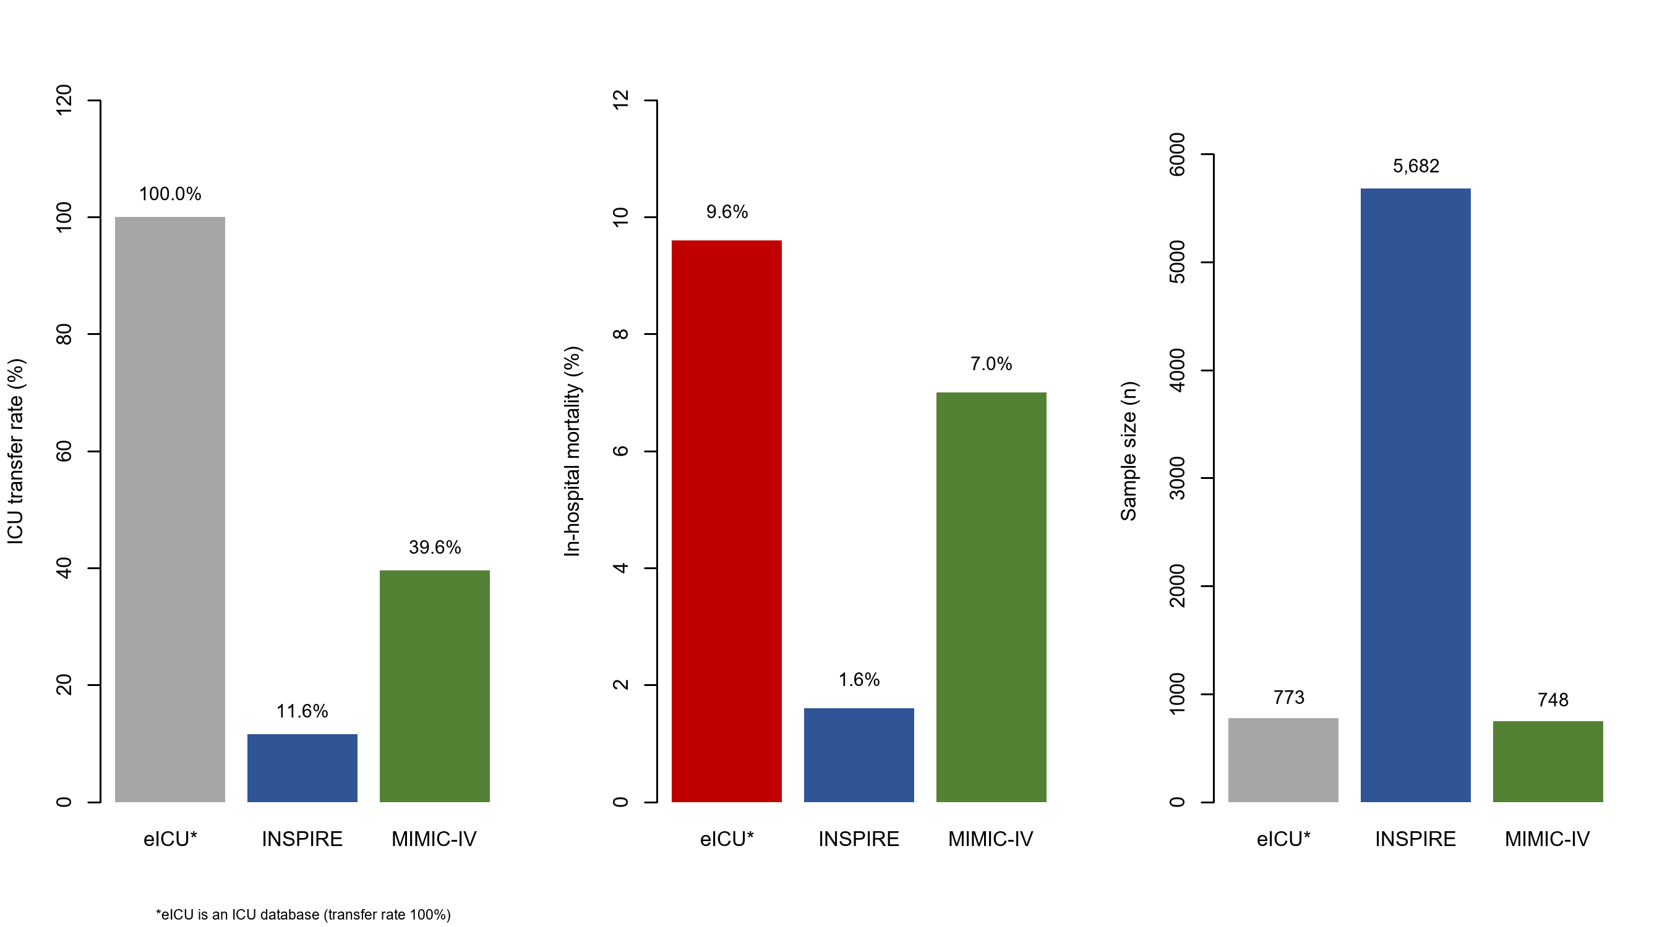
Figure S1. Comparison of the three public databases (MIMIC-IV, INSPIRE, and eICU) in terms of sample size, ICU transfer rate, and in-hospital mortality rate. eICU is an intensive care database in which all included patients received ICU-level care; therefore, postoperative ICU transfer could not be defined in the same way as in MIMIC-IV and INSPIRE, and eICU was excluded from the prediction analyses.
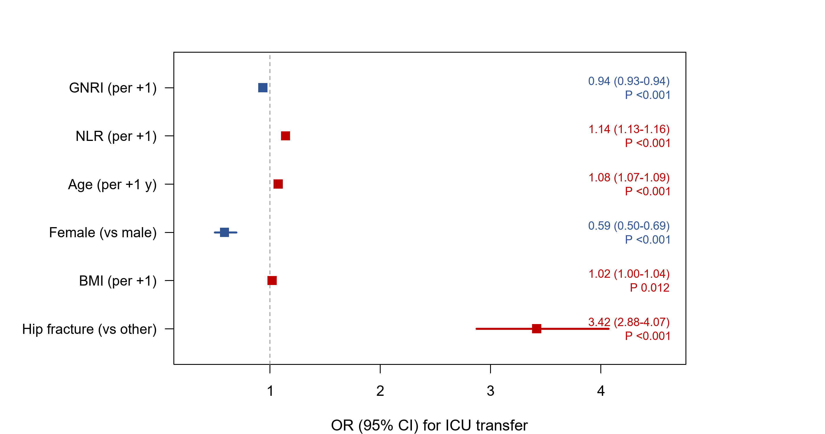
Figure S2. Forest plot of univariate logistic regression for postoperative ICU transfer in the pooled development data (MIMIC-IV and INSPIRE).
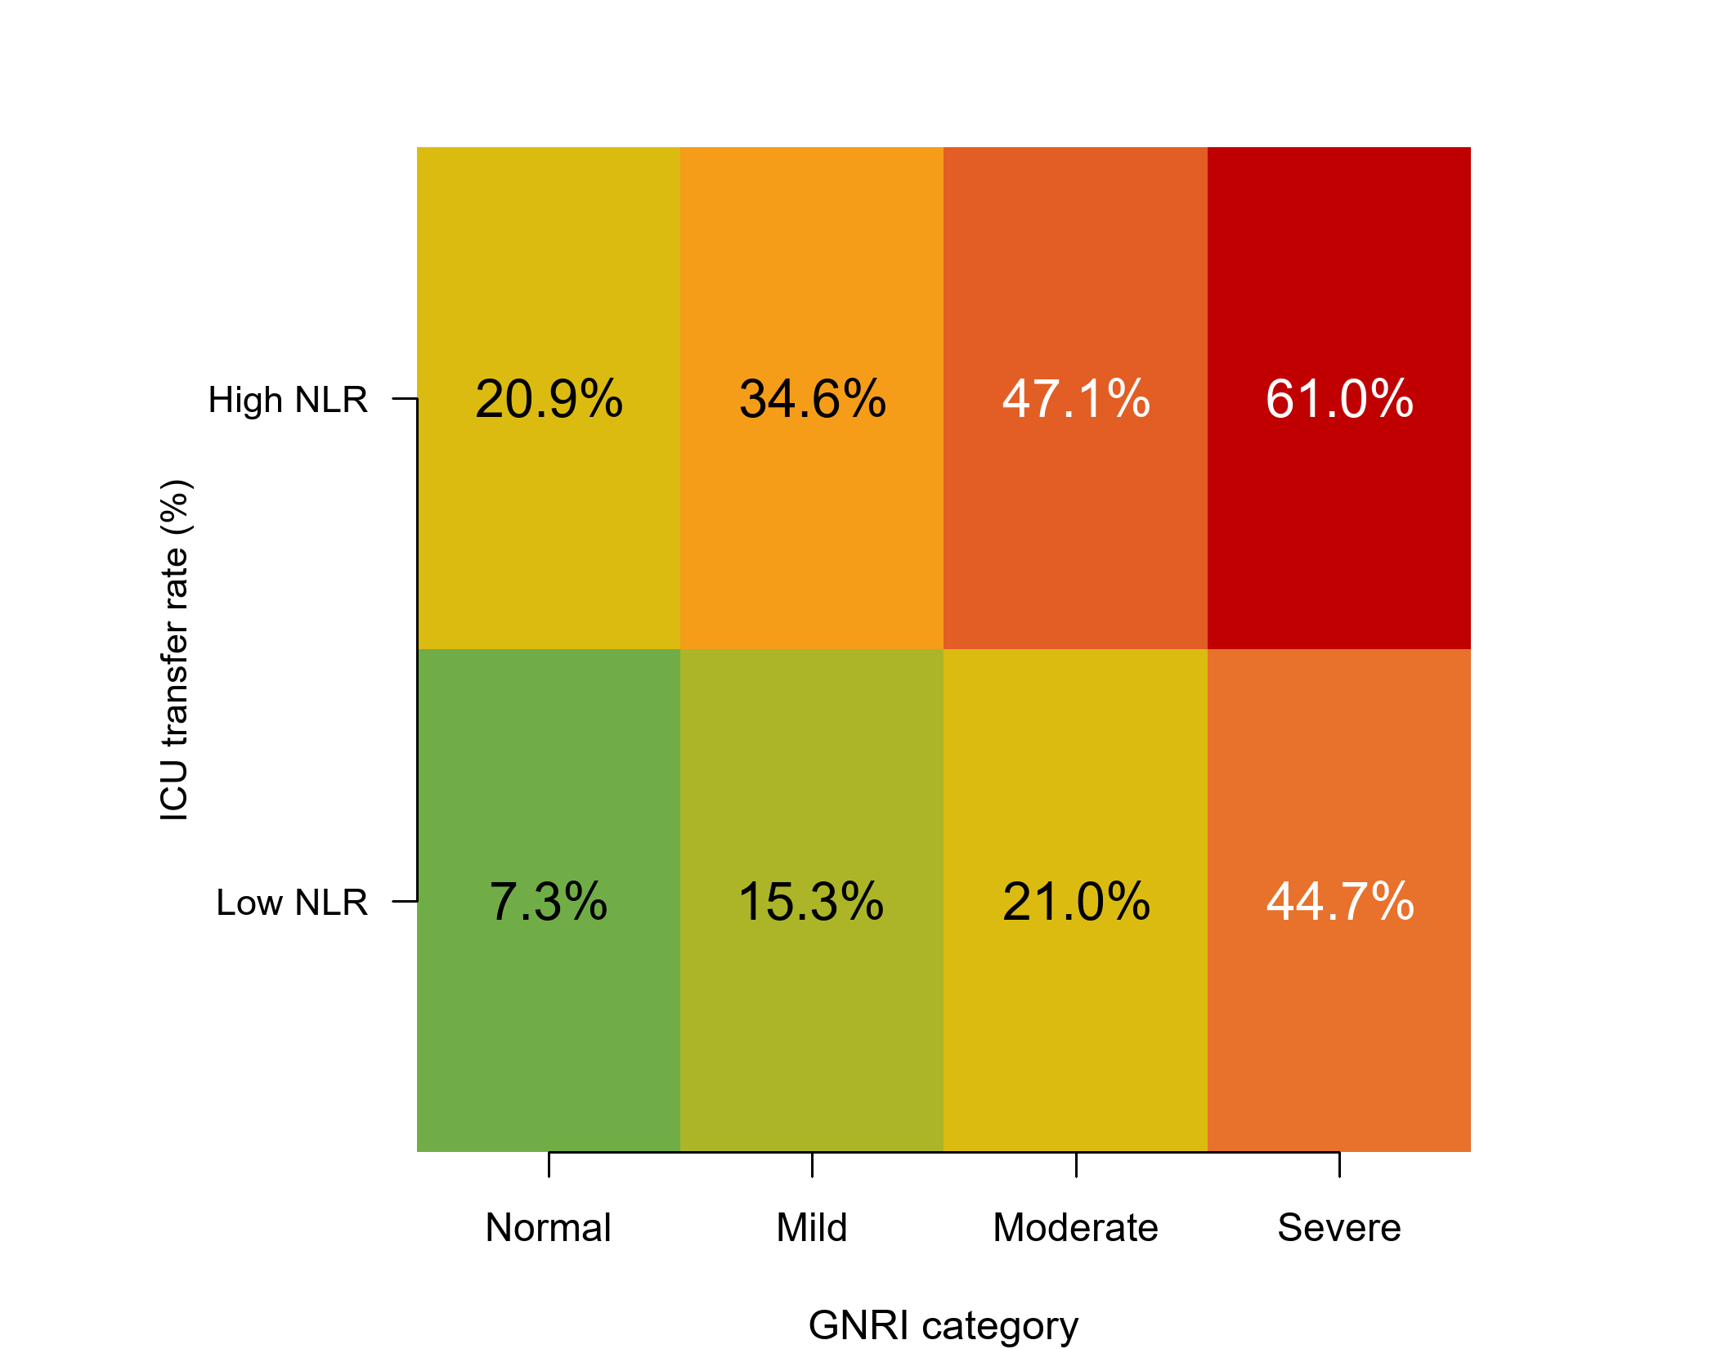
Figure S3. Heatmap of postoperative ICU transfer rates by combined GNRI nutritional risk category and NLR level, showing higher transfer rates in patients with both low GNRI and high NLR.
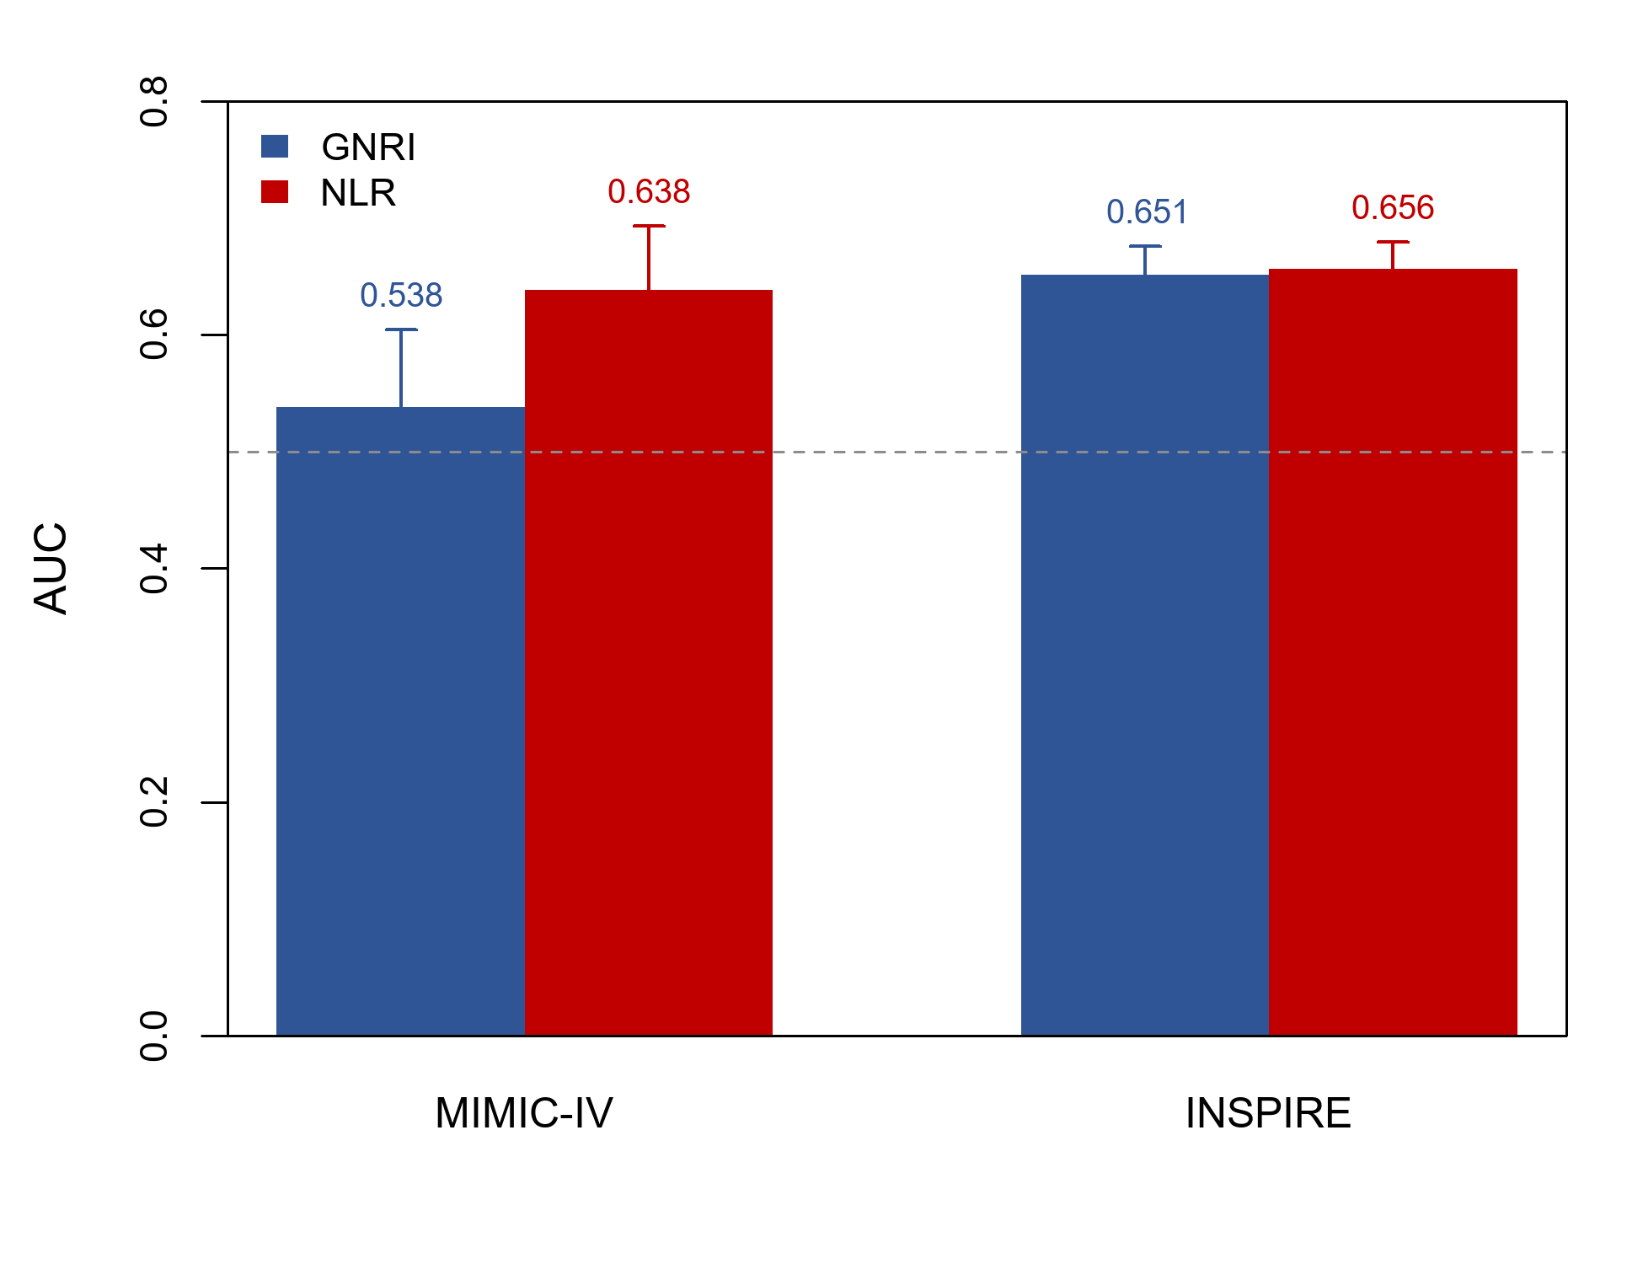
Figure S4. AUC of GNRI and NLR for postoperative ICU transfer by database (MIMIC-IV and INSPIRE). Error bars indicate 95% confidence intervals.

