Preoperative GNRI and NLR for Perioperative Risk Prediction of Postoperative ICU-Level Monitoring in Elderly Orthopedic Surgical Patients
Preoperative GNRI and NLR for Predicting the Need for Postoperative ICU-Level Monitoring in Older Orthopedic Surgical Patients: Development and Independent Validation of a Multifactorial Model

Yun Zhong¹, Yisheng Xu², Weimin Wang¹, Kai Wang³, Chunli Liu^{4,*}, Qinsheng Wei^{4,*}

¹Department of Geriatrics, the Affiliated Huaian No.1 People's Hospital of Nanjing Medical University, Huaian 223001, China

²Department of Orthopaedics, Guangdong Provincial Hospital of Traditional Chinese Medicine, Guangzhou 510000, China

³Department of Rheumatology and Immunology, the Affiliated Huaian No.1 People's Hospital of Nanjing Medical University, Huaian 223001, China

⁴Department of Joint Surgery, Qianxinan Prefecture Hospital of Traditional Chinese Medicine, Qianxinan Prefecture 562400, China

*Correspondence: Qinsheng Wei, Department of Joint Surgery, Qianxinan Prefecture Hospital of Traditional Chinese Medicine, Qianxinan Prefecture 562400, China (785135570@qq.com); Chunli Liu, Department of Joint Surgery, Qianxinan Prefecture Hospital of Traditional Chinese Medicine, Qianxinan Prefecture 562400, China (1186474955@qq.com).

Abstract

Postoperative transfer to the intensive care unit (ICU) reflects the need for higher-level monitoring after orthopedic surgery in older adults. Preoperative identification of high-risk patients could support perioperative risk stratification and ICU resource planning. This study evaluated whether the Geriatric Nutritional Risk Index (GNRI) and the neutrophil-to-lymphocyte ratio (NLR) predict postoperative ICU transfer in older orthopedic surgical patients, and developed and independently validated a multifactorial prediction model. The development cohort comprised 5,466 patients aged ≥65 years from MIMIC-IV and INSPIRE (ICU transfer, n = 685, 12.5%); eICU was used only for supplementary descriptive comparison because all of its patients received ICU-level care. A single-center matched case-control cohort (395 patients, 77 ICU transfers) served for independent validation. A common multivariable logistic model including GNRI, NLR, age, sex, and body mass index was fitted in the development cohort, and its coefficients were applied unchanged to the validation cohort. The model achieved an AUC of 0.712 (95% CI 0.689–0.734) in the development cohort, with an optimism-corrected AUC of 0.711, and 0.726 (95% CI 0.661–0.790) in the validation cohort using fixed coefficients. GNRI (OR 0.911, 95% CI 0.901–0.922) and NLR (OR 1.028, 95% CI 1.012–1.044) were independent predictors. The model showed acceptable calibration and net benefit in the development cohort. Because administrative databases did not consistently distinguish planned from unplanned ICU admission, postoperative ICU transfer was interpreted as the need for ICU-level monitoring. Preoperative GNRI and NLR were independently associated with this outcome, and the five-variable model showed acceptable discrimination with preserved performance in an independent case-control cohort. Further prospective validation is needed to assess absolute risk estimation and clinical decision utility.

Keywords: older adults; orthopedic surgery; perioperative management; Geriatric Nutritional Risk Index; neutrophil-to-lymphocyte ratio; ICU-level monitoring; risk prediction

1. Introduction

Rapid population aging has steadily increased the number of older adults undergoing surgery, and this population has become a major challenge in perioperative medicine [1]. Older patients frequently carry multiple chronic conditions, reduced physiological reserve, and varying degrees of frailty; their surgical outcomes depend not only on the procedure itself but also on multidisciplinary perioperative care, including preoperative optimization, anesthetic strategy, and postoperative monitoring [2,3]. Systematic and accurate preoperative risk stratification is therefore an important step toward improving perioperative outcomes and allocating medical resources efficiently [4,5].

Nutritional status is an important and modifiable determinant of surgical outcome in older patients. Malnutrition is highly prevalent among older orthopedic patients, particularly those with hip fracture, and is closely associated with infection, prolonged hospital stay, and increased mortality [6,7]. The Geriatric Nutritional Risk Index (GNRI) is calculated from serum albumin, actual body weight, and ideal body weight, and does not rely on patient-reported recent weight change, which makes it suitable for rapid nutritional risk assessment in older adults [8]. Several studies have reported that preoperative GNRI is associated with postoperative complications and prognosis across several surgical settings, including non-cardiac and orthopedic surgery in older patients [9-11]. Systemic inflammation also plays a key role in postoperative complications. The neutrophil-to-lymphocyte ratio (NLR), a simple and low-cost marker of systemic inflammation, has been associated with adverse outcomes such as postoperative delirium and death in older orthopedic patients [12,13].

Postoperative ICU transfer is an important component of surgical monitoring and rescue. In older patients, unplanned postoperative ICU admission usually signals a serious complication and is associated with higher morbidity, mortality, and costs [14,15]. However, criteria for ICU admission after surgery in older patients remain inconsistent across institutions. Preoperative identification of patients who will require ICU-level monitoring would allow care teams to plan monitoring intensity and resources in advance and to optimize modifiable risk factors before surgery. Although machine-learning models have been developed to predict unplanned ICU admission [14], simple tools tailored to older orthopedic populations and computable from routine preoperative laboratory tests remain scarce.

In this study, we built a cohort of older orthopedic surgical patients from multicenter public databases. We evaluated the predictive value of preoperative GNRI and NLR for postoperative ICU transfer, interpreted as the need for ICU-level postoperative monitoring, developed a multifactorial logistic model, and validated it in a local matched case-control cohort using fixed model coefficients. The aim was to provide a simple and practical tool to support perioperative risk stratification.

2. Materials and Methods

2.1. Study design and data sources

This was a multicenter retrospective study with two stages: model development using public databases and independent validation using a local hospital matched case-control cohort. The development cohort was derived from two publicly available perioperative databases: MIMIC-IV (an electronic health record database from Beth Israel Deaconess Medical Center, USA) [16] and INSPIRE (a perioperative medicine database from Seoul National University Hospital, Korea) [17]. The eICU Collaborative Research Database [18] was used only for supplementary descriptive comparison, because all patients in this intensive care database received ICU-level care, so a postoperative ICU transfer event cannot be defined. The validation cohort comprised older patients who underwent orthopedic surgery at the Qianxinan Prefecture Hospital of Traditional Chinese Medicine between 2018 and 2023, assembled with a matched case-control design (Section 2.2). The study followed the Declaration of Helsinki. Use of the public databases was covered by their respective ethics approvals and data use agreements. The local study was approved by the ethics committee of the Qianxinan Prefecture Hospital of Traditional Chinese Medicine (approval no. Ec2024006). Informed consent was waived because the study was retrospective and the data were anonymized.

2.2. Participants and eligibility criteria

Inclusion criteria were: (1) age ≥65 years; (2) orthopedic surgery (defined by ICD-9/10 procedure codes in MIMIC-IV, and by orthopedic department and procedure records in INSPIRE and the local cohort); and (3) availability of preoperative serum albumin, neutrophil, and lymphocyte measurements. Exclusion criteria were: (1) ICU admission within 24 hours before surgery or emergency surgery; and (2) missing key variables. The initial development cohort comprised 7,203 patients from the three databases. After excluding 773 patients from eICU and 964 patients with missing common model variables, 5,466 patients with complete data for all five model variables remained (ICU transfer, n = 685, 12.5%). The extended-model subset, which additionally required hemoglobin, C-reactive protein, and hip fracture data, comprised 5,324 patients. The validation cohort was a local matched case-control study. Seventy-seven patients transferred to the ICU within 24 hours after surgery were matched to 318 controls by age (±2 years), sex, and surgical type at a ratio of 1:4, forming a primary analysis cohort of 395 patients. Five additional patients who experienced in-hospital death without ICU transfer were included for the mortality sensitivity analysis (total 400 patients).

2.3. Variable and outcome definitions

GNRI was calculated according to Bouillanne et al.: GNRI = 1.489 × serum albumin (g/L) + 41.7 × (actual weight / ideal weight), where ideal weight corresponds to a body mass index (BMI) of 22 kg/m² (ideal weight = 22 × height², m) [8]. NLR was defined as the absolute neutrophil count divided by the absolute lymphocyte count. The primary outcome was postoperative ICU transfer, defined as transfer from a general ward to the ICU within 24 hours after surgery or direct ICU admission immediately after surgery. Because administrative databases did not consistently distinguish planned (e.g., preventive monitoring) from unplanned (e.g., deterioration-related) ICU admission, postoperative ICU transfer in this study should be interpreted as the need for ICU-level postoperative monitoring rather than exclusively as unexpected postoperative deterioration. The secondary outcome was in-hospital death. Comorbidity burden was assessed with the Charlson comorbidity index (CCI).

2.4. Statistical analysis

Continuous variables were summarized as mean ± SD or median (interquartile range) and compared using Student's t test or the Mann-Whitney U test, as appropriate; categorical variables were summarized as counts (%) and compared using the chi-square test. To ensure that the development and validation models were identical, a common multivariable logistic model including GNRI, NLR, age, sex, and BMI was fitted in the development cohort. These five variables were selected a priori because they are available in both datasets and are computable from routine preoperative data. The model formula is: logit(p) = 1.767 − 0.093 × GNRI + 0.027 × NLR + 0.012 × age + 0.364 × male + 0.196 × BMI. Sex was coded as male = 1 and female = 0, age in years, BMI in kg/m², GNRI per point, and NLR per unit. For independent validation, the coefficients from the development model were applied unchanged to the validation cohort (fixed-coefficient validation), and the resulting predicted probabilities were evaluated for discrimination and calibration; no refitting was performed in the validation cohort. Sensitivity analyses with an extended development model (adding hemoglobin, C-reactive protein, and hip fracture) and an extended validation model (adding the CCI) are reported in the Supplementary Materials.

Discrimination was assessed by the area under the receiver operating characteristic curve (AUC), and AUCs were compared using the DeLong test [19]. The development model was internally validated by bootstrap (500 resamples) with optimism correction. Calibration was assessed by calibration curves and by the recalibration intercept and slope in the validation cohort. The Brier score was calculated in both cohorts. Clinical utility was evaluated by decision curve analysis (DCA) [20]. The optimal cutoff was determined by the Youden index, and sensitivity, specificity, positive predictive value (PPV), and negative predictive value (NPV) were calculated. Multicollinearity was assessed by variance inflation factors (VIF), and nonlinearity of GNRI and NLR was tested by comparing linear models with natural spline (df = 3) terms. Events per variable exceeded 10 in the development model. Model reporting followed the TRIPOD statement [21]. All analyses were performed in R software (version 4.6.0), and a two-sided P < 0.05 was considered statistically significant.

3. Results

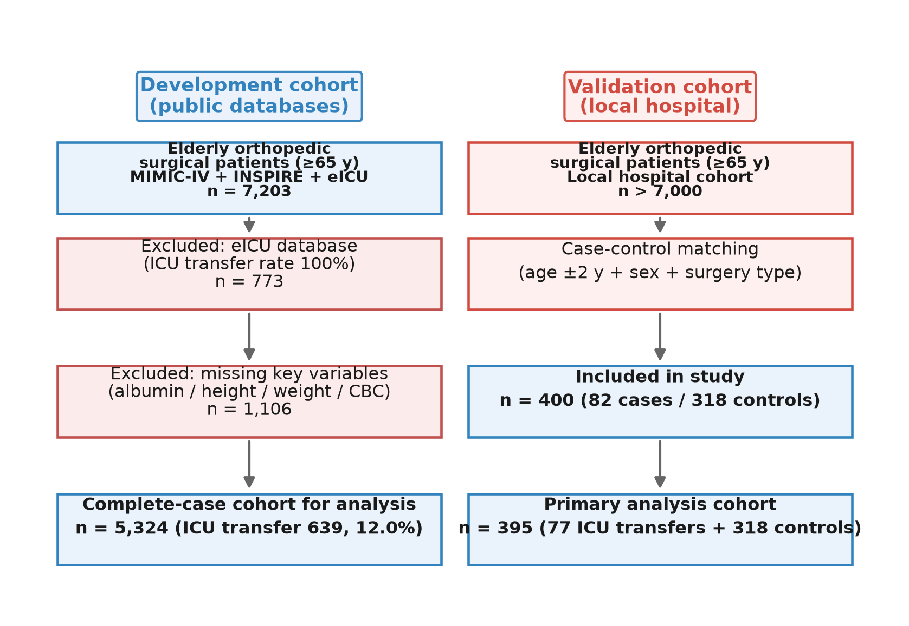

Figure 1. Study flow diagram. Left column: development cohort (MIMIC-IV and INSPIRE; eICU shown for descriptive reference). Right column: independent validation cohort (local matched case-control study).

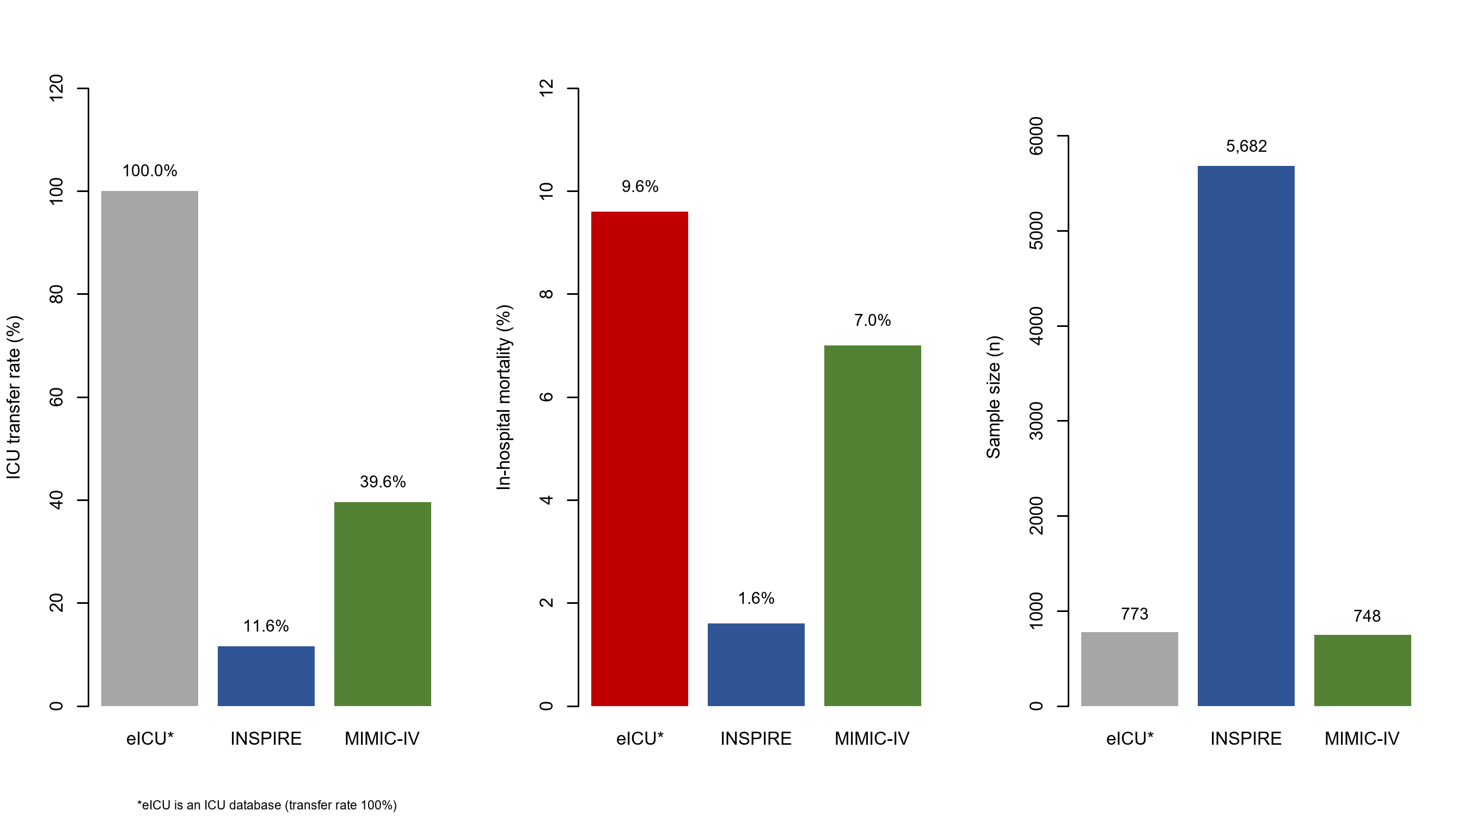

Figure 2. Comparison of the three public databases (MIMIC-IV, INSPIRE, and eICU) in sample size, ICU transfer rate, and in-hospital mortality. eICU is an intensive care database in which all patients received ICU-level care; therefore, postoperative ICU transfer could not be defined in the same way, and eICU was excluded from prediction analyses.

The three source databases differed substantially in sample size and outcome prevalence (Figure 2).

3.1. Baseline characteristics

In the development cohort, 685 of 5,466 patients (12.5%) were transferred to the ICU after surgery. Compared with patients not transferred, those transferred were older (73.0 ± 6.5 vs 71.5 ± 6.0 years), more often male (43.4% vs 31.2%), had lower GNRI (99.9 ± 14.3 vs 107.0 ± 10.2), and had higher NLR (3.4 [2.0–6.8] vs 2.1 [1.5–3.3]) (Table 1). In the validation cohort, cases and controls were well matched for age (76.1 ± 7.8 vs 76.2 ± 7.6 years) and sex (41.6% vs 43.1%); cases had significantly lower GNRI (99.1 ± 9.1 vs 103.4 ± 10.2) and higher NLR (3.5 [2.5–5.4] vs 2.6 [1.9–3.6]) than controls.

Table 1. Baseline characteristics of the development and validation cohorts

Variable | Development ICU transfer (n = 685) | Development no ICU transfer (n = 4,781) | Validation cases (n = 77) | Validation controls (n = 318)
Age (years) | 73.0 ± 6.5 | 71.5 ± 6.0 | 76.1 ± 7.8 | 76.2 ± 7.6
Male (%) | 43.4 | 31.2 | 41.6 | 43.1
BMI (kg/m²) | 24.7 ± 5.3 | 25.0 ± 3.7 | 23.8 ± 3.5 | 23.4 ± 4.1
GNRI | 99.9 ± 14.3 | 107.0 ± 10.2 | 99.1 ± 9.1 | 103.4 ± 10.2
NLR | 3.4 [2.0–6.8] | 2.1 [1.5–3.3] | 3.5 [2.5–5.4] | 2.6 [1.9–3.6]
Albumin (g/dL)† | 3.62 ± 0.62 | 4.00 ± 0.41 | 3.59 ± 0.40 | 3.97 ± 0.43
Hemoglobin (g/dL)† | 11.9 ± 1.9 | 12.7 ± 1.5 | — | —
CRP (mg/L)† | 6.6 ± 24.3 | 1.4 ± 8.9 | — | —
Hip fracture/surgery (%)† | 19.6 | 9.2 | 24.7 | 23.9

Note: Albumin is presented in g/dL in the table and converted to g/L for GNRI calculation. GNRI was calculated as 1.489 × albumin (g/L) + 41.7 × (actual weight / ideal body weight).

†Reported in the extended-data subset (development, n = 5,324).

3.2. Multivariable regression analysis

In the development cohort, GNRI (OR 0.911, 95% CI 0.901–0.922, P < 0.001), NLR (OR 1.028, 95% CI 1.012–1.044, P < 0.001), male sex (OR 1.439, 95% CI 1.206–1.714, P < 0.001), and BMI (OR 1.217, 95% CI 1.179–1.256, P < 0.001) were independent predictors of ICU transfer; age was not significant (OR 1.012, 95% CI 0.998–1.026, P = 0.091). Each 1-point increase in GNRI was associated with an 8.9% lower risk, and each unit increase in NLR with a 2.8% higher risk. Variance inflation factors ranged from 1.03 to 2.99, indicating no multicollinearity (Figure 4).

Univariate logistic regression identified several predictors associated with ICU transfer (Figure 3).

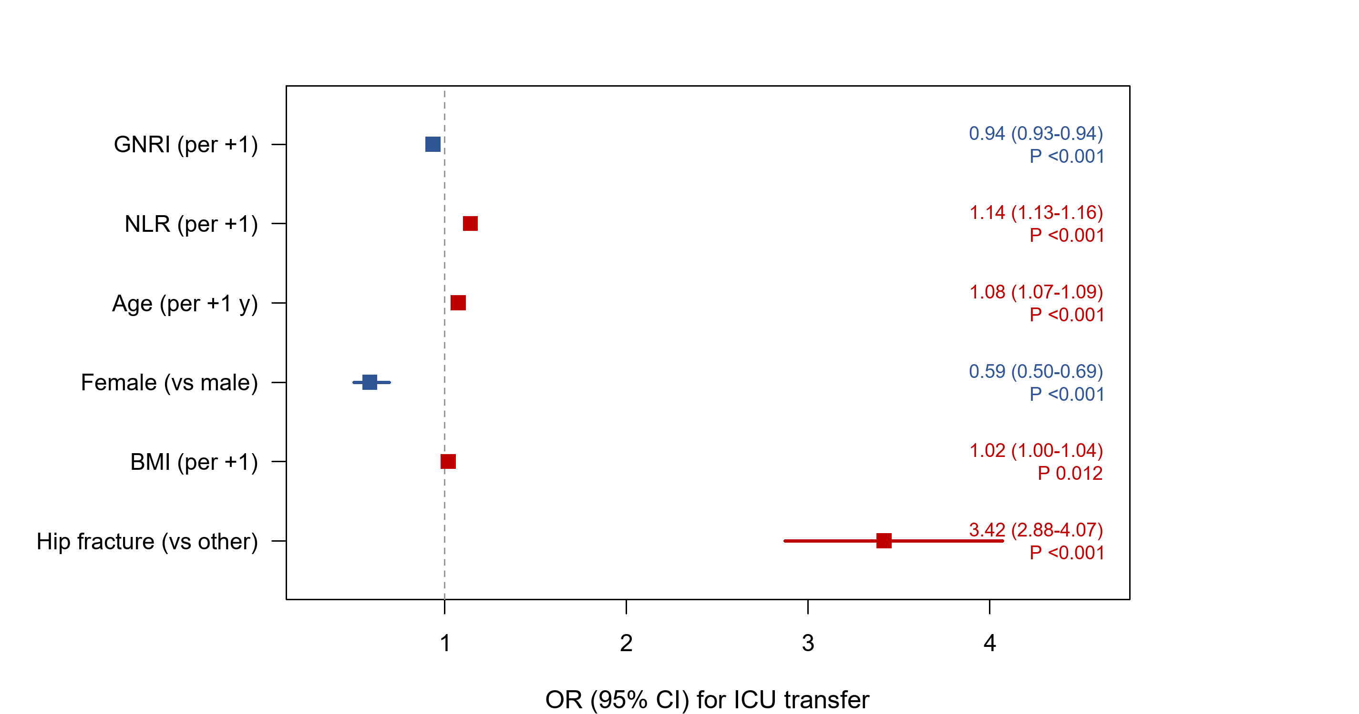

Figure 3. Forest plot of univariate logistic regression for postoperative ICU transfer in the pooled development data (MIMIC-IV and INSPIRE).

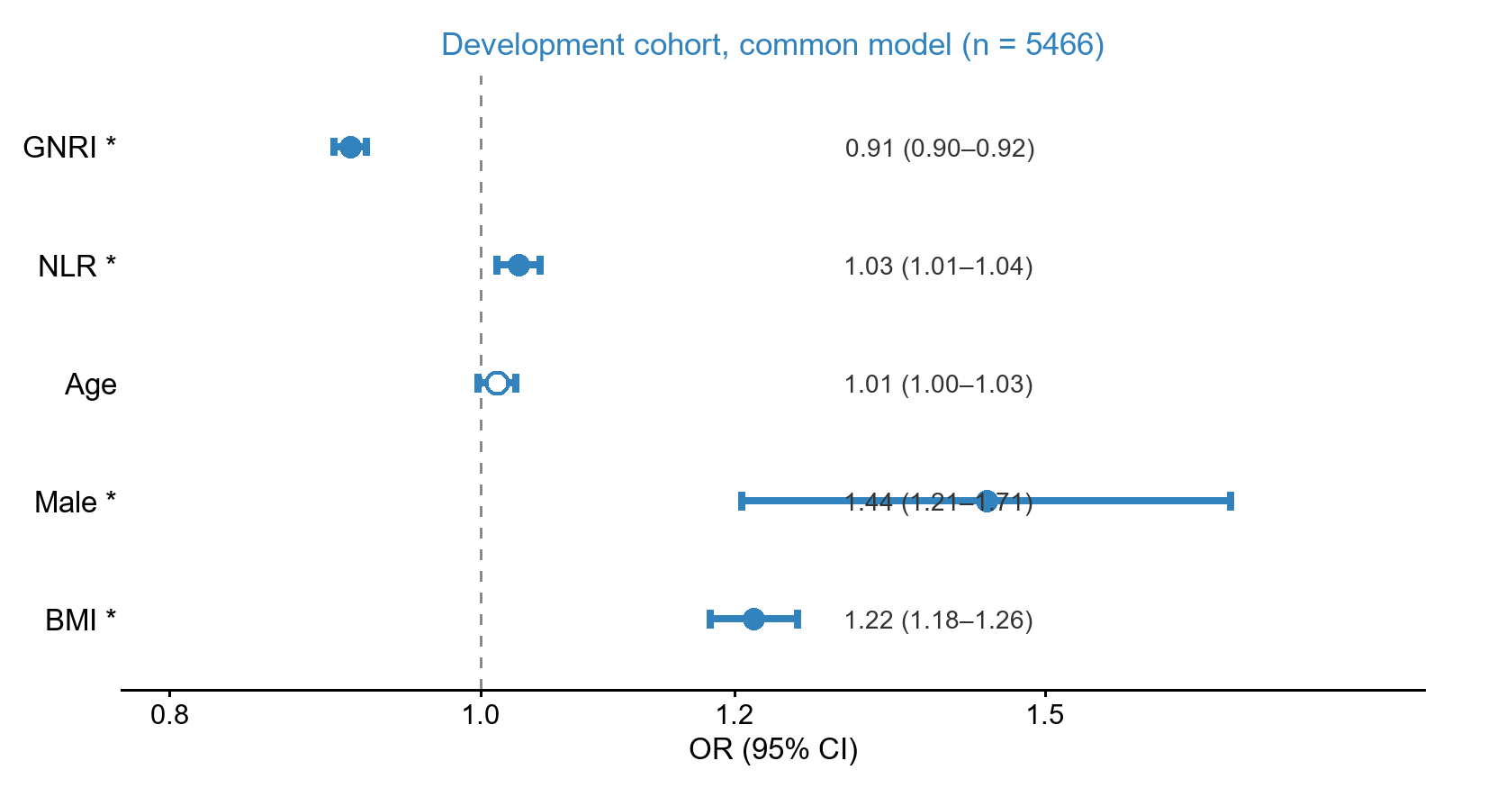

Figure 4. Forest plot of the common multivariable logistic model in the development cohort (n = 5,466). Squares represent OR estimates and horizontal lines the 95% CIs; *P < 0.05. ORs for continuous variables are per 1-unit increase. The same coefficients were applied unchanged to the validation cohort.

3.3. Model performance

The common model showed acceptable discrimination, with an AUC of 0.712 (95% CI 0.689–0.734) in the development cohort, significantly better than either single indicator (GNRI AUC 0.651, NLR AUC 0.675; DeLong test, both P < 0.05). Bootstrap internal validation (500 resamples) showed minimal optimism (apparent AUC 0.712; optimism 0.001; optimism-corrected AUC 0.711). When the fixed development coefficients were applied to the validation cohort, the AUC was 0.726 (95% CI 0.661–0.790), also indicating acceptable discrimination, with a recalibration intercept of 0.960 and a calibration slope of 1.265. The Brier score was 0.097 in the development cohort and 0.147 in the validation cohort. At the optimal cutoff of 0.150 in the validation cohort, the model had a sensitivity of 0.649, specificity of 0.752, PPV of 0.388, NPV of 0.898, and accuracy of 0.732 (Figure 5, Table 2). Because the validation cohort used a matched case-control design, absolute predicted probabilities, PPV, NPV, calibration metrics, and decision-curve results should be interpreted with caution. These measures may not directly generalize to unselected clinical populations; the validation was primarily used to assess discrimination.

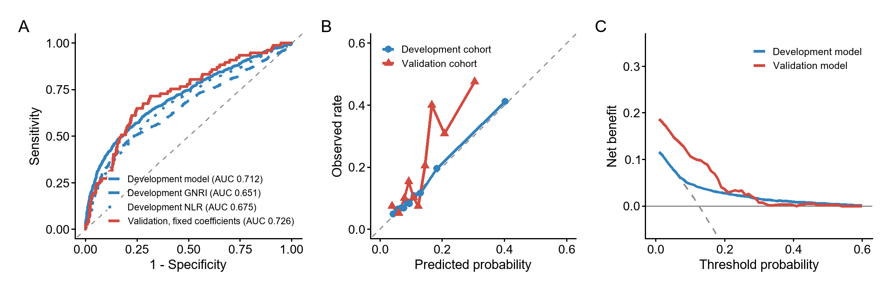

Figure 5. Performance of the common model. (A) ROC curves; (B) calibration curves; (C) decision curve analysis. Blue: development cohort (n = 5,466); red: validation cohort with fixed coefficients (n = 395).

The two individual indicators also discriminated ICU transfer within each database (Figure 6).

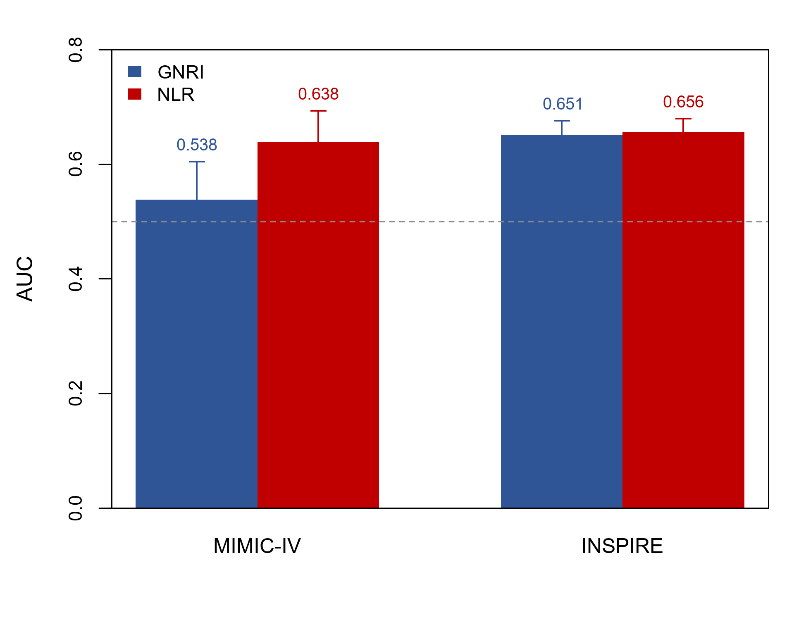

Figure 6. AUC of GNRI and NLR for postoperative ICU transfer by database (MIMIC-IV and INSPIRE). Error bars indicate 95% confidence intervals.

Table 2. Performance metrics of the prediction models

Cohort | Model | AUC | Cutoff | Sensitivity | Specificity | PPV | NPV | Accuracy
Development (n = 5,466) | GNRI | 0.651 | 98.934 | 0.451 | 0.821 | 0.265 | 0.913 | 0.775
Development (n = 5,466) | NLR | 0.675 | 2.806 | 0.593 | 0.692 | 0.216 | 0.922 | 0.679
Development (n = 5,466) | Common model | 0.712 | 0.129 | 0.547 | 0.785 | 0.267 | 0.924 | 0.755
Validation (n = 395) | GNRI | 0.626 | 106.750 | 0.870 | 0.409 | 0.263 | 0.929 | 0.499
Validation (n = 395) | NLR | 0.685 | 2.806 | 0.649 | 0.541 | 0.255 | 0.864 | 0.562
Validation (n = 395) | Common model (fixed coefficients) | 0.726 | 0.150 | 0.649 | 0.752 | 0.388 | 0.898 | 0.732

In the development cohort, calibration curves showed overall agreement between predicted and observed risks. In the validation cohort, calibration metrics suggested reasonable agreement after applying fixed coefficients; however, because matched case-control sampling altered the outcome prevalence, absolute probability calibration should be interpreted cautiously. In the development cohort, decision curve analysis showed a positive net benefit over both "treat all" and "treat none" strategies across threshold probabilities of approximately 0.05–0.50. Decision-curve results in the validation cohort are reported as exploratory and require confirmation in consecutive cohorts.

3.4. Stratified dose-response analysis

In the validation cohort, ICU transfer rates were 22.2% in the severe malnutrition group (GNRI < 82), 33.3% in the moderate group (82–91), 19.7% in the mild group (92–97), and 16.7% in the normal group (≥98); the severe group was small (n = 9), which limited its stability. When NLR was dichotomized at 2.806 (the cutoff derived from the development cohort and applied to the validation cohort), the high-NLR group had a higher ICU transfer rate than the low-NLR group (25.5% vs 13.6%), supporting a dose-response relationship for NLR (Figure 7).

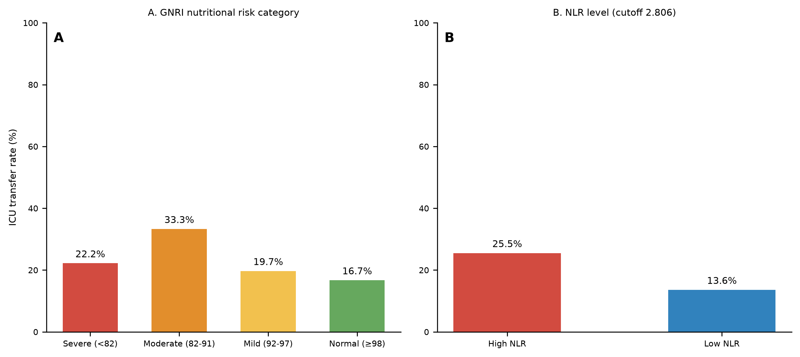

Figure 7. Postoperative ICU transfer rates in the validation cohort by stratum. (A) GNRI nutritional risk category (severe < 82, moderate 82–91, mild 92–97, normal ≥ 98); (B) NLR level (cutoff 2.806, derived from the development cohort).

A combined stratification by GNRI category and NLR level further showed elevated transfer rates among patients with both low GNRI and high NLR (Figure 8).

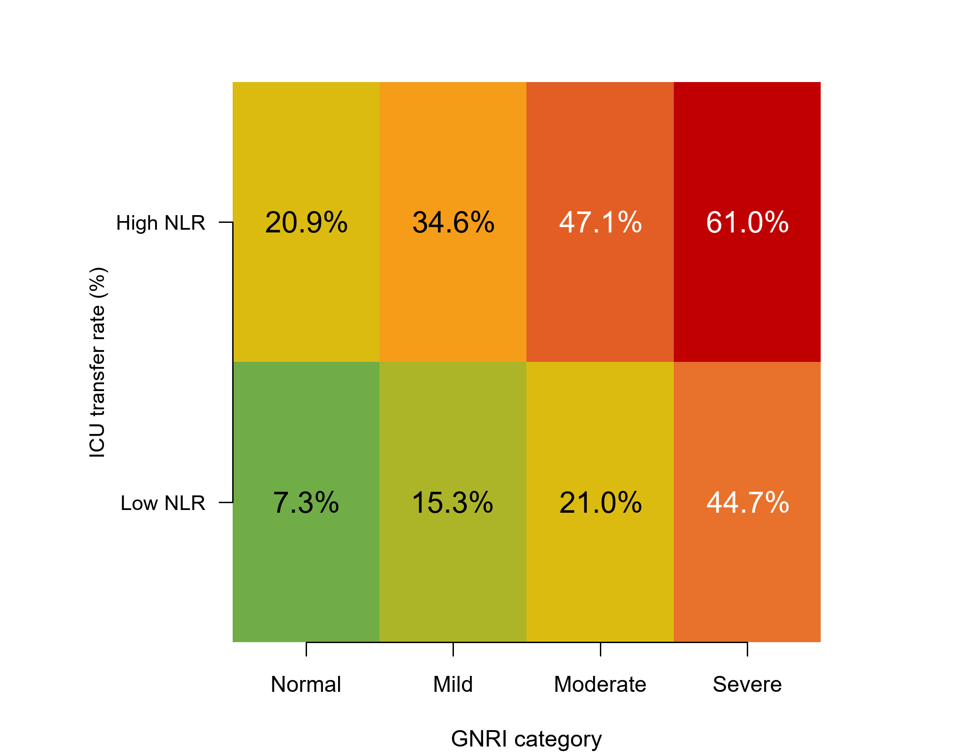

Figure 8. Heatmap of postoperative ICU transfer rates by combined GNRI nutritional risk category and NLR level, showing higher transfer rates in patients with both low GNRI and high NLR.

3.5. Secondary outcome: in-hospital death

In-hospital death occurred in 15 of 400 local patients (3.8%). In an exploratory sensitivity analysis with in-hospital death as the outcome, NLR was independently associated with death (OR 1.220, 95% CI 1.087–1.390, P = 0.001). GNRI showed a protective but non-significant trend (OR 0.959, 95% CI 0.909–1.011, P = 0.105).

4. Discussion

Using multicenter public databases and an independent local cohort, this study developed and independently evaluated a simple multifactorial model for postoperative ICU transfer in older orthopedic surgical patients. GNRI and NLR were independent predictors in the development cohort; the common model showed acceptable discrimination (AUC 0.712), negligible overfitting (optimism-corrected AUC 0.711), and maintained discrimination when its coefficients were applied unchanged to an independent case-control cohort (AUC 0.726). These results suggest that two simple indicators, both computable from routine preoperative tests, may help with perioperative risk stratification in this population.

The independent predictive value of GNRI observed here is consistent with previous studies. In 28,762 older patients undergoing non-cardiac surgery, nutritional risk (GNRI ≤ 98) was independently associated with postoperative ICU admission, prolonged hospital stay, and worse long-term survival [9]. In older patients after proximal femoral nailing, a GNRI below 82 predicted a 1-year mortality as high as 76.9% [11]. Low GNRI has likewise been associated with postoperative complications and mortality after pancreaticoduodenectomy [22], colorectal cancer surgery [23], and hip fracture surgery [24,25]. Similar associations were reported in non-surgical populations, such as patients on chronic hemodialysis [26]. Because the GNRI derives ideal body weight from height and weight, it does not depend on patient-reported weight change. It therefore remains practical for older patients with cognitive impairment or unreliable recall [8], which favors its use as a routine preoperative screening index. Although BMI partly overlaps with the weight component of GNRI, the VIF values suggested no serious multicollinearity. The positive association between BMI and ICU transfer may reflect obesity-related anesthetic difficulty, cardiopulmonary burden, and postoperative monitoring requirements; this finding should be interpreted cautiously and validated in future studies.

As a marker of systemic inflammation, NLR was independently associated with ICU transfer in the development cohort (OR 1.028). Elevated preoperative NLR has been independently associated with postoperative delirium [13], death [12], and myocardial injury [27] in older surgical patients. A meta-analysis of seven studies (2,424 patients) confirmed an association between preoperative NLR and delirium after non-cardiac surgery [28]. The present study extends these findings by linking NLR to postoperative ICU transfer, a clinically important event, and supports its inclusion in perioperative risk stratification. Although spline-based tests suggested statistical nonlinearity for GNRI (P = 0.044) and NLR (P = 0.001), a sensitivity model with natural splines for both predictors did not materially improve discrimination (AUC 0.720 vs 0.712). The linear model was therefore retained for parsimony and interpretability.

Compared with machine-learning models for postoperative ICU admission [14,29], the present model has three practical advantages. First, it relies only on routine preoperative laboratory tests and basic demographics, so the risk can be computed in the outpatient setting before admission. Second, multivariable logistic regression is transparent and interpretable, with the full model formula available for external application. Third, although machine-learning models often show marked performance loss on external validation across databases [14], the parsimonious logistic model retained acceptable discrimination when its fixed coefficients were applied to an independent cohort. This provides preliminary support for the model's transportability. Postoperative ICU transfer carries both clinical and economic consequences: patients transferred to the ICU have often developed serious complications requiring higher-intensity monitoring [15], whereas unnecessary routine ICU admission consumes scarce and costly resources. A preoperative risk-stratification tool could therefore help care teams identify high-risk patients for preemptive nutritional and comorbidity optimization [6,7,30], plan monitoring levels and beds in advance, and avoid unnecessary ICU admission in low-risk patients. The ESPEN guideline recommends routine nutritional screening and perioperative nutritional support for older surgical patients [6], and a Cochrane review found that postoperative nutritional supplementation reduced complications in older patients after hip fracture [30]. Combining GNRI and NLR integrates two modifiable dimensions, nutrition and inflammation, into preoperative risk stratification and may inform individualized perioperative management.

This study has several limitations. First, administrative databases did not consistently distinguish planned from unplanned ICU admission. Postoperative ICU transfer in this study therefore represents the need for ICU-level postoperative monitoring rather than exclusively unexpected deterioration, and this should be considered when interpreting the results. Second, the independent validation cohort used a matched case-control design. The estimated intercept, absolute predicted probabilities, PPV, NPV, calibration, and decision-curve results may therefore not generalize to unselected clinical populations. The validation was primarily used to assess discrimination, and prospective validation in consecutive cohorts is required before implementation. Third, the number of in-hospital deaths was small (n = 15), so the mortality analysis was exploratory. Fourth, the public databases covered broad clinical periods, and temporal confounding cannot be excluded. Fifth, some potential confounders, such as anesthetic technique and intraoperative events, were not available. Finally, although spline-based tests suggested statistical nonlinearity for GNRI and NLR, a spline sensitivity model did not materially improve discrimination, and the linear specification was retained; nonlinear specifications could still be considered in larger samples or future model updates. Future studies should validate the model in larger prospective cohorts and evaluate its clinical benefit once integrated into care pathways.

5. Conclusion

Preoperative GNRI and NLR are independent predictors of the need for postoperative ICU-level monitoring in older orthopedic surgical patients. A multifactorial logistic model combining these indicators with age, sex, and BMI showed acceptable discrimination, minimal optimism, and preserved performance when its coefficients were applied unchanged to an independent case-control cohort. As a simple, low-cost, and interpretable tool, the model may support perioperative risk stratification and ICU resource planning after further prospective validation.

Supplementary Materials

The following supporting information can be downloaded at the journal website: Supplementary Methods S1–S3 and Supplementary Tables S1–S6 (see the accompanying Supplementary Material file), including the complete model formula, calibration metrics, bootstrap validation results, sensitivity analyses with extended and spline models, and a completed TRIPOD checklist.

Author Contributions

Conceptualization, Q.W., C.L., and Y.Z.; methodology, Y.Z., Y.X., and K.W.; formal analysis, Y.Z. and W.W.; data curation, W.W., Y.X., and K.W.; writing-original draft preparation, Y.Z. and Y.X.; writing-review and editing, Q.W., C.L., and K.W.; supervision, Q.W. and C.L. All authors have read and agreed to the published version of the manuscript.

Funding

This work was supported by the Key Project of the Qianxinan Prefecture Joint Medical Research Program (grant no. 2024-6).

Institutional Review Board Statement

The study was conducted in accordance with the Declaration of Helsinki. The local study was approved by the Ethics Committee of the Qianxinan Prefecture Hospital of Traditional Chinese Medicine (approval no. Ec2024006). Use of the MIMIC-IV, INSPIRE, and eICU databases was covered by their respective approvals and data use agreements.

Informed Consent Statement

Informed consent was waived because the study was retrospective and used anonymized data.

Data Availability Statement

MIMIC-IV, INSPIRE, and eICU are publicly available after registration and data use agreement with PhysioNet. The local dataset used in this study is not publicly available because of institutional privacy regulations but is available from the corresponding authors on reasonable request. The de-identified derived cohort, analysis code, and a bilingual (English/Chinese) web calculator are archived and publicly available at Zenodo (https://doi.org/10.5281/zenodo.22087936); the live calculator is at https://morrosun.github.io/ortho-gnri-nlr-icu-transfer/.

Conflicts of Interest

The authors declare no conflicts of interest.

Abbreviations

AUC, area under the receiver operating characteristic curve; BMI, body mass index; CCI, Charlson comorbidity index; CI, confidence interval; CRP, C-reactive protein; DCA, decision curve analysis; GNRI, Geriatric Nutritional Risk Index; ICU, intensive care unit; NLR, neutrophil-to-lymphocyte ratio; NPV, negative predictive value; OR, odds ratio; PPV, positive predictive value; ROC, receiver operating characteristic; TRIPOD, Transparent Reporting of a multivariable prediction model for Individual Prognosis Or Diagnosis; VIF, variance inflation factor.

References

- Tian BWCA, Stahel PF, Picetti E, et al. Assessing and managing frailty in emergency laparotomy: a WSES position paper. World J Emerg Surg. 2023;18(1):38.

- Fried LP, Tangen CM, Walston J, et al. Frailty in older adults: evidence for a phenotype. J Gerontol A Biol Sci Med Sci. 2001;56(3):M146-M157.

- Rockwood K, Song X, MacKnight C, et al. A global clinical measure of fitness and frailty in elderly people. CMAJ. 2005;173(5):489-495.

- Dunlop RAN, Van Zundert A. A systematic review of predictive accuracy via c-statistic of preoperative frailty tests for extended length of stay, post-operative complications, and mortality. Saudi J Anaesth. 2023;17(4):575-580.

- Sandrucci S. Frailty: how to assess, prognostic role. Eur J Surg Oncol. 2024;50(5):106862.

- Volkert D, Beck AM, Cederholm T, et al. ESPEN guideline on clinical nutrition and hydration in geriatrics. Clin Nutr. 2019;38(1):10-47.

- Meermans G, van Egmond JC. Malnutrition in older hip fracture patients: prevalence, pathophysiology, clinical outcomes, and treatment—a systematic review. J Clin Med. 2025;14(16):5662.

- Bouillanne O, Morineau G, Dupont C, et al. Geriatric Nutritional Risk Index: a new index for evaluating at-risk elderly medical patients. Am J Clin Nutr. 2005;82(4):777-783.

- Zhao W, Liu L, Zhang J, et al. Preoperative geriatric nutritional risk index predicts prognosis and postoperative complications in elderly patients undergoing non-cardiac surgery: a retrospective cohort study. BMC Geriatr. 2025;25(1):101.

- Liu SH, Cerri-Droz P, Loyst RA, et al. Shoulder arthroscopy in elderly patients: malnutrition and early postoperative outcomes. JSES Int. 2024;8(1):41-46.

- Gökgöz MB, Kahraman HÇ, Gür V, et al. Preoperative geriatric nutritional risk index (GNRI) and comorbidity burden as mortality risk markers after proximal femoral nailing in older patients with pertrochanteric hip fractures. J Clin Med. 2026;15(14):5400.

- Atlas A, Duran E, Pehlivan B, et al. The effect of increased neutrophil lymphocyte ratio on mortality in patients operated on due to hip fracture. Cureus. 2020;12(4):e6543.

- Ji S, Li Z, Li M, et al. Relationship between neutrophil/lymphocyte ratio and postoperative delirium in elderly patients with proximal femoral nail anti-rotation for intertrochanteric fractures. Am J Transl Res. 2023;15(2):1367-1373.

- Chiu C, Braehler MR, Donovan AL, et al. Development of a machine learning-derived model to predict unplanned ICU admissions after major non-cardiac surgery. BMC Anesthesiol. 2025;25(1):351.

- Fahim M, Visser RA, Dijksman LM, et al. Routine postoperative intensive care unit admission after colorectal cancer surgery for the elderly patient reduces postoperative morbidity and mortality. Colorectal Dis. 2020;22(4):408-415.

- Johnson AEW, Bulgarelli L, Shen L, et al. MIMIC-IV, a freely accessible electronic health record dataset. Sci Data. 2023;10(1):1.

- Lim L, Lee H, Jung CW, et al. INSPIRE, a publicly available research dataset for perioperative medicine. Sci Data. 2024;11(1):655.

- Pollard TJ, Johnson AEW, Raffa JD, et al. The eICU collaborative research database, a freely available multi-center database for critical care research. Sci Data. 2018;5:180178.

- DeLong ER, DeLong DM, Clarke-Pearson DL. Comparing the areas under two or more correlated receiver operating characteristic curves: a nonparametric approach. Biometrics. 1988;44(3):837-845.

- Vickers AJ, Elkin EB. Decision curve analysis: a novel method for evaluating prediction models. Med Decis Making. 2006;26(6):565-574.

- Collins GS, Reitsma JB, Altman DG, Moons KGM. Transparent reporting of a multivariable prediction model for individual prognosis or diagnosis (TRIPOD): the TRIPOD statement. Ann Intern Med. 2015;162(1):55-63.

- Liu X, Xue K, Zhang Y, Tian B. Geriatric nutritional risk index predicts postoperative outcomes in elderly patients with pancreatoduodenectomy: a propensity score-matched analysis. Gland Surg. 2025;14(5):807-817.

- Teraishi F, Utsumi M, Yoshida Y, et al. The geriatric nutritional risk index: a key indicator of perioperative outcome in oldest-old patients with colorectal cancer. In Vivo. 2025;39(5):2810-2817.

- Wu W, Zhu H, Chen X, et al. Geriatric nutritional risk index and prognostic nutritional index as predictors of one-year mortality in older patients after hip fracture surgery: a retrospective cohort study. Geriatr Orthop Surg Rehabil. 2025;16:21514593251340568.

- Kurt C, Capkin S, Kilic AI, et al. Geriatric nutritional risk index as an independent predictor of 1-year mortality in elderly patients with hip fractures. PLoS One. 2026;21(6):e0348117.

- Yajima T, Yajima K, Arao M. Combined evaluation of geriatric nutritional risk index and modified creatinine index for predicting mortality in patients on hemodialysis. Nutrients. 2022;14(4):752.

- Meng B, Zhang K, Liu C, et al. Association and comparison of systemic inflammation indicators and myocardial injury after noncardiac surgery in older patients. J Inflamm Res. 2025;18:3499-3510.

- Zhou B, Yu DD, Xu X, et al. Association of preoperative neutrophil-to-lymphocyte ratio with the risk of postoperative delirium in elderly patients undergoing noncardiac surgery: a systematic review and meta-analysis. Psychogeriatrics. 2024;24(4):993-1003.

- Neumann JO, Schmidt S, Nohman A, et al. Routine ICU surveillance after brain tumor surgery: patient selection using machine learning. J Clin Med. 2024;13(19):5747.

- Avenell A, Smith TO, Curtain JP, et al. Nutritional supplementation for hip fracture aftercare in older people. Cochrane Database Syst Rev. 2016;11:CD001880.

