**Annotation**

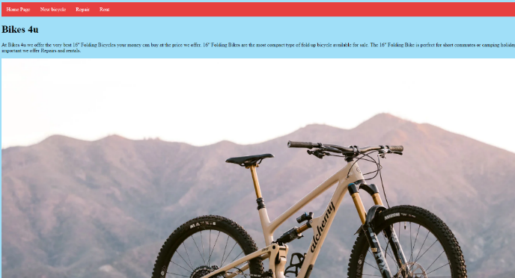

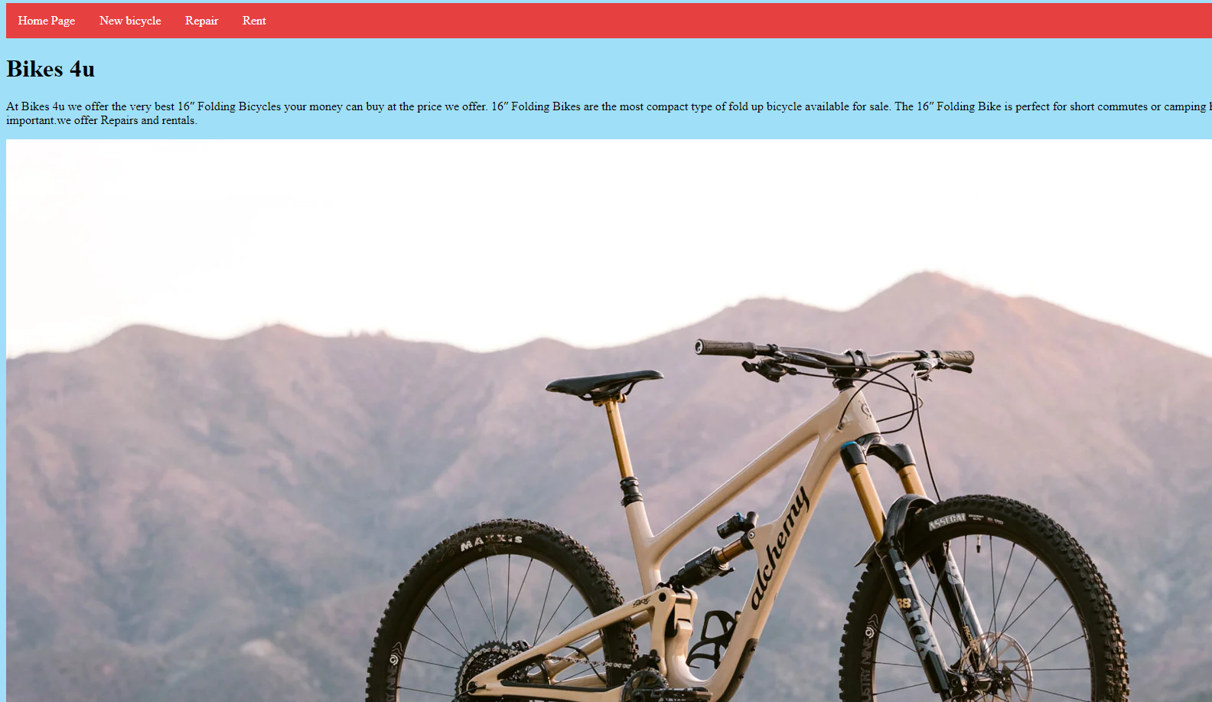

This is the “home page” for my website, the home page is there for the consumers to understand more about our business, and make it easier for them to know what were based on.

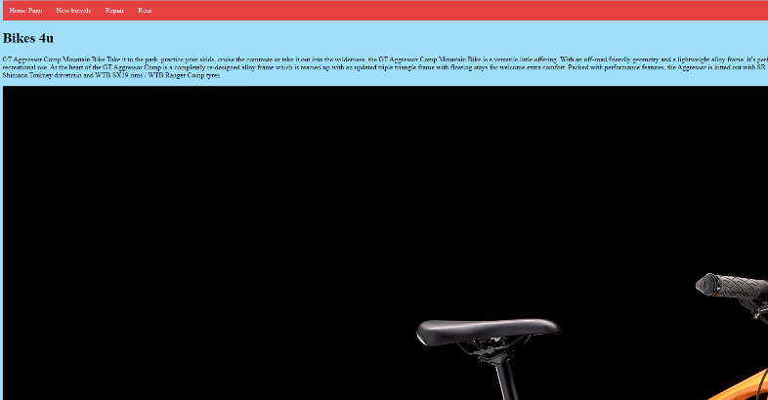

This is my “new bicycle” page for the website. This page is to show our new bicycles to the customers. This page was created to make it easier for the people who are looking for new bicycle so they can see our product just by a click.

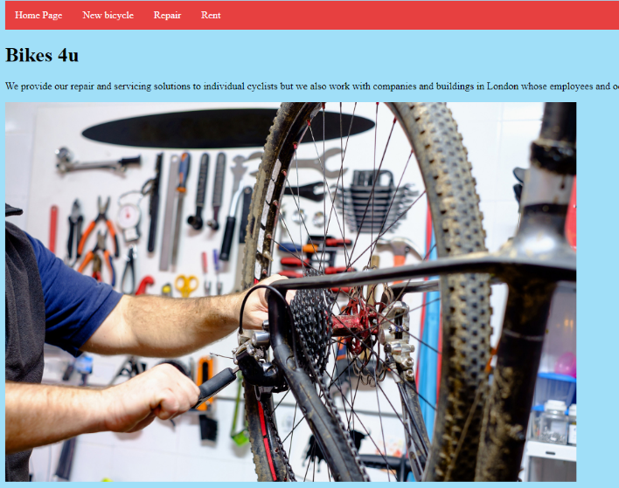

This is the “repair page” of my website that I created for the customers who wants to repair their bicycles.

This page was created to make it easier for the consumers who are visiting the website for repairing, they can just click the button and go straight to the repair page.

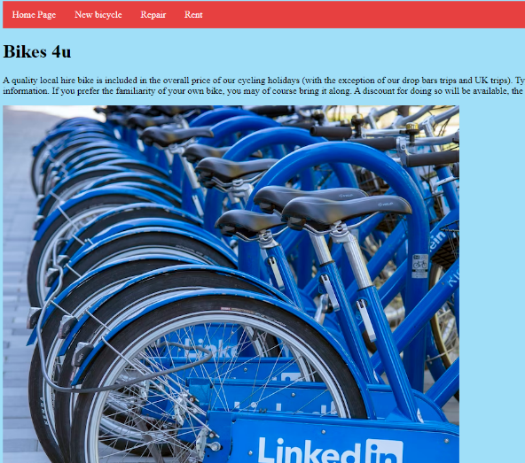

This is “rent page” for our website that I created for the people who are trying to rent bicycles from our website. This page will make it easier for the consumers, they can just click the button and go straight to the rent page which will make their life easier just by a click.