https://www.tensorflow.org/datasets/catalog/movielens

building recommendation systems with TensorFlow on Google Cloud Platform.

https://www.cloudskillsboost.google/course_templates/39

When you watch a video on YouTube and you see a list of suggested videos to watch next, that list is being built by a recommendation machine-learning model, often called a recommendation engine.

Of course, just the ML model, just the recommendation engine, is not enough, someone needs to build a data pipeline to collect whatever input data the model needs.

Inputs like the last five videos that you watched. That is done by a recommendation system.

When Google Maps suggests the route that avoids toll roads, that's a recommendation system. When Smart Reply in Gmail suggests possible replies to an email that you received, that too is a recommendation system. Recommendation systems are about personalization. It's about taking your product that works for everyone and personalizing it for an individual user

Let's say you want to recommend movies to users. You can do this in several ways.
The first of these is to use a content-based recommendation system. In a content-based recommendation system, you use the metadata about your products. For example, perhaps you know which movies are cartoons and which movies are Sci-Fi. Now, suppose you have a user who has seen and rated a few movies, some that she liked and give a thumbs up, and that some that she didn't. We would like to know which movie in our database we need to recommend next. Remember, that we have metadata about the movies. We know that this particular user likes Sci-Fi and doesn't like cartoons, so we might use that information to recommend popular Sci-Fi dramas to this user. Perhaps we recommend The Dark Knight Rises.

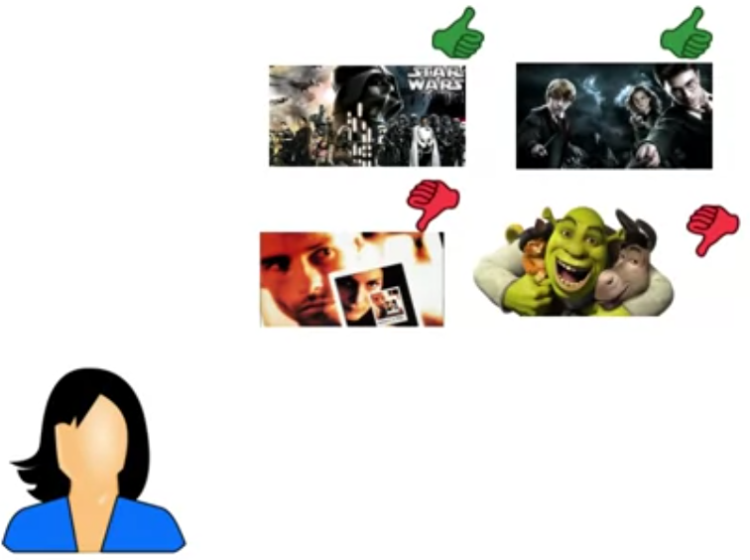
Notice that this recommendation is based on knowing something about the content. You're simply recommending the most popular items in a category that the user likes.

Maybe you don't even have the individual user's preferences. All you might have is a market segmentation, which movies are liked by users in which regions of the country, and that is enough to build a content-based recommendation system. Arguably, there is no machine-learning here. It's a simple rule that relies on the builder of the recommendation system to assign proper tags to items and users.

That's a content-based recommendation system

In collaborative filtering, you don't have any metadata about the products. Instead, you learn about item similarity and user similarity from the ratings data itself.

We might store our user movie data in a matrix like this, with checkmarks indicating whether the user watched the complete movie, or commented on it, or gave it a star rating, or however it is that we measure that a specific user liked a specific movie.

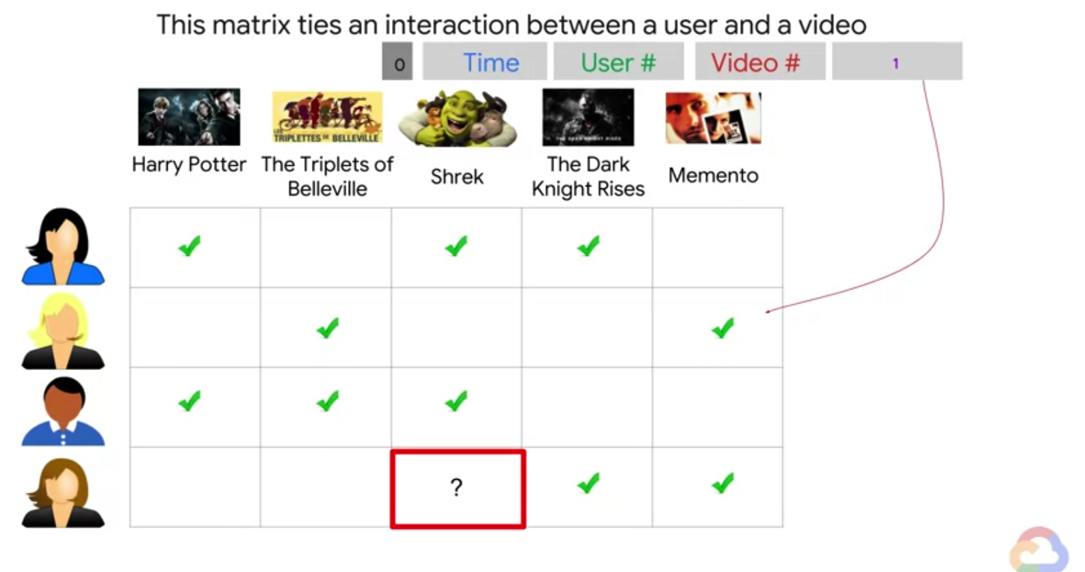

This matrix is very large.

Since you might have millions to billions of users and a hundreds to millions of movies, an individual will have tend to have watched only a handful of these movies. Most of this matrix is not only large, this matrix is sparse.

The idea behind collaborative filtering is that this very large, very sparse user by item matrix can be approximated by the product of two smaller matrices called user-factors and item factors.
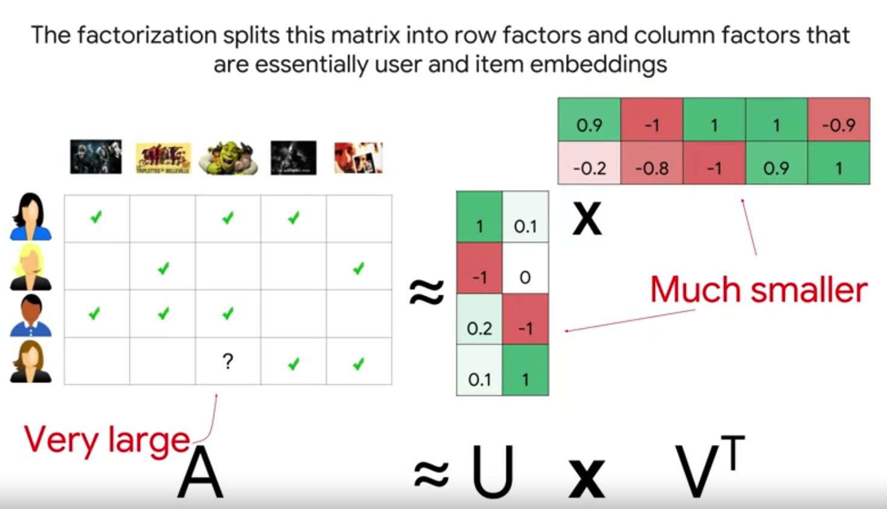
Then, if we need to find whether a particular user will like a particular movie, it's as simple as taking the row corresponding to the user and the column corresponding to the movie, and multiplying them to get the predicted rating.

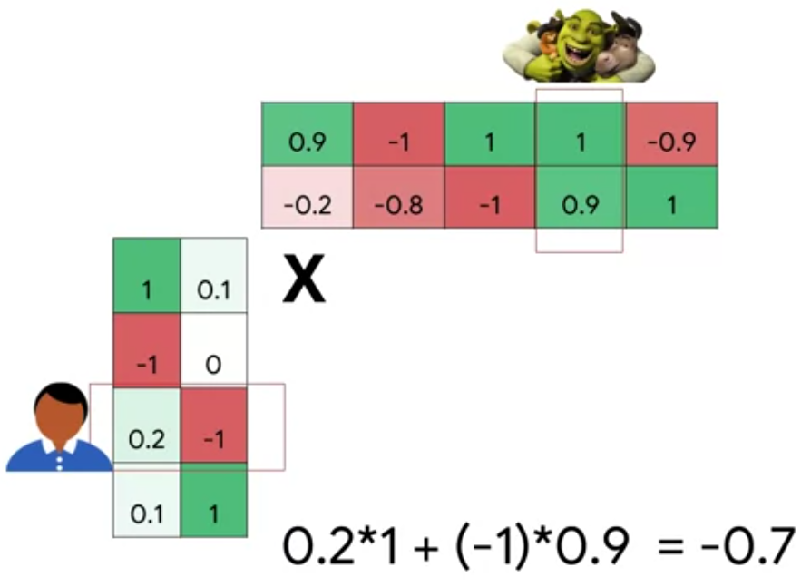

To recommend movies to users, we recommend the movies that we predict, they will rate the highest.

Of course, you will learn how to implement collaborative filtering in TensorFlow.

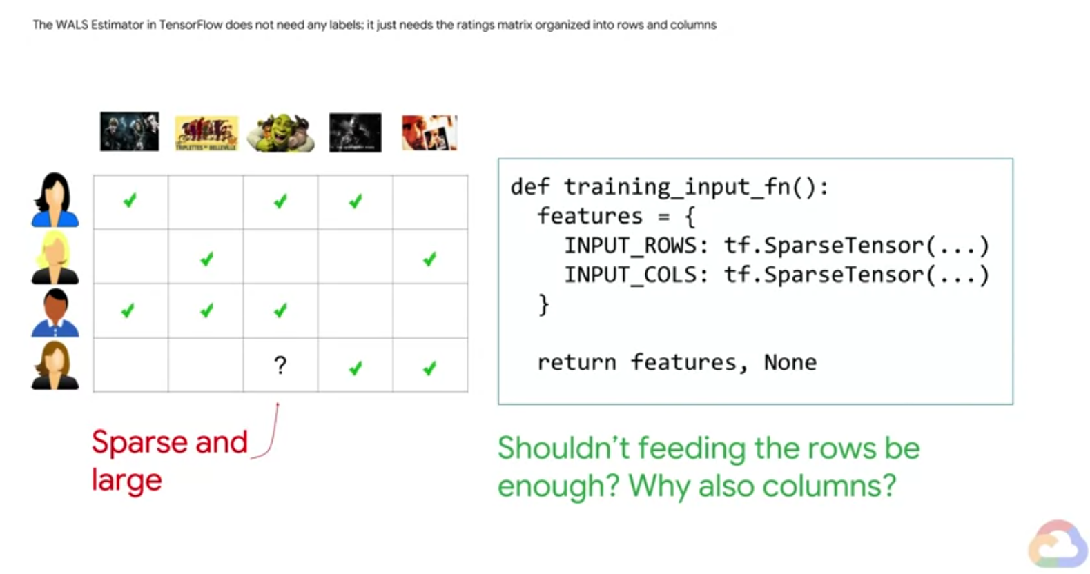

One of the really cool things about collaborative filtering, is that you don't need to know any metadata about your items.

You also don't need to do market segmentation of your users. As long as you have an interactions matrix, you're ready to go.

But if you do have metadata about users and items, you can use content-based recommendation systems. But what if you have both? You have metadata and you have an interactions matrix. If you have both, you can use neural networks to combine all of the advantages, and eliminate the disadvantages of all three types of recommendation systems.

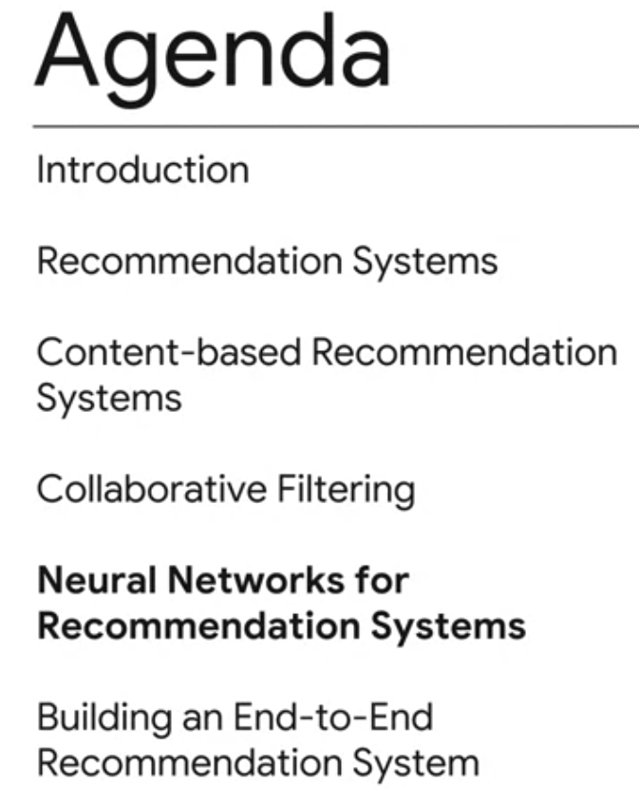

Three types?

Well, there's actually a third type of recommendation system called a knowledge-based recommendation system that can be used to provide business impact inputs to systems.

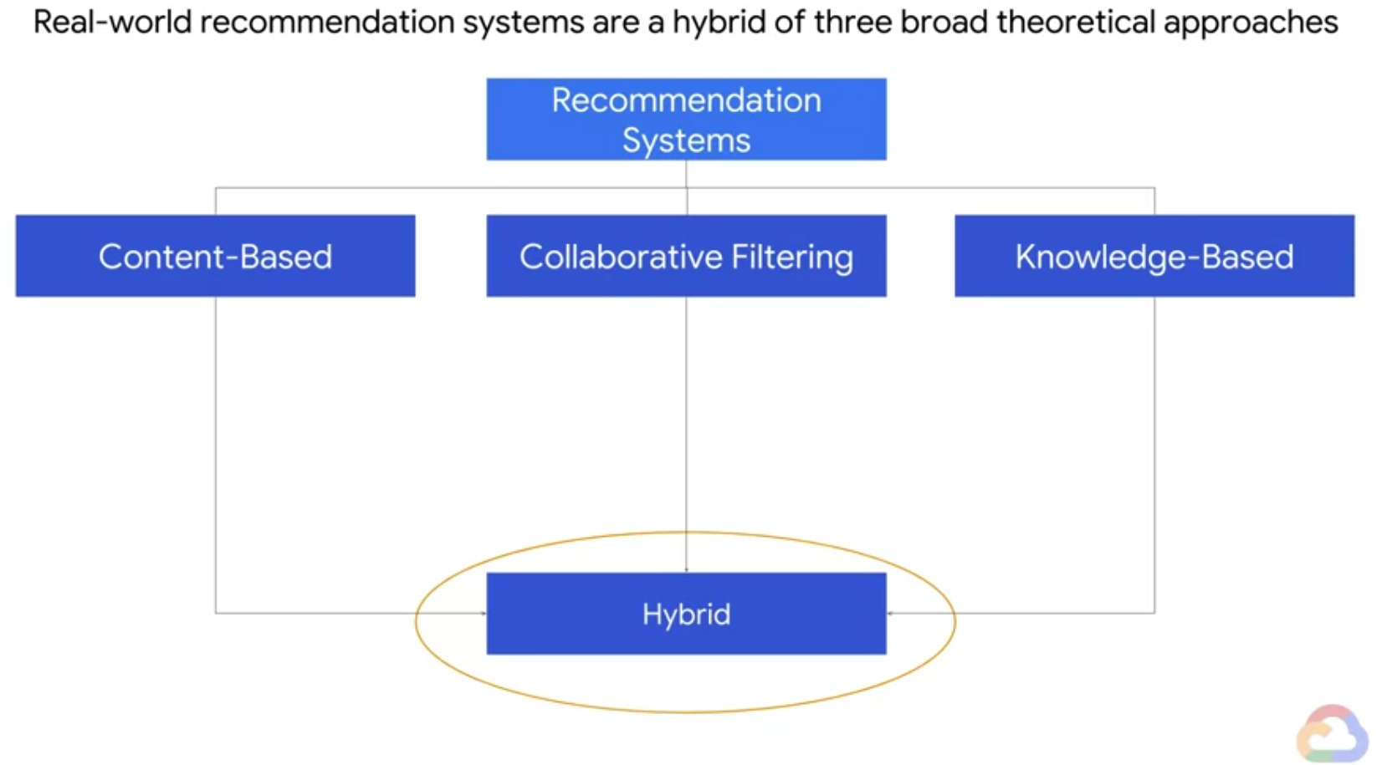

The hybrid models of all three of these types of systems use all the data available and connect all of these models together into an ML pipeline.

content-based and collaborative filtering, knowledge based recommenders, and deep learning techniques

Incidentally, this is how YouTube works.

Further outlook:

1- Learn some of the inner workings of the YouTube video hybrid recommendation system as an inspiration to building your own hybrid model.
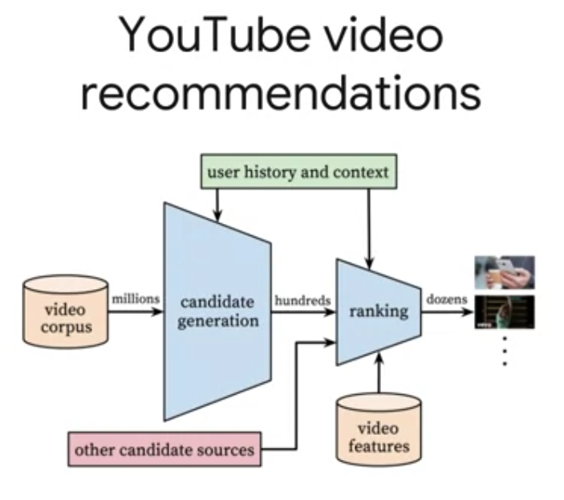

2- Productionize and automate much of the necessary pipeline using Google Cloud Platform ecosystem.
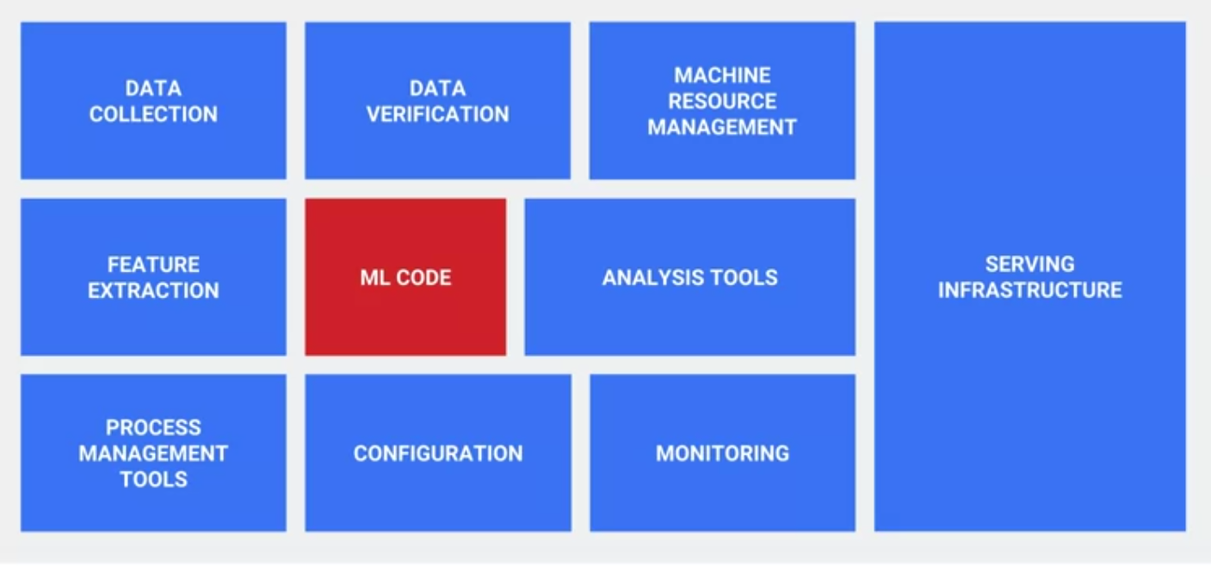
3- Because the machine learning model is only a small part of the overall system. We can look at the architecture of an end-to-end system for recommendations so that we can orchestrate the continuous retraining of the recommendation system as new ratings data comes in from users.

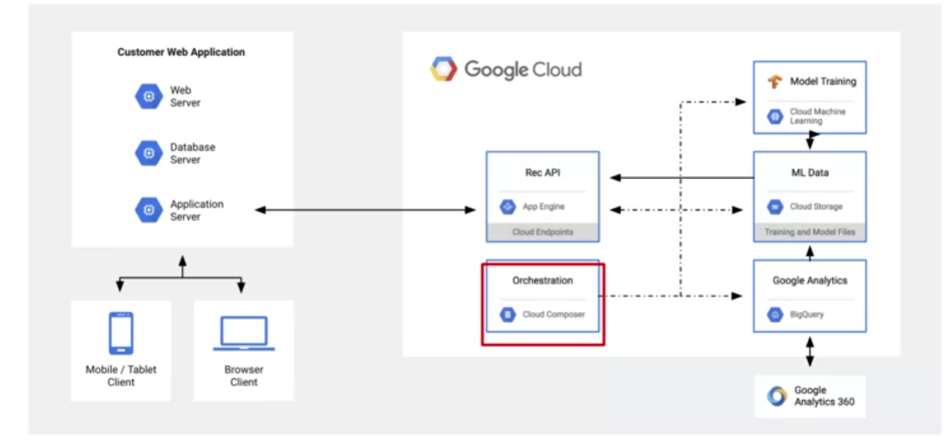

4- Build a (django) web application for a movie platform with our recommendation system and test the cold behavior and the time evolution of our system by adding new users and new ratings to our system.

5- Monitor your model after production:
https://neptune.ai/blog/how-to-monitor-your-models-in-production-guide

6- How to measure the success of a recommender?
how to define and measure the quality of a recommender system. We'll review different metrics that can be used to measure for this purpose. At the end of the module you'll be able to identify the correct evaluation activities required to measure the quality of a given recommender system, based on goals and needs.
https://neptune.ai/blog/recommender-systems-metrics (mean , rmsqs, map, etc)

workflow in the cloud providers:(z.B Azur) (these are general steps then go to the feetures of the movielens describing its featuresfrom tensorflow)

https://learn.microsoft.com/en-us/azure/architecture/example-scenario/ai/movie-recommendations-with-machine-learning

Workflow of the content based re commender (get the picture from there)

https://learn.microsoft.com/en-us/azure/architecture/solution-ideas/articles/build-content-based-recommendation-system-using-recommender

steps to build/design the recommendation system:
1……..8?
one of those steps is called https://learn.microsoft.com/en-us/azure/machine-learning/how-to-configure-auto-features#feature-engineering-and-featurization

Phases of recommendation process(https://www.sciencedirect.com/science/article/pii/S1110866515000341)

3.1. Information collection phase

- .1.1. Explicit feedback
- 3.1.2. Implicit feedback
- 3.1.3. Hybrid feedback

3.2. Learning phase
3.3. Prediction/recommendation phase
Recommendation filtering techniques
picture from marie on whats app was in the above articles
https://ars.els-cdn.com/content/image/1-s2.0-S1110866515000341-gr2.jpg

4.1. Content-based filtering

Similarity measures

4.1.1. Pros and Cons of content-based filtering techniques

4.1.2. Examples of content-based filtering systems

4.2. Collaborative filtering
4.2.1. Memory based techniques
4.2.2. Model-based techniques see the link to correct and summarize the following sub points
- clustering
- decision tree
- association rule , etc...etc

4.2.3. Pros and Cons of collaborative filtering techniques (see the link)
4.2.4. Examples of collaborative systems
4.2.5. Trust in collaborative filtering recommendation systems
4.3. Hybrid filtering
-sub point1
-subpoint2
etc

5. Evaluation metrics for recommendation algorithms

table of recommeder algorithms used by microsoft can be found here

https://github.com/microsoft/recommenders

by amazon
https://docs.aws.amazon.com/personalize/latest/dg/how-it-works.html
https://docs.aws.amazon.com/personalize/latest/dg/personalize-workflow.html

Conclusion:
Recommendation systems are often the machine learning systems that you encounter the most often in enterprise settings. From a business impact standpoint, recommendation systems can allow you to sell products you could never sell before, to users you could never reach before.

How to recommend a hotel to a user?

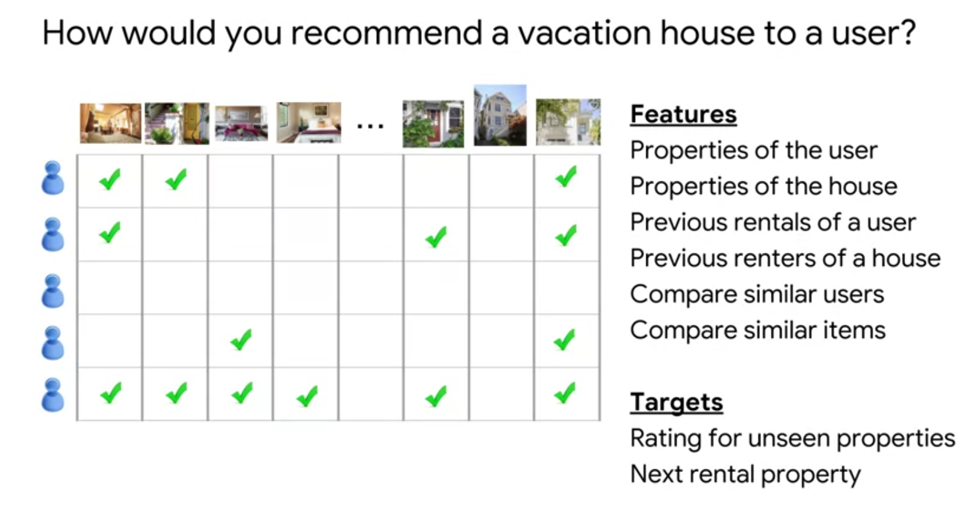

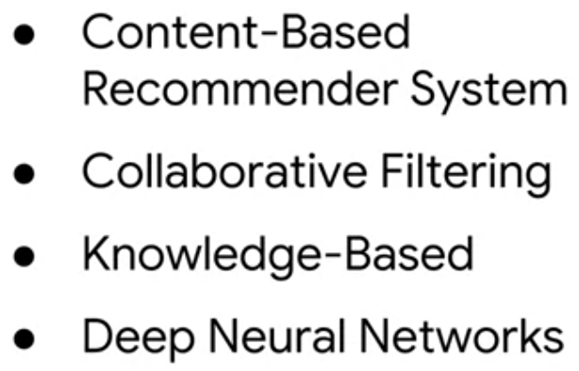

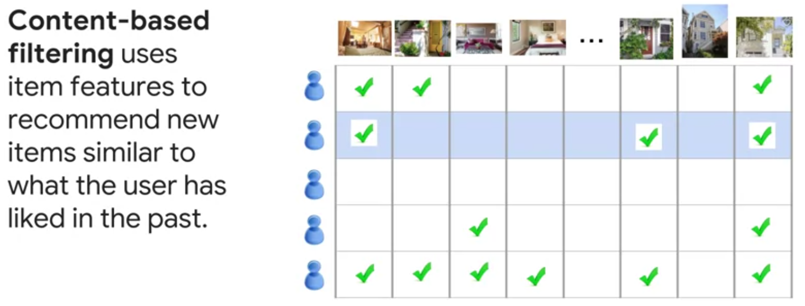

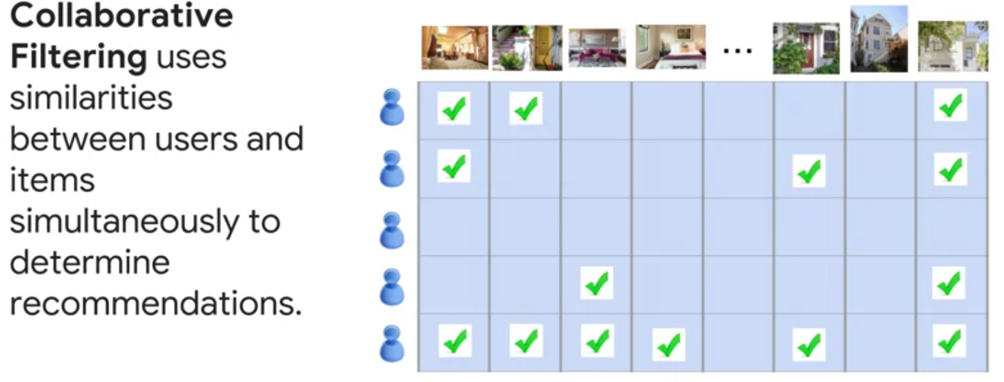
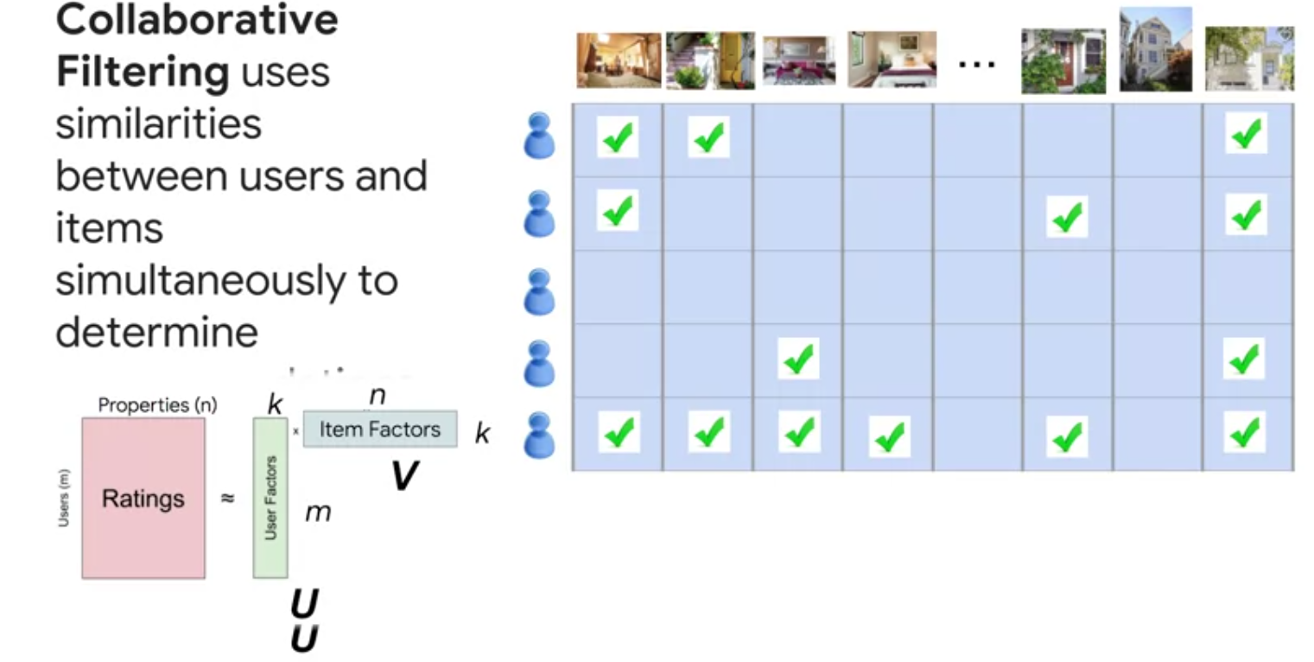

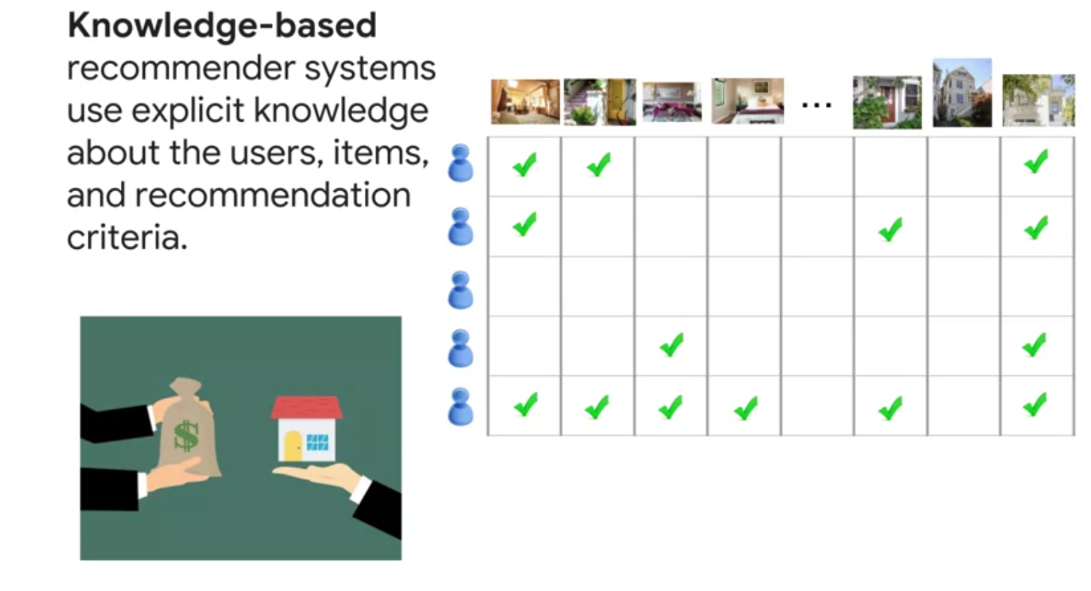
When no Data about previous behaviour are avalable then they explicitly ask the user about their preferences and recommend them items based on this knowledge

hybrid appraoch

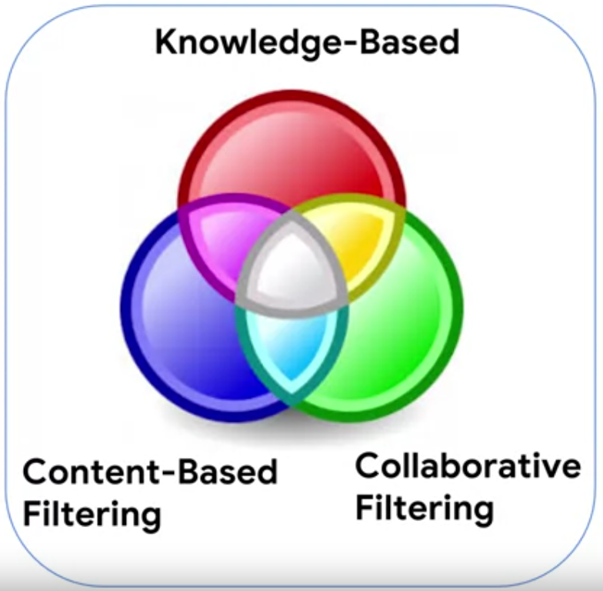

https://www.youtube.com/watch?v=5Lm1UMogEkI
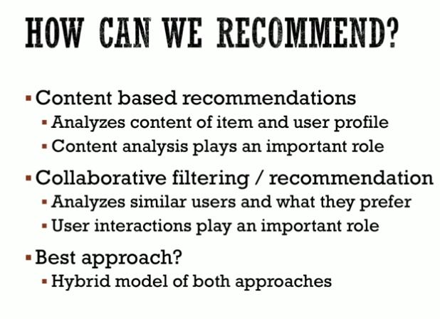

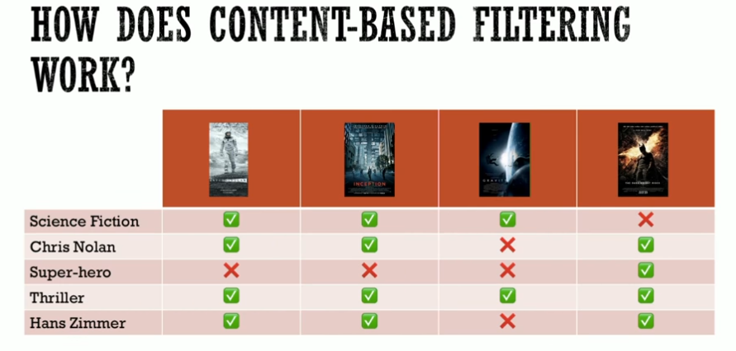
https://youtu.be/5Lm1UMogEkI?t=1010

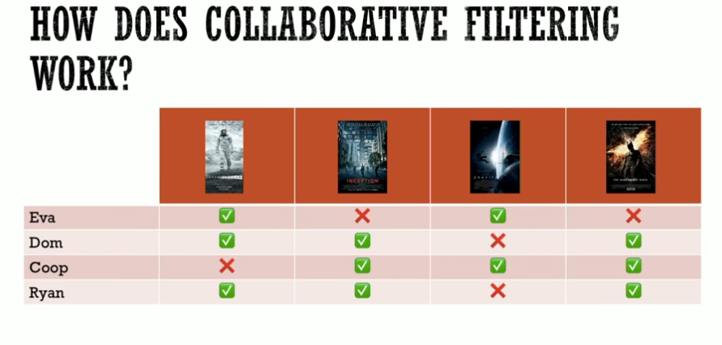
https://youtu.be/5Lm1UMogEkI?t=1171
Challlenges:
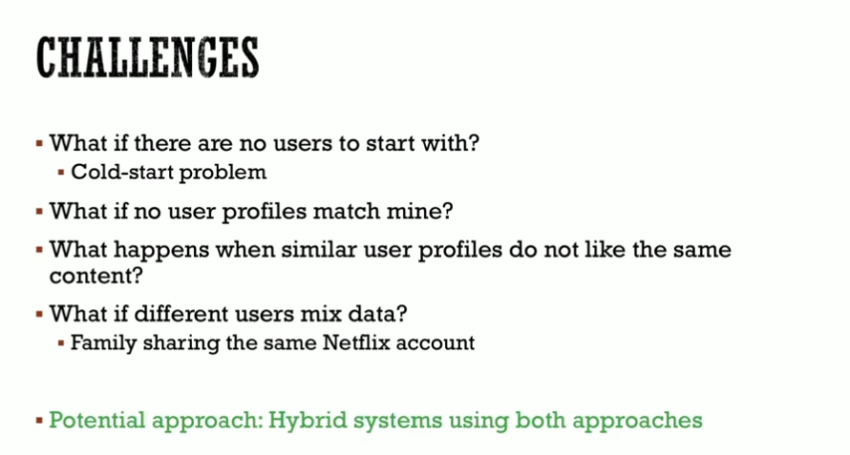
their code:
https://github.com/karthikmswamy/RecSys/blob/master/Train_RecSys.ipynb

Challenges with Collaborative Filtering (from here : https://analyticsindiamag.com/collaborative-filtering-vs-content-based-filtering-for-recommender-systems/)

The only issue with this method is that the prediction of the model for a given user, item pair is the dot product of the corresponding embeddings. So, if an item is not seen during training, the system cannot generally create an embedding for it and hence cannot query the model with this item. This issue is known as the cold-start problem.

(solution agains cold start : popularity based recommenders + ---?) (from here)

comparing content base vs colborative filtering
https://arxiv.org/pdf/1912.08932.pdf

https://analyticsindiamag.com/collaborative-filtering-vs-content-based-filtering-for-recommender-systems/

comparing the data:

https://medium.com/analytics-vidhya/movie-recommender-system-using-content-based-and-collaborative-filtering-84a98b9bd98e

https://www.coursera.org/learn/basic-recommender-systems
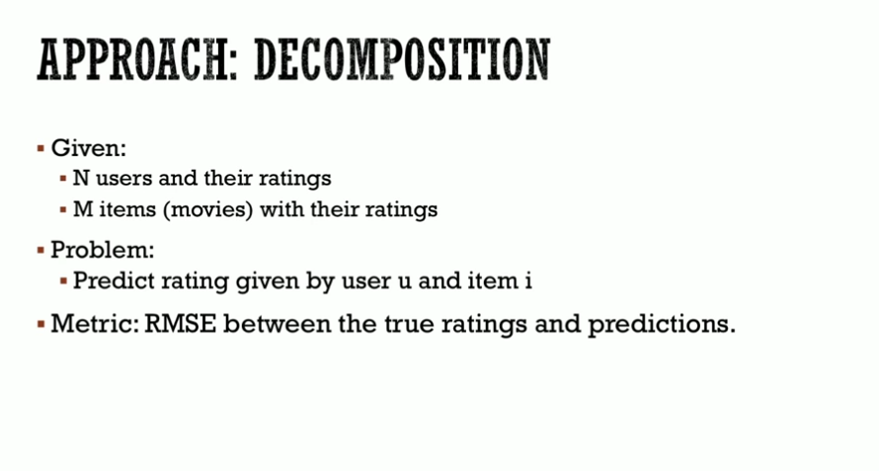
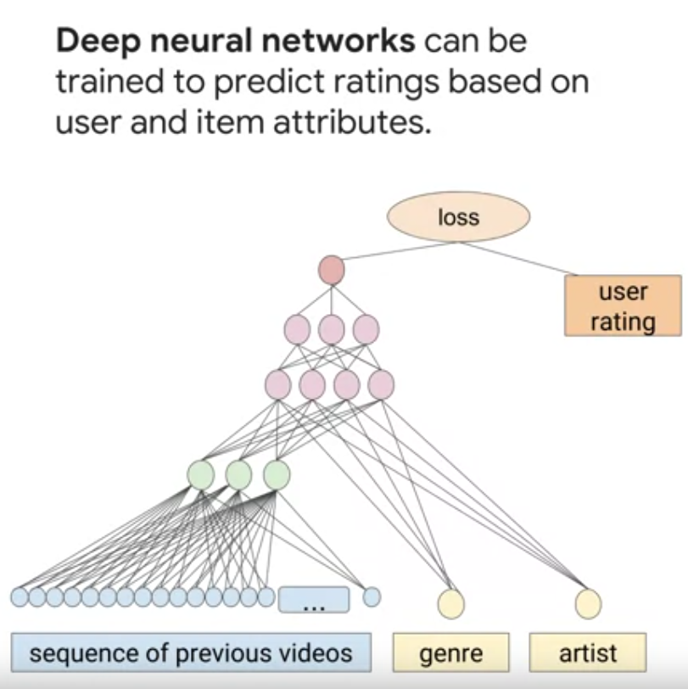
The model recommends a hiking app to a user because they recently installed a similar app. This is an example of what kind of filtering?
Content based filtering
(copy the explanation why this example is not collaborative based nor deep neural networks)

(did not work on the video before the discussion)

outlook further works:
a project that used the tensorflow to build a recommender system is available here
https://github.com/GoogleCloudPlatform/tensorflow-recommendation-wals/blob/master/notebooks/Part1.ipynb
from the above notebook we can find a way to get and download the data in the notebook

also the gliederung here:
https://www.pluralsight.com/courses/recommendation-systems-tensorflow-google-cloud

another project with good explanaation of the third model is here
https://blog.codecentric.de/bigquery-ml-schnelles-training-recommendation-modell

and here : https://medium.com/google-cloud/recommendation-systems-with-deep-learning-69e5c1772571
(matrix factorization)

https://www.analyticssteps.com/blogs/what-are-recommendation-systems-machine-learning

(Using tensorflow , add summery of the concepttraining data, vs tet data )

group from singapore
https://www.youtube.com/watch?v=5Lm1UMogEkI
their repo
https://github.com/karthikmswamy/RecSys/blob/master/Train_RecSys.ipynb

google developer:
https://developers.google.com/machine-learning/recommendation

Google cloud is offering solutions for recommendation system, thay were offering tuotrial on how to use tesorflow to build machine learning but they are unavailable now

new links :
https://cloud.google.com/recommender/docs/key-concepts?hl=en
https://cloud.google.com/architecture/data-preprocessing-for-ml-with-tf-transform-pt1
https://cloud.google.com/ai-platform/prediction/docs/deploying-models

old links (not available or redirect to the cloud artichecture center)
https://cloud.google.com/solutions/machine-learning/recommendation-system-tensorflow-overview
https://cloud.google.com/solutions/machine-learning/recommendation-system-tensorflow-deploy

other things

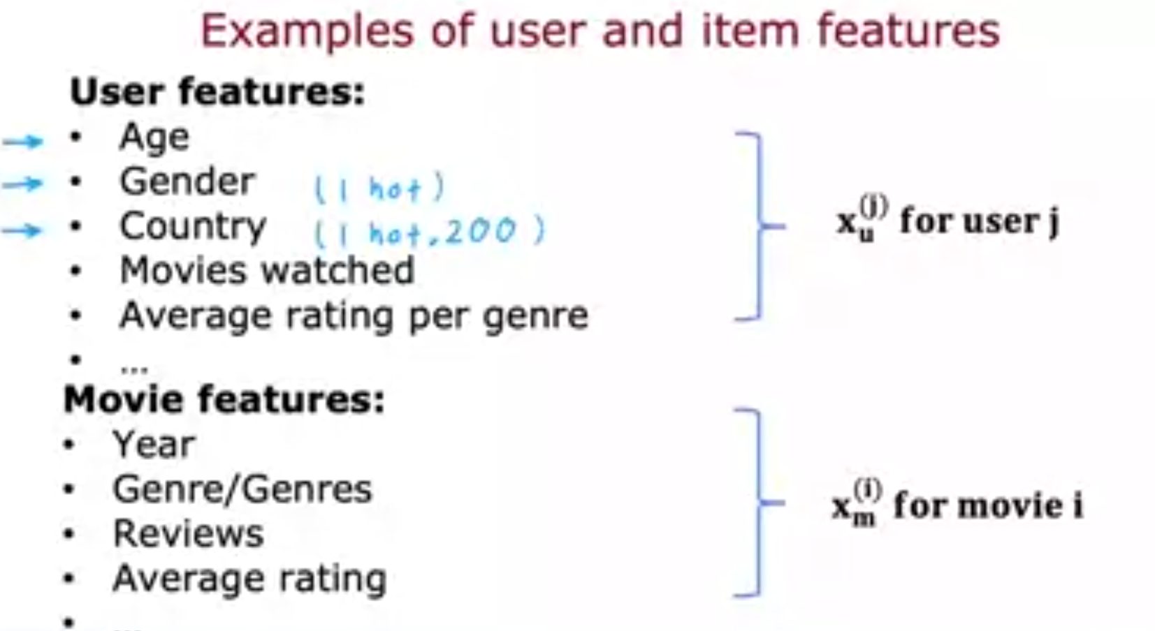
https://www.coursera.org/learn/unsupervised-learning-recommenders-reinforcement-learning/lecture/cOHyS/making-recommendations

4:37 - 5:31
So with this framework for recommended systems one possible way to approach the problem is to look at the movies that users have not rated. And to try to predict how users would rate those movies because then we can try to recommend to users things that they are more likely to rate as five stars. And in the next video we'll start to develop an algorithm for doing exactly that. But making one very special assumption. Which is we're going to assume temporarily that we have access to features or extra information about the movies such as which movies are romance movies, which movies are action movies. And using that will start to develop an algorithm. But later this week will actually come back and ask what if we don't have these features, how can you still get the algorithm to work then? But let's go on to the next video to start building up this algorithm.

