SimCreator Script Documentation

About
The SimCreator Script was written by Peter Roelants at the KULeuven Department of Mechanical Engineering under supervision of Prof. Herman Bruyninckx, Koen Buys and the help of Izaak van Crombrugge. It uses the GPL Licence.
The script is written for Blender 2.5, it was last tested on Build 2.53.0 r'30594'.
It is currently beeing adapted for Blender 2.56 by Koen Buys.

Introduction
This script is not complete, it is written to test out the panel scripting possibilities in Blender 2.5.
This script gives you the possiblity to create a simulation. The simulation elements are in the provided SimCreator library.
A simulation consists of an environment and actors like robots, sensors and tools. When you start a simulation you first need to create an environment and then you have the option to add different actors.
Each environment or actor can have multiple anchor points (AnchorPoints), these points represent locations were new actors can be added to the simulation.
Each actor has 1 AnchorConnection which is a place where the actor will be connected to an anchor point in the current simulation.
Because this script is incomplete I tried to write my code so it can be extended. The simulation data, the simCreator library, the environment and actors all representend in different objects that can be extended as you like. I tried to disconnect as much as possible these objects from their Blender objects.

Running the script
You can run the script by loading it into the Blender script window and press 'Run Script'.
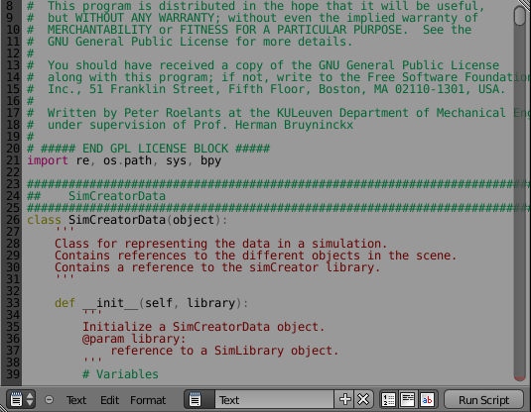 1: Run Script in Blender
When you run the script, the robotics panel will appear in the Blender 'Properties area' under 'Scene', you may have to scroll down because the panel will be displayed at the bottom.
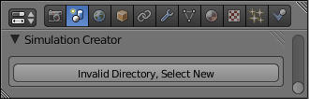2: Panel location

Selecting a directory
When you press the 'Invalid Directory, Select New' button, a file browser window will open in Blender. Here you can search for a folder that contains the SimCreator library and select this by clicking on the 'Set the library directory' button.
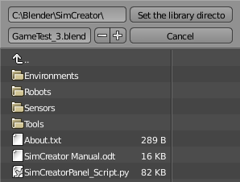 3: Selecting a SimCreator library directory

Creating an environment
After you selected a valid simCreator library you can create and environment for your simulation. You can do this by pressing the 'Create new Environment...' button. The environment selection box will open up and you can choose an environment in the dropdown box and then click 'Create Environment' to create the environment.
When you create a new environment, all the previous objects and data will be removed.
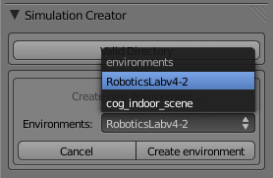4: Creating an environment

Adding an actor
After you created an environment you can add different actors to the simulation. For now the different supported actors are Robots, Sensors and Tools. These actors are connected to an available anchor point in the simulation.
You can add an actor through the 'Add a new robot...', 'Add a new sensor...' and 'Add a new tool...' buttons. These all work in a uniform way.
For example, click on the 'Add a new robot...' button. The robot selection box will open up and you can chose a holder type to select an anchor point from in the first dropdown box. These holder types are just a distinction to let you easily find an anchor point.
A new dropdown box can show up under the first dropdown box, this will let you select a specific holder from the selected holder type. For example if you selected the 'Robots' holder type, you can select a specific robot to search anchor points on this robot.
In the next dropdown box you can select a specific anchor point where you want to add the new robot. The selected anchor point will be selected in the Blender 3D view.
In the last dropdown box you can select a robot from the simCreator library that you want to add to the simulation.
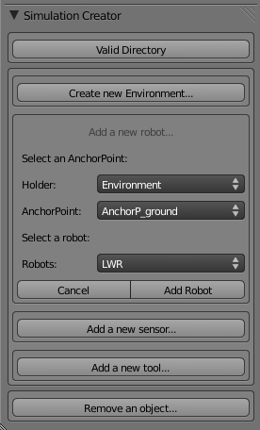5: Adding a robot

Removing an actor
You can remove an added actor by clicking on the 'Remove an object...' button. Clicking this will open the actor removing box where you can select an actor to remove.
At the top of the box you will see a checkbox that is unchecked by default. If you check this, the dropdown boxes under it will dissapear and you will be able to select an object by right clicking in the 3D view window, only actor objects will be selected.
If the checkbox is unchecked you will see two dropdown boxes. In the first you can select an actor type to select from. And in the second you can select between different actors of the selected actor type. The selected object will be selected in the Blender 3D view.
Clicking 'Remove object' will remove the selected object and all other actors connected to it.
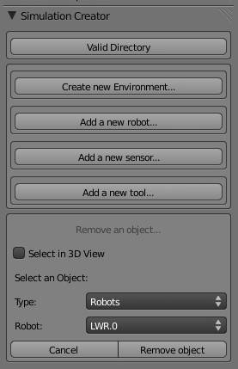6: Removing an object

The Script code
The script is contained in 1 file called 'SimCreatorPanel_Script.py', all the classes are put in this file to make it easier to load the script in Blender.
The script is divided into different classes, these will be explained below.

SimCreatorData
This class is used for representing simulation data and holds references to all the objects in the current simulation and to the simCreator library.

SimCreatorLibrary
This class is used to create a connection with the simCreator library, so you can import objects from this library.

SimObject
This class is used to represent an object in a simulation. This is used as a superclass for SimEnvironment en SimActorObject.

SimActorObject
This class is used to represent an actor in a simulation. This class inherits from SimObject and is a superclass for SimRobot, SimSensor and SimTool.
A SimActorObject object is direct or indirected connected to an environment.

SimEnvironment
This class is used to represent an environment in a simulation. It inherits from SimObject.

SimRobot
This class is used to represent a robot in a simulation. It inherits from SimActorObject. For now there isn't much in this class. The class is provided to differentiate between different actor types and for extending the script.

SimSensor
This class is used to represent a sensor in a simulation. It inherits from SimActorObject. For now there isn't much in this class. The class is provided to differentiate between different actor types and for extending the script.

SimTool
This class is used to represent a tool in a simulation. It inherits from SimActorObject. For now there isn't much in this class. The class is provided to differentiate between different actor types and for extending the script.

ROBOTICS_PT_SimCreatorPanel
This class is used to represent a custom robotics panel in Blender. This panel can be seen in Blender under 'Properties' – 'Scene'
This panel will hold all the buttons and information, it is divided in boxes, sometimes called 'subpanels.'

All other classes
The other classes in the script are all classes that are extensions of Blender classes, they represent buttons that will be drawn on the panel.

TODO
- Export/Import simulation
- Export/Import robot with specific sensors or tools
- Add new AnchorPoints to simulation (Izaak van Crombrugge is working on this)
- Add view control and options (Izaak van Crombrugge is working on this)
- Add option to import robot control scripts
- ...

