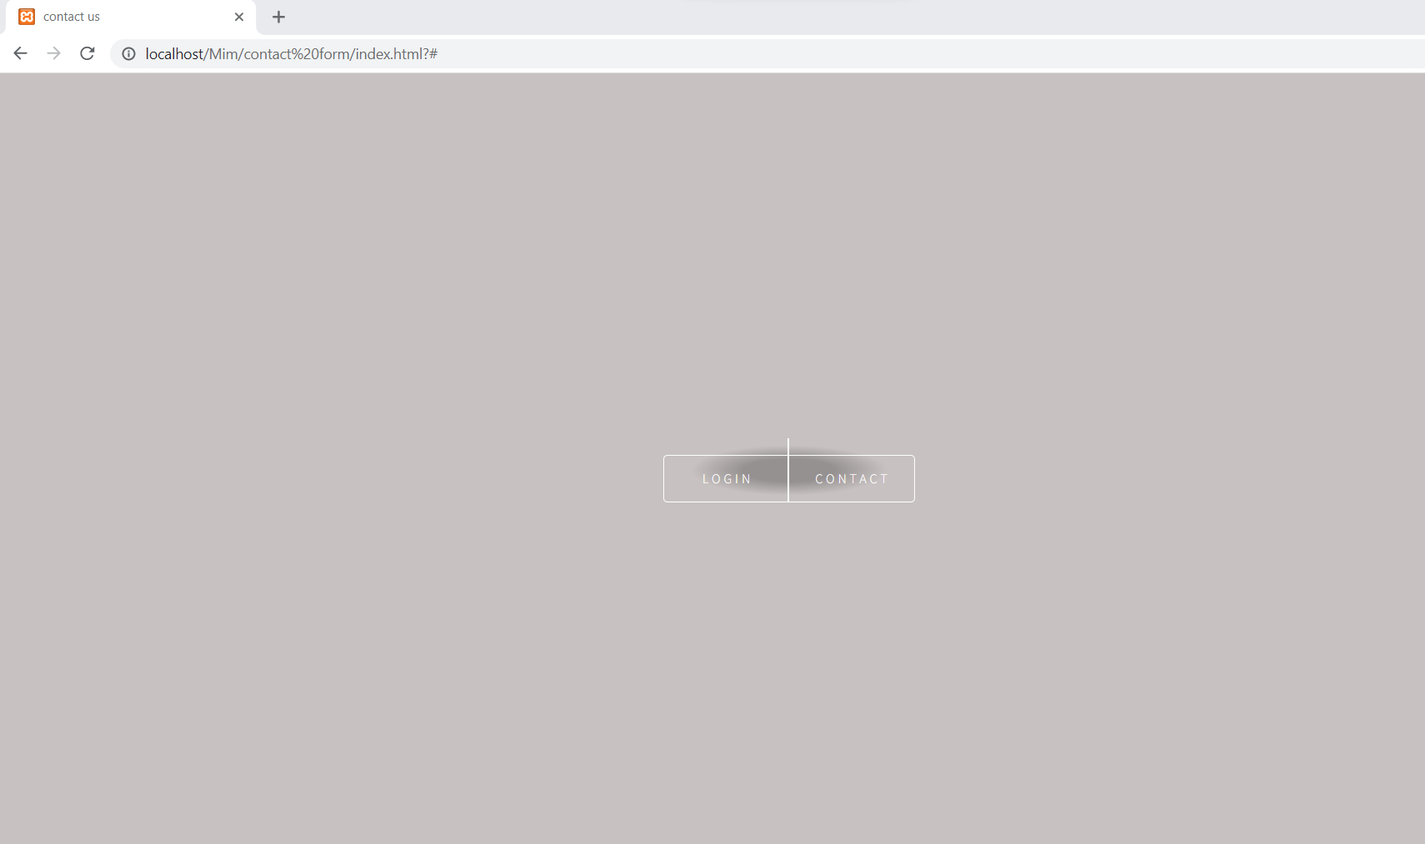

Home page

Contact

After Send message, show successful.

Login page for admin

After login, shows all users